If your business has previously registered with the City, had a contract (excluding subcontracts) or received a payment from the City, your organization should follow the process in the body of this document to register with the City of South Bend Vendor Portal. The City of South Bend’s Vendor Portal allows you to:
- View purchasing documents (purchase orders, invoices)
- View and respond to City solicitations – Coming soon!
- Participate in online invoicing

Follow the procedures below to register as a vendor, navigate the vendor portal, view and respond to City solicitations and participate in online invoicing.
If you have any questions please email purchasing@southbendin.gov

Contents
Vendor registration 3
General navigation 6
Workspaces 6
Edit vendor information 7
Add a new user 8
Processes – Purchase orders, online invoicing and solicitations 10
View purchase orders 10
Confirm purchase order 11
Create an invoice 12
Invoice status and lists 15
Solicitations 15
Frequently asked questions 15

Vendor registration
Access Web Path: | southbendin.gov/vendorregisration
Step 1: Visit the website above to apply to be a vendor of the City of South Bend.

Step 2: After the City of South Bend reviews your basic information you will receive an email from invites@microsoft.com titled “You’re invited to the City of South Bend organization”.
- Click “Get Started” on the email.
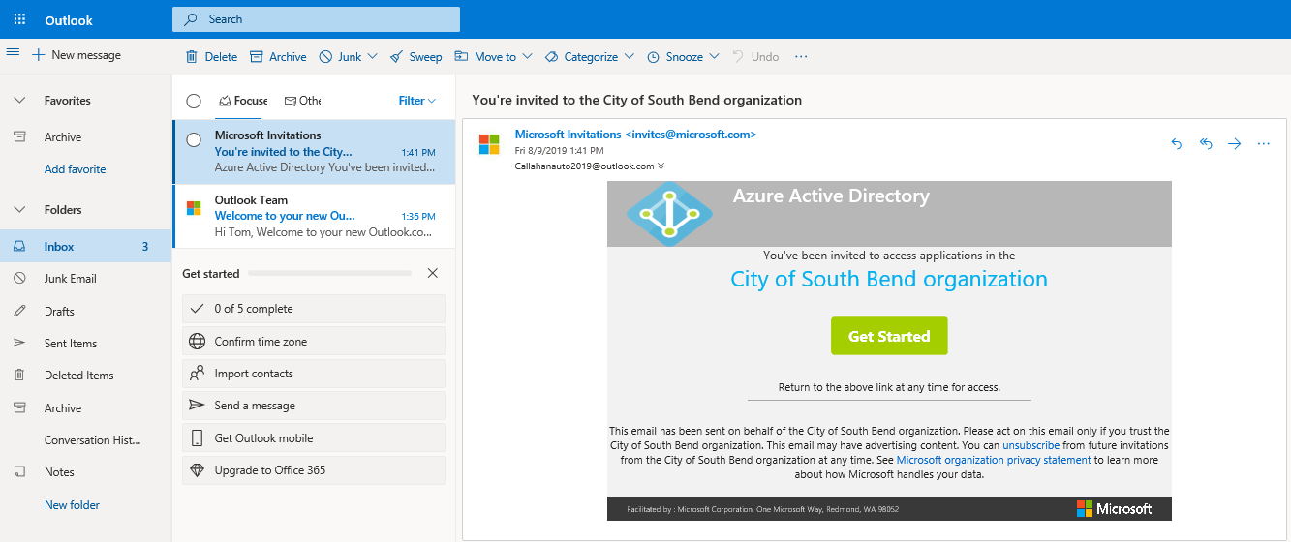

Step 3: You will be directed to Microsoft Dynamics 365 Finance and Operations where you will fill out additional information about your organization, but first you must sign in. If your email provider is Microsoft (outlook) then input your email credentials. If your email is Gmail or another provider then you will have to follow the on screen wizard to create a Microsoft account.
Registering with Microsoft:
- Click Next.
- Specify a password
- Verify your email

Step 4: Review the permissions granted to the City of South Bend to allow the City to process your data to administer your Dynamics 365 Finance and Operations account. Click Accept if you agree.

Step 5: The Vendor registration wizard has opened. Follow the on-screen prompt to move through the various pages.

Country/region: Use the filter to easily search for the Country your organization is established in. Select the Country then click Next.

Terms and conditions: Review the City of South Bends terms and conditions. If you accept the terms and conditions click the Yes/No toggle under “I accept the terms and conditions” and then Next.

Company information: Specify the organizations name, dba (if applicable) Telephone, Fax, Email and Website. Click Add to input your organization’s address.
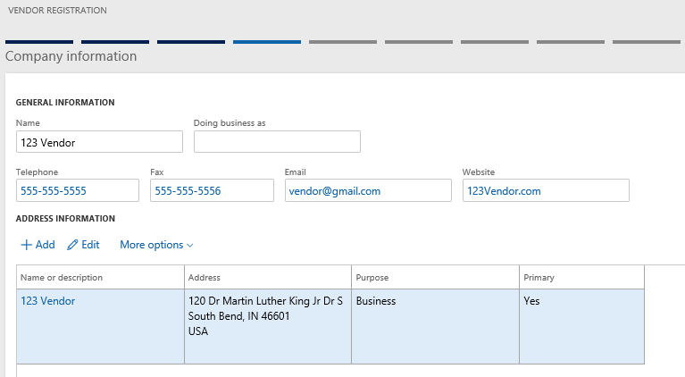

General information: This page is for general information about the user that will be using this Dynamics account.

Business information: This page is for additional information about your business. The required fields are Federal Tax ID and Currency, but specify additional information as it applies to your business.
- Input USD as the currency.
- Change the Federal tax ID type to Employer Identification Number
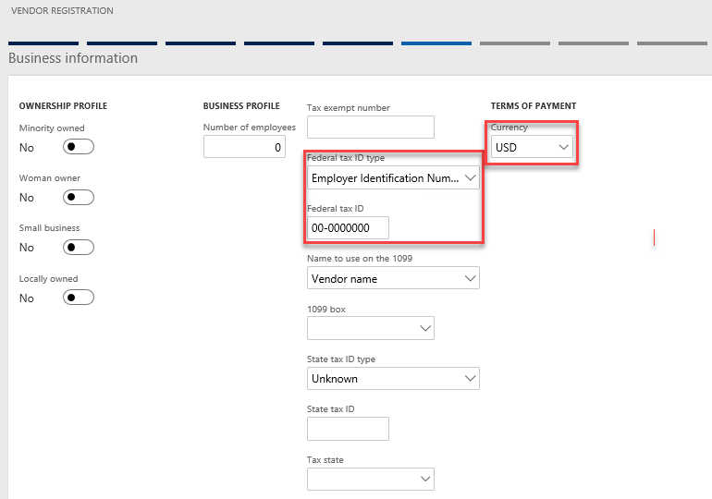

Procurement categories: This section is to assign commodity codes (procurement categories) to your vendor account. The City of South Bend uses the North American Industry Classification System (NAICS). Click Add category to view the NAICs codes for selection.
Questionnaire: Complete the questionnaire for additional information about your organization.
Step 6: Submit your vendor registration information to the City for their review by clicking Finish.
Step 7: After the City has reviewed your information, you will get another email from invites@microsoft.com. You are now a verified vendor with the City of South Bend. Click Get Started to access the vendor portal applications in Microsoft Dynamics 365 Finance and Operations.

General navigation
After the City has reviewed and accepted your vendor portal registration you will have access to the City’s vendor portal. The web-based vendor portal is powered by Microsoft Dynamics 365: Finance and Operations.

Workspaces
There are four workspaces in the vendor portal that should be used for confirming and viewing purchase orders, online invoicing, viewing and responding to solicitations and updating your vendor record. The four workspaces are:
- Invoicing
- Purchase order confirmation
- Vendor bidding – Coming soon!
- Vendor information
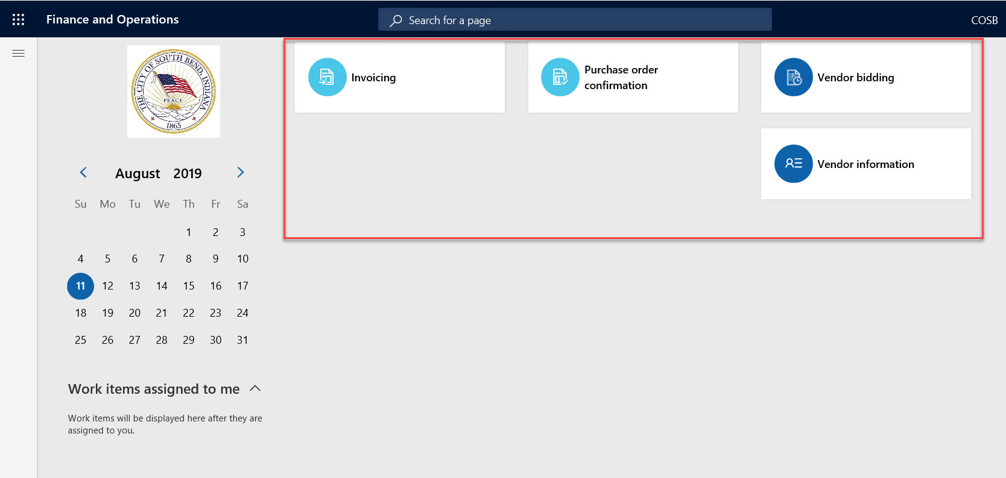

The subsequent sections of this document involve navigating through these workspaces to perform the vendor portal functionality.

Edit vendor information
Step 1: Click on the Vendor information workspace

Step 2: In the summary section, click More details then General
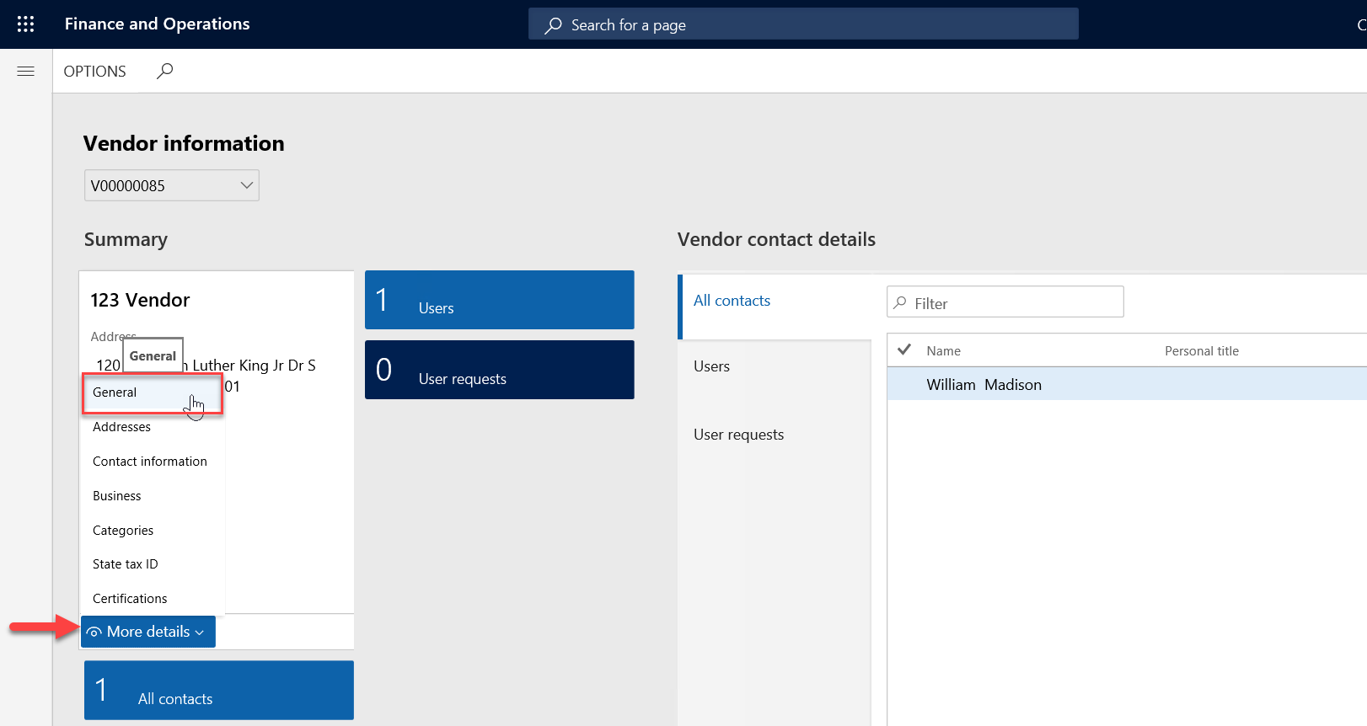

Step 3: Click Edit and update information on the various tabs as needed. When complete, click Save.

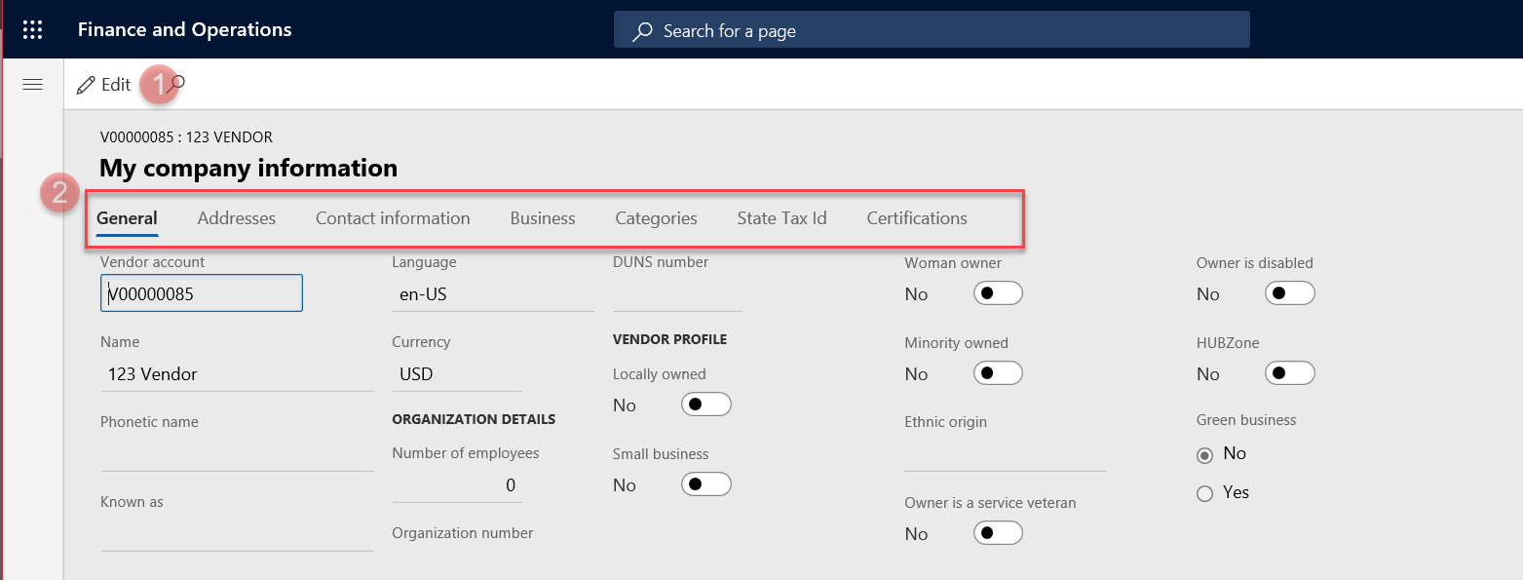

Add a new user

Step 1: Click on the Vendor information workspace

Step 2: Click on All contacts

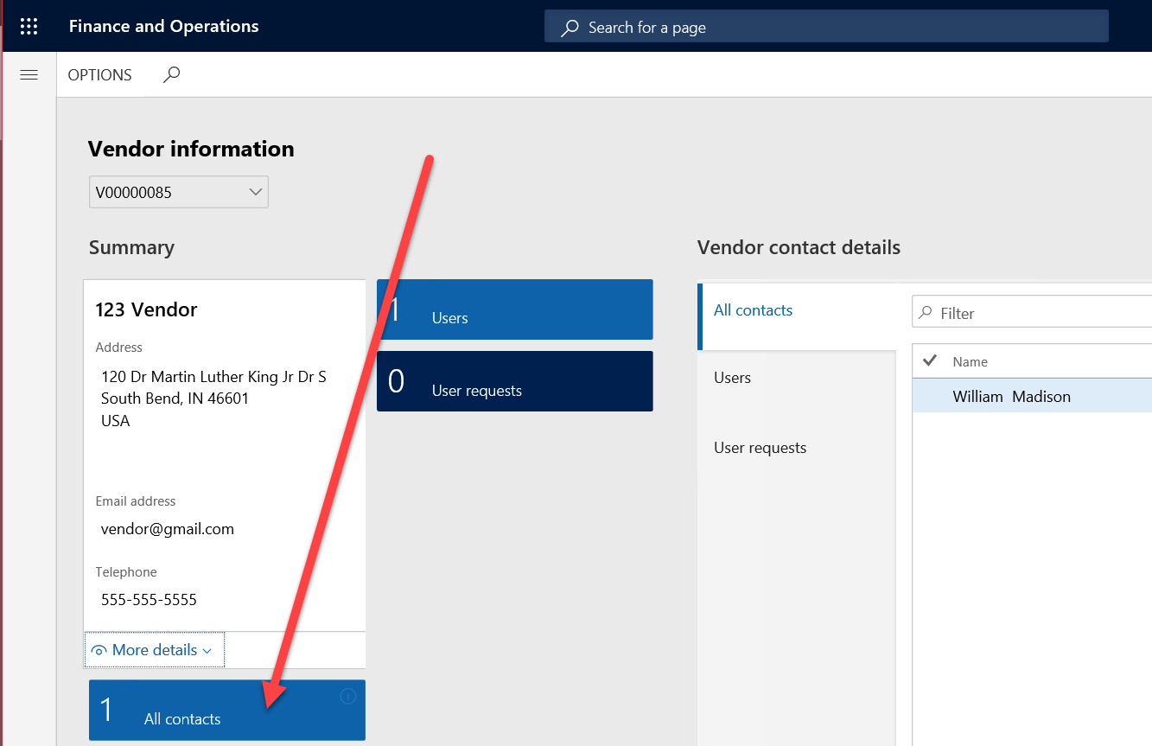

Step 3: Click New.
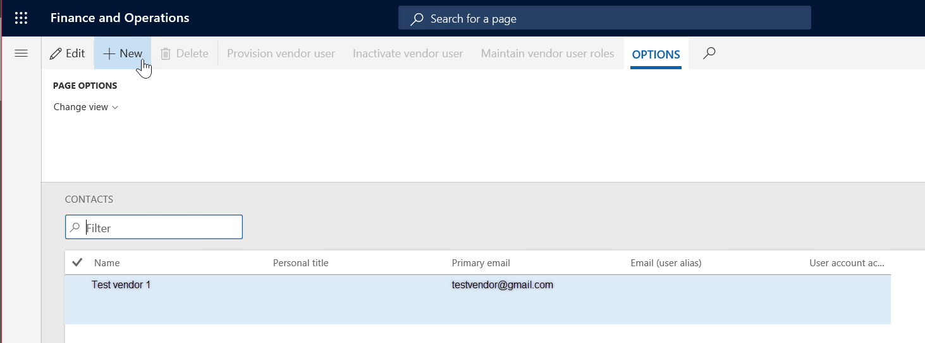

Step 4: Input the first and last name of the new user. Click Create.
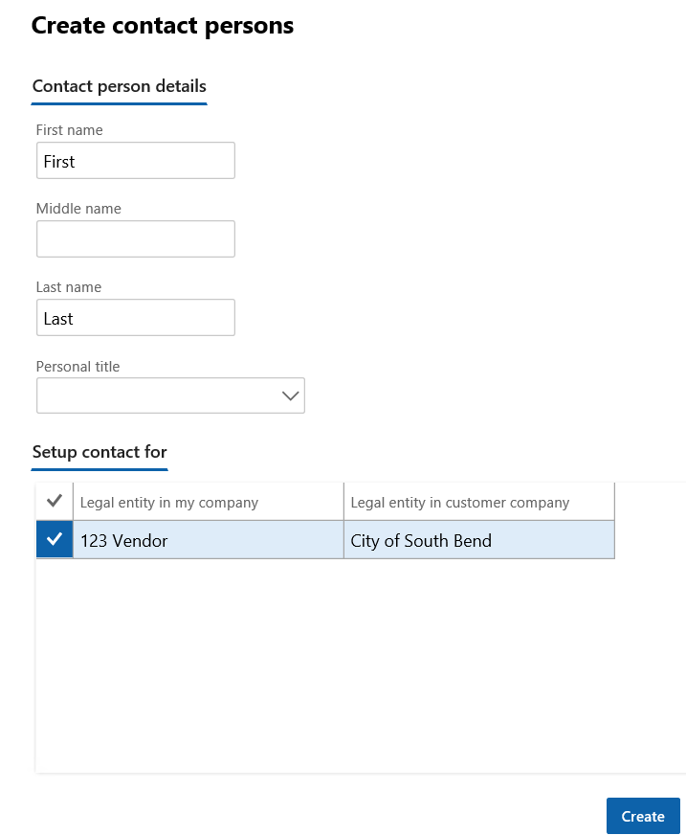

Step 5: Click Provision vendor user
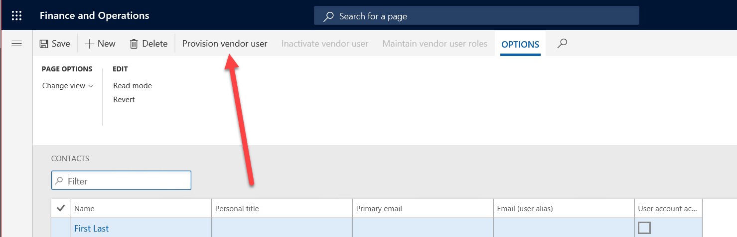

Step 6: Click on the down arrow to expand the fast tabs. Update the information for the bullets below and click Submit.
- Input an Email on the contact person details fast tab
- Input New user request as business justification on the Contact person details fast tab
- Checkmark vendor collaboration allowed on the Legal entities the person is a contact for fast tab
- Assign security roles by check marking applicable boxes on the Assign user roles fast tab

Step 7: The City will review the user request. When the City accepts the user request the new user will receive an email from invites@microsoft.com

Processes – Purchase orders, online invoicing and solicitations

View purchase orders
Step 1: Navigate to the Purchase order confirmation workspace

Step 2: Click All confirmed purchase orders to be directed to a listing of all purchase orders to see if they are open, invoiced and closed (paid).

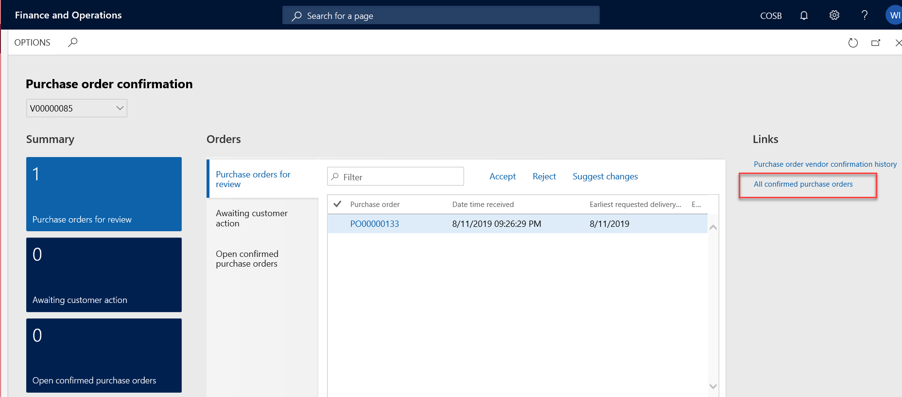

Confirm purchase order
View and confirm draft purchase orders from the City. You have the ability to confirm purchase orders that were submitted from the City. These Purchase orders will show in Purchase orders for review. Take action on these purchase orders by click on the purchase order number.

Step 1: Click on the Purchase order number (starting with PO#########).

Step 2: Review the Purchase order details and Approve, Reject or Suggest changes. Print the Purchase order which includes the City of South Bend’s terms and conditions by clicking Preview/Print.
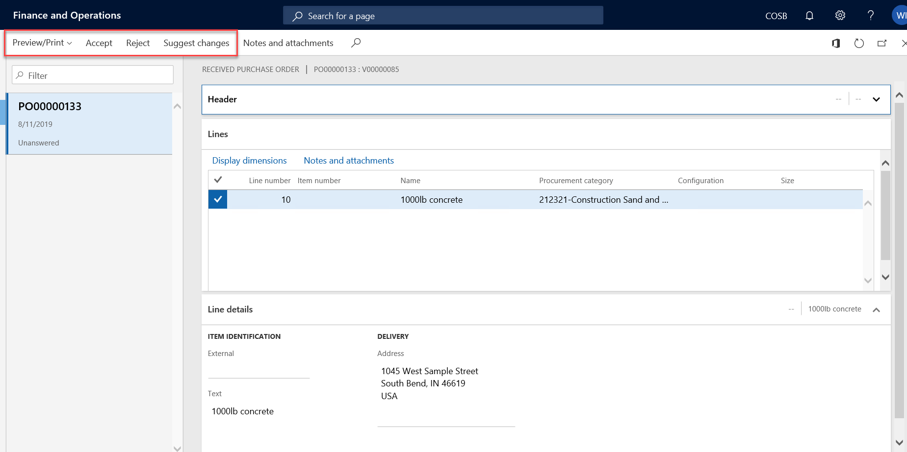

Create an invoice
Step 1: Navigate to the Invoicing workspace.
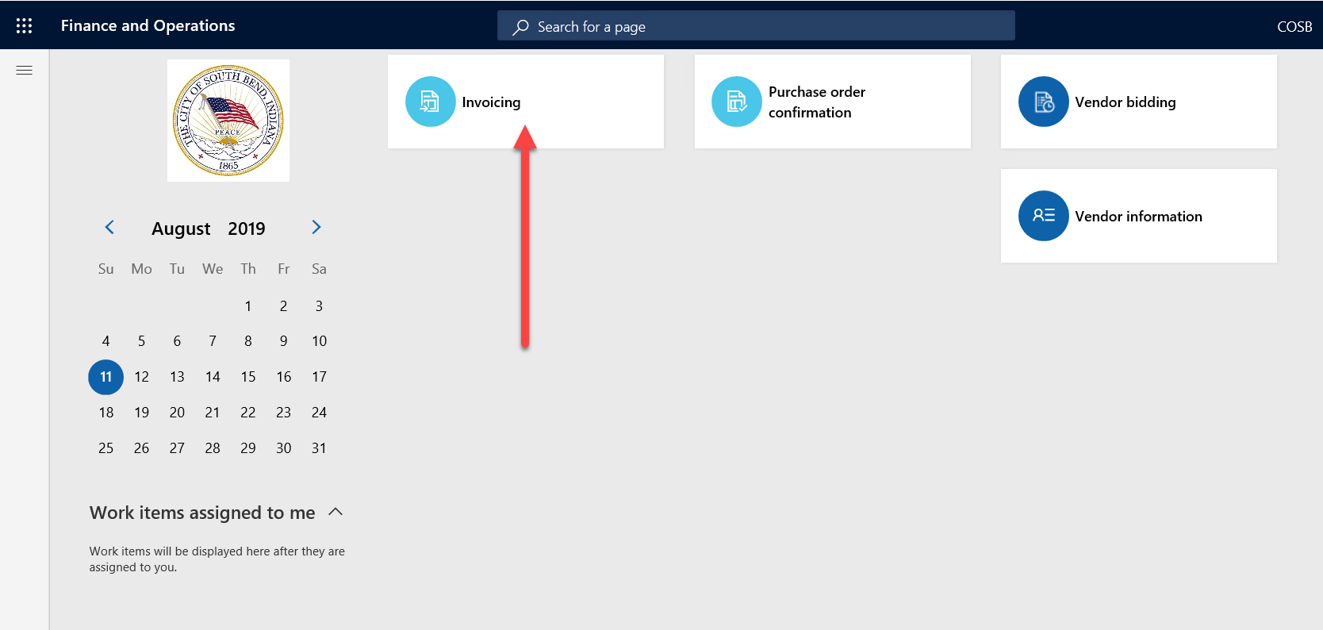

Step 2: Click New.
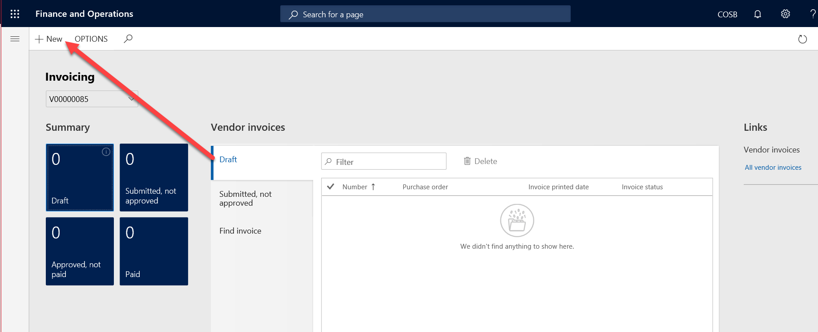

Step 3: A form will appear on the side. If applicable, select the purchase order the invoice is for. Input an invoice number, invoice date and an invoice description. Click Create invoice.
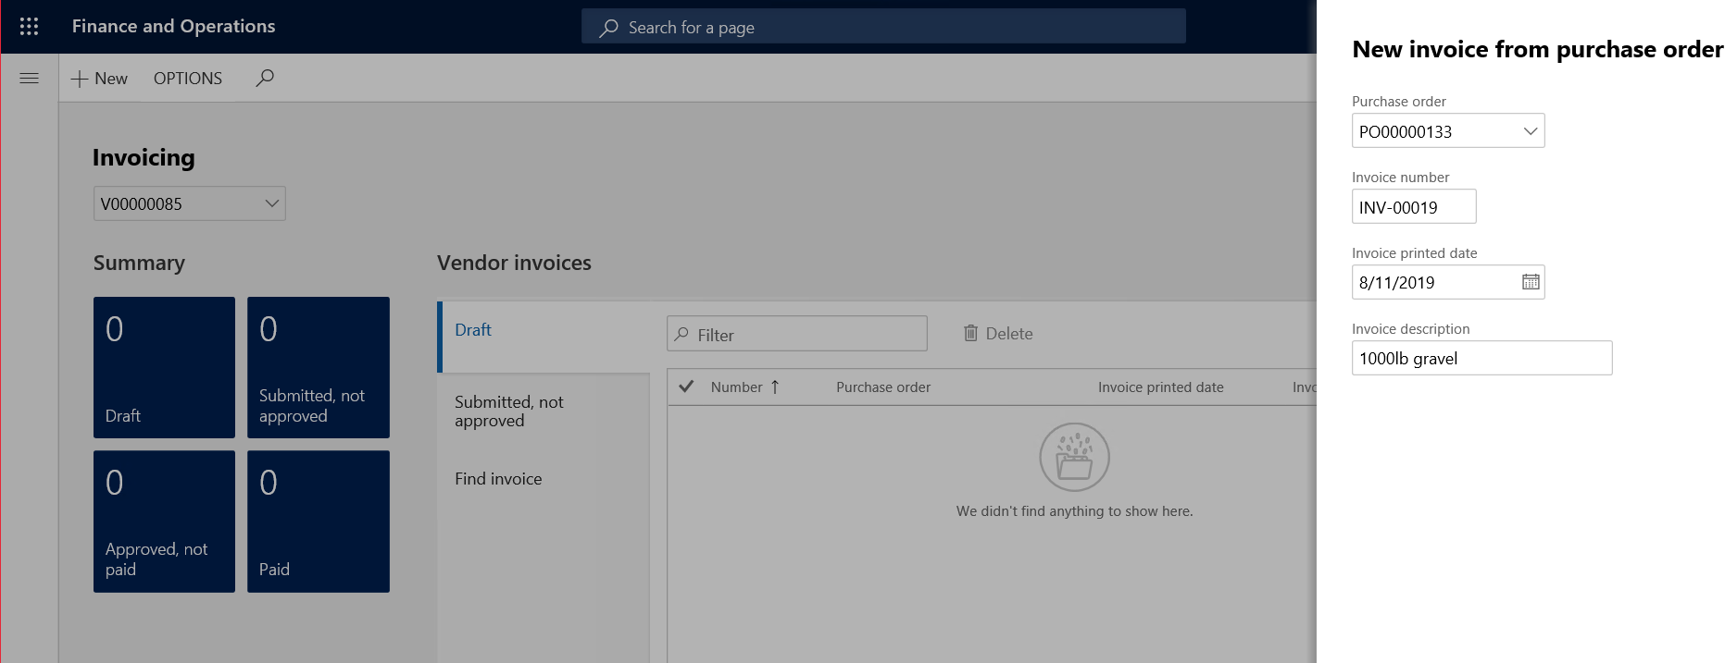
Step 4: Confirm the information on the header view (remittance location, invoice number and description).
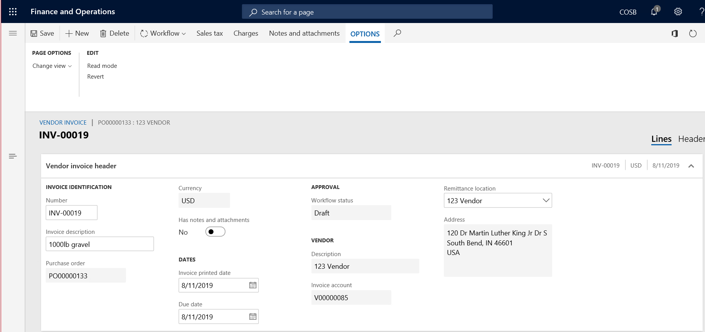

Step 5: Confirm or update (if applicable) the product information. This information is carried over from the purchase order. Do not update the price on the invoice – Contact City of South Bend Purchasing to initiate a change order if the purchase order does not match the invoice.
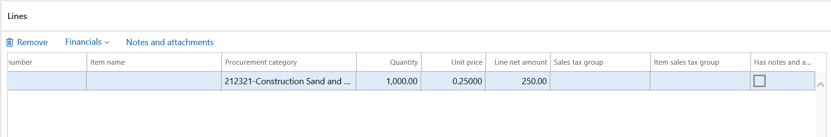

Step 6: Attach an image or file of the original invoice by clicking Notes and attachments in the ribbon. This can be utilized for a copy of the original invoice or any other information to be communicated to the City of South Bend. The City will reject this invoice if there is no attachment.

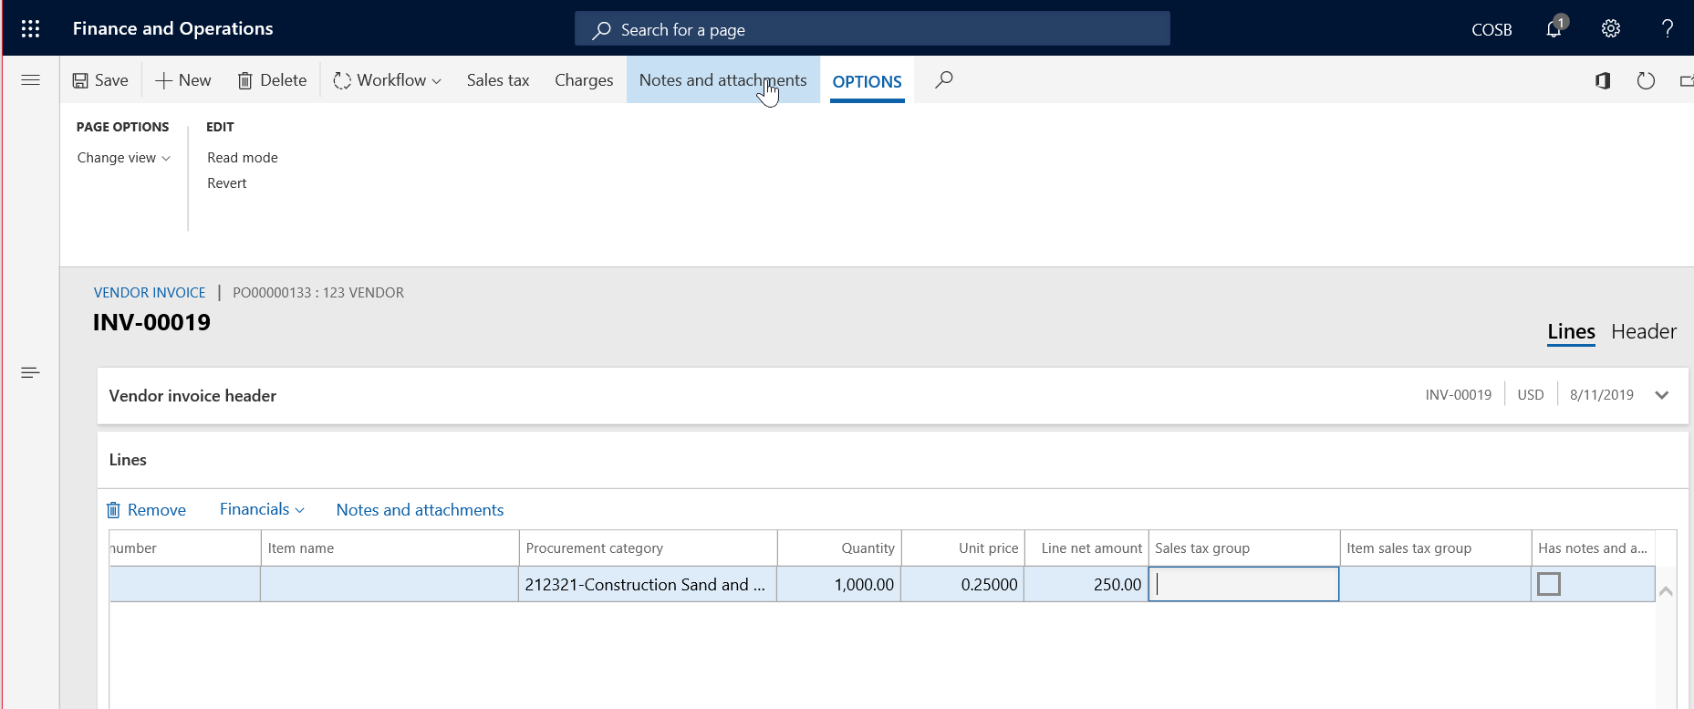
Click New and select the applicable type. Then click Browse and attach a document. Hit the escape key to return to the invoice.
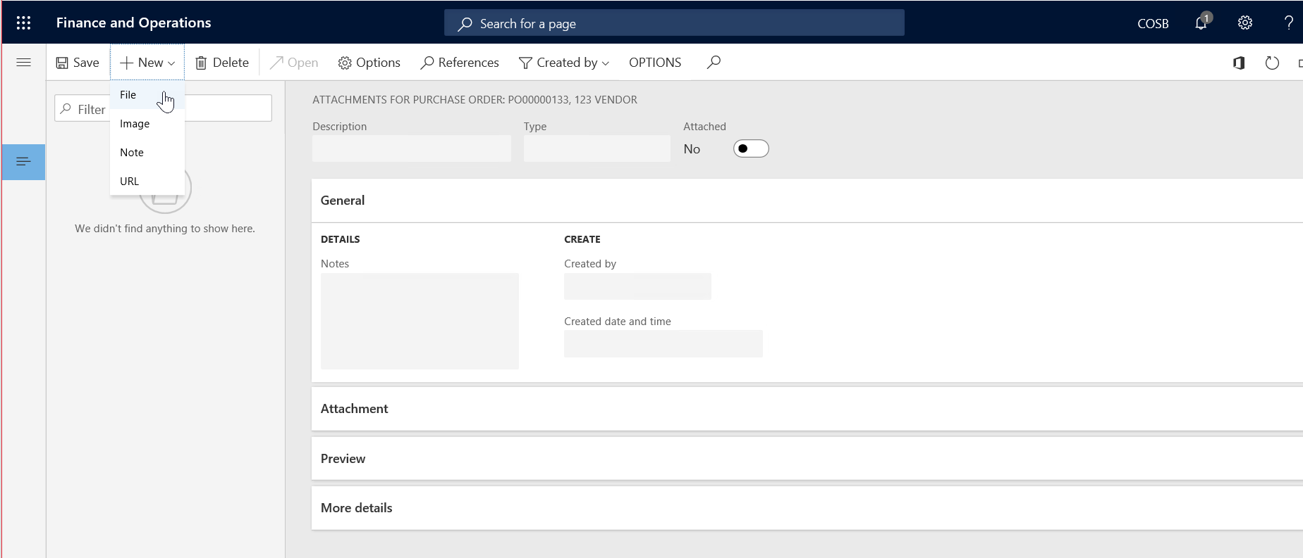
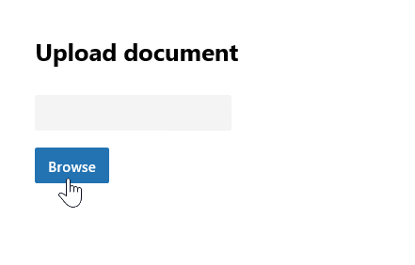
Step 7: Submit the invoice for City of South Bend review and eventual payment by clicking Workflow > Submit to workflow. Leave a comment if necessary and click Submit.
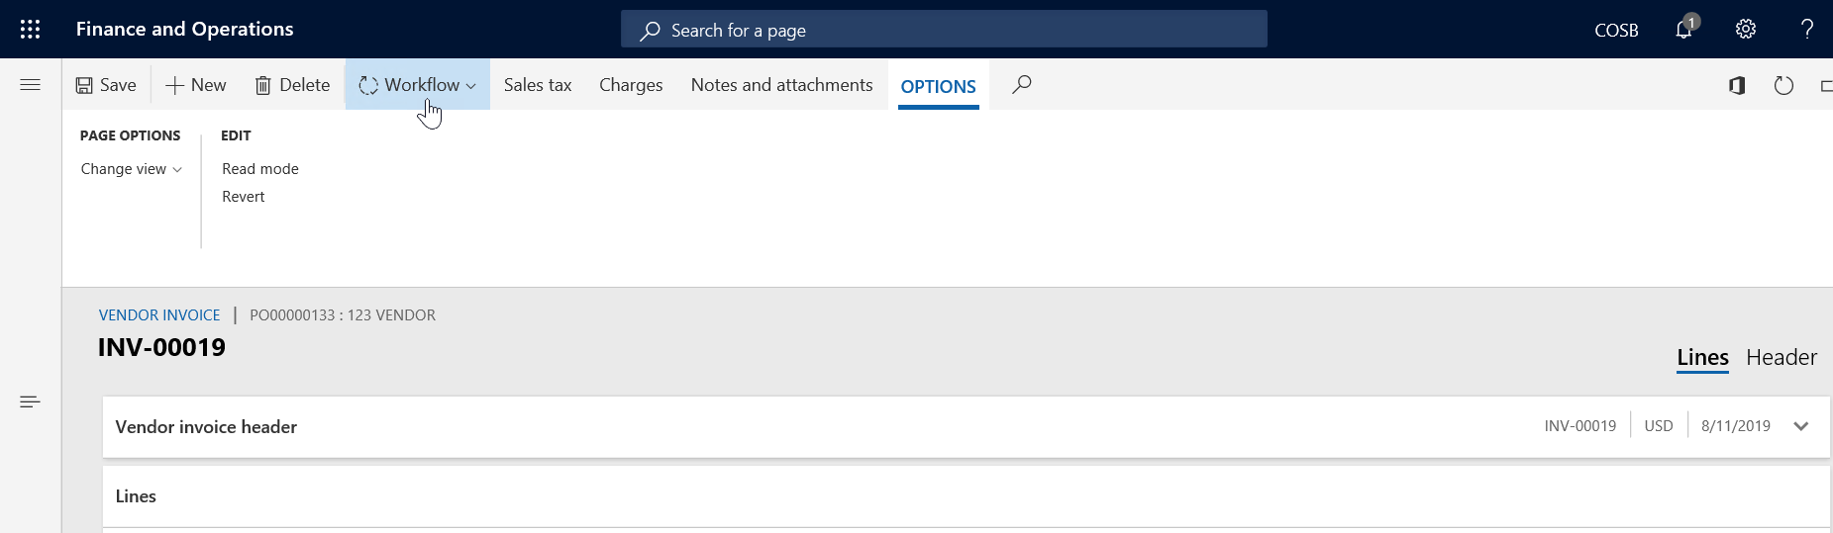

Invoice status and lists
There are 4 invoice statuses:
Draft: You have created a new invoice, but it has not been submitted to the City.
Submitted, not approved: The City has not approved the invoice yet.
Approved, not paid: The City has approved the invoice, but payment has not been rendered. This will show as “unpaid” in the all vendor invoices listing.
Paid: The City has paid your invoice.

View the status of each invoice navigate to the invoicing workspace.
- Click All vendor invoices under Links.

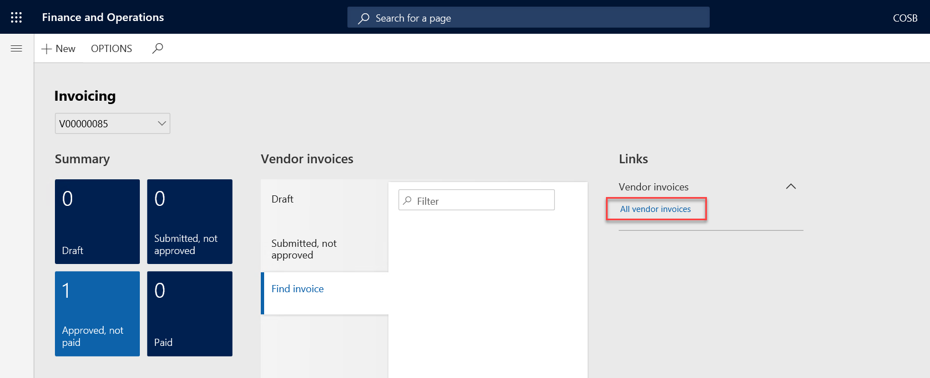

Solicitations
Coming soon!

Frequently asked questions

