Executive Summary

ES-05 Executive Summary – 24 CFR 91.200(c), 91.220(b)
1. Introduction
The City of South Bend, Indiana is an entitlement community under the U.S. Department of Housing & Urban Development's (HUD) Community Development Block Grant (CDBG) Program and Emergency Solutions Grant (ESG) Program. The City of South Bend is the Participating Jurisdiction (PJ) of the St. Joseph County Housing Consortium. In compliance with HUD regulations, the City of South Bend has prepared this FY 2020-2024 Five Year Consolidated Plan for the period of January 1, 2020 through December 31, 2024. This consolidated plan is a strategic plan for the implementation of the Consortium’s HOME Program for affordable housing within St. Joseph County and the City's CDBG and ESG Programs for housing, community and economic development, emergency shelter, and rapid rehousing within the City of South Bend.
The Five Year Consolidated Plan establishes the goals for the next five (5) year period and outlines the specific initiatives the City and the Consortium will undertake to address the needs and objectives by promoting: the rehabilitation and construction of decent, safe, sanitary, and affordable housing; creating a suitable living environment; removing slums and blighting conditions; affirmatively furthering fair housing; improving public services; expanding economic opportunities; and principally benefitting low- and moderate-income persons.
This Five Year Consolidated Plan is a collaborative effort of the St. Joseph County Housing Consortium, the City of South Bend, the community at large, social service agencies, housing providers, community development agencies, economic development groups, and other stakeholders. The planning process was accomplished through a series of public meetings, stakeholder interviews, resident surveys, statistical data, and review of the City's Comprehensive Plan and other community plans. A separate Five Year Consolidated Plan has been prepared for the City of Mishawaka which is also a Federal Entitlement Community and a member of the St. Joseph County Housing Consortium.
Maps:
Included in this Plan are the following maps which illustrate the demographic characteristics of the City of South Bend and St. Joseph County:
- Percent White Population by Block Group – City of South Bend
- Percent Minority Population by Block Group – City of South Bend
- Number Aged 65+ by Block Group – City of South Bend
- Percent Age 65+ by Block Group – City of South Bend
- Population Density by Block Group – City of South Bend
- Housing Density by Block Group – City of South Bend
- Percent Owner-Occupied Housing Units by Block Group – City of South Bend
- Percent Renter-Occupied Housing Units by Block Group – City of South Bend
- Percent Vacant Housing Units by Block Group – City of South Bend
- Low/Moderate Income Percentage by Block Group – City of South Bend
- Low/Moderate Income and Minority Concentration by Block Group – City of South Bend
- Percent White Population by Block Group – St. Joseph County
- Percent Minority Population by Block Group – St. Joseph County
- Number Aged 65+ by Block Group – St. Joseph County
- Percent Age 65+ by Block Group – St. Joseph County
- Population Density by Block Group – St. Joseph County
- Housing Density by Block Group – St. Joseph County
- Percent Owner-Occupied Housing Units by Block Group – St. Joseph County
- Percent Renter-Occupied Housing Units by Block Group – St. Joseph County
- Percent Vacant Housing Units by Block Group – St. Joseph County
- Low/Moderate Income Percentage by Block Group – St. Joseph County
- Low/Moderate Income and Minority Concentration by Block Group – St. Joseph County
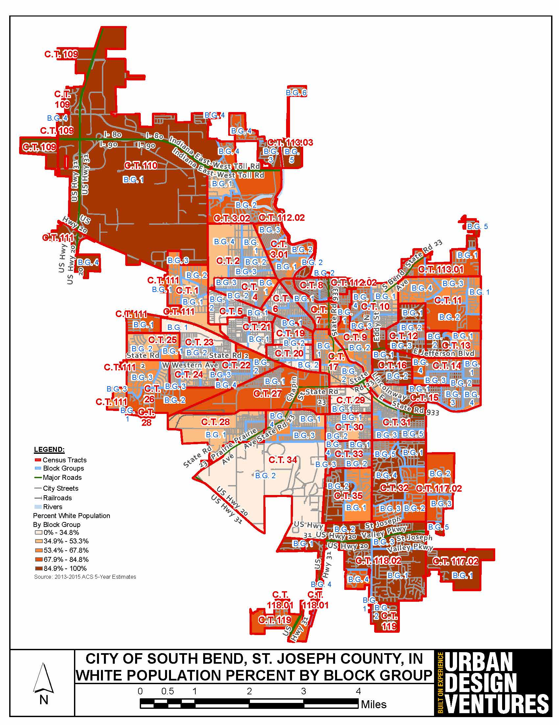
Percent White Population - City of South Bend
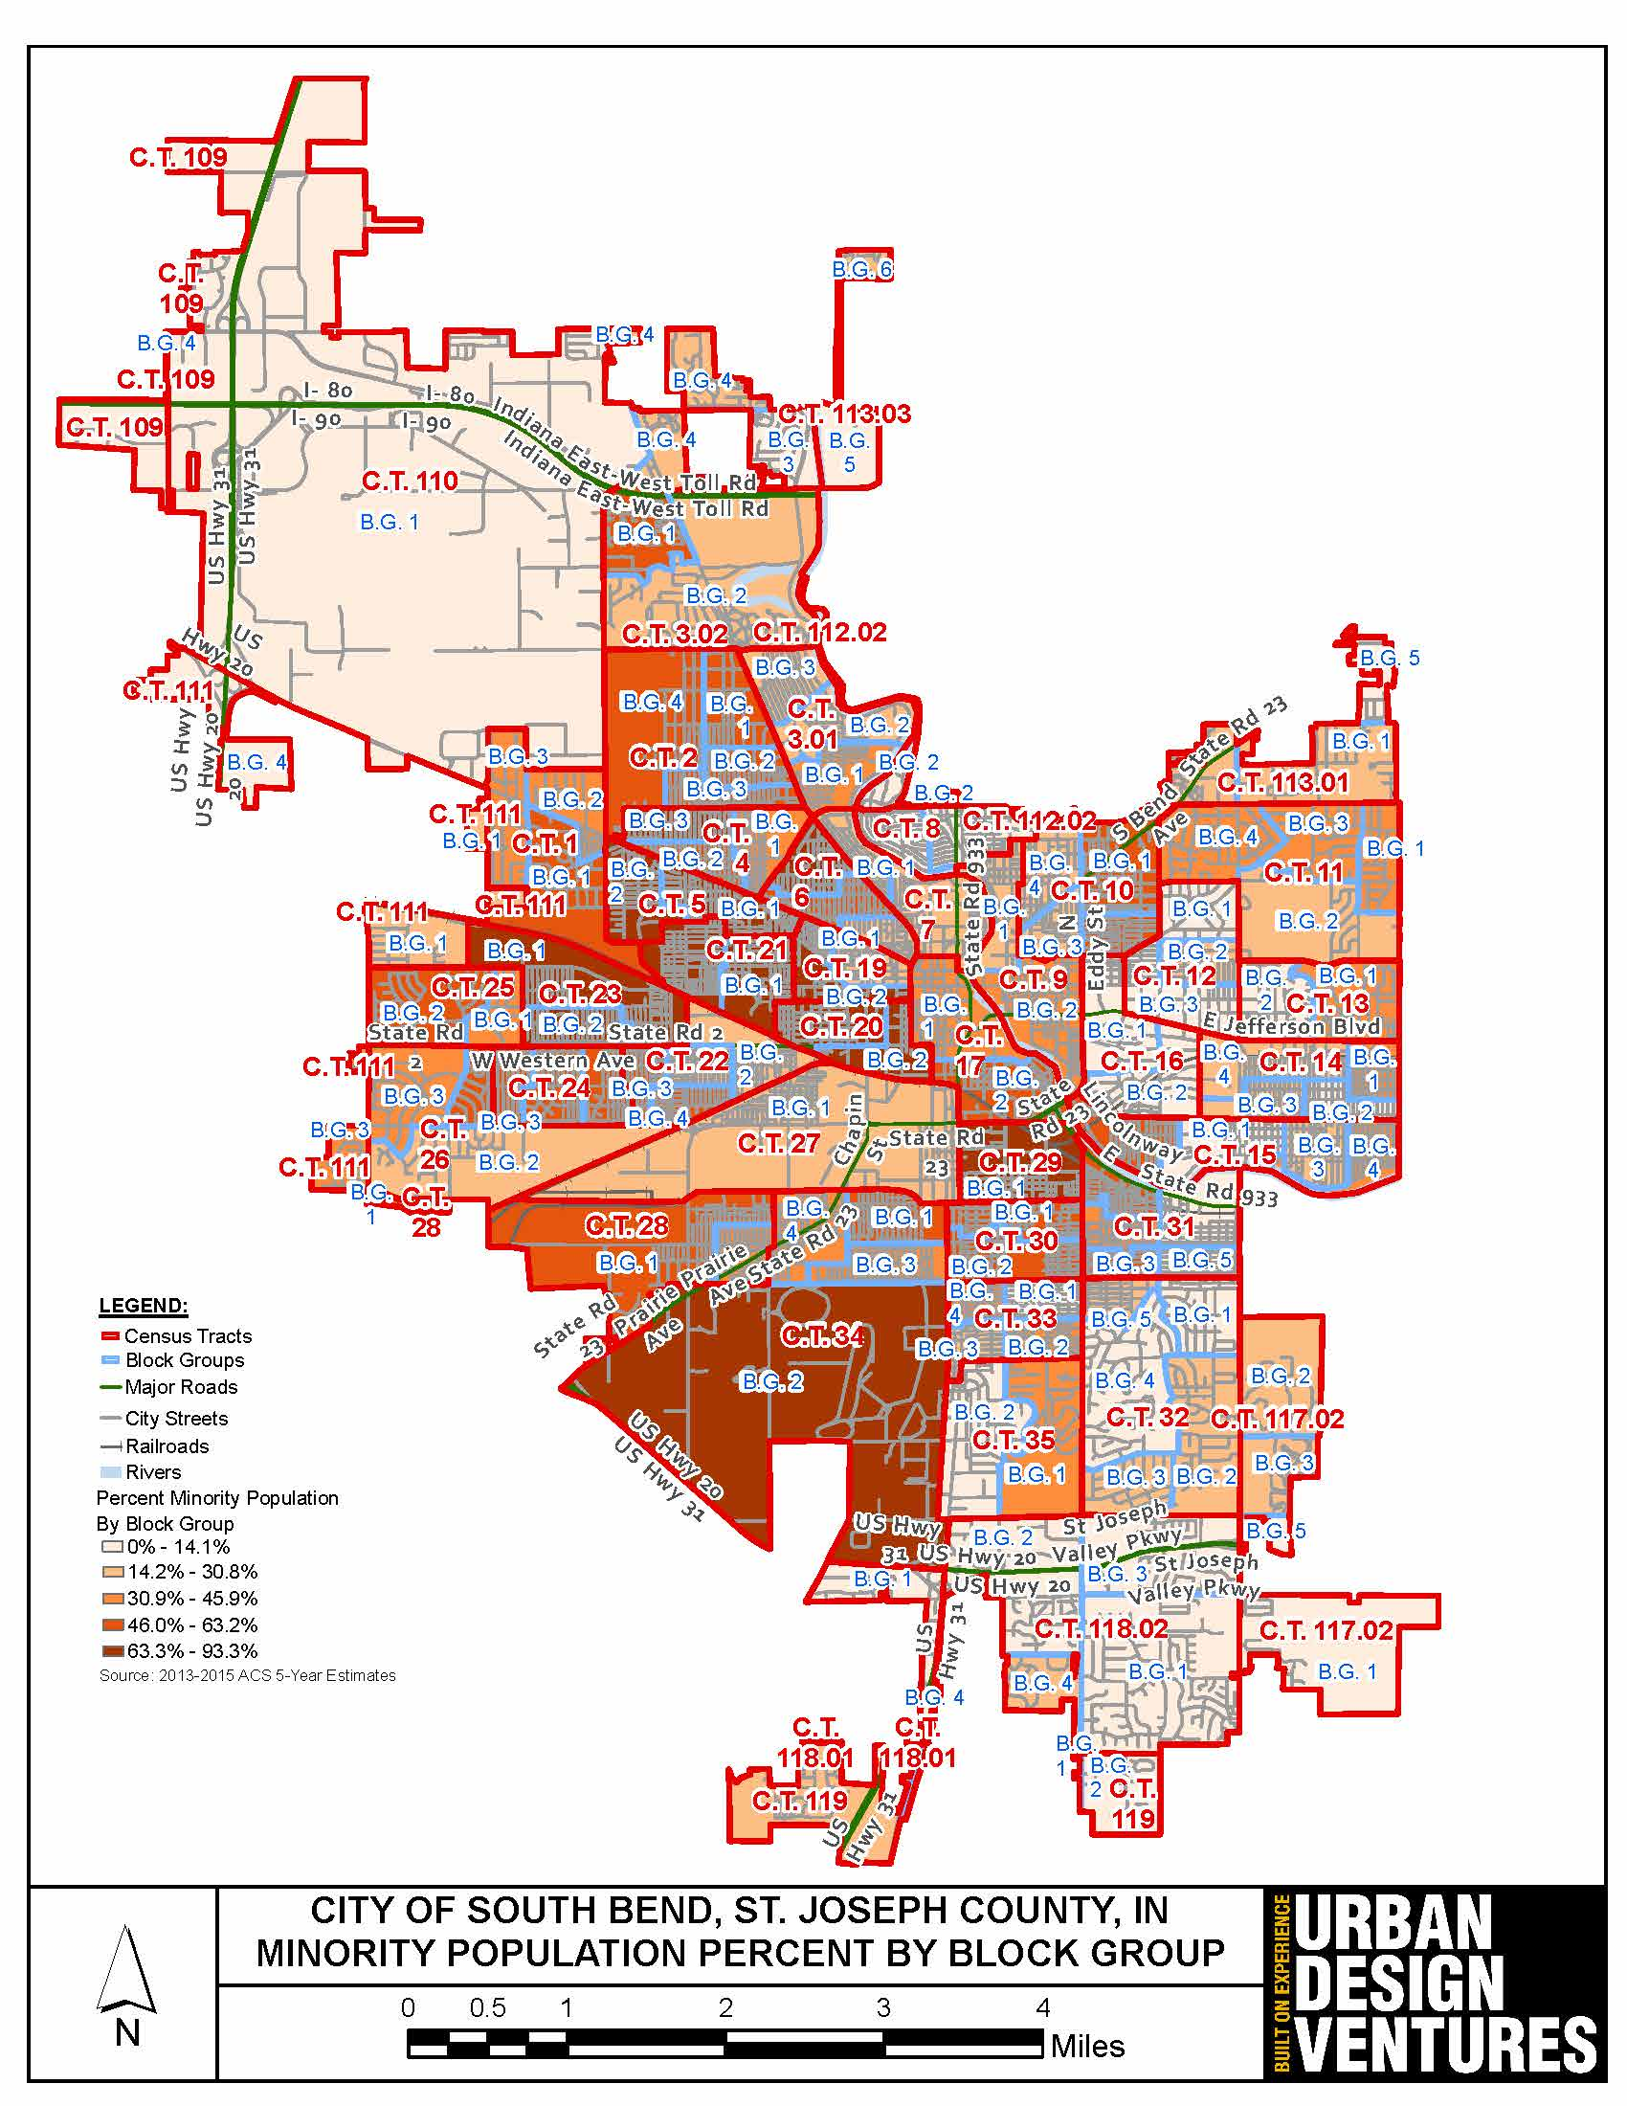
Percent Minority Population - City of South Bend
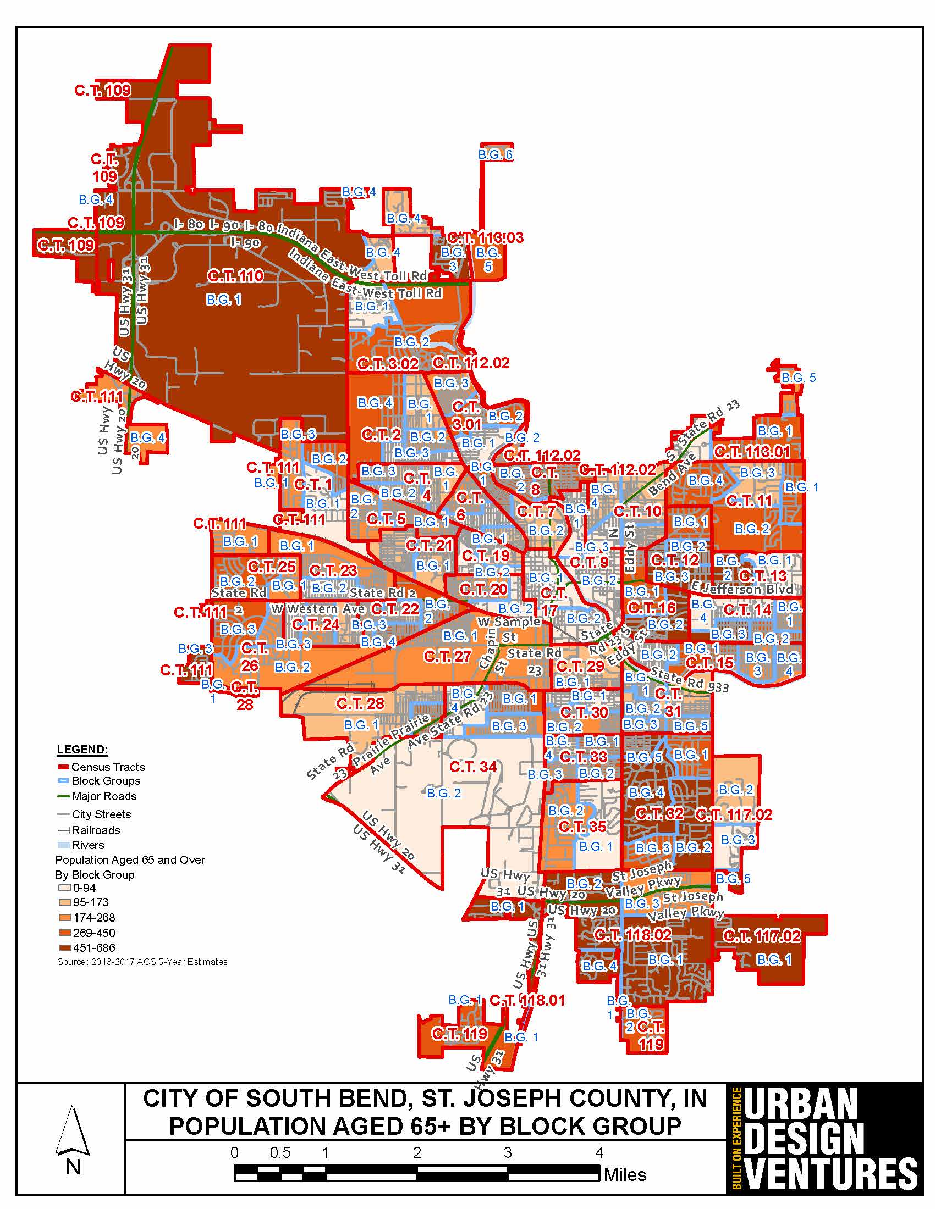
Number of People Aged 65+ - City of South Bend
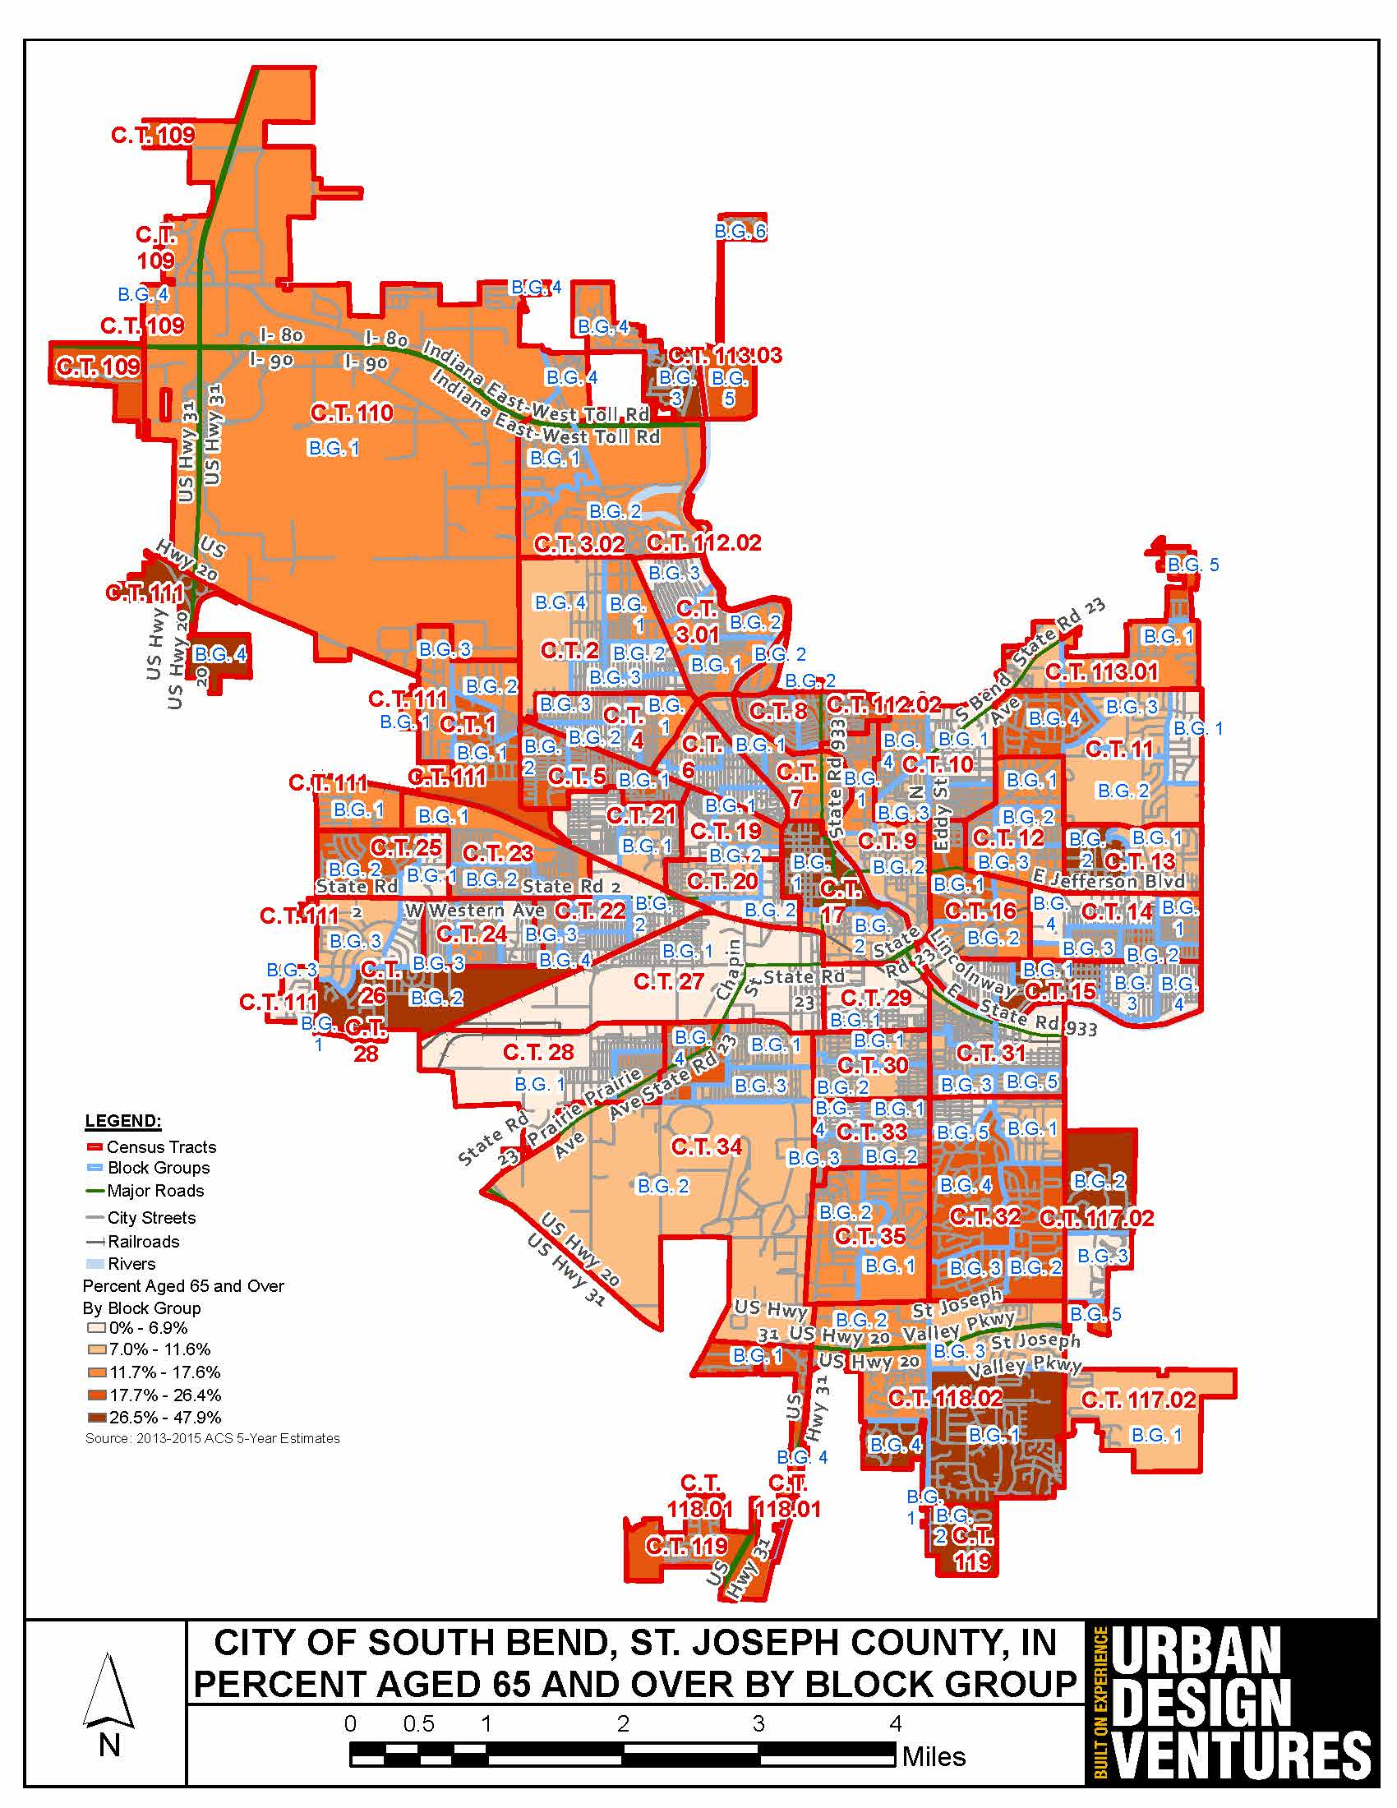
Percent of Population Aged 65+ - City of South Bend
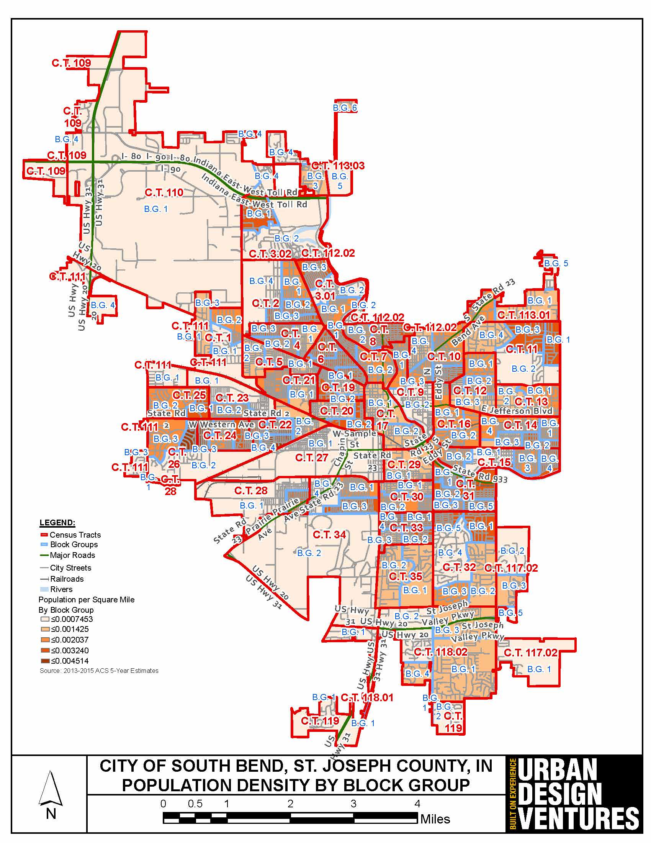
Population Density - City of South Bend
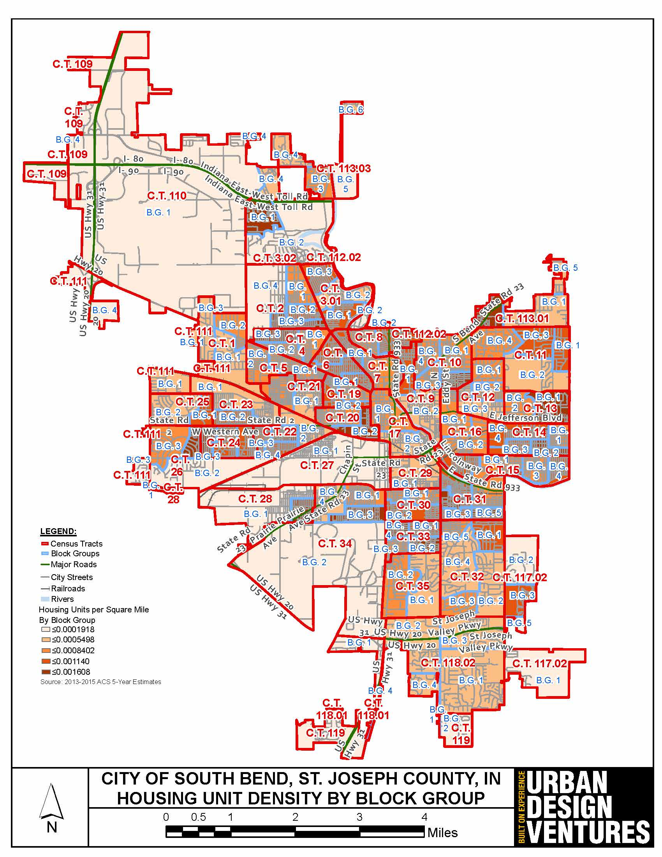
Housing Density - City of South Bend
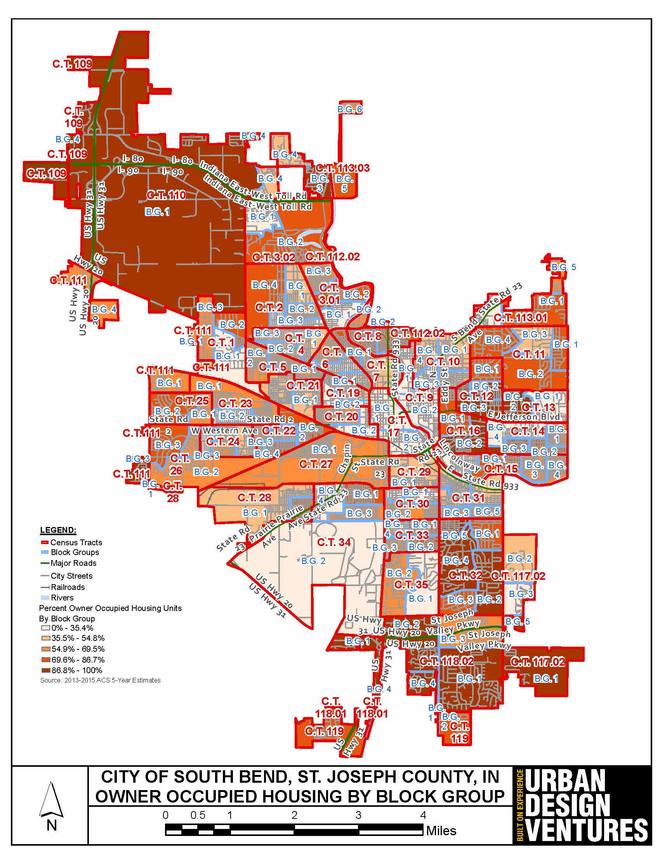
Owner-Occupied Housing - City of South Bend
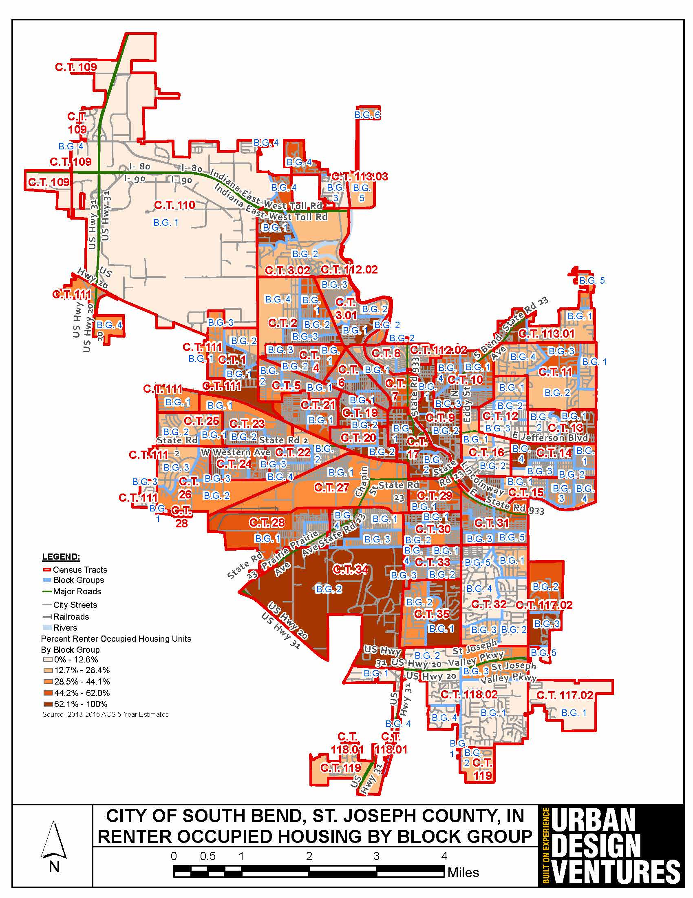
Renter-Occupied Housing - City of South Bend
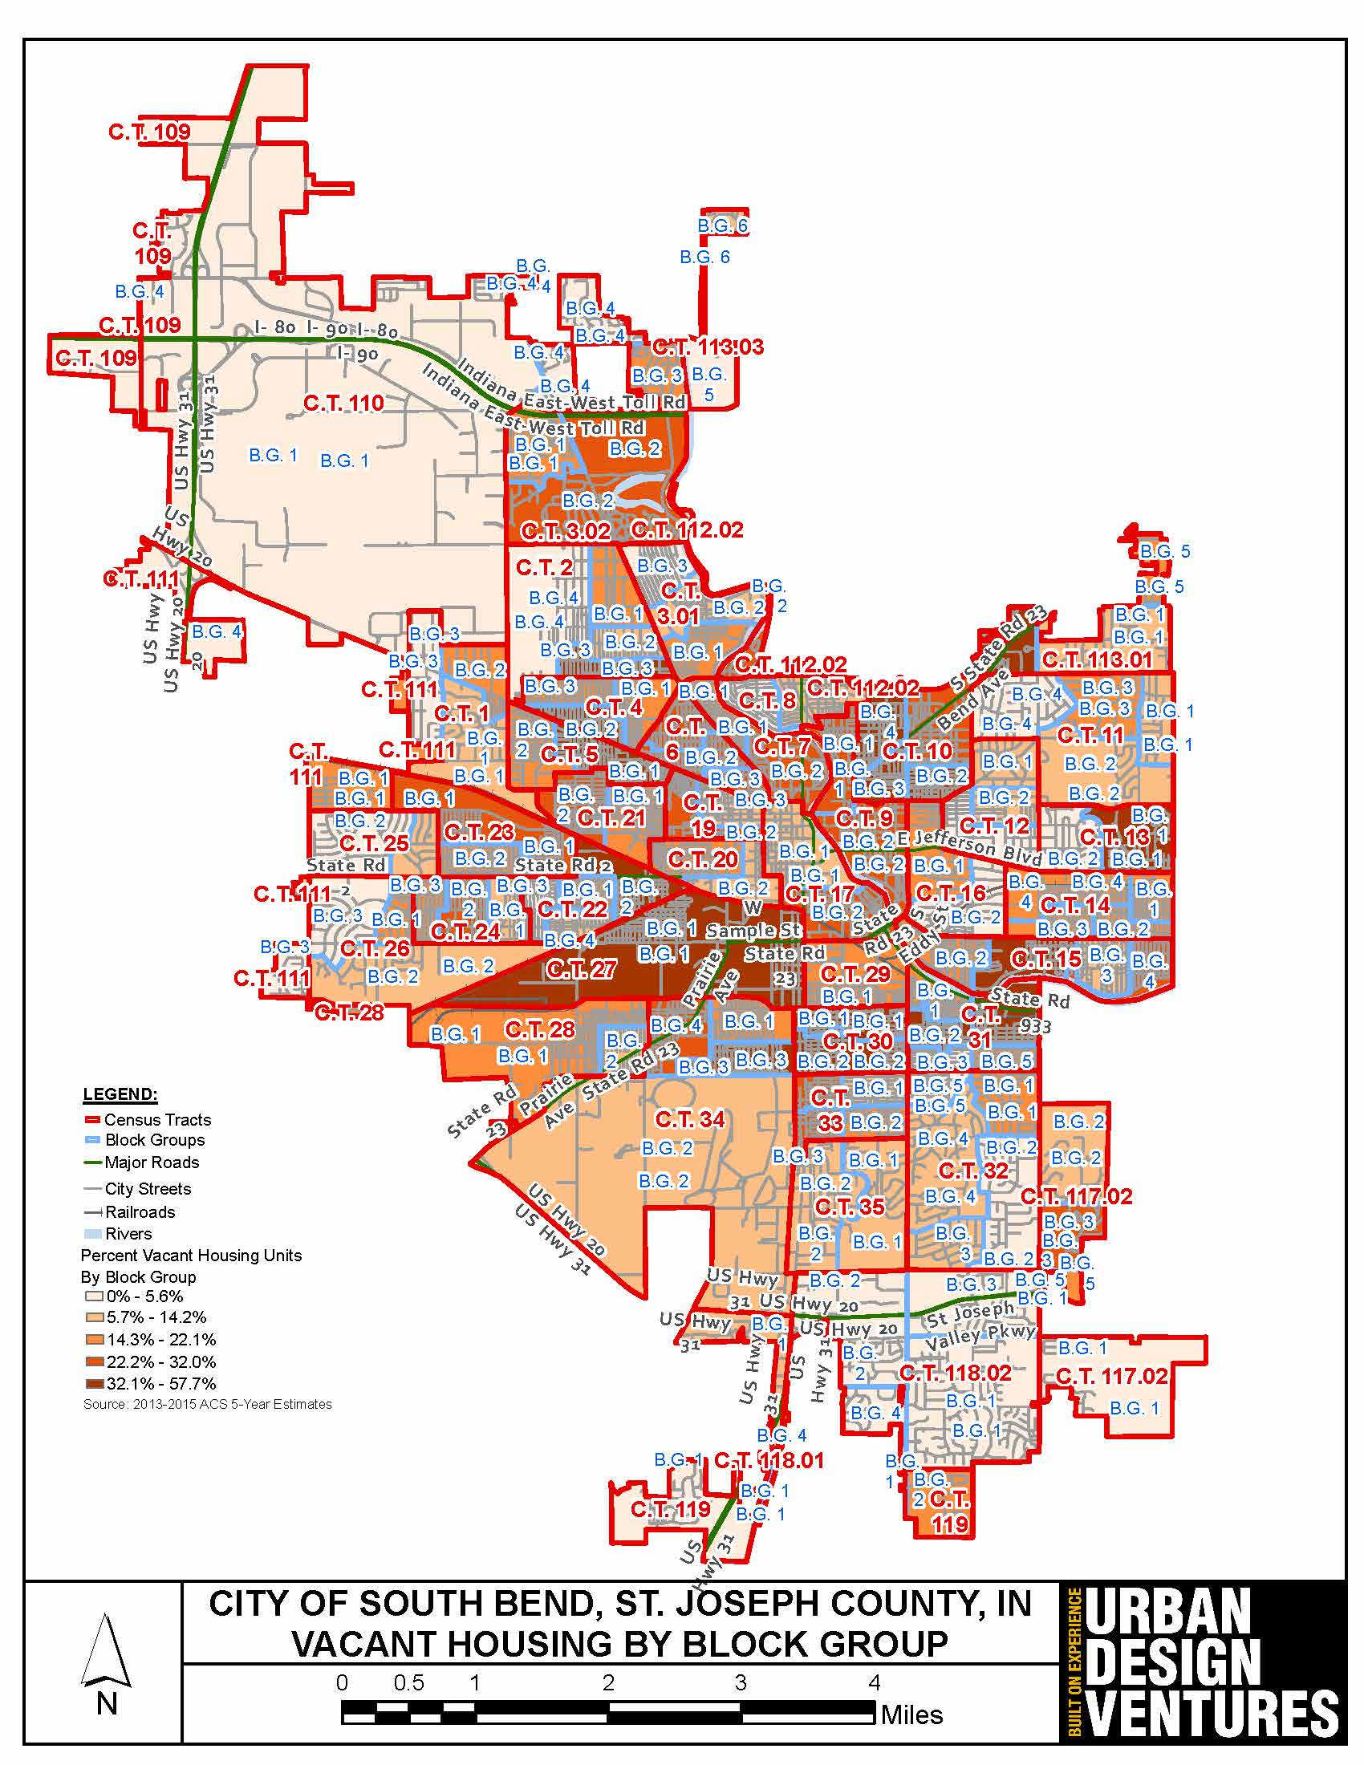
Vacant Housing Units - City of South Bend
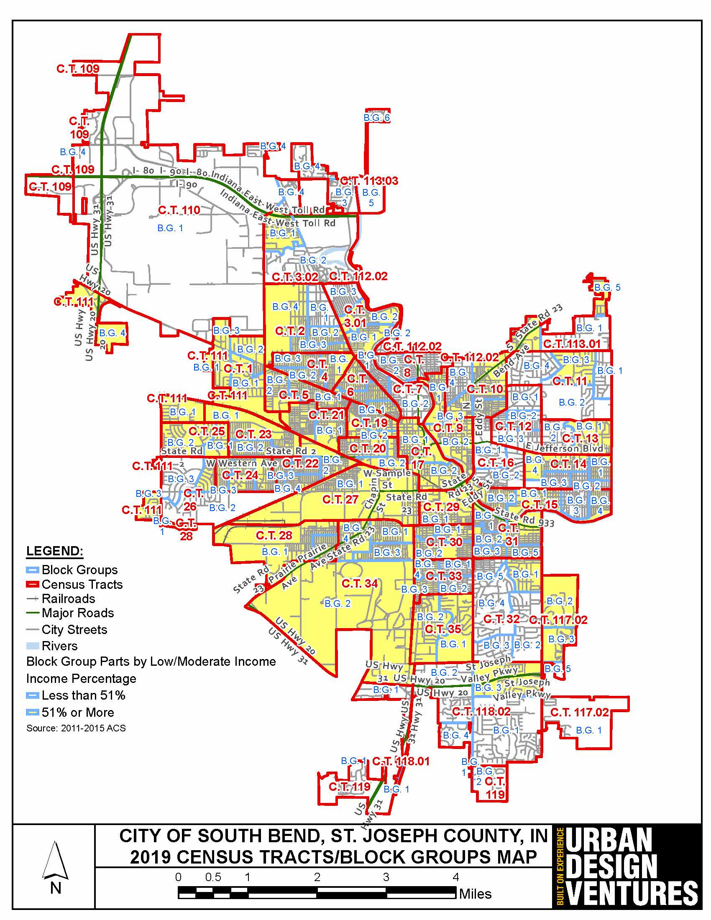
Low/Moderate Income Population by Block Group - City of South Bend
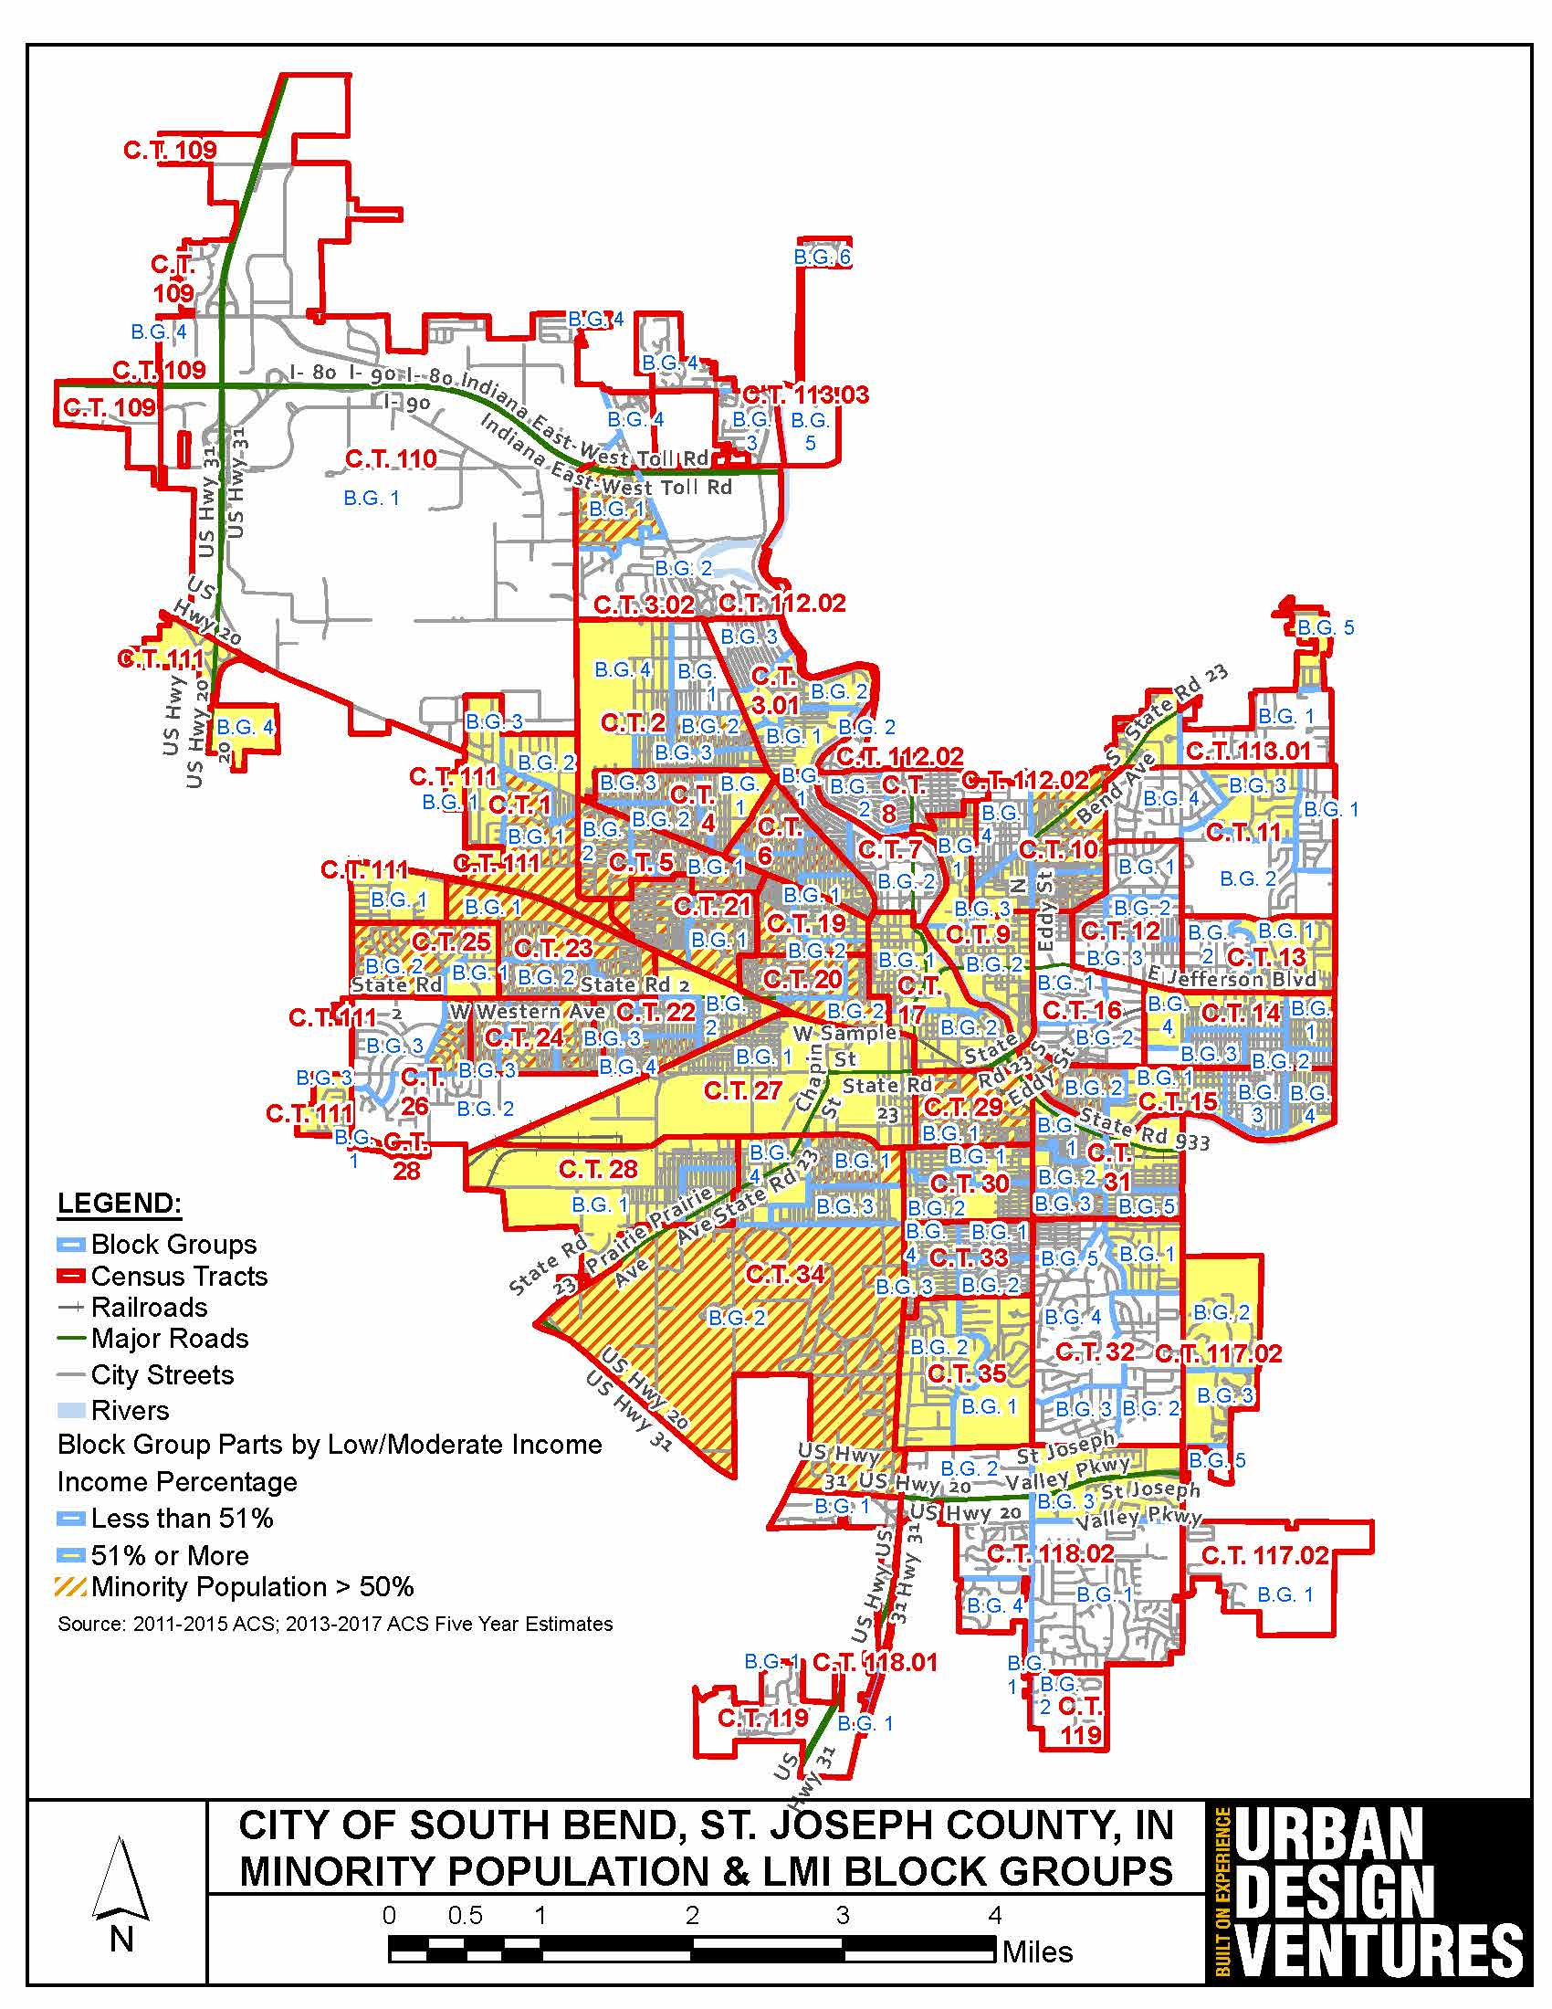
Low/Moderate Income Population ÿ Areas of Minority Concentration - City of South Bend
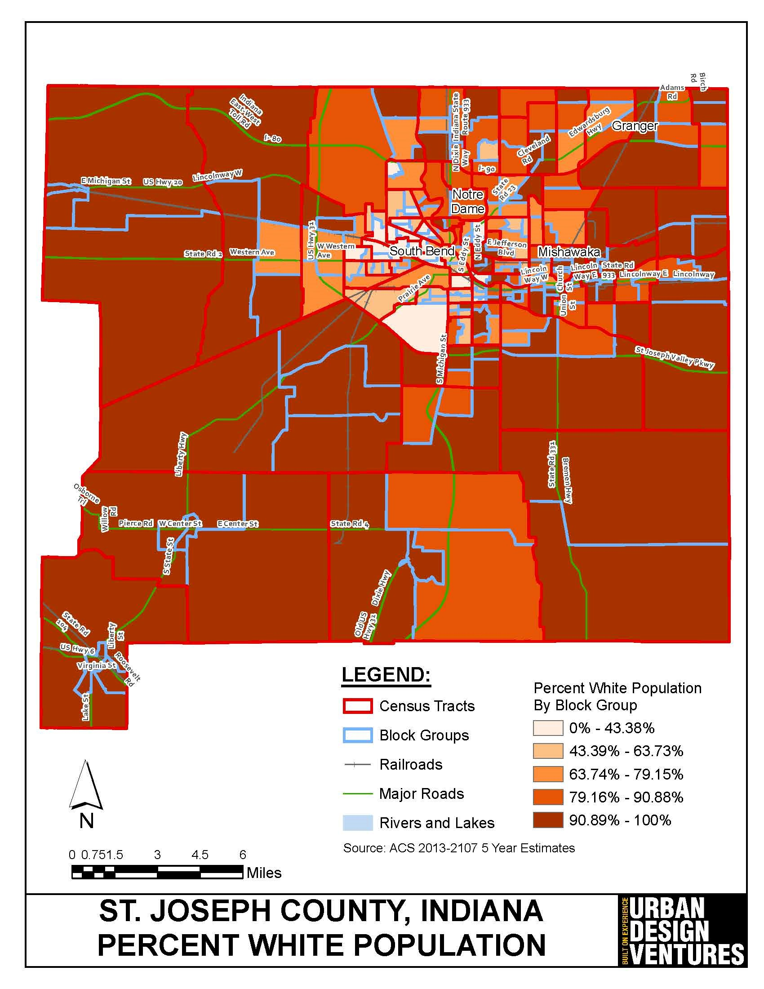
Percent White Population - St. Joseph County
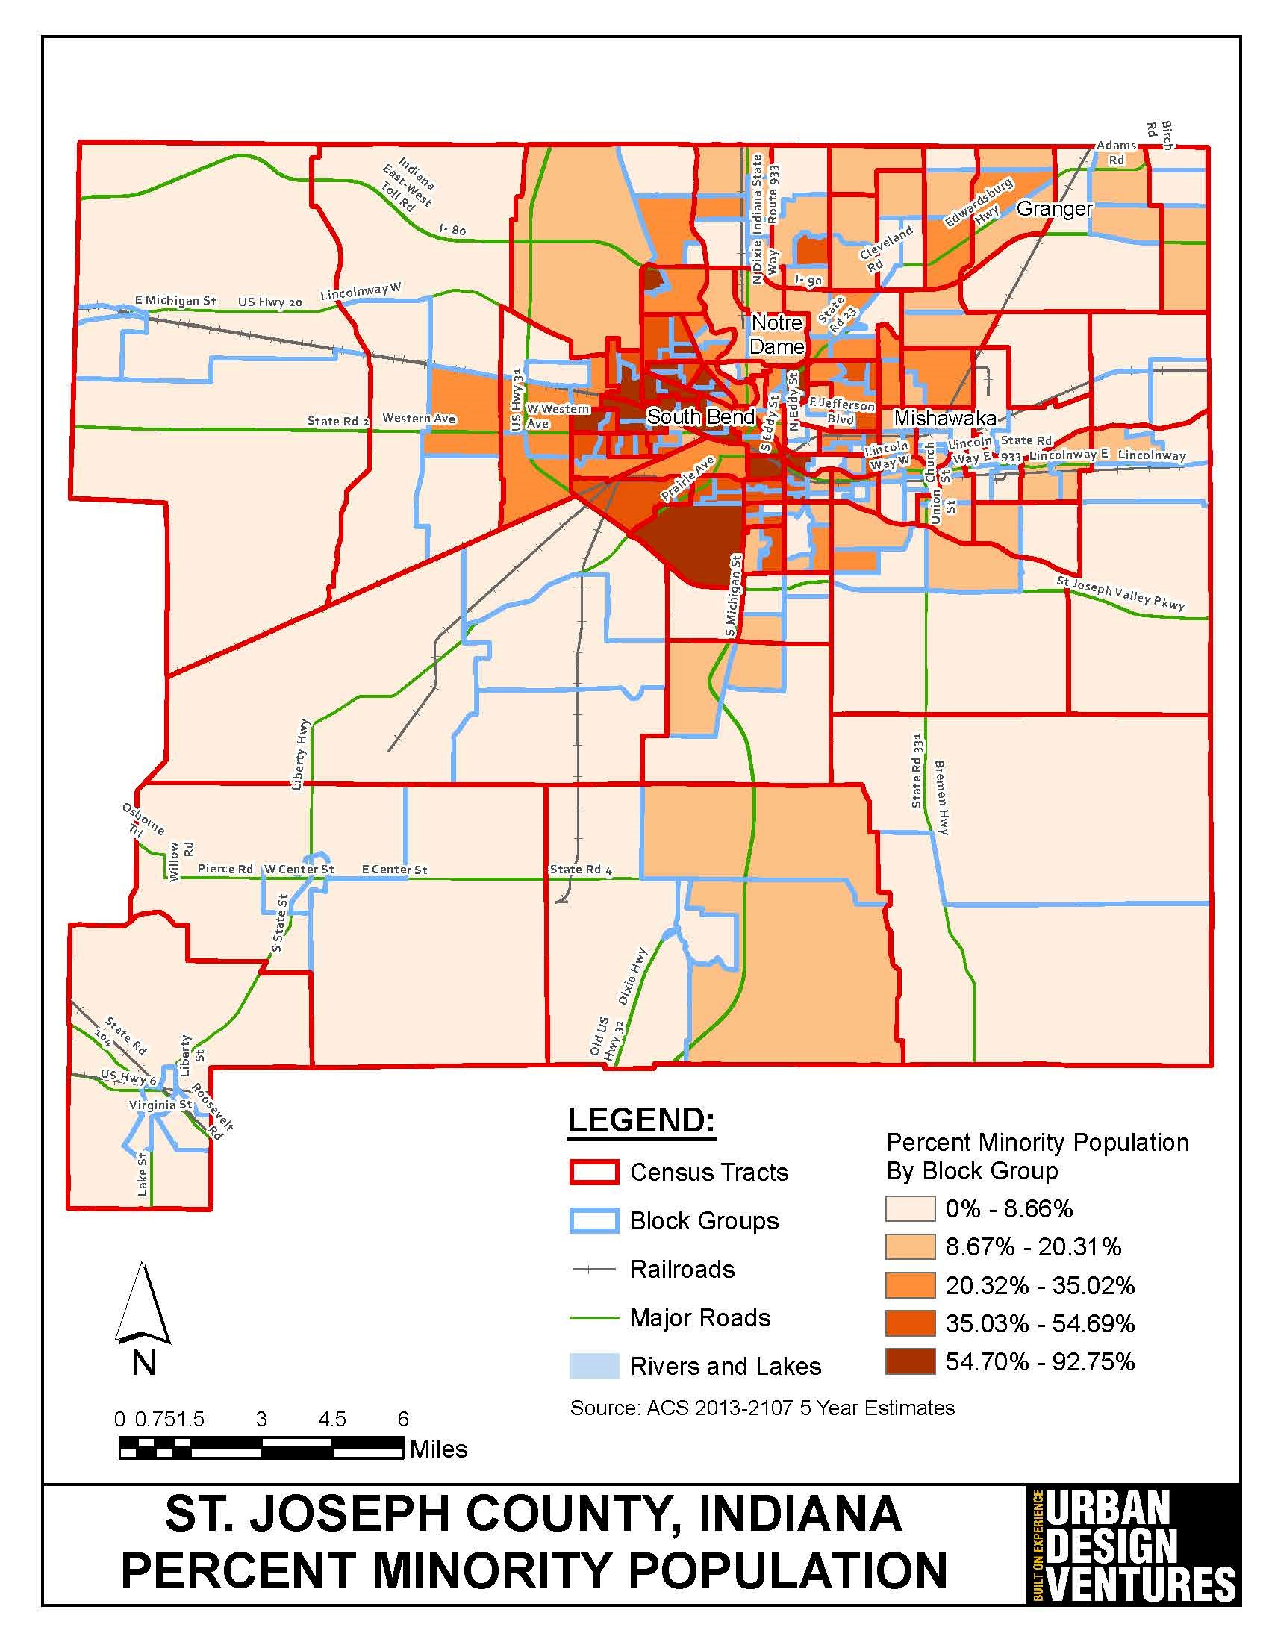
Percent Minority Population - St. Joseph County
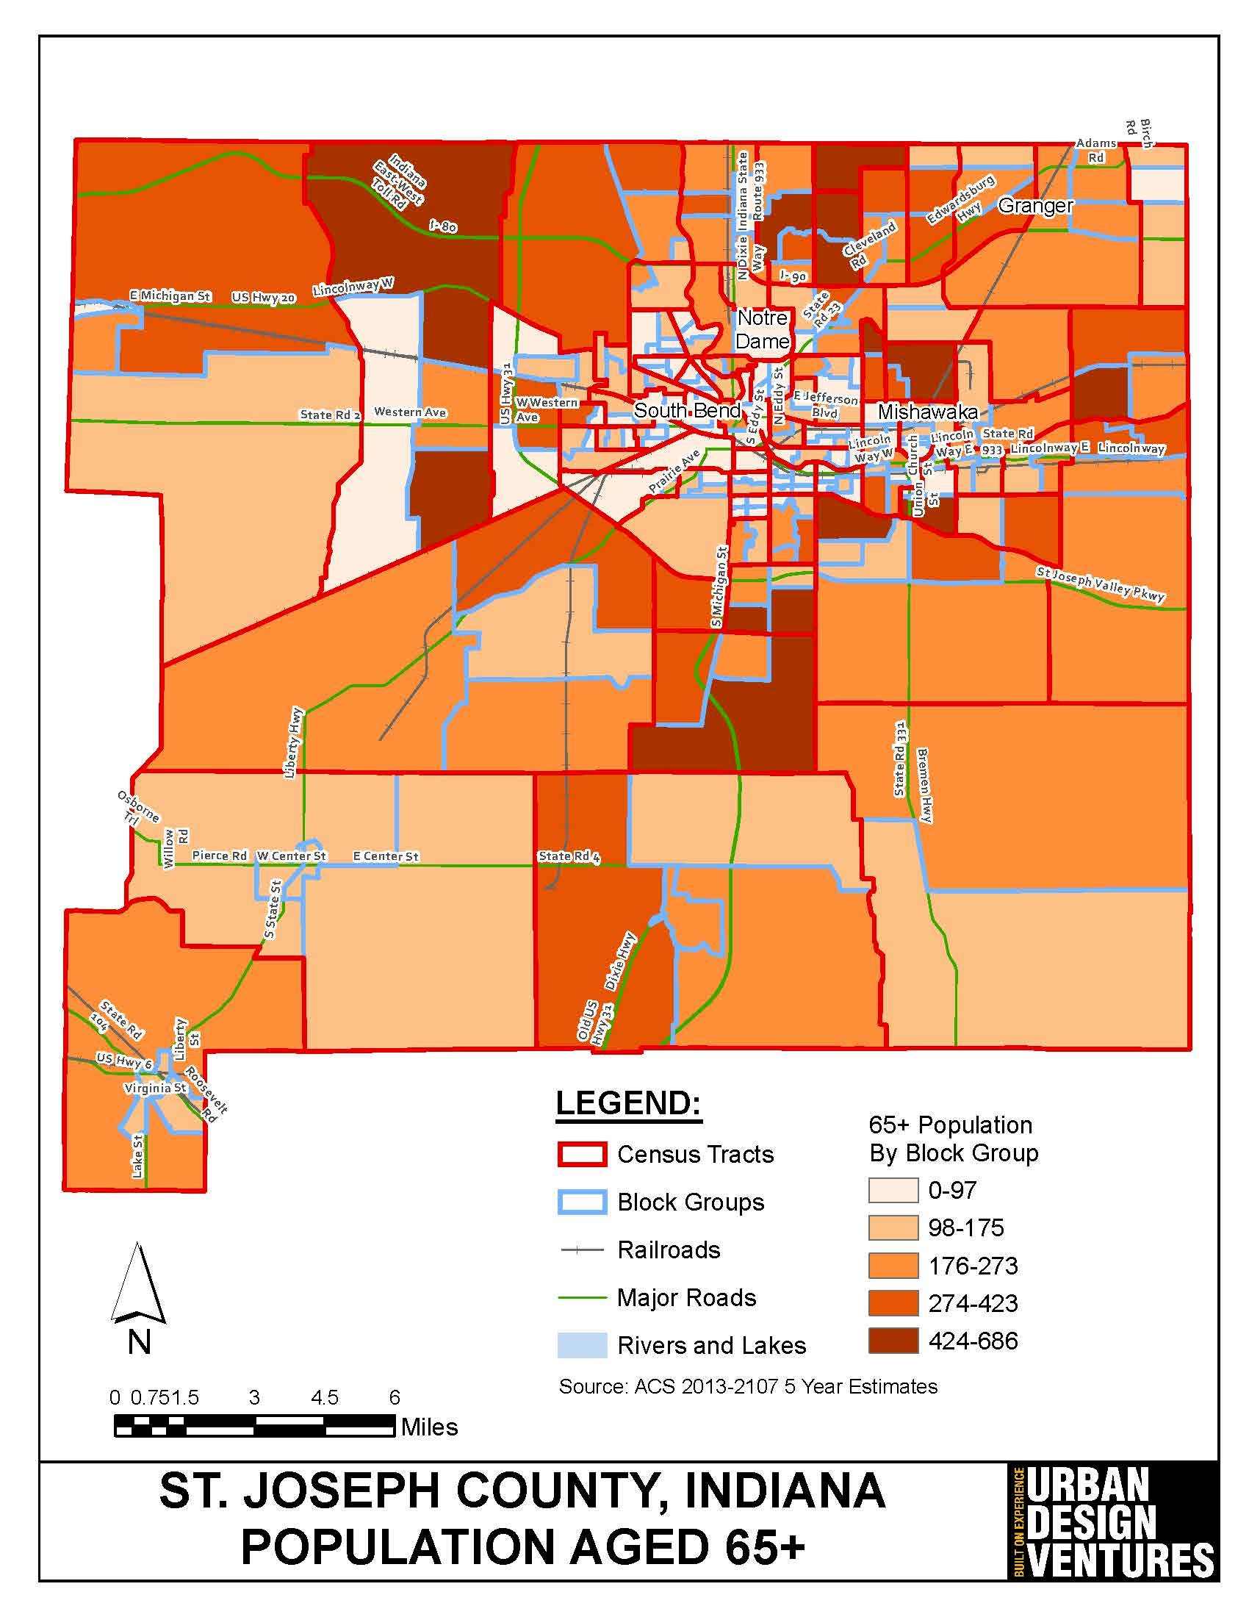
Number of People Aged 65+ - St. Joseph County
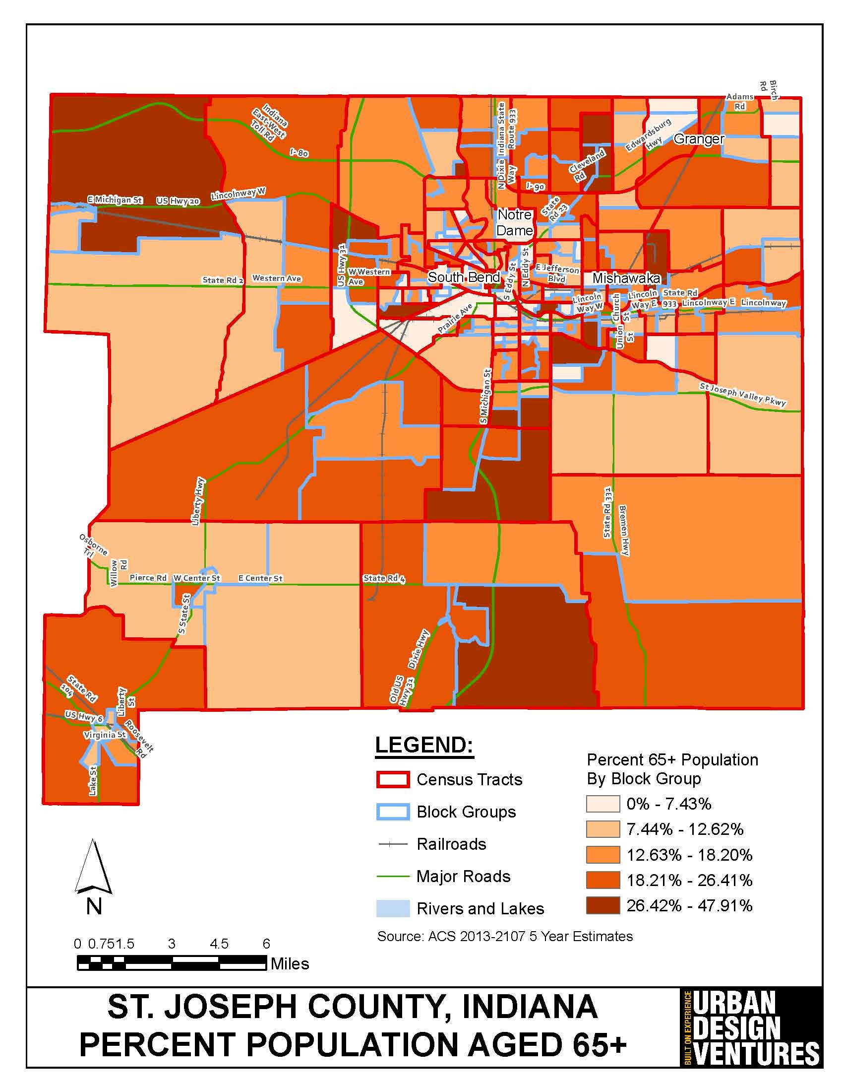
Percent of Population Aged 65+ - St. Joseph County
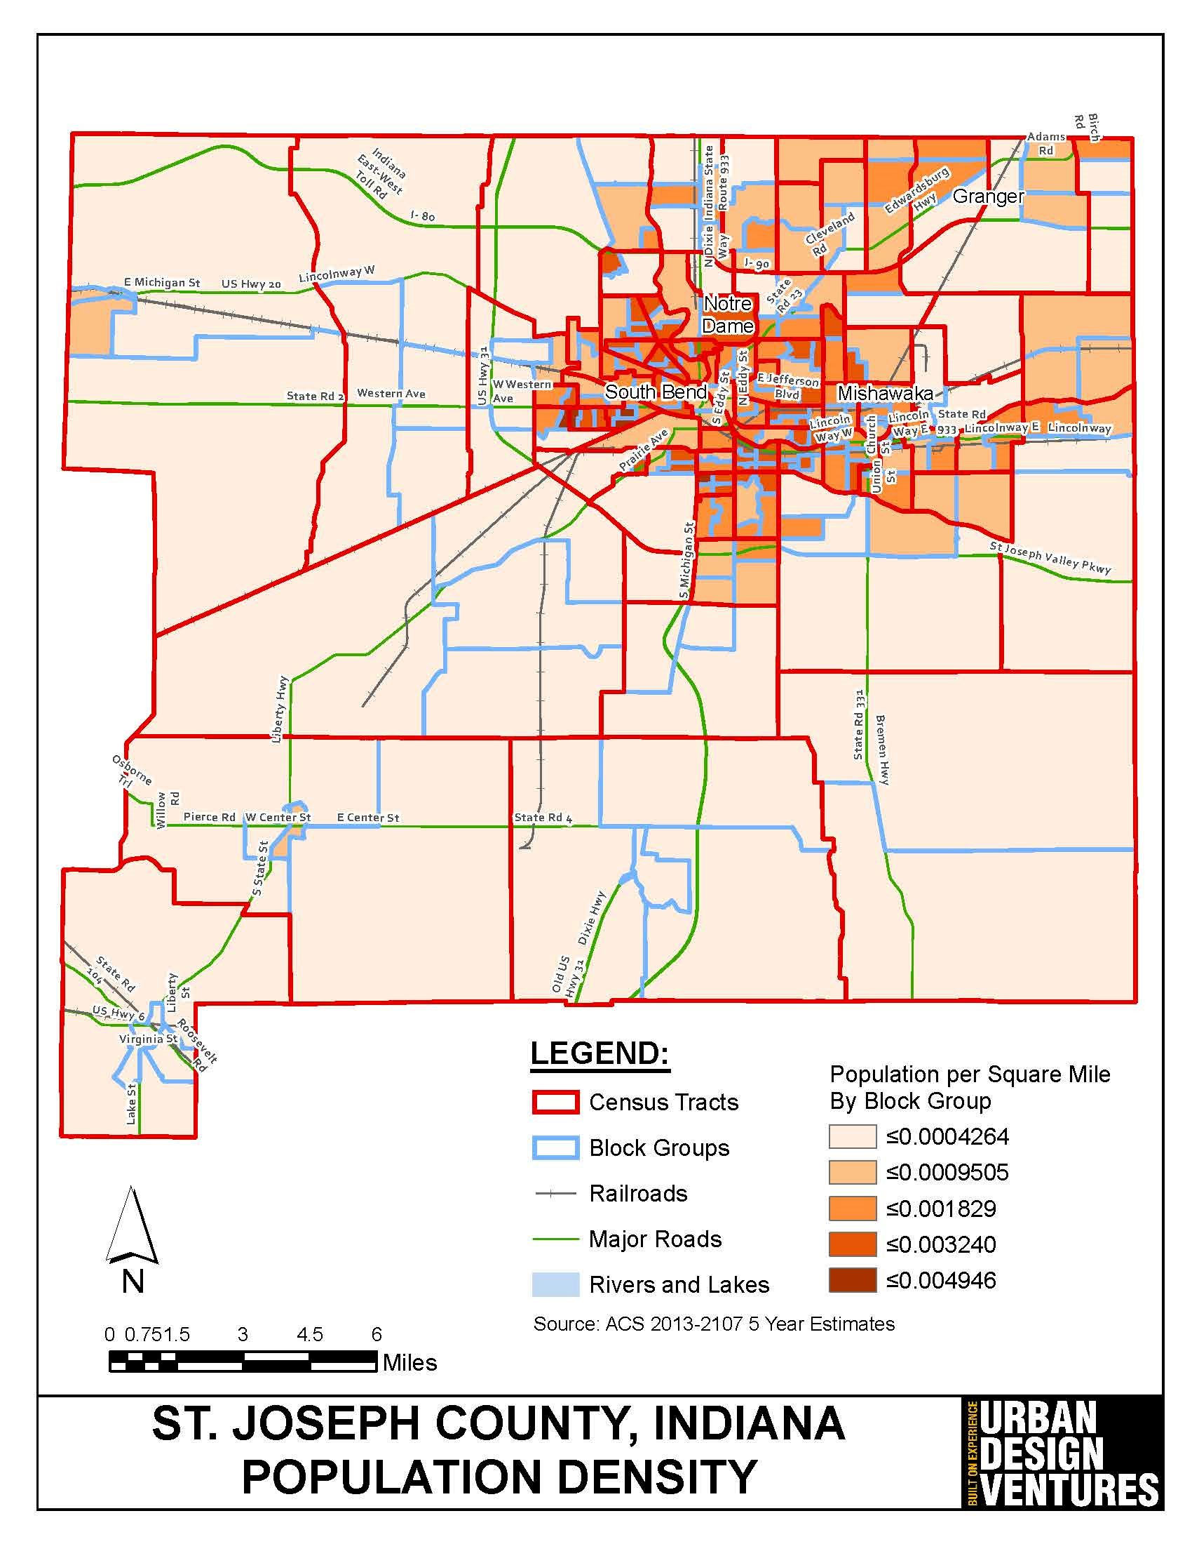
Population Density - St. Joseph County
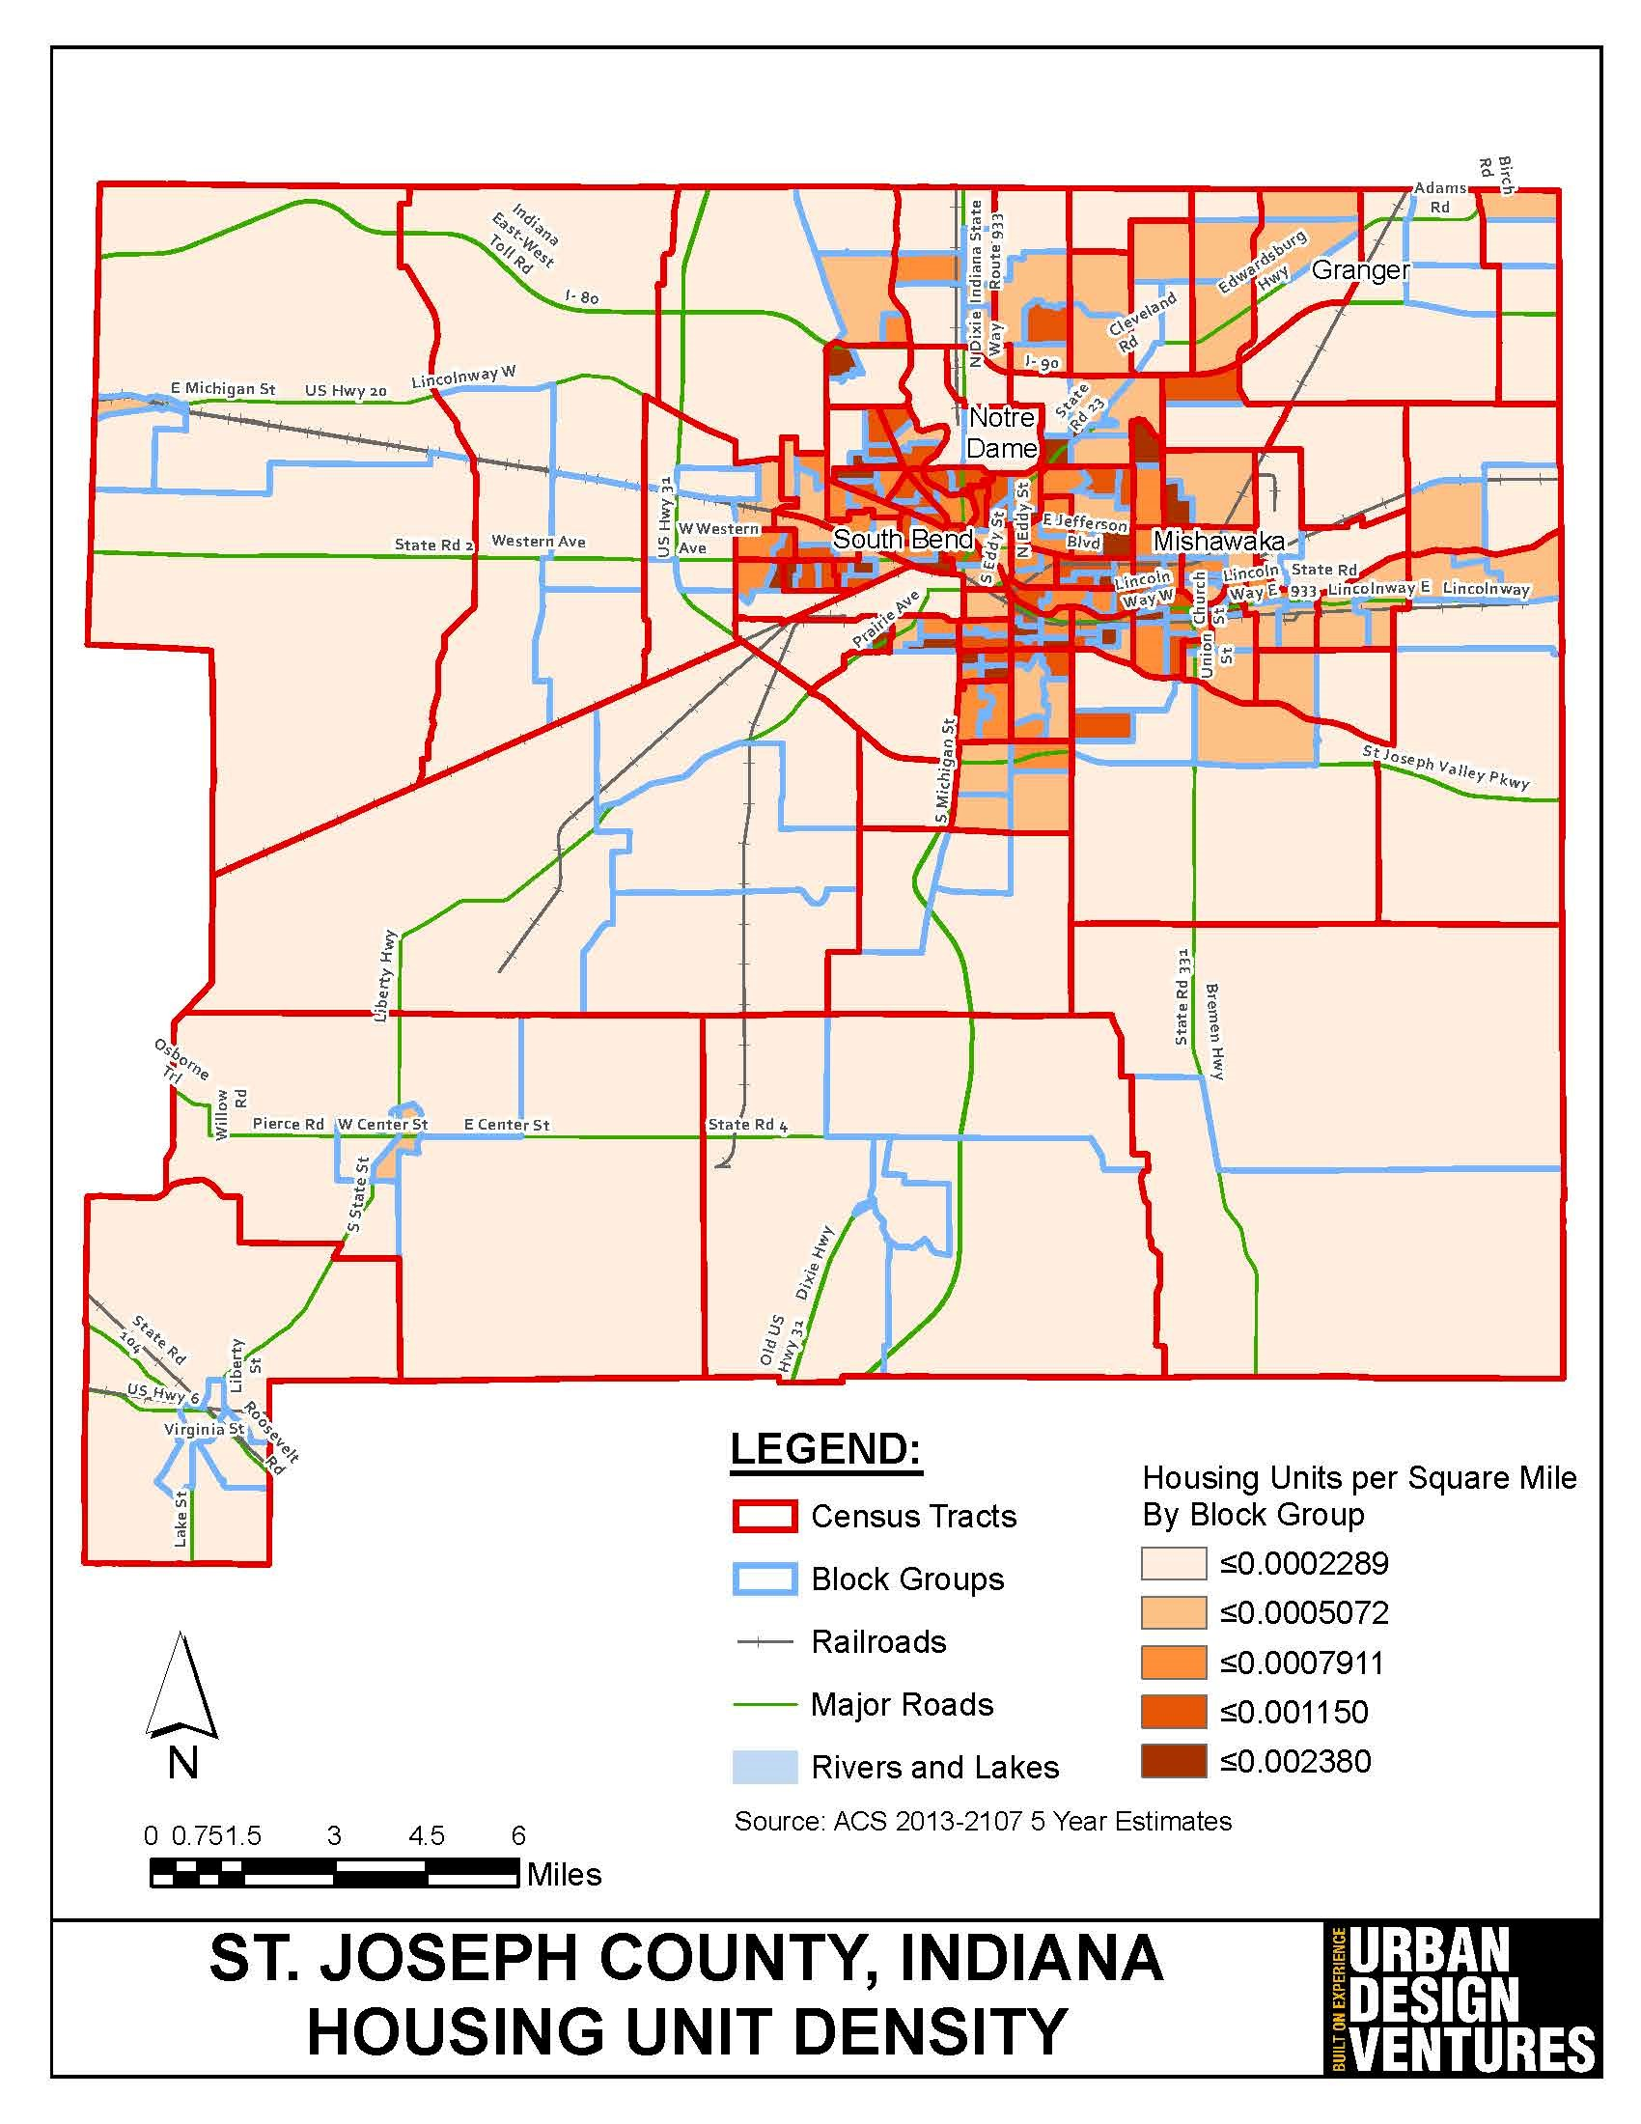
Housing Density - St. Joseph County
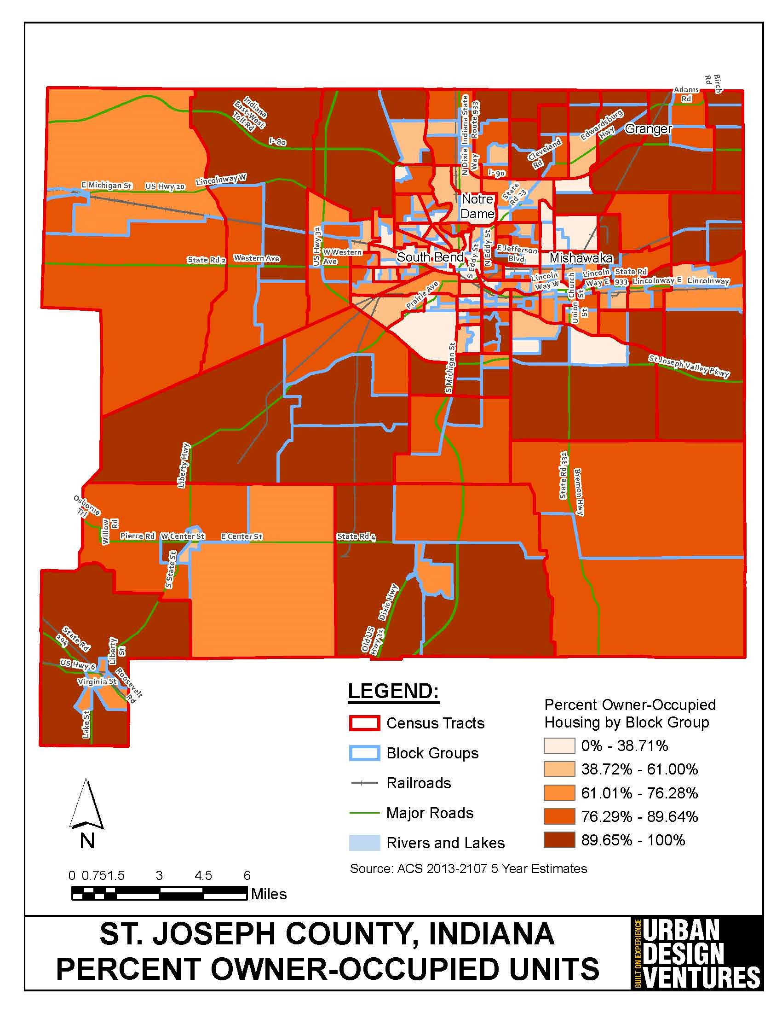
Owner-Occupied Housing - St. Joseph County
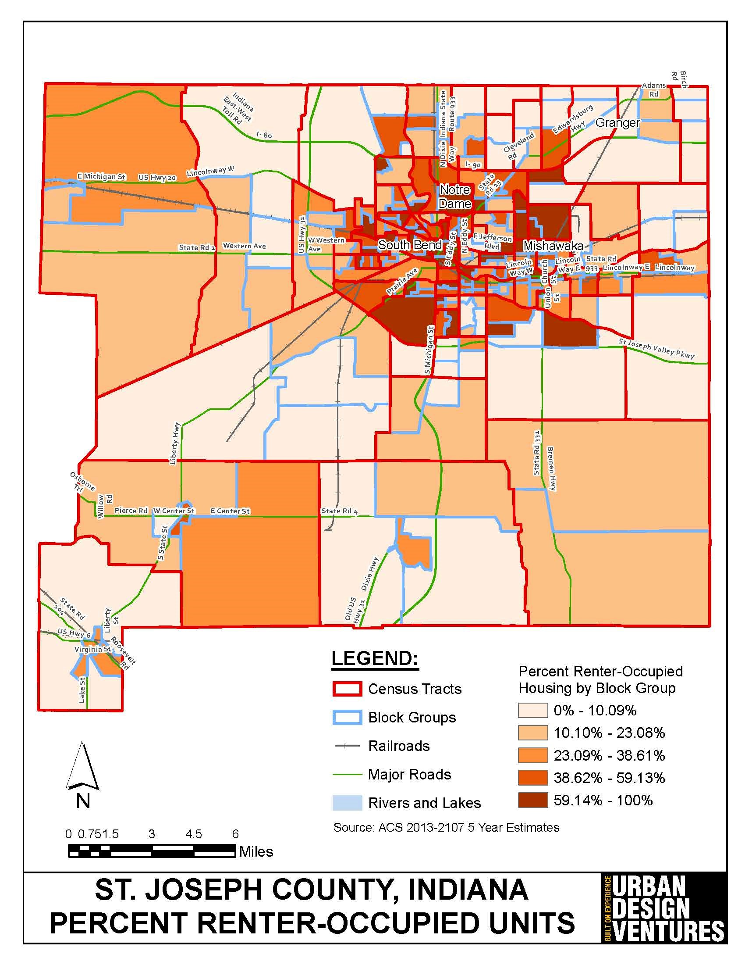
Renter-Occupied Housing - St. Joseph County
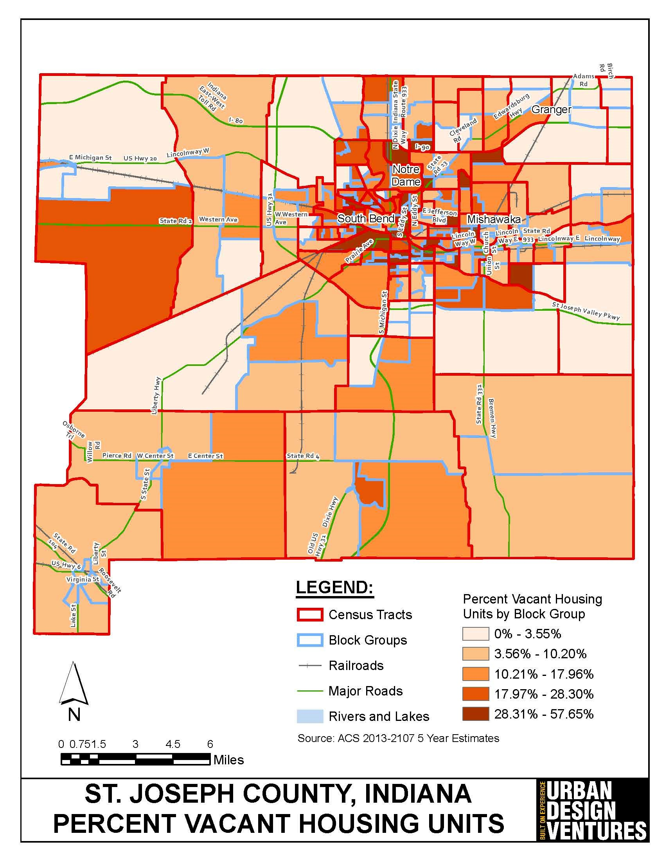
Vacant Housing Units - St. Joseph County
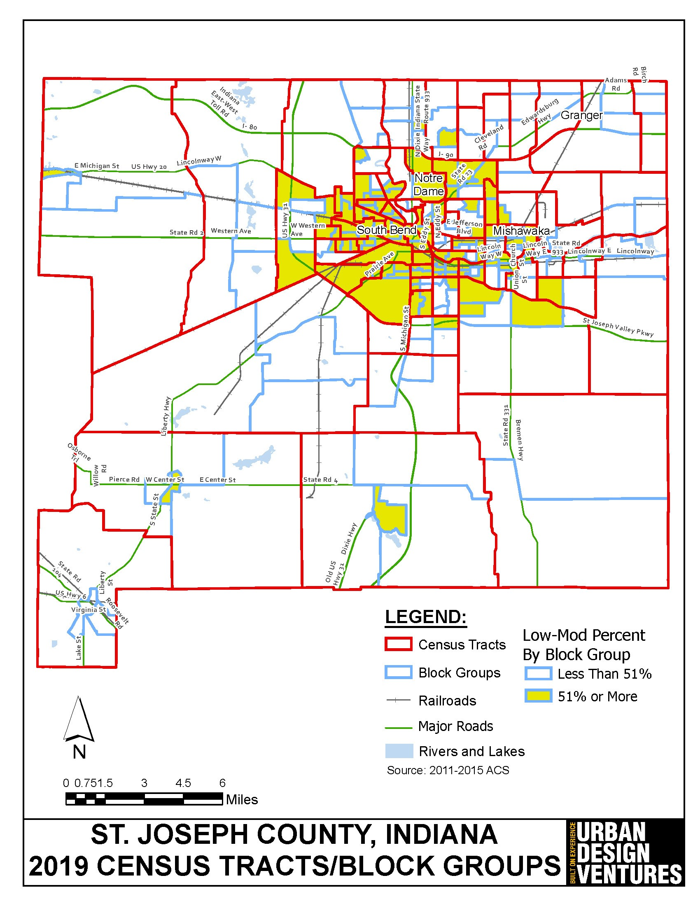
Low/Moderate Income Population by Block Group - St. Joseph County
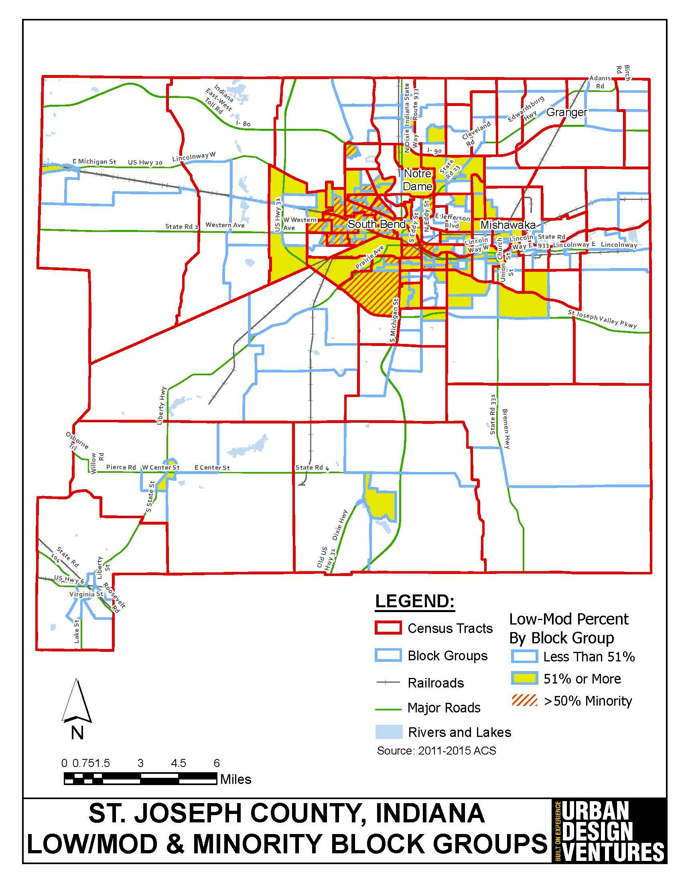
Low/Moderate Income Population ÿ Areas of Minority Concentration - St. Joseph County
2. Summary of the objectives and outcomes identified in the Plan Needs Assessment Overview
The purpose of this Five Year Consolidated Plan is to serve as a consolidated planning document, an application, and a strategic plan for the City of South Bend and the St. Joseph County Housing Consortium. As part of the Five Year Consolidated Plan, the community must develop goals and objectives.
The following strategies with subsequent goals and priorities have been identified for the St. Joseph County Housing Consortium for the period of FY 2020 through FY 2024 for the use of HOME Investment Partnership (HOME) funds:
HOUSING STRATEGY - HSS
Goal:
Improve, preserve, and expand the supply of affordable housing for low- and moderate-income persons and families in the cities of South Bend and Mishawaka, and the unincorporated areas of St. Joseph County.
Objectives:
- HSS-1 Homeownership Assistance - Promote and assist in developing homeownership opportunities for low- and moderate-income persons & families.
- HSS-2 Housing Construction - Promote and assist in the development of new affordable housing, both rental and sales housing.
- HSS-3 Housing Rehabilitation - Promote and assist in the preservation of existing owner and renter occupied housing stock in St. Joseph County.
- HSS-4 Fair Housing - Affirmatively further fair housing by promoting fair housing choice throughout St. Joseph County.
- HSS-5 Lead-Based Paint - Promote and assist in addressing lead-based paint in owner and renter occupied housing stock in St. Joseph County.
- HSS-6 Housing Education - Promote and assist in educating homeowners, tenants, and new homebuyers in best practices for purchase and upkeep, affordable housing rentals, and foreclosure and eviction prevention.
- HSS-7 Rental Assistance - Provide funds for tenant based rental assistance to make housing affordable to low- and moderate-income persons and families.
The City of South Bend, in addition to the overall Housing Strategies of the St. Joseph County Housing Consortium, proposes the following additional strategies for its Community Development Block Grant (CDBG) Program and Emergency Solutions Grant (ESG) Program:
HOMELESS STRATEGY - HOM
Goal:
Improve the living conditions and services for persons and families experiencing homelessness in the City of South Bend.
Objectives:
- HOM-1 Housing - Promote and assist in developing housing opportunities for persons and families experiencing homelessness, and those who are at-risk of becoming homeless.
- HOM-2 Operations/Support - Promote and assist in program support services for the homeless.
- HOM-3 Homeless Prevention - Promote and assist in anti-eviction and prevention of unfair housing practices which may contribute to homelessness.
- HOM-4 Permanent Supportive Housing - Promote and assist in the development and supportive service provisions of permanent supportive housing options.
- HOM-5 Shelter Housing - Support and assist in the development and operations of shelters for persons who are homeless or victims of domestic violence.
SPECIAL NEEDS STRATEGY - SNS
Goal:
Improve, preserve, and expand facilities for persons with special needs and the disabled in the City of South Bend.
Objectives:
- SNS-1 Housing - Promote and assist to increase the supply of affordable, decent, safe, sound, and accessible housing for the elderly, persons with disabilities, and persons with other special needs through rehabilitation of existing housing and new construction of accessible housing.
- SNS-2 Social Services - Promote and assist in supporting social service programs and facilities for the elderly, persons with disabilities, and persons with other special needs.
- SNS-3 Accessibility - Promote and assist in making accessibility improvements to owner occupied housing through rehabilitation and improve renter occupied housing by promoting reasonable accommodations for the physically disabled.
HOUSING STRATEGY - HSS
Goal:
Improve, preserve, and expand the supply of affordable housing for low- and moderate-income persons and families in the City of South Bend.
Objectives:
- HSS-1 Homeownership Assistance - Promote and assist in developing homeownership opportunities for low- and moderate-income persons & families.
- HSS-2 Housing Construction - Promote and assist in the development of new affordable housing, both rental and sales housing.
- HSS-3 Housing Rehabilitation - Promote and assist in the preservation of existing owner and renter occupied housing stock in the City of South Bend.
- HSS-4 Fair Housing - Affirmatively further fair housing by promoting fair housing choice throughout the City of South Bend.
- HSS-5 Lead-Based Paint - Promote and assist in addressing lead-based paint in owner and renter occupied housing stock in the City of South Bend.
- HSS-6 Housing Education - Promote and assist in educating homeowners, tenants, and new homebuyers in best practices for purchase and upkeep, affordable housing rentals, and foreclosure and eviction prevention.
- HSS-7 Rental Assistance - Provide funds for tenant based rental assistance to make housing affordable to low- and moderate-income persons and families.
COMMUNITY DEVELOPMENT STRATEGY - CDS
Goal:
Improve, preserve, and create new public and community facilities, infrastructure, and public services to ensure the quality of life for all residents of the City of South Bend.
Objectives:
- CDS-1 Infrastructure - Improve the City’s infrastructure through rehabilitation, reconstruction, and new construction of streets, walks, curbs, ADA ramps, retaining walls, sewer, linear lines, water, flood control, storm water management and separation, bridges, bike trails, green infrastructure, etc.
- CDS-2 Community Facilities - Improve the City's parks, recreational centers, and public and community facilities through rehabilitation and new construction.
- CDS-3 Public Services - Improve and increase public service programs for the youth, the elderly, disabled, and target income population, including feeding programs and social/welfare programs throughout the City.
- CDS-4 Public Transit - Promote the development of additional bus routes and improve public transportation for low- and moderate-income persons.
- CDS-5 Clearance - Remove and eliminate slum and blighting conditions through demolition of vacant and abandoned structures throughout the City.
- CDS-6 Architectural Barriers - Remove architectural barriers and make public and community facilities accessible.
- CDS-7 Public Safety - Improve public safety through upgrades to facilities, purchase of new equipment, crime prevention, community policing, and ability to respond to emergency situations.
- CDS-8 Revitalization - Promote and assist in the stabilization of residential neighborhoods by removing slums and blight, assembling sites for new housing, rehabilitation of existing housing, and code enforcement.
- CDS-9 Neighborhood Organizations - Improve capacity and encourage grassroots organizing and neighborhood development by neighborhood residents.
ECONOMIC DEVELOPMENT STRATEGY - EDS
Goal:
Increase and promote job creation, job retention, self-sufficiency, education, job training, technical assistance, and economic empowerment of low- and moderate-income residents of the City of South Bend.
Objectives:
- EDS-1 Employment - Support and encourage new job creation, job retention, employment, and job training services.
- EDS-2 Financial Assistance - Support business and commercial growth through expansion and new development with technical assistance and low interest loan programs including Section 108 loans.
- EDS-3 Development Program - Plan and promote the development and reuse of vacant commercial and industrial sites, and facilities.
- EDS-4 Financial Incentives - Support and encourage new economic development through local, state and Federal tax incentives and programs.
ADMINISTRATION, PLANNING, AND MANAGEMENT STRATEGY - APM
Goal:
Provide sound and professional planning, administration, oversight and management of the CDBG, HOME, and ESG federally funded programs.
Objectives:
- APM-1 Management - Continue to provide sound and professional planning, program management and oversight for the successful administration of federally funded programs.
- APM-2 Planning - Continue to develop and plan for special studies, environmental clearance, fair housing, and compliance with all Federal, state, and local laws and regulations.
3. Evaluation of past performance
The City of South Bend has a good performance record with HUD. The City regularly meets the performance standards established by HUD. Each year the City prepares its Consolidated Annual Performance and Evaluation Report (CAPER). This report is submitted within ninety (90) days after the start of the new program year. Copies of the CAPER are available for review at the City of South Bend’s Community Investment offices and online at the City’s website.
The FY 2018 CAPER, which was the fourth CAPER for the FY 2015-2019 Five-Year Consolidated Plan, was approved by HUD in a letter dated May 8, 2019. In the FY 2018 CAPER, the City of South Bend expended 96.77% of its CDBG funds to benefit low- and moderate-income persons. The City expended 14.47% of its funds during the FY 2018 CAPER period on public service, which is below the statutory maximum of 15%. The City’s drawdown ratio was 1.36 as of December 31, 2018. This was within HUD’s timeliness limit of a drawdown ratio of 1.5.
4. Summary of citizen participation process and consultation process
The City of South Bend has followed its Citizen Participation Plans in the planning and preparation of the Five Year Consolidated Plan. The City of South Bend and St. Joseph County Housing Consortium held its first public hearing on the needs of the community and its residents on April 23, 2019. This provided the residents, agencies and organizations with the opportunity to discuss the City's CDBG, HOME, and ESG programs and to provide suggestions for future CDBG, HOME, and ESG Program priorities and activities.
The Cities and County emailed and contacted all the agencies, organizations, and stakeholders that were contacted as part of the planning informing them know that the Five Year Plan and FY 2020 Annual Action Plan were on public display. This information was provided for the second public hearing.
A copy of the "Draft Five Year Consolidated Plan and the FY 2020Annual Action Plan" was placed on public display for review by the general public, agencies, organizations, and stakeholders in the community. A newspaper notice announcing that these documents were placed on public display was published in a newspaper of general circulation in the area. The "Draft Five Year Consolidated Plan and the FY 2020 Annual Action Plan" were on public display at the following locations:
- The St. Joseph County Public Library (all branches)
- Mishawaka Public Library (all branches)
- Walkerton Public Library
- New Carlisle-Olive Township Public Library
- City of South Bend Department of Community Investment
- City of South Bend Office of the Clerk
- City of Mishawaka Planning Department
A citizen survey was prepared and sent out to residents. A link was placed on the City's website. The results of the survey were used to help determine the goals and objectives.
The City of South Bend updated its Citizen Participation Plan to include provisions for public display and public comment during a declaration of a state of emergency by the Governor of Indiana. These provisions shortened display periods for plans and substantial amendments to 5 days, allowed for virtual public meetings, and the requirement that plans be emailed to any resident that requests them.
A more detailed analysis and description of the citizen participation process is contained in Section PR-15 Citizen Participation.
5. Summary of public comments
The City of South Bend and St. Joseph County Housing Consortium held its First Public Hearing on Tuesday, April 23, 2019 at 5:30 PM. Comments received at that public hearing are included in the attachments at the end of the Five Year Plan.
The FY 2020-2024 Five Year Consolidated Plan and FY 2020 Annual Action Plan were placed on public display and a Second Public Hearing was scheduled for October 15, 2019. Comments received at the Second Public Hearing are included in the attachments at the end of the Five Year Plan.
6. Summary of comments or views not accepted and the reasons for not accepting them
All comments and suggestions received to date have been accepted and incorporated into the planning document.
7. Summary
The City of South Bend followed its Citizen Participation Plan. The City of South Bend provided residents and stakeholders with the opportunity to participate in the planning process, which they did. Based on that input the St. Joseph County Housing Consortium prepared and developed a thorough and comprehensive Five Year Consolidated Plan which includes the cities of South Bend and Mishawaka.

The Process

PR-05 Lead & Responsible Agencies - 91.200(b)
1. Describe agency/entity responsible for preparing the Consolidated Plan and those responsible for administration of each grant program and funding source
The following are the agencies/entities responsible for preparing the Consolidated Plan and those responsible for administration of each grant program and funding source.
Agency Role | Name | Department/Agency
Lead Agency | SOUTH BEND

CDBG Administrator | SOUTH BEND | Department of Community Investment
HOPWA Administrator
HOME Administrator | SOUTH BEND | Department of Community Investment
ESG Administrator | SOUTH BEND | Department of Community Investment
HOPWA-C Administrator | SOUTH BEND | Community Development
Table 1 – Responsible Agencies

Narrative
The administering lead agency is the City of South Bend’s Department of Community Investment, Neighborhood Development division for the CDBG, HOME, and ESG Programs. The City of South Bend Neighborhood Development division prepares the Five Year Consolidated Plan, Annual Action Plans, Environmental Review Records (ERR), and the Consolidated Annual Performance and Evaluation Reports (CAPERs), processes pay requests, and performs contracting, monitoring, and oversight of the program on a day to day basis. In addition, the St. Joseph County Housing Consortium hired a private planning consulting firm to assist the City in preparation of the Five Year Consolidated Plan.
Consolidated Plan Public Contact Information
Ms. Pamela Meyer, Director
Neighborhood Development
City of South Bend’s Department of Community Investment
227 W. Jefferson Boulevard, South Bend, IN 46601
Phone: (574) 235-5845
Email: pmeyer@southbendin.gov
Website: https://southbendin.gov/department/community-investment/neighborhood-development/

PR-10 Consultation - 91.100, 91.110, 91.200(b), 91.300(b), 91.215(l) and 91.315(I)
1. Introduction
The City of South Bend and the St. Joseph County Housing Consortium held a series of meetings and interviews with non-profits, the Housing Authority of South Bend, local housing providers, social service agencies, community and economic development organizations, the local Region 2.a Planning Council of the Balance of State members, City department representatives, and St. Joseph County department representatives. Additionally, an online survey was created for stakeholders and residents to complete, which identified needs, gaps in the system, and programmatic goals for the next five years. Input from the meetings and surveys were used in the development of specific strategies and priorities for the Five Year Consolidated Plan.
Provide a concise summary of the jurisdiction’s activities to enhance coordination between public and assisted housing providers and private and governmental health, mental health and service agencies (91.215(I)).
The City of South Bend and the St. Joseph County Housing Consortium work with the following agencies to enhance coordination:
- The Housing Authority of South Bend – Improvements to public housing communities.
- The Housing Authority of Mishawaka – Section 8 Housing Choice Vouchers.
- Social Services Agencies – funds to improve services to low and moderate income persons.
- Housing Providers – funds to rehabilitate and develop affordable housing and provide housing opportunities for low- and moderate-income households.
- Community and Economic Development Agencies – funds to improve services to low and moderate income persons, and workforce development.
Describe coordination with the Continuum of Care and efforts to address the needs of homeless persons (particularly chronically homeless individuals and families, families with children, veterans, and unaccompanied youth) and persons at risk of homelessness
The Indiana Balance of State CoC addresses the needs of homeless persons and persons at risk of becoming homeless. St. Joseph County is a separate region within the Balance of State CoC that encompasses only St. Joseph County. The region has utilized Coordinated Entry since January of 2018 to determine the needs of homeless individuals and families and offer them housing programs best suited to their needs. Persons who are homeless or at-risk of becoming homeless are evaluated using the Vulnerability Index – Service Prioritization Decision Assistance Tool (VI-SPDAT) and placed in appropriate housing. In addition to the VI-SPDAT’s prioritization metrics, the Region 2.a. Planning Council chose to also prioritize veterans and domestic violence survivors. Since the adoption of Coordinated Entry, placement rates of homeless individuals and families has increased.
The Point-In-Time Counts for sheltered and unsheltered homeless persons are completed on a designated date twice a year, in the months of January and July. The results of the statewide counts are available to the public on the Indiana Balance of State CoC website (https://www.indianabos.org).
Describe consultation with the Continuum(s) of Care that serves the jurisdiction's area in determining how to allocate ESG funds, develop performance standards and evaluate outcomes, and develop funding, policies and procedures for the administration of HMIS
ESG – The Center for the Homeless, the YWCA, Youth Service Bureau, AIDS Ministries/AIDS Assist, and Life Treatment Centers receive ESG funds through the City of South Bend. The Neighborhood Development division issues an RFP for ESG-funded projects on behalf of the City. The process is competitive for projects that provide emergency shelter, related services, and rapid re-housing for the homeless.
Develop Performance Standards and Evaluate Outcomes – The Indiana Balance of State CoC’s written standards focus on a “Housing First Model” and follow the best practices of that model. The written standards utilize several strategies to increase the number of people who exit Emergency Shelter, Transitional Housing, and Rapid Re-housing into Permanent Housing. Evaluations of these standards will be based on the length-of-time of being homeless. Their measures the amount of time an individual or family resides in emergency shelter, transitional housing, or rapid re-housing. The CoC seeks to make progress on preventing evictions, the targeting of individuals and families based on risk, and influencing housing developers in the area to create Permanent Supportive Housing.
HMIS – Throughout different times of the year, the Indiana Balance of State CoC and the HMIS Lead work together to assess data quality throughout the CoC. This includes working on the Annual Homeless Assessment Report (AHAR), the Point-In-Time (PIT) count, project reviews/ranking, and working with programs for individuals, while completing their Annual Performance Reports (APRs). The system ensures data quality by requiring many of the universal data elements upon enrolling a participant into a program. Additionally, the system has an alert system with exit date reminders. The work flow of data entry has been updated to improve data quality. The HMIS Lead supports users through the staffing of a Help Desk and ongoing training opportunities. Agency users are able to run self-reports to assess their program’s data quality. ESG-funded applications are required to use the HMIS system. CoC-funded organizations are motivated to provide good data quality, because the Indiana Balance of State CoC has moved toward a data-driven project review and ranking system. Projects with poor data quality are more likely to show poor outcomes, which can impact their funding.
2. Describe Agencies, groups, organizations and others who participated in the process and describe the jurisdictions consultations with housing, social service agencies and other entities

Table 2 – Agencies, groups, organizations who participated
1 | Agency/Group/Organization | SOUTH BEND
 | Agency/Group/Organization Type | Other government - Local  Planning organization  Grantee Department
 | What section of the Plan was addressed by Consultation? | Housing Need Assessment  Lead-based Paint Strategy  Homelessness Strategy  Homeless Needs - Chronically homeless  Homeless Needs - Families with children  Homelessness Needs - Veterans  Homelessness Needs - Unaccompanied youth  Non-Homeless Special Needs  Economic Development  Market Analysis  Anti-poverty Strategy  Community Development Strategy
 | How was the Agency/Group/Organization consulted and what are the anticipated outcomes of the consultation or areas for improved coordination? | The City of South Bend was the lead entity on the Five Year Consolidated Plan. The City reviewed its program and funded activities that met the goals and objectives as outlined in the City's Five Year Consolidated Plan.
2 | Agency/Group/Organization | Housing Authority of South Bend
 | Agency/Group/Organization Type | Housing  PHA  Planning organization
 | What section of the Plan was addressed by Consultation? | Housing Need Assessment  Lead-based Paint Strategy  Public Housing Needs  Non-Homeless Special Needs  Anti-poverty Strategy  Community Development Strategy
 | How was the Agency/Group/Organization consulted and what are the anticipated outcomes of the consultation or areas for improved coordination? | The Housing Authority of South Bend was contacted to determine the housing needs of its very low-income clients. The City reviewed its program and funded activities that met the goals and objectives as outlined in the City's Five Year Consolidated Plan to address these housing needs.
3 | Agency/Group/Organization | MISHAWAKA
 | Agency/Group/Organization Type | Other government - Local
 | What section of the Plan was addressed by Consultation? | Housing Need Assessment  Lead-based Paint Strategy  Homelessness Strategy  Homeless Needs - Chronically homeless  Homeless Needs - Families with children  Homelessness Needs - Veterans  Homelessness Needs - Unaccompanied youth  Non-Homeless Special Needs  Economic Development  Market Analysis  Anti-poverty Strategy
 | How was the Agency/Group/Organization consulted and what are the anticipated outcomes of the consultation or areas for improved coordination? | The City of Mishawaka is a participating member of the St. Joseph County Housing Consortium. The City reviewed its program and funded activities that met the goals and objectives as outlined in the City's Five Year Consolidated Plan to address these housing needs.
4 | Agency/Group/Organization | OAKLAWN PSYCHIATRIC CENTER, INC.
 | Agency/Group/Organization Type | Services-homeless  Regional organization
 | What section of the Plan was addressed by Consultation? | Housing Need Assessment  Homelessness Strategy  Homeless Needs - Chronically homeless  Homeless Needs - Families with children  Homelessness Needs - Veterans  Homelessness Needs - Unaccompanied youth  Non-Homeless Special Needs  Anti-poverty Strategy  Community Development Strategy
 | How was the Agency/Group/Organization consulted and what are the anticipated outcomes of the consultation or areas for improved coordination? | Group meeting held, phone calls; housing and community development priorities; social service needs.
5 | Agency/Group/Organization | HOPE Ministries
 | Agency/Group/Organization Type | Housing  Services - Housing  Services-Children  Services-Elderly Persons  Services-Victims of Domestic Violence  Services-homeless  Services - Victims
 | What section of the Plan was addressed by Consultation? | Housing Need Assessment  Homelessness Strategy  Homeless Needs - Chronically homeless  Homeless Needs - Families with children  Homelessness Needs - Veterans  Homelessness Needs - Unaccompanied youth  Non-Homeless Special Needs  Anti-poverty Strategy  Community Development Strategy
 | How was the Agency/Group/Organization consulted and what are the anticipated outcomes of the consultation or areas for improved coordination? | Group meeting held, phone calls; housing and community development priorities; social service and economic development needs.
6 | Agency/Group/Organization | YOUTH SERVICE BUREAU
 | Agency/Group/Organization Type | Housing  Services - Housing  Services-Children  Services-homeless  Child Welfare Agency  Regional organization
 | What section of the Plan was addressed by Consultation? | Housing Need Assessment  Homelessness Strategy  Homeless Needs - Chronically homeless  Homeless Needs - Families with children  Homelessness Needs - Veterans  Homelessness Needs - Unaccompanied youth  Non-Homeless Special Needs  Anti-poverty Strategy  Community Development Strategy
 | How was the Agency/Group/Organization consulted and what are the anticipated outcomes of the consultation or areas for improved coordination?
7 | Agency/Group/Organization | ST. MARGARET'S HOUSE
 | Agency/Group/Organization Type | Services - Housing  Services-Children  Services-Victims of Domestic Violence  Services - Victims
 | What section of the Plan was addressed by Consultation? | Housing Need Assessment  Homelessness Strategy  Homeless Needs - Chronically homeless  Homeless Needs - Families with children  Homelessness Needs - Veterans  Homelessness Needs - Unaccompanied youth  Non-Homeless Special Needs  Anti-poverty Strategy  Community Development Strategy
 | How was the Agency/Group/Organization consulted and what are the anticipated outcomes of the consultation or areas for improved coordination? | Group meeting held, phone calls; housing and community development priorities; social service and economic development needs.
8 | Agency/Group/Organization | Center for the Homeless, Inc
 | Agency/Group/Organization Type | Housing  Services - Housing  Services-Children  Services-Persons with HIV/AIDS  Services-Victims of Domestic Violence  Services-homeless  Publicly Funded Institution/System of Care  Regional organization  Correction Facilities
 | What section of the Plan was addressed by Consultation? | Housing Need Assessment  Homelessness Strategy  Homeless Needs - Chronically homeless  Homeless Needs - Families with children  Homelessness Needs - Veterans  Homelessness Needs - Unaccompanied youth  Anti-poverty Strategy  Community Development Strategy
 | How was the Agency/Group/Organization consulted and what are the anticipated outcomes of the consultation or areas for improved coordination? | Group meeting held, phone calls; housing and community development priorities; social service and economic development needs.
9 | Agency/Group/Organization | St. Joseph County Public Library
 | Agency/Group/Organization Type | Services-Children  Services-Elderly Persons  Services-homeless  Services-Education  Services-Employment
 | What section of the Plan was addressed by Consultation? | Housing Need Assessment  Homelessness Strategy  Homeless Needs - Chronically homeless  Homeless Needs - Families with children  Homelessness Needs - Veterans  Homelessness Needs - Unaccompanied youth  Non-Homeless Special Needs  Anti-poverty Strategy  Community Development Strategy
 | How was the Agency/Group/Organization consulted and what are the anticipated outcomes of the consultation or areas for improved coordination? | Group meeting held, phone calls; housing and community development priorities; social service and economic development needs.
10 | Agency/Group/Organization | BOYS AND GIRLS CLUB OF ST. JOSEPH COUNTY
 | Agency/Group/Organization Type | Services-Children  Services-Education  Child Welfare Agency  Regional organization
 | What section of the Plan was addressed by Consultation? | Housing Need Assessment  Homelessness Strategy  Homeless Needs - Chronically homeless  Homeless Needs - Families with children  Homelessness Needs - Veterans  Homelessness Needs - Unaccompanied youth  Non-Homeless Special Needs  Anti-poverty Strategy  Community Development Strategy
 | How was the Agency/Group/Organization consulted and what are the anticipated outcomes of the consultation or areas for improved coordination? | Group meeting held, phone calls; housing and community development priorities; social service and economic development needs.
11 | Agency/Group/Organization | Goodwill Bridges out of Poverty
 | Agency/Group/Organization Type | Services-Education  Services-Employment
 | What section of the Plan was addressed by Consultation? | Housing Need Assessment  Homelessness Strategy  Homeless Needs - Chronically homeless  Homeless Needs - Families with children  Homelessness Needs - Veterans  Homelessness Needs - Unaccompanied youth  Non-Homeless Special Needs  Anti-poverty Strategy  Community Development Strategy
 | How was the Agency/Group/Organization consulted and what are the anticipated outcomes of the consultation or areas for improved coordination? | Group meeting held, phone calls; housing and community development priorities; social service and economic development needs.
12 | Agency/Group/Organization | AIDS MINISTRIES/AIDS ASSIST
 | Agency/Group/Organization Type | Services-Persons with HIV/AIDS  Services-homeless  Health Agency
 | What section of the Plan was addressed by Consultation? | Housing Need Assessment  Homelessness Strategy  Homeless Needs - Chronically homeless  Homeless Needs - Families with children  Homelessness Needs - Veterans  Homelessness Needs - Unaccompanied youth  Non-Homeless Special Needs  Anti-poverty Strategy  Community Development Strategy
 | How was the Agency/Group/Organization consulted and what are the anticipated outcomes of the consultation or areas for improved coordination? | Group meeting held, phone calls; housing and community development priorities; social service and economic development needs.
13 | Agency/Group/Organization | Upper Room Recovery
 | Agency/Group/Organization Type | Services-homeless  Services-Employment
 | What section of the Plan was addressed by Consultation? | Housing Need Assessment  Homelessness Strategy  Homeless Needs - Chronically homeless  Homeless Needs - Families with children  Homelessness Needs - Veterans  Homelessness Needs - Unaccompanied youth  Non-Homeless Special Needs  Anti-poverty Strategy  Community Development Strategy
 | How was the Agency/Group/Organization consulted and what are the anticipated outcomes of the consultation or areas for improved coordination? | Group meeting held, phone calls; housing and community development priorities; social service and economic development needs.
14 | Agency/Group/Organization | Dismas House of South Bend
 | Agency/Group/Organization Type | Services-homeless
 | What section of the Plan was addressed by Consultation? | Housing Need Assessment  Homelessness Strategy  Homeless Needs - Chronically homeless  Homeless Needs - Families with children  Homelessness Needs - Veterans  Homelessness Needs - Unaccompanied youth  Non-Homeless Special Needs  Anti-poverty Strategy  Community Development Strategy
 | How was the Agency/Group/Organization consulted and what are the anticipated outcomes of the consultation or areas for improved coordination? | Group meeting held, phone calls; housing and community development priorities; social service and economic development needs.
15 | Agency/Group/Organization | St. Joseph Area Plan Commission
 | Agency/Group/Organization Type | Other government - County  Regional organization  Planning organization
 | What section of the Plan was addressed by Consultation? | Housing Need Assessment  Homelessness Strategy  Homeless Needs - Chronically homeless  Homeless Needs - Families with children  Homelessness Needs - Veterans  Homelessness Needs - Unaccompanied youth  Non-Homeless Special Needs  Economic Development  Market Analysis  Anti-poverty Strategy  Community Development Strategy
 | How was the Agency/Group/Organization consulted and what are the anticipated outcomes of the consultation or areas for improved coordination? | Group meeting held, phone calls; housing and community development priorities; social service and economic development needs.
16 | Agency/Group/Organization | Dept of Code Enforcement
 | Agency/Group/Organization Type | Services - Housing  Other government - Local
 | What section of the Plan was addressed by Consultation? | Housing Need Assessment  Homelessness Strategy  Homeless Needs - Chronically homeless  Homeless Needs - Families with children  Homelessness Needs - Veterans  Homelessness Needs - Unaccompanied youth  Non-Homeless Special Needs  Economic Development  Market Analysis  Anti-poverty Strategy  Community Development Strategy
 | How was the Agency/Group/Organization consulted and what are the anticipated outcomes of the consultation or areas for improved coordination? | Group meeting held, phone calls; housing and community development priorities; social service and economic development needs.
17 | Agency/Group/Organization | Office of Sustainability
 | Agency/Group/Organization Type | Other government - County  Planning organization
 | What section of the Plan was addressed by Consultation? | Housing Need Assessment  Homelessness Strategy  Homeless Needs - Chronically homeless  Homeless Needs - Families with children  Homelessness Needs - Veterans  Homelessness Needs - Unaccompanied youth  Non-Homeless Special Needs  Economic Development  Market Analysis  Anti-poverty Strategy  Community Development Strategy
 | How was the Agency/Group/Organization consulted and what are the anticipated outcomes of the consultation or areas for improved coordination? | Group meeting held, phone calls; housing and community development priorities; social service and economic development needs.
18 | Agency/Group/Organization | Business Development Division, DCI
 | Agency/Group/Organization Type | Other government - Local  Planning organization  Business Leaders  Business and Civic Leaders
 | What section of the Plan was addressed by Consultation? | Housing Need Assessment  Economic Development  Market Analysis  Anti-poverty Strategy  Community Development Strategy
 | How was the Agency/Group/Organization consulted and what are the anticipated outcomes of the consultation or areas for improved coordination? | Group meeting held, phone calls; housing and community development priorities; social service and economic development needs.
19 | Agency/Group/Organization | Indiana Small Business Development Center
 | Agency/Group/Organization Type | Services-Employment  Regional organization  Planning organization  Business Leaders
 | What section of the Plan was addressed by Consultation? | Housing Need Assessment  Economic Development  Market Analysis  Anti-poverty Strategy  Community Development Strategy
 | How was the Agency/Group/Organization consulted and what are the anticipated outcomes of the consultation or areas for improved coordination? | Group meeting held, phone calls; housing and community development priorities; social service and economic development needs.
20 | Agency/Group/Organization | South Bend Career Pathways
 | Agency/Group/Organization Type | Services-Employment  Planning organization  Business Leaders  Business and Civic Leaders
 | What section of the Plan was addressed by Consultation? | Housing Need Assessment  Economic Development  Market Analysis  Anti-poverty Strategy  Community Development Strategy
 | How was the Agency/Group/Organization consulted and what are the anticipated outcomes of the consultation or areas for improved coordination? | Group meeting held, phone calls; housing and community development priorities; social service and economic development needs.
21 | Agency/Group/Organization | Women's Entrepreneurship Initiative
 | Agency/Group/Organization Type | Services-Education  Services-Employment  Regional organization  Business Leaders  Civic Leaders  Business and Civic Leaders
 | What section of the Plan was addressed by Consultation? | Housing Need Assessment  Economic Development  Market Analysis  Anti-poverty Strategy  Community Development Strategy
 | How was the Agency/Group/Organization consulted and what are the anticipated outcomes of the consultation or areas for improved coordination? | Group meeting held, phone calls; housing and community development priorities; social service and economic development needs.
22 | Agency/Group/Organization | Notre Dame Economic Justice Clinic
 | Agency/Group/Organization Type | Housing  Service-Fair Housing
 | What section of the Plan was addressed by Consultation? | Housing Need Assessment  Public Housing Needs  Homelessness Strategy  Homeless Needs - Chronically homeless  Homeless Needs - Families with children  Homelessness Needs - Veterans  Homelessness Needs - Unaccompanied youth  Non-Homeless Special Needs  Market Analysis  Community Development Strategy
 | How was the Agency/Group/Organization consulted and what are the anticipated outcomes of the consultation or areas for improved coordination? | Group meeting held, phone calls; housing and community development priorities; social service and economic development needs.
23 | Agency/Group/Organization | St. Joseph County Department of Health
 | Agency/Group/Organization Type | Services - Housing  Services-Health  Health Agency  Other government - County  Other government - Local
 | What section of the Plan was addressed by Consultation? | Housing Need Assessment  Lead-based Paint Strategy  Market Analysis  Community Development Strategy
 | How was the Agency/Group/Organization consulted and what are the anticipated outcomes of the consultation or areas for improved coordination? | Group meeting held, phone calls; housing and community development priorities; social service and economic development needs.
24 | Agency/Group/Organization | 466 Works
 | Agency/Group/Organization Type | Housing  Services - Housing
 | What section of the Plan was addressed by Consultation? | Housing Need Assessment  Homelessness Strategy  Homeless Needs - Chronically homeless  Homeless Needs - Families with children  Homelessness Needs - Veterans  Homelessness Needs - Unaccompanied youth  Non-Homeless Special Needs  Economic Development  Market Analysis  Anti-poverty Strategy  Community Development Strategy
 | How was the Agency/Group/Organization consulted and what are the anticipated outcomes of the consultation or areas for improved coordination? | Group meeting held, phone calls; housing and community development priorities; social service and economic development needs.
25 | Agency/Group/Organization | Neighborhood Development Associates
 | Agency/Group/Organization Type | Housing  Services - Housing
 | What section of the Plan was addressed by Consultation? | Housing Need Assessment  Homelessness Strategy  Homeless Needs - Chronically homeless  Homeless Needs - Families with children  Homelessness Needs - Veterans  Homelessness Needs - Unaccompanied youth  Non-Homeless Special Needs  Economic Development  Market Analysis  Anti-poverty Strategy  Community Development Strategy
 | How was the Agency/Group/Organization consulted and what are the anticipated outcomes of the consultation or areas for improved coordination? | Group meeting held, phone calls; housing and community development priorities; social service and economic development needs.
26 | Agency/Group/Organization | Place Homes, Inc.
 | Agency/Group/Organization Type | Housing  Services - Housing  Business Leaders
 | What section of the Plan was addressed by Consultation? | Housing Need Assessment  Homelessness Strategy  Homeless Needs - Chronically homeless  Homeless Needs - Families with children  Homelessness Needs - Veterans  Homelessness Needs - Unaccompanied youth  Non-Homeless Special Needs  Economic Development  Market Analysis  Anti-poverty Strategy  Community Development Strategy
 | How was the Agency/Group/Organization consulted and what are the anticipated outcomes of the consultation or areas for improved coordination? | Group meeting held, phone calls; housing and community development priorities; social service and economic development needs.
27 | Agency/Group/Organization | NEAR NORTHWEST NEIGHBORHOOD, INC.
 | Agency/Group/Organization Type | Housing  Services - Housing
 | What section of the Plan was addressed by Consultation? | Housing Need Assessment  Homelessness Strategy  Homeless Needs - Chronically homeless  Homeless Needs - Families with children  Homelessness Needs - Veterans  Non-Homeless Special Needs  Economic Development  Market Analysis  Anti-poverty Strategy  Community Development Strategy
 | How was the Agency/Group/Organization consulted and what are the anticipated outcomes of the consultation or areas for improved coordination? | Group meeting held, phone calls; housing and community development priorities; social service and economic development needs.
28 | Agency/Group/Organization | HABITAT FOR HUMANITY OF ST. JOSEPH COUNTY
 | Agency/Group/Organization Type | Housing  Services - Housing
 | What section of the Plan was addressed by Consultation? | Housing Need Assessment  Homelessness Strategy  Homeless Needs - Chronically homeless  Homeless Needs - Families with children  Homelessness Needs - Veterans  Homelessness Needs - Unaccompanied youth  Non-Homeless Special Needs  Economic Development  Market Analysis  Anti-poverty Strategy
 | How was the Agency/Group/Organization consulted and what are the anticipated outcomes of the consultation or areas for improved coordination? | Group meeting held, phone calls; housing and community development priorities; social service and economic development needs.
29 | Agency/Group/Organization | Hurry Home
 | Agency/Group/Organization Type | Housing  Services - Housing
 | What section of the Plan was addressed by Consultation? | Housing Need Assessment  Homelessness Strategy  Homeless Needs - Chronically homeless  Homeless Needs - Families with children  Homelessness Needs - Veterans  Homelessness Needs - Unaccompanied youth  Non-Homeless Special Needs  Economic Development  Market Analysis  Anti-poverty Strategy  Community Development Strategy
 | How was the Agency/Group/Organization consulted and what are the anticipated outcomes of the consultation or areas for improved coordination? | Group meeting held, phone calls; housing and community development priorities; social service and economic development needs.
30 | Agency/Group/Organization | SOUTH BEND HERITAGE FOUNDATION
 | Agency/Group/Organization Type | Housing  Services - Housing
 | What section of the Plan was addressed by Consultation? | Housing Need Assessment  Homelessness Strategy  Homeless Needs - Chronically homeless  Homeless Needs - Families with children  Homelessness Needs - Veterans  Homelessness Needs - Unaccompanied youth  Non-Homeless Special Needs  Economic Development  Market Analysis  Anti-poverty Strategy  Community Development Strategy
 | How was the Agency/Group/Organization consulted and what are the anticipated outcomes of the consultation or areas for improved coordination? | Group meeting held, phone calls; housing and community development priorities; social service and economic development needs.
31 | Agency/Group/Organization | NAACP South Bend
 | Agency/Group/Organization Type | Civic Leaders  Services - Advocacy
 | What section of the Plan was addressed by Consultation? | Housing Need Assessment  Homelessness Strategy  Homeless Needs - Chronically homeless  Homeless Needs - Families with children  Homelessness Needs - Veterans  Homelessness Needs - Unaccompanied youth  Non-Homeless Special Needs  Economic Development  Market Analysis  Anti-poverty Strategy  Community Development Strategy
 | How was the Agency/Group/Organization consulted and what are the anticipated outcomes of the consultation or areas for improved coordination? | Group meeting held, phone calls; housing and community development priorities; social service and economic development needs.
32 | Agency/Group/Organization | IN*Source
 | Agency/Group/Organization Type | Services-Children  Services-Persons with Disabilities  Services-Health  Services-Education  Health Agency  Child Welfare Agency
 | What section of the Plan was addressed by Consultation? | Housing Need Assessment  Homelessness Strategy  Homeless Needs - Chronically homeless  Homeless Needs - Families with children  Homelessness Needs - Veterans  Homelessness Needs - Unaccompanied youth  Non-Homeless Special Needs  Economic Development  Market Analysis  Anti-poverty Strategy  Community Development Strategy
 | How was the Agency/Group/Organization consulted and what are the anticipated outcomes of the consultation or areas for improved coordination? | Group meeting held, phone calls; housing and community development priorities; social service and economic development needs.
33 | Agency/Group/Organization | LOGAN CENTER - REGIONAL AUTISM CENTER
 | Agency/Group/Organization Type | Services-Children  Services-Persons with Disabilities  Services-Education  Child Welfare Agency  Regional organization
 | What section of the Plan was addressed by Consultation? | Housing Need Assessment  Homelessness Strategy  Homeless Needs - Chronically homeless  Homeless Needs - Families with children  Homelessness Needs - Veterans  Homelessness Needs - Unaccompanied youth  Non-Homeless Special Needs  Economic Development  Market Analysis  Anti-poverty Strategy  Community Development Strategy
 | How was the Agency/Group/Organization consulted and what are the anticipated outcomes of the consultation or areas for improved coordination? | Group meeting held, phone calls; housing and community development priorities; social service and economic development needs.
34 | Agency/Group/Organization | La Casa de Amistad
 | Agency/Group/Organization Type | Regional organization  Civic Leaders  Services - Advocacy
 | What section of the Plan was addressed by Consultation? | Housing Need Assessment  Homelessness Strategy  Homeless Needs - Chronically homeless  Homeless Needs - Families with children  Homelessness Needs - Veterans  Homelessness Needs - Unaccompanied youth  Non-Homeless Special Needs  Economic Development  Market Analysis  Anti-poverty Strategy  Community Development Strategy
 | How was the Agency/Group/Organization consulted and what are the anticipated outcomes of the consultation or areas for improved coordination? | Group meeting held, phone calls; housing and community development priorities; social service and economic development needs.
35 | Agency/Group/Organization | Catholic Worker of Michiana
 | Agency/Group/Organization Type | Services - Housing  Services-homeless
 | What section of the Plan was addressed by Consultation? | Housing Need Assessment  Homelessness Strategy  Homeless Needs - Chronically homeless  Homeless Needs - Families with children  Homelessness Needs - Veterans  Homelessness Needs - Unaccompanied youth  Non-Homeless Special Needs  Economic Development  Market Analysis  Anti-poverty Strategy  Community Development Strategy
 | How was the Agency/Group/Organization consulted and what are the anticipated outcomes of the consultation or areas for improved coordination? | Group meeting held, phone calls; housing and community development priorities; social service and economic development needs.
36 | Agency/Group/Organization | Cross Community
 | Agency/Group/Organization Type | Housing  Services - Housing  Civic Leaders
 | What section of the Plan was addressed by Consultation? | Housing Need Assessment  Homelessness Strategy  Homeless Needs - Chronically homeless  Homeless Needs - Families with children  Homelessness Needs - Veterans  Homelessness Needs - Unaccompanied youth  Non-Homeless Special Needs  Economic Development  Market Analysis  Anti-poverty Strategy  Community Development Strategy
 | How was the Agency/Group/Organization consulted and what are the anticipated outcomes of the consultation or areas for improved coordination? | Group meeting held, phone calls; housing and community development priorities; social service and economic development needs.
37 | Agency/Group/Organization | Doulos Chapel
 | Agency/Group/Organization Type | Civic Leaders  Faith
 | What section of the Plan was addressed by Consultation? | Housing Need Assessment  Homelessness Strategy  Homeless Needs - Chronically homeless  Homeless Needs - Families with children  Homelessness Needs - Veterans  Homelessness Needs - Unaccompanied youth  Non-Homeless Special Needs  Economic Development  Market Analysis  Anti-poverty Strategy  Community Development Strategy
 | How was the Agency/Group/Organization consulted and what are the anticipated outcomes of the consultation or areas for improved coordination? | Group meeting held, phone calls; housing and community development priorities; social service and economic development needs.
38 | Agency/Group/Organization | Mt. Carmel Missionary Baptist Church
 | Agency/Group/Organization Type | Civic Leaders  Faith
 | What section of the Plan was addressed by Consultation? | Housing Need Assessment  Homelessness Strategy  Homeless Needs - Chronically homeless  Homeless Needs - Families with children  Homelessness Needs - Veterans  Homelessness Needs - Unaccompanied youth  Non-Homeless Special Needs  Economic Development  Market Analysis  Anti-poverty Strategy  Community Development Strategy
 | How was the Agency/Group/Organization consulted and what are the anticipated outcomes of the consultation or areas for improved coordination? | Group meeting held, phone calls; housing and community development priorities; social service and economic development needs.
39 | Agency/Group/Organization | Broadway Christian Parish United Methodist Church
 | Agency/Group/Organization Type | Civic Leaders  Faith
 | What section of the Plan was addressed by Consultation? | Housing Need Assessment  Homelessness Strategy  Homeless Needs - Chronically homeless  Homeless Needs - Families with children  Homelessness Needs - Veterans  Homelessness Needs - Unaccompanied youth  Non-Homeless Special Needs  Economic Development  Market Analysis  Anti-poverty Strategy  Community Development Strategy
 | How was the Agency/Group/Organization consulted and what are the anticipated outcomes of the consultation or areas for improved coordination? | Group meeting held, phone calls; housing and community development priorities; social service and economic development needs.
40 | Agency/Group/Organization | United Religious Community
 | Agency/Group/Organization Type | Civic Leaders  Faith
 | What section of the Plan was addressed by Consultation? | Housing Need Assessment  Homelessness Strategy  Homeless Needs - Chronically homeless  Homeless Needs - Families with children  Homelessness Needs - Veterans  Homelessness Needs - Unaccompanied youth  Non-Homeless Special Needs  Economic Development  Market Analysis  Anti-poverty Strategy  Community Development Strategy
 | How was the Agency/Group/Organization consulted and what are the anticipated outcomes of the consultation or areas for improved coordination? | Group meeting held, phone calls; housing and community development priorities; social service and economic development needs.
41 | Agency/Group/Organization | Bowman Creek Educational Ecosystem
 | Agency/Group/Organization Type | Services - Housing  Planning organization
 | What section of the Plan was addressed by Consultation? | Housing Need Assessment  Homelessness Strategy  Homeless Needs - Chronically homeless  Homeless Needs - Families with children  Homelessness Needs - Veterans  Homelessness Needs - Unaccompanied youth  Non-Homeless Special Needs  Economic Development  Market Analysis  Anti-poverty Strategy  Community Development Strategy
 | How was the Agency/Group/Organization consulted and what are the anticipated outcomes of the consultation or areas for improved coordination? | Group meeting held, phone calls; housing and community development priorities; social service and economic development needs.
42 | Agency/Group/Organization | River Park Neighborhood Association
 | Agency/Group/Organization Type | Services - Housing  Regional organization  Planning organization  Civic Leaders  Neighborhood Organization
 | What section of the Plan was addressed by Consultation? | Housing Need Assessment  Homelessness Strategy  Homeless Needs - Chronically homeless  Homeless Needs - Families with children  Homelessness Needs - Veterans  Homelessness Needs - Unaccompanied youth  Non-Homeless Special Needs  Economic Development  Market Analysis  Anti-poverty Strategy  Community Development Strategy
 | How was the Agency/Group/Organization consulted and what are the anticipated outcomes of the consultation or areas for improved coordination? | Group meeting held, phone calls; housing and community development priorities; social service and economic development needs.
43 | Agency/Group/Organization | Near West Side Neighborhood Organization
 | Agency/Group/Organization Type | Services - Housing  Civic Leaders  Neighborhood Organization
 | What section of the Plan was addressed by Consultation? | Housing Need Assessment  Homelessness Strategy  Homeless Needs - Chronically homeless  Homeless Needs - Families with children  Homelessness Needs - Veterans  Homelessness Needs - Unaccompanied youth  Non-Homeless Special Needs  Economic Development  Market Analysis  Anti-poverty Strategy  Community Development Strategy
 | How was the Agency/Group/Organization consulted and what are the anticipated outcomes of the consultation or areas for improved coordination? | Group meeting held, phone calls; housing and community development priorities; social service and economic development needs.
44 | Agency/Group/Organization | Veterans Administration
 | Agency/Group/Organization Type | Services-homeless  Services-Health  Services-Employment  Health Agency  Publicly Funded Institution/System of Care  Other government - Federal  Veterans
 | What section of the Plan was addressed by Consultation? | Housing Need Assessment  Homelessness Strategy  Homeless Needs - Chronically homeless  Homeless Needs - Families with children  Homelessness Needs - Veterans  Homelessness Needs - Unaccompanied youth  Non-Homeless Special Needs  Economic Development  Market Analysis  Anti-poverty Strategy  Community Development Strategy
 | How was the Agency/Group/Organization consulted and what are the anticipated outcomes of the consultation or areas for improved coordination? | Group meeting held, phone calls; housing and community development priorities; social service and economic development needs.
45 | Agency/Group/Organization | Far Northwest Neighborhood Association
 | Agency/Group/Organization Type | Services - Housing  Planning organization  Civic Leaders  Neighborhood Organization
 | What section of the Plan was addressed by Consultation? | Housing Need Assessment  Homelessness Strategy  Homeless Needs - Chronically homeless  Homeless Needs - Families with children  Homelessness Needs - Veterans  Homelessness Needs - Unaccompanied youth  Non-Homeless Special Needs  Economic Development  Market Analysis  Anti-poverty Strategy  Community Development Strategy
 | How was the Agency/Group/Organization consulted and what are the anticipated outcomes of the consultation or areas for improved coordination? | Group meeting held, phone calls; housing and community development priorities; social service and economic development needs.
46 | Agency/Group/Organization | Southeast Organized Area Residents
 | Agency/Group/Organization Type | Regional organization  Planning organization  Civic Leaders  Neighborhood Organization
 | What section of the Plan was addressed by Consultation? | Housing Need Assessment  Homelessness Strategy  Homeless Needs - Chronically homeless  Homeless Needs - Families with children  Homelessness Needs - Veterans  Homelessness Needs - Unaccompanied youth  Non-Homeless Special Needs  Economic Development  Market Analysis  Anti-poverty Strategy  Community Development Strategy
 | How was the Agency/Group/Organization consulted and what are the anticipated outcomes of the consultation or areas for improved coordination? | Group meeting held, phone calls; housing and community development priorities; social service and economic development needs.
47 | Agency/Group/Organization | Neighborhood Resources Connection
 | Agency/Group/Organization Type | Civic Leaders  Neighborhood Organization
 | What section of the Plan was addressed by Consultation? | Housing Need Assessment  Homelessness Strategy  Homeless Needs - Chronically homeless  Homeless Needs - Families with children  Homelessness Needs - Veterans  Homelessness Needs - Unaccompanied youth  Non-Homeless Special Needs  Economic Development  Market Analysis  Anti-poverty Strategy  Community Development Strategy
 | How was the Agency/Group/Organization consulted and what are the anticipated outcomes of the consultation or areas for improved coordination? | Group meeting held, phone calls; housing and community development priorities; social service and economic development needs.
48 | Agency/Group/Organization | Kennedy Park Neighborhood Association
 | Agency/Group/Organization Type | Civic Leaders  Neighborhood Organization
 | What section of the Plan was addressed by Consultation? | Housing Need Assessment  Homelessness Strategy  Homeless Needs - Chronically homeless  Homeless Needs - Families with children  Homelessness Needs - Veterans  Homelessness Needs - Unaccompanied youth  Non-Homeless Special Needs  Economic Development  Market Analysis  Anti-poverty Strategy  Community Development Strategy
 | How was the Agency/Group/Organization consulted and what are the anticipated outcomes of the consultation or areas for improved coordination? | Group meeting held, phone calls; housing and community development priorities; social service and economic development needs.
49 | Agency/Group/Organization | Edgewater Place
 | Agency/Group/Organization Type | Civic Leaders  Neighborhood Organization
 | What section of the Plan was addressed by Consultation? | Housing Need Assessment  Homelessness Strategy  Homeless Needs - Chronically homeless  Homeless Needs - Families with children  Homelessness Needs - Veterans  Homelessness Needs - Unaccompanied youth  Non-Homeless Special Needs  Economic Development  Market Analysis  Anti-poverty Strategy  Community Development Strategy
 | How was the Agency/Group/Organization consulted and what are the anticipated outcomes of the consultation or areas for improved coordination? | Group meeting held, phone calls; housing and community development priorities; social service and economic development needs.
50 | Agency/Group/Organization | Kankakee Wetlands Organic Gardens
 | Agency/Group/Organization Type | Services-Health  Civic Leaders  Neighborhood Organization
 | What section of the Plan was addressed by Consultation? | Housing Need Assessment  Homelessness Strategy  Homeless Needs - Chronically homeless  Homeless Needs - Families with children  Homelessness Needs - Veterans  Homelessness Needs - Unaccompanied youth  Non-Homeless Special Needs  Economic Development  Market Analysis  Anti-poverty Strategy  Community Development Strategy
 | How was the Agency/Group/Organization consulted and what are the anticipated outcomes of the consultation or areas for improved coordination? | Group meeting held, phone calls; housing and community development priorities; social service and economic development needs.
51 | Agency/Group/Organization | Transpo
 | Agency/Group/Organization Type | Regional organization  Planning organization  Public Transit
 | What section of the Plan was addressed by Consultation? | Housing Need Assessment  Economic Development  Market Analysis  Anti-poverty Strategy  Community Development Strategy
 | How was the Agency/Group/Organization consulted and what are the anticipated outcomes of the consultation or areas for improved coordination? | Group meeting held, phone calls; housing and community development priorities; social service and economic development needs.
52 | Agency/Group/Organization | 1st Source Bank
 | Agency/Group/Organization Type | Business Leaders  Private Sector Banking / Financing
 | What section of the Plan was addressed by Consultation? | Housing Need Assessment  Economic Development  Market Analysis  Anti-poverty Strategy  Community Development Strategy
 | How was the Agency/Group/Organization consulted and what are the anticipated outcomes of the consultation or areas for improved coordination? | Group meeting held, phone calls; housing and community development priorities; social service and economic development needs.
53 | Agency/Group/Organization | Communitywide FCU
 | Agency/Group/Organization Type | Business Leaders  Private Sector Banking / Financing
 | What section of the Plan was addressed by Consultation? | Housing Need Assessment  Economic Development  Market Analysis  Anti-poverty Strategy  Community Development Strategy
 | How was the Agency/Group/Organization consulted and what are the anticipated outcomes of the consultation or areas for improved coordination? | Group meeting held, phone calls; housing and community development priorities; social service and economic development needs.
54 | Agency/Group/Organization | Teachers Credit Union
 | Agency/Group/Organization Type | Business Leaders  Private Sector Banking / Financing
 | What section of the Plan was addressed by Consultation? | Housing Need Assessment  Economic Development  Market Analysis  Anti-poverty Strategy  Community Development Strategy
 | How was the Agency/Group/Organization consulted and what are the anticipated outcomes of the consultation or areas for improved coordination? | Group meeting held, phone calls; housing and community development priorities; social service and economic development needs.
55 | Agency/Group/Organization | Mutual Bank
 | Agency/Group/Organization Type | Business Leaders  Private Sector Banking / Financing
 | What section of the Plan was addressed by Consultation? | Housing Need Assessment  Economic Development  Market Analysis  Anti-poverty Strategy  Community Development Strategy
 | How was the Agency/Group/Organization consulted and what are the anticipated outcomes of the consultation or areas for improved coordination? | Group meeting held, phone calls; housing and community development priorities; social service and economic development needs.
56 | Agency/Group/Organization | Community Homebuyers Corporation
 | Agency/Group/Organization Type | Housing  Services - Housing  Business and Civic Leaders  Private Sector Banking / Financing
 | What section of the Plan was addressed by Consultation? | Housing Need Assessment  Economic Development  Market Analysis  Anti-poverty Strategy  Community Development Strategy
 | How was the Agency/Group/Organization consulted and what are the anticipated outcomes of the consultation or areas for improved coordination? | Group meeting held, phone calls; housing and community development priorities; social service and economic development needs.
57 | Agency/Group/Organization | Notre Dame FCU
 | Agency/Group/Organization Type | Business Leaders  Private Sector Banking / Financing
 | What section of the Plan was addressed by Consultation? | Housing Need Assessment  Economic Development  Market Analysis  Anti-poverty Strategy  Community Development Strategy
 | How was the Agency/Group/Organization consulted and what are the anticipated outcomes of the consultation or areas for improved coordination? | Group meeting held, phone calls; housing and community development priorities; social service and economic development needs.
58 | Agency/Group/Organization | Lake City Bank
 | Agency/Group/Organization Type | Business Leaders  Private Sector Banking / Financing
 | What section of the Plan was addressed by Consultation? | Housing Need Assessment  Economic Development  Market Analysis  Anti-poverty Strategy  Community Development Strategy
 | How was the Agency/Group/Organization consulted and what are the anticipated outcomes of the consultation or areas for improved coordination? | Group meeting held, phone calls; housing and community development priorities; social service and economic development needs.
59 | Agency/Group/Organization | REAL SERVICES, INC.
 | Agency/Group/Organization Type | Services-Elderly Persons  Services-Persons with Disabilities
 | What section of the Plan was addressed by Consultation? | Housing Need Assessment  Homelessness Strategy  Homeless Needs - Chronically homeless  Homeless Needs - Families with children  Homelessness Needs - Veterans  Homelessness Needs - Unaccompanied youth  Economic Development  Market Analysis  Anti-poverty Strategy  Community Development Strategy
 | How was the Agency/Group/Organization consulted and what are the anticipated outcomes of the consultation or areas for improved coordination? | Phone calls; housing and community development priorities; social service and economic development needs.

Identify any Agency Types not consulted and provide rationale for not consulting
All agency types were consulted and contacted during the planning process.

Other local/regional/state/federal planning efforts considered when preparing the Plan
Name of Plan | Lead Organization | How do the goals of your Strategic Plan overlap with the goals of each plan?
Continuum of Care | Indiana Balance of State Continuum of Care | They are incorporated in the Five Year Consolidated Plan and the Annual Action Plans.
Annual and Five Year Capital Plans | Housing Authority of South Bend | The Housing Authority of South Bend is the lead agency providing public housing assistance in and the City of South Bend. The goals of the County, City, and the Housing Authority are complementary.
Five Year Consolidated Plan and Annual Action Plan | City of Mishawaka | They are incorporated in the Five Year Consolidated Plan and the Annual Action Plans.
2015 Childhood Lead Surveillance Report | Indiana Environmental Public Health Division Lead & Health Homes Program | Blood Lead levels are incorporated in the Needs Assessment.
Table 3 – Other local / regional / federal planning efforts
Describe cooperation and coordination with other public entities, including the State and any adjacent units of general local government, in the implementation of the Consolidated Plan (91.215(l))
The City of South Bend’s Department of Community Investment’s Neighborhood Development division is the administrating agency for the CDBG and ESG programs. The City of South Bend is the Participating Jurisdiction (PJ) for the St. Joseph County Housing Consortium and is the administering agency for the HOME Program. Close coordination is maintained with other City Departments such as Code Enforcement, Planning, Sustainability, Business Development, Human Rights, Engagement & Economic Empowerment, and Diversity & Inclusion, the Housing Authority of South Bend, as well as County departments such as the Health Department, the Area Plan Commission, and the Indiana Balance of State Continuum of Care. Coordination with various non-profit organizations, such as the Center for the Homeless, La Casa de Amistad, Youth Services Bureau, 466 Works, Near Northwest Neighborhood, and South Bend Heritage Foundation helped in the planning process and developed priorities. The City works closely with regional organizations, the neighboring City of Mishawaka, and County staff to address projects and activities that extend beyond the City limits. The City and the County agencies have a good working relationship.
The Indiana Balance of State CoC coordinates statewide Con Planning, CoC strategic planning and ESG policies/priorities/allocations with the City of South Bend. This improved process results in greater statewide input in identifying unmet needs, priority populations, and ESG performance standards.
Narrative
The following agencies were consulted during the preparation of the Five Year Consolidated Plan:
- IN*Source
- Logan Center
- La Casa de Amistad
- Catholic Workers
- Cross Communities CDC
- St. Joseph County Area Planning Commission
- 1st Source Bank
- Communitywide FCU
- Mutual Bank
- Teachers Credit Union
- Community Homebuyers Corporation
- Halpin Slough, PC, Attorneys
- Notre Dame FCU
- Lake City Bank
- Region 2.a. Balance of State Regional Planning Council
- South Bend Human Rights Commission
- City of South Bend Office of Diversity & Inclusion
- Indiana Small Business Development Center
- South Bend Career Pathways
- Women’s Entrepreneurship Initiative
- Doulos Chapel
- Mt. Carmel Missionary Baptist Church
- Broadway Christian Parish United Methodist Church
- United Religious Community of St. Joseph County
- St. Joseph County Health Department
- Housing Authority of the City of South Bend
- Housing Authority of the City of Mishawaka
- 466 Works Community Development Corporation
- Neighborhood Development Division, Department of Community Investment
- Place Builders, Inc.
- Near Northwest Neighborhood, Inc.
- Habitat for Humanity of St. Joseph County
- Hurry Home
- South Bend Heritage Foundation
- BCE2 (Southeast)
- River Park Neighborhood Association
- Near West Side Neighborhood Organization
- Near Northwest Neighborhood
- Veterans’ Administration
- Far North West Neighborhood Association
- Edgewater Neighborhood Association
- Kennedy Park Neighborhood Association
- Kankakee Wetlands Organic Gardens
- Oaklawn Psychiatric Center
- HOPE Ministries
- Youth Service Bureau of St. Joseph County
- St. Margaret’s House
- Center for the Homeless, Inc.
- St. Joseph County Public Library
- Boys & Girls Club of St. Joseph County
- Goodwill Bridges Out of Poverty
- AIDS Ministries/AIDS Assist
- Upper Room Recovery
- Dismas House
- Transpo
- Notre Dame Economic Justice Clinic

PR-15 Citizen Participation - 91.105, 91.115, 91.200(c) and 91.300(c)
1. Summary of citizen participation process/Efforts made to broaden citizen participation
Summarize citizen participation process and how it impacted goal-setting

The City of South Bend (in its PJ role with the St. Joseph County Housing Consortium) has followed its adopted Citizens Participation Plan to develop this Five Year Consolidated Plan.
The FY 2020-2024 Consolidated Plan and FY 2020 Annual Action Plan have many components that require and encourage citizen participation. These components are the following: interviews and roundtable discussions with various stakeholders; a public needs hearing; and a public hearing to gather comments on the draft plan on public display. The Housing Consortium also developed a survey to obtain resident input. The Survey was made available in an online version on both City’s websites and in a hard copy version available in the South Bend City Hall, Mishawaka City Hall, Department of Neighborhood Investment, and other public facilities. St. Joseph County received 133 completed surveys, 112 of which were completed by residents of South Bend. All of these comments are included in the Consolidated and Annual Action Plan in the Exhibit Section. Through the citizen participation process, the Housing Consortium uses citizen input to develop how the plan will serve the low- and moderate-income population to reach the goals set forth in the Five Year Consolidated Plan.
The City of South Bend updated its Citizen Participation Plan to include provisions for public display and public comment during a declaration of a state of emergency by the Governor of Indiana. These provisions shortened display periods for plans and substantial amendments to 5 days, allowed for virtual public meetings, and the requirement that plans be emailed to any resident that requests them.

Citizen Participation Outreach
Sort Order | Mode of Outreach | Target of Outreach | Summary of  response/attendance | Summary of  comments received | Summary of comments not accepted and reasons | URL (If applicable)
1 | Public Meeting | Minorities  Persons with disabilities  Non-targeted/broad community  Residents of Public and Assisted Housing  Agencies/Organizations | See public hearing sign-in sheets in the Exhibit Section of the Consolidated Plan. | See public hearing comments in the Exhibits Section of the Consolidated Plan. | None. | Not Applicable.
2 | Newspaper Ad | Minorities  Non-English Speaking - Specify other language: Spanish  Persons with disabilities  Non-targeted/broad community  Residents of Public and Assisted Housing  Agencies/Organizations | None. | None. | None. | Not Applicable.
3 | Resident Surveys | Minorities  Persons with disabilities  Non-targeted/broad community  Residents of Public and Assisted Housing  Citywide | Placed the Resident Survey on the City's website and emailed surveys to agencies/ organizations. In addition, they were passed out at public hearing and agencies/ organizations meetings. | The City received back over 100 resident surveys. The tabulations of the Resident Surveys are in the Exhibit Section of this Consolidated Plan. | All comments were accepted. | https://www.surveymonkey.com/r/2020StJosephCounty
4 | Resident Surveys | Minorities  Persons with disabilities  Non-targeted/broad community  Residents of Public and Assisted Housing  Agencies/Organizations | The agency/ organization surveys were sent out to agencies/ organizations in the County and City. | A summary of the survey responses and meeting minutes can be found in the Exhibit Section of this Consolidated Plan. | All comments were accepted. | Not Applicable.
5 | Newspaper Ad | Minorities  Non-English Speaking - Specify other language: Spanish  Persons with disabilities  Non-targeted/broad community  Residents of Public and Assisted Housing  Agencies/Organizations | None. | None. | None. | not Applicable.
6 | Public Hearing | Minorities  Persons with disabilities  Non-targeted/broad community  Residents of Public and Assisted Housing  Agencies/Organizations | There were no attendees. | Not applicable. | Not applicable. | Not Applicablee.
Table 4 – Citizen Participation Outreach

Needs Assessment

NA-05 Overview
Needs Assessment Overview
The City of South Bend and in its role as PJ for St. Joseph Housing Consortium used the HUD Comprehensive Housing Affordability Strategy (CHAS) data, which provides statistical data on housing needs, to prepare its estimates and projections. The tables in this section have been prepopulated with HUD data sets, based on the American Community Survey (ACS) 2011-2015 Five Year Estimates, and the 2010 U.S. Census. This data is the most current information available to assess housing needs, homeless needs, special needs, social service needs, economic development needs, etc.
The City of South Bend is part of the Indiana-Balance of State Continuum of Care. The Balance of State is split into sixteen (16) individual regions, which are overseen by regional planning councils and chairpersons that lead them. Regional CoCs hold regular meetings to develop and implement strategies for homeless alleviation and prevention. The City of South Bend is located in region 2A, which includes all of St. Joseph County. Data for the development for the homeless needs section was obtained from consultation with the CoC and member agencies that serve on the St. Joseph County Housing Consortium, including the Center for the Homeless, Youth Services Bureau of St. Joseph County, YWCA of North Central Indiana, AIDS Ministries/AIDS Assist, Life Treatment Centers, Hope Ministries, St. Margaret’s House, and Dismas House.
Additional needs indicated for the City of South Bend were obtained from input and interviews with various social service agencies, housing providers, City staff, and survey responses.

NA-10 Housing Needs Assessment - 24 CFR 91.405, 24 CFR 91.205 (a,b,c)
Summary of Housing Needs
The populations of the City of South Bend and St. Joseph County have been relatively stable. Based on a comparison between the 2010 and 2017 population, St. Joseph County had a 0.6% increase in its population. The population increase was 1,682 persons, but the housing supply only increased by 154 units. There are neighborhoods of the City of South Bend with poor housing stock. The City of South Bend undertook the “1,000 houses in 1,000 days” initiative in 2013 and completed it in 2015 to address this large number of substandard housing units.
The Household Area Median Family Income (HAMFI) for St. Joseph County increased by 8% from $44,644 to $48,121. This increase represents a change in nominal dollars and not a change in real dollars. To determine the change in real dollars, the Consumer Price Index is used to calculate the inflation rate for a given period. Between 2010 and 2017, the cumulative inflation rate was approximately 12.4%, meaning that the $44,644.00 median income in 2010 would be $50,184.99 if it were expressed in terms of 2017 dollars. By taking into consideration the rate of inflation, the median income in St. Joseph County has not kept pace with the rate of inflation.
Demographics | Base Year: 2010 | Most Recent Year: 2017 | % Change
Population | 266,391 | 268,613 | 1%
Households | 100,540 | 100,694 | 0%
Median Income | $44,644.00 | $48,121.00 | 8%
Table 5 - Housing Needs Assessment Demographics

Alternate Data Source Name:
2013-2017 ACS

Data Source Comments:

Number of Households Table
 | 0-30% HAMFI | >30-50% HAMFI | >50-80% HAMFI | >80-100% HAMFI | >100% HAMFI
Total Households | 12,475 | 12,415 | 18,500 | 10,084 | 44,705
Small Family Households | 4,568 | 3,739 | 5,935 | 3,720 | 23,539
Large Family Households | 940 | 829 | 1,379 | 794 | 3,264
Household contains at least one person 62-74 years of age | 1,474 | 2,328 | 3,648 | 2,034 | 9,928
Household contains at least one person age 75 or older | 1,386 | 2,778 | 3,400 | 1,464 | 2,909
Households with one or more children 6 years old or younger | 2,772 | 1,916 | 2,794 | 1,418 | 3,887

Table 6 - Total Households Table
Data Source: | 2011-2015 CHAS

Housing Needs Summary Tables
1. Housing Problems (Households with one of the listed needs)
 | Renter |  |  |  |  | Owner
 | 0-30% AMI | >30-50% AMI | >50-80% AMI | >80-100% AMI | Total | 0-30% AMI | >30-50% AMI | >50-80% AMI | >80-100% AMI | Total
NUMBER OF HOUSEHOLDS
Substandard Housing - Lacking complete plumbing or kitchen facilities | 95 | 95 | 85 | 35 | 310 | 58 | 19 | 79 | 25 | 181
Severely Overcrowded - With >1.51 people per room (and complete kitchen and plumbing) | 59 | 100 | 20 | 15 | 194 | 0 | 19 | 20 | 4 | 43
Overcrowded - With 1.01-1.5 people per room (and none of the above problems) | 179 | 107 | 64 | 134 | 484 | 45 | 189 | 210 | 60 | 504
Housing cost burden greater than 50% of income (and none of the above problems) | 4,860 | 1,509 | 249 | 70 | 6,688 | 2,140 | 1,227 | 593 | 72 | 4,032
Housing cost burden greater than 30% of income (and none of the above problems) | 875 | 2,933 | 2,088 | 230 | 6,126 | 730 | 1,610 | 2,575 | 850 | 5,765
Zero/negative Income (and none of the above problems) | 1,173 | 0 | 0 | 0 | 1,173 | 499 | 0 | 0 | 0 | 499
Table 7 – Housing Problems Table
Data Source: | 2011-2015 CHAS

2. Housing Problems 2 (Households with one or more Severe Housing Problems: Lacks kitchen or complete plumbing, severe overcrowding, severe cost burden)
 | Renter |  |  |  |  | Owner
 | 0-30% AMI | >30-50% AMI | >50-80% AMI | >80-100% AMI | Total | 0-30% AMI | >30-50% AMI | >50-80% AMI | >80-100% AMI | Total
NUMBER OF HOUSEHOLDS
Having 1 or more of four housing problems | 5,190 | 1,818 | 424 | 249 | 7,681 | 2,245 | 1,457 | 903 | 158 | 4,763
Having none of four housing problems | 2,094 | 4,470 | 6,759 | 2,834 | 16,157 | 1,285 | 4,660 | 10,420 | 6,865 | 23,230
Household has negative income, but none of the other housing problems | 1,173 | 0 | 0 | 0 | 1,173 | 499 | 0 | 0 | 0 | 499
Table 8 – Housing Problems 2
Data Source: | 2011-2015 CHAS

3. Cost Burden > 30%
 | Renter |  |  |  | Owner
 | 0-30% AMI | >30-50% AMI | >50-80% AMI | Total | 0-30% AMI | >30-50% AMI | >50-80% AMI | Total
NUMBER OF HOUSEHOLDS
Small Related | 2,640 | 1,841 | 667 | 5,148 | 1,023 | 791 | 1,113 | 2,927
Large Related | 449 | 254 | 130 | 833 | 244 | 279 | 194 | 717
Elderly | 904 | 810 | 553 | 2,267 | 829 | 1,354 | 1,189 | 3,372
Other | 2,050 | 1,749 | 1,013 | 4,812 | 789 | 494 | 738 | 2,021
Total need by income | 6,043 | 4,654 | 2,363 | 13,060 | 2,885 | 2,918 | 3,234 | 9,037
Table 9 – Cost Burden > 30%
Data Source: | 2011-2015 CHAS

4. Cost Burden > 50%
 | Renter |  |  |  | Owner
 | 0-30% AMI | >30-50% AMI | >50-80% AMI | Total | 0-30% AMI | >30-50% AMI | >50-80% AMI | Total
NUMBER OF HOUSEHOLDS
Small Related | 2,320 | 589 | 14 | 2,923 | 808 | 342 | 214 | 1,364
Large Related | 355 | 44 | 20 | 419 | 169 | 55 | 29 | 253
Elderly | 605 | 270 | 114 | 989 | 510 | 567 | 243 | 1,320
Other | 1,820 | 640 | 94 | 2,554 | 659 | 272 | 139 | 1,070
Total need by income | 5,100 | 1,543 | 242 | 6,885 | 2,146 | 1,236 | 625 | 4,007
Table 10 – Cost Burden > 50%
Data Source: | 2011-2015 CHAS

5. Crowding (More than one person per room)
 | Renter |  |  |  |  | Owner
 | 0-30% AMI | >30-50% AMI | >50-80% AMI | >80-100% AMI | Total | 0-30% AMI | >30-50% AMI | >50-80% AMI | >80-100% AMI | Total
NUMBER OF HOUSEHOLDS
Single family households | 188 | 207 | 84 | 109 | 588 | 45 | 154 | 110 | 64 | 373
Multiple, unrelated family households | 25 | 4 | 0 | 20 | 49 | 0 | 59 | 129 | 0 | 188
Other, non-family households | 25 | 4 | 0 | 15 | 44 | 0 | 0 | 0 | 0 | 0
Total need by income | 238 | 215 | 84 | 144 | 681 | 45 | 213 | 239 | 64 | 561
Table 11 – Crowding Information - 1/2
Data Source: | 2011-2015 CHAS

 | Renter |  |  |  | Owner
 | 0-30% AMI | >30-50% AMI | >50-80% AMI | Total | 0-30% AMI | >30-50% AMI | >50-80% AMI | Total
Households with Children Present | 0 | 0 | 0 | 0 | 0 | 0 | 0 | 0
Table 12 – Crowding Information – 2/2

Data Source Comments:

Describe the number and type of single person households in need of housing assistance.
According to the 2013-2017 American Community Survey (ACS), there were 100,694 households in 2017 in St. Joseph County. 39,025 of these households were in the City of South Bend and 20,568 of these households were in the City of Mishawaka. Based on the number of households in St. Joseph County, 30,812 (30.5%) of all households were single person households living alone. Single person households aged 65 and over, comprised 11,781 households or (11.7%) of all households. Based on the ACS estimates, 38.2% of all persons living alone are seniors, and it is presumed that as they age in place, additional accommodations and supportive services will be necessary for this portion of the County’s population. The County will need to assist in obtaining funding and collaborating with housing services and elderly support agencies to provide programs, activities, and accommodations for its growing elderly population.
Of the 1,436 families/individuals on the public housing waiting list according to the Housing Authority of South Bend as of July 21, 2018 (last waiting list available), and 38.7%, are single-person households. This shows that there is a shortage of subsidized, affordable housing for single-person households, many of whom are elderly, disabled, and living on fixed-incomes.
Estimate the number and type of families in need of housing assistance who are disabled or victims of domestic violence, dating violence, sexual assault and stalking.
Disabled Population – Based on the 2011-2015 CHAS Data and the 2011-2015 ACS Data, it is estimated that the disabled population of St. Joseph County is 13.7%, and about 35.3% of the elderly in the County are disabled. The City of South Bend had a disabled population of 15.4% and about 39.8% of the elderly population of the City is disabled. Based on these percentages, it is estimated that approximately 2,620 disabled renters have a housing problem that includes cost overburdened by 30% or another type of housing problem, and approximately 2,743 disabled homeowners, have a housing problem that includes cost overburdened by 30% or another type of housing problem. A breakdown of the types of disability (of the total civilian noninstitutionalized population in St. Joseph County) is as follows: hearing difficulty = 3.9%; vision difficulty = 2.3%; cognitive difficulty = 6.0%; ambulatory difficulty = 7.3%; self-care difficulty = 2.9%; and independent living difficulty = 6.5%.
Victims of Domestic Violence, Dating Violence, sexual assault, and stalking – Domestic violence survivors have additional needs beyond housing. These include: transportation, employment, and job training. Women and children who are displaced by domestic violence face problems that their children will have a disruption in their education. The YWCA North Central Indiana serves victims of domestic violence, dating violence, sexual assault, and stalking in St. Joseph County. This shelter has waiting lists for women, who struggle to find available beds, since many facilities that serve them are day centers.
What are the most common housing problems?
The largest housing problem in the St. Joseph County is housing affordability. According to the 2013-2017 ACS data, an estimated 41.8% of all renter households are cost overburdened by 30% or more in the County, and an estimated 15.8% of all owner households are cost overburdened by 30% or more. Approximately 20.1% of owner occupied households with a mortgage are cost overburdened by 30% or more, compared to only 8.4% of owner occupied households without a mortgage.
In consultations, interviews and surveys, the shortage of affordable, decent, safe, sound, and accessible housing for the area residents is a problem. Though St. Joseph County has a reputation for affordability, and is marketed as an affordable area to potential new residents from larger cities such as Chicago, the affordable housing that is available is in need of major rehabilitation work. Affordable rental housing in the area is outdated, has high utility costs, and requires rehabilitation and expensive repairs. Area landlords do not always rehabilitate their housing due to a lack of funding, lower rents, return on investment, and costly repairs.
The eviction rate in the City of South Bend is extremely high, and is amongst the highest in the State and Country. There is a need for affordable housing for those with the lowest income, and who are at the highest risk of eviction and becoming homeless.
Low- and Moderate-income renters who would like to purchase a home also face financial challenges. Less expensive housing in the area is often older, and means it also requires major rehabilitation work. The financing for purchasing and rehabbing older housing is not readily available. Banks are not willing to loan to home buyers that are searching for a home that costs $70,000 or less.
There is a need for permanent supportive housing for the homeless. Based on interviews with the Region 2.a. Planning Council and homeless providers, as well as a review of the 2017 Working Group Report on Chronic Homelessness, it is estimated that there is a need for over fifty (50) units of permanent supportive housing for the homeless.
There are many vacant lots in the City of South Bend, in part as a result of the City’s Vacant and Abandoned properties initiative. There is an opportunity to build on these vacant lots for infill housing as they present a potential for affordable housing locations. The City has conducted targeted planning processes to determine what to construct on the vacant lots, and how to best utilize the lots that will remain vacant going forward. Additional planning is needed and is under discussion.
Are any populations/household types more affected than others by these problems?
According to the CHAS data, single-person households, such as the elderly and disabled and Black or African American households and tend to be the most cost over-burdened in the cost of housing in St. Joseph County are the most affected by the lack of affordable, accessible housing. The elderly and disabled are often on fixed or limited incomes. The lack of affordable housing that is decent, safe, sound, and accessible forces them into housing that does not meet these standards. Many of the populations that are disproportionately affected by housing problems are concentrated in the City of South Bend.
Other groups affected by the lack of affordable housing are the homeless and persons at-risk of becoming homeless, including persons who are victims of domestic violence. Much of the population, which is at-risk of becoming homeless, is facing a housing cost overburden problem, and would benefit from emergency housing assistance for rent, emergency rehabilitation work, and/or mortgage payments and utilities to help them avoid eviction or foreclosures. There are some short term assistance options available, but these are scarce and hard to come by, especially if it is needed by the same person more than once. People transitioning from shelter care, prison, or a health care facility are also affected by the cost overburden housing problem, particularly when trying to secure a source of income to maintain housing.
Describe the characteristics and needs of Low-income individuals and families with children (especially extremely low-income) who are currently housed but are at imminent risk of either residing in shelters or becoming unsheltered 91.205(c)/91.305(c)). Also discuss the needs of formerly homeless families and individuals who are receiving rapid re-housing assistance and are nearing the termination of that assistance
According to the area homeless service providers, characteristics and needs of both low-income individuals and families with children who receive services in St. Joseph County are as follows:
Individuals: Mental Health issues; criminal histories (including sex offense histories) which severely limit job opportunities; lack of sustainable living wages and skills for available jobs; a lack of transportation; a lack of quality affordable medical care; substance abuse issues; and those with evictions on their records that could increase the likelihood of later evictions.
Families with Children: Single mothers with an average of 2.5 children; no means of transportation; lack of affordable childcare; a lack of education; a lack of job skills; unemployed, or underemployed in a low paying job that cannot sustain a family with one income; a lack of quality affordable medical care; substance abuse issues; and those with previous evictions on their records that increase the likelihood of later evictions.
Formerly Homeless Individuals / Families Receiving Rapid Re-Housing Assistance Nearing Termination: The timeframe of assistance is not always long enough; more assistance is required. The Indiana Balance of State CoC encourages formerly homeless individuals to contribute to the CoC decision-making process to develop strategies to target this group. There is a need to increase and target funding for eviction prevention programs and homeless prevention programs.
Specific needs of former homeless individuals and families receiving rapid re-housing include: affordable and decent housing; job training; and affordable medical care.
As previously stated, the Balance of State CoC has subdivided its 91 counties into 16 individual regions, with St. Joseph County acting as its own region. The St. Joseph County regional Planning Council utilizes Coordinated Entry to track the various subpopulations.
If a jurisdiction provides estimates of the at-risk population(s), it should also include a description of the operational definition of the at-risk group and the methodology used to generate the estimates:
The McKinney-Vento Act established categories in the Homeless Definition Final Rule for the At Risk Group. The Act was amended to include assistance to those at risk of becoming homeless who did not meet the definition in the Final Rule. These include: 1) individuals and families; 2) unaccompanied children and youth and; 3) families with children and youth.
According to the Indiana Balance of State CoC, the methodology used to generate estimates is based on historical incidence, such as the yearly Point In Time (PIT) Counts and Homeless Management Information System (HMIS) data. HMIS is a local information technology system used to collect client-level data on the provision of housing and services to homeless individuals and families and persons at risk of becoming homeless. The Indiana Balance of State CoC has adopted the HUD definitions of homelessness. Included in these definitions are two types of at-risk groups: persons that are imminently in danger of losing their housing; and those who are housed in unstable units and are at risk of losing their housing.
Imminently losing their housing - Persons who are housed but are at imminent risk of losing housing include people who at program entry or program exit are experiencing one of the following:
- Being evicted from a private dwelling unit (including housing provided by family/friends).
- Being discharged from a hospital or other institution.
- Living in housing that has been condemned by housing inspectors and is no longer considered safe for human habitation.
Additionally, a person residing in one of these places must also meet the following two conditions:
- Have no appropriate subsequent housing options identified; AND
- Lack the financial resources and support networks needed to obtain immediate housing or remain in their existing housing.
Unstable housed and at-risk of losing their housing - persons who are housed and are at-risk of losing housing include people who at program entry or program exit:
- Are in their own housing or doubled up with friends or relatives and are at-risk of losing their housing due to high housing costs, conflict, or other conditions negatively impacting their ability to remain housed; AND
- Lack the resources and support networks needed to maintain or obtain housing.
Specify particular housing characteristics that have been linked with instability and an increased risk of homelessness
The cost of decent, safe, sound, and affordable housing in the City creates instability and an increased risk of homelessness for lower income families in the area. Many families are living from paycheck to paycheck and are paying over 30% of their income for housing, which may or may not be decent, safe, sound, and affordable.
Contributing housing characteristics which contribute to instability and increased risk of homelessness include: absentee landlords charging higher rent and not maintaining property; shortage of available units; untreated/undiagnosed mental health issues; substance abuse issues; physical disabilities, rendering a person unable to work, but not receiving Social Security Disability benefits; single and unemployed mothers expecting another child; poor rental and credit issues; and unemployed, often troubled, young adults aging out of foster care, who are made to leave the home by the foster parents.
In the City of South Bend, the foreclosure rate is high, at 1 in every 1,719 homes in 2019. The eviction rate in the City of South Bend is also high, with 6.71 in 100 renter homes evicted in 2016 (the most recent year data is available).
Discussion
There is a trend for persons moving into St. Joseph County from areas where it is more expensive to live (such as Chicago). This has caused a strain on the limited affordable housing resources in the County and likewise has contributed to the rise in the cost of housing in St. Joseph County.

NA-15 Disproportionately Greater Need: Housing Problems - 91.405, 91.205 (b)(2)
Assess the need of any racial or ethnic group that has disproportionately greater need in comparison to the needs of that category of need as a whole.
Introduction
During the planning process for the preparation of the City of South Bend and St. Joseph County Housing Consortium’s Five Year Consolidated Plan, an evaluation and comparison was made to determine if any racial or ethnic group has a greater disproportionate need in the County. Disproportionately greater need is defined as a group having at least 10 percentage points higher than the percentage of persons as a whole. The total number of White Households in St. Joseph County is 82,976 households (62.5%); the number of Black/African American Households is 12,460 households (12.4%); the number of American Indian and Alaska Native is 397 households (0.4%), the number of Asian Households is 1,921 households (1.9%); the number of Native Hawaiian and Other Pacific Islander is 43 households (0.04%), and the number of Hispanic Households is 4,809 households (4.8%).
0%-30% of Area Median Income
Housing Problems | Has one or more of four housing problems | Has none of the four housing problems | Household has no/negative income, but none of the other housing problems
Jurisdiction as a whole | 9,045 | 1,771 | 1,672
White | 5,380 | 1,172 | 817
Black / African American | 2,760 | 409 | 665
Asian | 148 | 25 | 99
American Indian, Alaska Native | 10 | 8 | 0
Pacific Islander | 0 | 0 | 0
Hispanic | 570 | 115 | 40
Table 13 - Disproportionally Greater Need 0 - 30% AMI
Data Source: | 2011-2015 CHAS

*The four housing problems are:
1. Lacks complete kitchen facilities, 2. Lacks complete plumbing facilities, 3. More than one person per room, 4.Cost Burden greater than 30%

30%-50% of Area Median Income
Housing Problems | Has one or more of four housing problems | Has none of the four housing problems | Household has no/negative income, but none of the other housing problems
Jurisdiction as a whole | 7,812 | 4,599 | 0
White | 4,917 | 3,555 | 0
Black / African American | 1,885 | 575 | 0
Asian | 97 | 48 | 0
American Indian, Alaska Native | 44 | 23 | 0
Pacific Islander | 0 | 0 | 0
Hispanic | 745 | 320 | 0
Table 14 - Disproportionally Greater Need 30 - 50% AMI
Data Source: | 2011-2015 CHAS

*The four housing problems are:
1. Lacks complete kitchen facilities, 2. Lacks complete plumbing facilities, 3. More than one person per room, 4.Cost Burden greater than 30%

50%-80% of Area Median Income
Housing Problems | Has one or more of four housing problems | Has none of the four housing problems | Household has no/negative income, but none of the other housing problems
Jurisdiction as a whole | 5,988 | 12,515 | 0
White | 4,404 | 9,530 | 0
Black / African American | 883 | 1,944 | 0
Asian | 139 | 89 | 0
American Indian, Alaska Native | 70 | 60 | 0
Pacific Islander | 0 | 0 | 0
Hispanic | 360 | 773 | 0
Table 15 - Disproportionally Greater Need 50 - 80% AMI
Data Source: | 2011-2015 CHAS

*The four housing problems are:
1. Lacks complete kitchen facilities, 2. Lacks complete plumbing facilities, 3. More than one person per room, 4.Cost Burden greater than 30%
80%-100% of Area Median Income
Housing Problems | Has one or more of four housing problems | Has none of the four housing problems | Household has no/negative income, but none of the other housing problems
Jurisdiction as a whole | 1,474 | 8,604 | 0
White | 1,149 | 7,344 | 0
Black / African American | 160 | 729 | 0
Asian | 40 | 59 | 0
American Indian, Alaska Native | 4 | 8 | 0
Pacific Islander | 0 | 0 | 0
Hispanic | 105 | 294 | 0
Table 16 - Disproportionally Greater Need 80 - 100% AMI
Data Source: | 2011-2015 CHAS

*The four housing problems are:
1. Lacks complete kitchen facilities, 2. Lacks complete plumbing facilities, 3. More than one person per room, 4.Cost Burden greater than 30%
Discussion
The racial composition of households in St. Joseph County, according to the 2013-2017 American Community Survey, was 82.4% White; 12.4% African American/Black; 1.9% Asian; 0.4% American Indian and Alaska Native; and 0.04% Native Hawaiian or Pacific Islander. The Hispanic or Latino population was 4.8%. In the 0%-30% and 30%-50% of Area Median Income categories, African American/Black households in St. Joseph County had one or more housing problems, with a disproportionate need at 30.5% and 24.1%, respectively.

NA-20 Disproportionately Greater Need: Severe Housing Problems - 91.405, 91.205 (b)(2)
Assess the need of any racial or ethnic group that has disproportionately greater need in comparison to the needs of that category of need as a whole.
Introduction
During the planning process for the preparation of the St. Joseph County Housing Consortium, the City of South Bend’s Five Year Consolidated Plan, and the City of Mishawaka’s Five Year Consolidated Plan (submitted separately), an evaluation and comparison was made to determine if any racial or ethnic group is disproportionately affected by severe housing problems in the County. Disproportionately greater need is defined as a group having at least 10 percentage points higher than the percentage of persons as a whole. Severe housing problems are distinguished from housing problems by a threshold of more than 1.5 persons per room as opposed to more than 1 person per room for overcrowding, as well as a cost burden threshold of over 50% of income as opposed to over 30% of income. Data detailing information by racial group and Hispanic origin has been compiled from the 2011-2015 CHAS data and the 2011-2015 American Community Survey Five Year Estimates. The following tables illustrate the disproportionate needs of specific groups living in St. Joseph County.
0%-30% of Area Median Income
Severe Housing Problems* | Has one or more of four housing problems | Has none of the four housing problems | Household has no/negative income, but none of the other housing problems
Jurisdiction as a whole | 7,435 | 3,379 | 1,672
White | 4,400 | 2,159 | 817
Black / African American | 2,250 | 925 | 665
Asian | 148 | 25 | 99
American Indian, Alaska Native | 10 | 8 | 0
Pacific Islander | 0 | 0 | 0
Hispanic | 480 | 200 | 40
Table 17 – Severe Housing Problems 0 - 30% AMI
Data Source: | 2011-2015 CHAS

*The four severe housing problems are:
1. Lacks complete kitchen facilities, 2. Lacks complete plumbing facilities, 3. More than 1.5 persons per room, 4.Cost Burden over 50%

30%-50% of Area Median Income
Severe Housing Problems* | Has one or more of four housing problems | Has none of the four housing problems | Household has no/negative income, but none of the other housing problems
Jurisdiction as a whole | 3,275 | 9,130 | 0
White | 2,015 | 6,459 | 0
Black / African American | 780 | 1,680 | 0
Asian | 84 | 68 | 0
American Indian, Alaska Native | 14 | 53 | 0
Pacific Islander | 0 | 0 | 0
Hispanic | 325 | 745 | 0
Table 18 – Severe Housing Problems 30 - 50% AMI
Data Source: | 2011-2015 CHAS

*The four severe housing problems are:
1. Lacks complete kitchen facilities, 2. Lacks complete plumbing facilities, 3. More than 1.5 persons per room, 4.Cost Burden over 50%

50%-80% of Area Median Income
Severe Housing Problems* | Has one or more of four housing problems | Has none of the four housing problems | Household has no/negative income, but none of the other housing problems
Jurisdiction as a whole | 1,327 | 17,179 | 0
White | 992 | 12,934 | 0
Black / African American | 109 | 2,727 | 0
Asian | 0 | 228 | 0
American Indian, Alaska Native | 20 | 110 | 0
Pacific Islander | 0 | 0 | 0
Hispanic | 185 | 954 | 0
Table 19 – Severe Housing Problems 50 - 80% AMI
Data Source: | 2011-2015 CHAS

*The four severe housing problems are:
1. Lacks complete kitchen facilities, 2. Lacks complete plumbing facilities, 3. More than 1.5 persons per room, 4.Cost Burden over 50%

80%-100% of Area Median Income
Severe Housing Problems* | Has one or more of four housing problems | Has none of the four housing problems | Household has no/negative income, but none of the other housing problems
Jurisdiction as a whole | 407 | 9,699 | 0
White | 212 | 8,289 | 0
Black / African American | 85 | 809 | 0
Asian | 15 | 84 | 0
American Indian, Alaska Native | 0 | 12 | 0
Pacific Islander | 0 | 0 | 0
Hispanic | 80 | 314 | 0
Table 20 – Severe Housing Problems 80 - 100% AMI
Data Source: | 2011-2015 CHAS

*The four severe housing problems are:
1. Lacks complete kitchen facilities, 2. Lacks complete plumbing facilities, 3. More than 1.5 persons per room, 4.Cost Burden over 50%

Discussion
The racial composition of households in St. Joseph County, according to the 2013-2017 American Community Survey, was 82.4% White; 12.4% African American/Black; 1.9% Asian; 0.4% American Indian and Alaska Native; and 0.04% Native Hawaiian or Pacific Islander. The Hispanic or Latino population was 4.8%. In the 0%-30% and 30%-50% of Area Median Income categories, the African American/Black ethnic group has a disproportionate need in terms of severe housing problems at 30.3% and 23.8% of the total households in that income category, respectively. The Hispanic or Latino population also has a disproportionate need in terms of severe housing problems in the 50%-80% and 80-100% of Area Median Income categories at 13.9% and 19.6% of total households in that category, respectively.

NA-25 Disproportionately Greater Need: Housing Cost Burdens - 91.405, 91.205 (b)(2)
Assess the need of any racial or ethnic group that has disproportionately greater need in comparison to the needs of that category of need as a whole.
Introduction
During the planning process for the preparation of this Five Year Consolidated Plan, an evaluation and comparison was made to determine if any racial or ethnic group is disproportionately affected by housing problems in the City and County. Disproportionately greater need is defined as a group having at least 10 percentage points higher than the percentage of persons as a whole.
The greatest housing problem facing St. Joseph County is the lack of quality affordable housing and the fact that many of the City and County’s lower income households are paying more than 30% of their total household income on housing related costs. The following information was noted: 9,664 White households were cost overburdened by 30% to 50%, and 7,084 White households were severely cost over burdened by greater than 50%; 2,614 Black/African American households were cost overburdened by 30% to 50%, and 3,005 Black/African American households were severely cost overburdened by greater than 50%; 259 Asian households were cost overburdened by 30% to 50%, and 168 Asian households were severely cost overburdened by greater than 50%; 84 American Indian/Alaska Native households were severely cost overburdened by 30 to 50% and 40 were severely cost overburdened by greater than 50%; and lastly, 784 Hispanic households were cost overburdened by 30% to 50%, and 649 Hispanic households were severely cost overburdened by greater than 50%.
Housing Cost Burden
Housing Cost Burden | <=30% | 30-50% | >50% | No / negative income (not computed)
Jurisdiction as a whole | 71,717 | 13,668 | 11,179 | 1,693
White | 60,295 | 9,664 | 7,084 | 827
Black / African American | 6,063 | 2,614 | 3,005 | 665
Asian | 1,105 | 259 | 168 | 99
American Indian, Alaska Native | 183 | 84 | 40 | 0
Pacific Islander | 49 | 0 | 0 | 0
Hispanic | 3,270 | 784 | 649 | 45
Table 21 – Greater Need: Housing Cost Burdens AMI
Data Source: | 2011-2015 CHAS

Discussion
Black/African American households were disproportionately affected by a housing cost overburden in St. Joseph County. Black/African American households were considered to be severely cost overburdened, where 26.8% of the total cases of households were considered cost overburdened by greater than 50%. This is fourteen percentage points higher than the 12.4% of the total number of households that the Black/African American category comprises.
A total of 9,664 White households were considered cost overburdened by between 30% and 50%, which is 70.7% of the total cases of households that were considered cost overburdened in this category. This number is below the 82.4% of the total number of households that the White category comprises. A total of 2,614 Black/African American households were considered cost overburdened by between 30% and 50%, which is 19.1% of the total cases of households that were considered cost overburdened by between 30% and 50%. This number is above the 12.4% of the total number of households that the Black/African American category comprises, but is not considered disproportionate by HUD’s criteria. A total of 259 Asian households were considered cost overburdened by between 30% and 50%, which is 1.9% of the total cases of households that were considered cost overburdened by between 30% and 50%. This number is comparable to the 1.9% of the total number of households that the Asian category comprises. A total of 84 American Indian/Alaska Native households are cost overburdened between 30% and 50%, which is 0.6% of the total cases of households that were considered cost overburdened between 30% and 50%. This number is slightly above the 0.4% of the total number of households that the American Indian/Alaska Native category comprises. A total of 784 Hispanic households were considered cost overburdened by between 30% and 50%, which is 5.7% of the total cases of households that were considered cost overburdened by between 30% and 50%. This number is slightly above the 4.8% of the total number of households that the Hispanic category comprises.
A total of 11,179 White households were considered severely cost overburdened by greater than 50%, which is 63.3% of the total cases of households that were considered cost overburdened by greater than 50%. This number is below the 82.4% of the total number of households that the White category comprises. A total of 168 Asian households were considered severely cost overburdened by greater than 50%, which is 1.5% of the total cases of households that were considered cost overburdened by greater than 50%. This number is slightly lower than the 1.9% of the total number of households that the Asian population comprises. A total of 40 American Indian/Alaska Native households are cost overburdened between 30% and 50%, which is 0.4% of the total cases of households that were considered cost overburdened between 30% and 50%. This number is comparable to the 0.4% of the total number of households that the American Indian/Alaska Native category comprises. A total of 649 Hispanic households were considered severely cost overburdened by greater than 50%, which is 5.8% of the total number of households that were considered cost overburdened by greater than 50%. This number is slightly higher than the 4.8% of the total number of households that the Hispanic category comprises.

NA-30 Disproportionately Greater Need: Discussion - 91.205 (b)(2)
Are there any Income categories in which a racial or ethnic group has disproportionately greater need than the needs of that income category as a whole?
The racial composition of St. Joseph County households, according to the 2013-2017 American Community Survey data, was 82.4% White; 12.4% African American/Black; 0.4% American Indian and Alaska Native; 1.9% Asian; 0.04% Native Hawaiian and Other Pacific Islander; and 4.8% Hispanic or Latino. African American/Black residents of St. Joseph County are disproportionately affected by all housing problems and severe housing problems, including cost overburdens. This is true of Black/African American residents in the 0%-50% area median income range. Hispanic or Latino residents also faced housing problems at a disproportionate level when at the 50%-100% area median income range.
Generally, there are large groups of Black/African American residents and Hispanic or Latino residents in St. Joseph County. These groups are concentrated in the City of South Bend, with 77.3% of Black/African American residents and 65.5% of Hispanic or Latino residents living within the City of South Bend, as opposed to other parts of St. Joseph County. Though the disproportionate housing needs are not exclusive to the City of South Bend, they are more prevalent in the City of South Bend than in other parts of St. Joseph County by nature of population concentrations.
If they have needs not identified above, what are those needs?
When comparing the housing problem numbers to the cost-overburdened numbers, minority groups with large populations in St. Joseph County are most affected by both types of housing problems. 26.8% of African American/Black households are considered severely cost overburdened. African American/Black populations also have a disproportionate amount of housing problems and severe housing problems, such as overcrowding or incomplete kitchen or plumbing facilities. 30.5% of this population at 0%-30% area median income has at least one housing problem, and 30.3% of this population at 0%-30% area median income has at least one severe housing problem. Additionally, 24.1% of this population at 30%-50% area median income has at least one housing problem, and 23.8% of this population at 30%-50% area median income has at least one severe housing problem. Consultations with social service providers and housing providers support this theory, as these organizations have described the poor housing conditions in the largely Black/African American neighborhoods. Renting is more common for the residents in the majority Black/African American neighborhoods. Rents in those areas have increased significantly while incomes have not. Thus, there is a need to provide assistance for the Black/African American neighborhoods in St. Joseph County, and by extension, the City of South Bend. The City has created a rental registry and is identifying problem landlords.
Hispanic or Latino households are more likely to face severe housing problems such as overcrowding or incomplete kitchen or plumbing facilities and cost overburden, with 13.9% of households at 50%-80% area median income experiencing at least one severe housing problem, and 19.7% of households at 80%-100% area median income experiencing at least one severe housing problem.
Are any of those racial or ethnic groups located in specific areas or neighborhoods in your community?
The Black/African American population is concentrated west of Downtown South Bend. The most recent data available on the concentration of racial or ethnic minorities is the 2013-2017 ACS data. According to this data, St. Joseph County has a minority population of 26.4% of its total population. The HUD definition of a minority neighborhood is "a neighborhood in which the percentage of persons of a particular racial or ethnic minority is at least 20 points higher than that minority's percentage in the housing market as a whole. The neighborhood's total percentage of minority persons is at least 20 points higher than the total percentage of minorities for the housing market area as a whole, or in the case of a metropolitan area, the neighborhood's total percentage of minority persons exceed 50 percent of its population." Black/African American and Hispanic or Latino population concentration in St. Joseph County is concentrated in the City of South Bend in neighborhoods with groups of 46.4% or more. Neighborhoods of African American/Black concentration are CT 1, BG 1; CT 2, BG 2; CT 3.02, BG 1; CT 4, BG 2; CT 4, BG 3; CT 5, BG 2; CT 6, BG 2; CT 10, BG 1; CT 15, BG 2; CT 19, BG 2; CT 20, BG 1 and 2; CT 21, BG 1 and 2; CT 23, BG 1 and 2; CT 29, BG 1; and CT 34, BG 2. Neighborhoods of Hispanic or Latino population concentration in St. Joseph County is concentrated in the City of South Bend in CT 2, BG 4; CT 22, BG 1, 2, and 4; CT 24, BG 2; and CT 26, BG 1.
According to the 2013-2017 ACS data, the Asian population of St. Joseph County is 1.9%. One Block Group, CT 113.01, BG 3 has a high Asian population concentration at 22.2%. This Block Group is on the campus of Notre Dame, outside of the City of South Bend.
Attached to this Plan are maps which illustrate the City of South Bend’s demographics which are included in the Exhibits section of the Plan.

NA-35 Public Housing - 91.405, 91.205 (b)
Introduction
The Housing Authority of South Bend’s (HASB) mission is to provide safe and affordable housing assistance to individuals and families in a manner that is respectful, professional, and service oriented. The HASB is committed to maximizing its existing resources and works in partnership with the community to assist residents in reaching individual and family goals, including self-sufficiency, through education, increasing employment and homeownership opportunities.
The Housing Authority of South Bend is not rated as a “troubled” agency by HUD.
The Housing Authority of South Bend owns and professionally manages family housing communities and elderly/disabled rental apartments. HASB has four (4) Asset Management Projects (AMP) that encompass nine (9) developments. There are 814 housing units across these nine (9) developments.
The waiting list for public housing is currently open, and is open indefinitely. The breakdown of the waiting list is 38.70% single-person households, 24.46% two-person households, 24.38% three-person households, 9.41% four-person households, and 3.04% five-person or greater households, as of September 30, 2019 (the last waiting list available). With public housing occupancy is at 95%, there is a greater demand than supply. However, public housing residents have been converting to Section 8, and demand for public housing has decreased among households who qualify for Section 8.
The Housing Authority of South Bend has two homebuyer programs: one for Public Housing residents and one for Section 8 Residents. HASB allows potential homebuyers to hold money in an escrow account to save toward the purchase of a home. HASB also has a Family Self-Sufficiency program which utilizes escrow accounts.
The Housing Authority of South Bend administers 2,021 Section 8 Housing Choice Vouchers as of April 22, 2019. A total of 1,937 of these vouchers are living in Section 8 Housing. Demand for a quality Section 8 Housing rental exceeds the supply of decent, affordable rental units. Section 8 Housing is currently at 95% occupancy. There were 1,489 families/individuals on the Housing Choice Voucher waiting list as of September 30, 2019 (the last waiting list available). The waiting list is currently closed.
Totals in Use
Program Type
 | Certificate | Mod-Rehab | Public Housing | Vouchers
 |  |  |  | Total | Project -based | Tenant -based | Special Purpose Voucher
 |  |  |  |  |  |  | Veterans Affairs Supportive Housing | Family Unification Program | Disabled  *
# of units vouchers in use | 0 | 0 | 1,036 | 2,260 | 0 | 2,244 | 16 | 0 | 0

Table 22 - Public Housing by Program Type
*includes Non-Elderly Disabled, Mainstream One-Year, Mainstream Five-year, and Nursing Home Transition

Data Source: | PIC (PIH Information Center)

Characteristics of Residents
Program Type
 | Certificate | Mod-Rehab | Public Housing | Vouchers
 |  |  |  | Total | Project -based | Tenant -based | Special Purpose Voucher
 |  |  |  |  |  |  | Veterans Affairs Supportive Housing | Family Unification Program
# Homeless at admission | 0 | 0 | 1 | 3 | 0 | 1 | 2 | 0
# of Elderly Program Participants (>62) | 0 | 0 | 202 | 195 | 0 | 195 | 0 | 0
# of Disabled Families | 0 | 0 | 252 | 410 | 0 | 404 | 6 | 0
# of Families requesting accessibility features | 0 | 0 | 1,036 | 2,260 | 0 | 2,244 | 16 | 0
# of HIV/AIDS program participants | 0 | 0 | 0 | 0 | 0 | 0 | 0 | 0
# of DV victims | 0 | 0 | 0 | 0 | 0 | 0 | 0 | 0

Table 23 – Characteristics of Public Housing Residents by Program Type

Data Source: | PIC (PIH Information Center)

Race of Residents
Program Type
Race | Certificate | Mod-Rehab | Public Housing | Vouchers
 |  |  |  | Total | Project -based | Tenant -based | Special Purpose Voucher
 |  |  |  |  |  |  | Veterans Affairs Supportive Housing | Family Unification Program | Disabled  *
White | 0 | 0 | 403 | 447 | 0 | 443 | 4 | 0 | 0
Black/African American | 0 | 0 | 615 | 1,794 | 0 | 1,782 | 12 | 0 | 0
Asian | 0 | 0 | 6 | 5 | 0 | 5 | 0 | 0 | 0
American Indian/Alaska Native | 0 | 0 | 9 | 11 | 0 | 11 | 0 | 0 | 0
Pacific Islander | 0 | 0 | 3 | 3 | 0 | 3 | 0 | 0 | 0
Other | 0 | 0 | 0 | 0 | 0 | 0 | 0 | 0 | 0

*includes Non-Elderly Disabled, Mainstream One-Year, Mainstream Five-year, and Nursing Home Transition
Table 25 – Race of Public Housing Residents by Program Type
Data Source: | PIC (PIH Information Center)

Ethnicity of Residents
Program Type
Ethnicity | Certificate | Mod-Rehab | Public Housing | Vouchers
 |  |  |  | Total | Project -based | Tenant -based | Special Purpose Voucher
 |  |  |  |  |  |  | Veterans Affairs Supportive Housing | Family Unification Program | Disabled  *
Hispanic | 0 | 0 | 37 | 44 | 0 | 44 | 0 | 0 | 0
Not Hispanic | 0 | 0 | 999 | 2,216 | 0 | 2,200 | 16 | 0 | 0

*includes Non-Elderly Disabled, Mainstream One-Year, Mainstream Five-year, and Nursing Home Transition
Table 26 – Ethnicity of Public Housing Residents by Program Type
Data Source: | PIC (PIH Information Center)

Section 504 Needs Assessment: Describe the needs of public housing tenants and applicants on the waiting list for accessible units:
HASB asks in writing for all applicants and resident families if they require any specific accommodations, on their intake application, reexamination documents, and notices of adverse action by HASB. A specific person and phone number is provided as the contact person for requests for accommodation for persons with disabilities.
HASB has sixty-two (62) units that are designated as disabled units. There are 2,555 persons with disabilities on the public housing waiting list, and 2,328 disabled heads of households.
The Housing Authority has been working to make reasonable accommodations to its public housing units to satisfy the Section 504 requirements for persons with physical disabilities such as mobility, visual, and hearing impairments. All units are open to elderly and disabled residents. There is currently one request for Section 504 accommodations at an HASB housing community. The request is open. The Housing Authority is committed to providing accommodations for any resident who is in need and requests them.
Residents of public housing who are disabled can utilize an Access bus to reach their healthcare appointments.
What are the number and type of families on the waiting lists for public housing and section 8 tenant-based rental assistance? Based on the information above, and any other information available to the jurisdiction, what are the most immediate needs of residents of public housing and Housing Choice voucher holders?
The most immediate needs of Public Housing residents is for employment, training, and transportation for shopping and medical services. The immediate needs of Housing Choice voucher holders is similar, but there is a lack of safe, sound, and affordable housing units that are available for rent and within the HUD-FMR rent allowance. The housing quality for Housing Choice Voucher holders is not always the best. The area has problems with absentee landlords that will buy properties sight-unseen and neglect bringing them up to code, but rent them anyways.
There are no Resident Councils or Resident Advisory Boards. The Housing Authority of South Bend has attempted to form these organizations to gain input from residents, but each attempt has been unsuccessful.
According to HASB’s 2019 Five Year Plan, the strategies for addressing the housing needs of families in the City including the waiting list for the upcoming year include maintaining “High Performer” status on both the public housing and Section 8 Housing Choice Voucher programs. The Housing Authority has 95% occupancy for both programs. However, demand has been decreasing for public housing among families that qualify for Section 8 Vouchers, as Section 8 Housing is preferred. There is a shortage of decent, safe, sound, and affordable housing that accepts Section 8 Vouchers. Absentee landlords are common, and some neglect properties and violate housing codes.
The HASB also runs the local Family Self-Sufficiency (FSS) Program. This program gives Section 8 Voucher Holders the opportunity to establish and reach goals that they set for themselves and their families, as well as save a significant amount of money. Section 8 Voucher Holders may also use their vouchers to realize the American dream of becoming a homeowner. Both of these opportunities are available to Section 8 holders who choose to become participants in the Section 8 Family Self-Sufficiency Program. There are two parts to the program. The first is Self-Sufficiency, where participants have the opportunity to work toward and meet goals that they set for their families, as well as save money, that will become theirs when they have completed their goals. The second part is the Homeownership Program, in which a Section 8 participant can choose to use his or her Section 8 Voucher to assist with the purchase and downpayment of a home, and pay the monthly costs of a mortgage in place of paying rent.
How do these needs compare to the housing needs of the population at large
Public housing residents needs are similar to the population at large, which is based on the fact that there is a shortage of decent, safe, sound, and affordable housing in the City.
As part of the Five Year Plan for FY 2020-2024, the Housing Authority was required to identify the housing needs of the low-income, very low-income, and extremely low-income families who reside in the jurisdiction served by the Housing Authority, including elderly families, families with disabilities, and households of various races and ethnic groups, as well as other families who are on the public housing waiting lists. The following are potential projects that will address needs of public housing residents through the use of the HASB Capital Fund: replacement of showers, furnaces, doors, exterior lighting, boilers, window blinds, ceiling panels, potable water tanks, roofs, retaining walls, air conditioners, and central air; addition of exterior lighting, gas line metering, security cameras, and automatic sprinkling; repairs of fencing, fire pumps, and retaining walls; landscaping; repaving parking lots; refurbishing elevator cabs; day care; upgrading plumbing; painting units; and general rehab.
Discussion
The City of South Bend has identified the need for affordable housing that is decent, safe, sound, and accessible. The Housing Authority of South Bend is a valuable resource in addressing that need. There is a significant number of households in the City that are at or below 50% of AMI that have housing problems, severe housing problems and/or housing cost overburdens. The following are a list of potential activities that could be undertaken by the Housing Authority:
- Mixed finance modernization or development.
- Demolition and/or disposition (specifically of 2017 and 1618 Olive Street, 631 Walnut Street, 733 Eddy Street, and 1112 Sorin Street).
- Conversion of public housing, homeownership programs, and project-based vouchers to RAD.

NA-40 Homeless Needs Assessment - 91.405, 91.205 (c)
Introduction:
The City of South Bend is part of the Indiana Balance of State Continuum of Care, which includes 91 of the 92 Counties in the State. The Balance of State is split into sixteen (16) individual regions, which are overseen by regional planning councils and chairpersons that lead them. Regional CoCs hold regular meetings to develop and implement strategies for homeless alleviation and prevention. The City of South Bend is located in Region 2A, which includes only St. Joseph County.
The Mayor convened a Working Group to address chronic homelessness in 2017 which brought together stakeholders to recommend strategies to address and prevent homelessness in the City of South Bend and St. Joseph County. The St. Joseph County - Region 2A Regional Planning Council incorporated these recommendations to better serve the homeless population of the area. As a result, Coordinated Entry and Street Outreach programs were developed and implemented, and the VI-SPDAT has been incorporated as an assessment tool. These programs and tools are utilized by those providing services to the homeless.
The City of South Bend also receives Emergency Solutions Grant (ESG) funding from HUD. The City’s Department of Community Investment issues an annual RFP for agencies to apply for ESG funding. Potential recipients submit their proposals to the City in order to receive funding.
Homeless Needs Assessment
Population | Estimate the # of persons experiencing homelessness on a given night |  | Estimate the # experiencing homelessness each year | Estimate the # becoming homeless each year | Estimate the # exiting homelessness each year | Estimate the # of days persons experience homelessness
 | Sheltered | Unsheltered
Persons in Households with Adult(s) and Child(ren) | 0 | 137 | 8 | 0 | 137 | 0
Persons in Households with Only Children | 0 | 5 | 0 | 5 | 10 | 0
Persons in Households with Only Adults | 15 | 256 | 0 | 41 | 271 | 0
Chronically Homeless Individuals | 0 | 56 | 8 | 4 | 65 | 0
Chronically Homeless Families | 0 | 9 | 9 | 0 | 9 | 0
Veterans | 0 | 33 | 0 | 18 | 33 | 0
Unaccompanied Child | 0 | 19 | 0 | 18 | 19 | 0
Persons with HIV | 2 | 9 | 0 | 18 | 11 | 0
Table 27 - Homeless Needs Assessment

Data Source Comments: | Indiana Balance of State CoC - Housing Inventory Count 2018

Indicate if the homeless population is: | Has No Rural Homeless

If data is not available for the categories "number of persons becoming and exiting homelessness each year," and "number of days that persons experience homelessness," describe these categories for each homeless population type (including chronically homeless individuals and families, families with children, veterans and their families, and unaccompanied youth):
Chronically homeless individuals and families – The Chronically Homeless is defined as: an individual or family that is homeless and lives or resides in a place not meant for human habitation, a safe haven or in an emergency shelter; has been homeless and living there continually for at least one year or on at least four separate occasions in the last three years; and has an adult head of household (or a minor head of household if no adult is present in the household) with a diagnosable substance use disorder, serious mental illness, developmental disability (as defined in Section 102 of the Developmental Disabilities Assistance and Bill of Rights Act of 2000 ( 42 U.S.C 15002)), post-traumatic stress disorder, cognitive impairments resulting from brain injury, or chronic physical illness or disability, including the co-occurrence or two or more to those conditions. According to Point In Time count data, St. Joseph County reported 42 chronically homeless persons in 2018 and 65 in 2019. There was one (1) chronically homeless unaccompanied youth in 2019. There appears to be a need in the area for outreach and services for the chronically homeless adult population.

Families with children – The Point In Time count for 2018 identified 41 homeless households with children in St. Joseph County, for a total of 129 persons. Numbers were higher in 2019 at 56 homeless households with 137 persons. These numbers have been consistent, though high for a single county in the Indiana Balance of State CoC.
Veterans and their families – The Center for the Homeless has a Veterans Annex called the Millers Veterans Center. Homeless Veterans often require additional services, with mental health services being the most commonly cited need. The number of homeless Veterans in St. Joseph County has decreased from 51 in 2018 to 33 in 2019.
Unaccompanied youth – Teens aging out of foster care, and young adults in the 18-24 age transition stage are difficult to locate. Many of them are staying with friends and family temporarily, but are technically homeless. Unaccompanied youth may also move between different shelters. There were 27 unaccompanied youth counted in the 2018 Point In Time count and 19 unaccompanied youth counted in 2019 for St. Joseph County.

Nature and Extent of Homelessness: (Optional)
Race: | Sheltered: | Unsheltered (optional)
White | 69 | 0
Black or African American | 66 | 0
Asian | 0 | 0
American Indian or Alaska Native | 1 | 0
Pacific Islander | 0 | 0
Ethnicity: | Sheltered: | Unsheltered (optional)
Hispanic | 19 | 0
Not Hispanic | 118 | 0

Data Source Comments: | Indiana Balance of State CoC - Housing Inventory Count 2018

Estimate the number and type of families in need of housing assistance for families with children and the families of veterans.
According to the HMIS administrator for Region 2.a of the Indiana Balance of State CoC, approximately 80% of the homeless individuals and families in St. Joseph County are originally from the County. The Point In Time count for 2018 reported 41 homeless households with children in St. Joseph County, for a total of 129 persons. There were 56 households with 137 children in 2019. Of the homeless households in 2018 and 2019, there were no unsheltered families with children, but 54 persons were in emergency shelters in 2019. The 2020 Point In Time Count will not occur until January 2020.
The Gateway or Intake center was proposed as a temporary location for those individuals experiencing homelessness as they prepare for placement in permanent supportive housing. The Working Group Report supported this concept, in combination with the development of PSH units, as the stay was discussed as a matter of weeks in anticipation of movement to units. It was also discussed that it would serve as a new location for the Coordinated Entry process already under contract for design and development with the Center for the Homeless housing the position.
This project, known as “The Gateway Center,” was proposed for development in a neighborhood that has many services for homeless individuals and families in the City of South Bend. “The Gateway Center” was proposed as a centralized intake location that will utilize coordinated entry, trauma-informed care for homeless individuals and families, up to 50 beds, and an office to coordinate placement. However, the development was opposed by the neighborhood and the site was withdrawn from consideration. Homeless individuals and families continue to face stigma in the region, and this stigma creates an obstacle to constructing locations for more social services. Outreach and education are required to encourage the construction of any development to serve the homeless.
The number of homeless Veterans in St. Joseph has decreased from 51 in 2018 to 33 in 2019. In addition to housing, there is a need for wrap around services for veterans. These services largely include mental health care and recovery systems for those with addictions. The Housing Authority of South Bend has 104 VASH vouchers which it partners to match with homeless veterans through the Center for the Homeless and the Veteran’s Administration. The Center for the Homeless offers beds for homeless veterans in the Robert L. Miller, Sr. Veteran’s Center (Miller’s Vets). There are 24 male-only beds for veterans and only 16 are full. The number of beds has decreased due to the successful use of VASH vouchers. Life Treatment Centers also has beds for homeless vets.
There is a need for Permanent Supportive Housing in the County and the region. Though there are shelters for homeless individuals and families in the County, they are typically concentrated in the City of South Bend and are only temporary housing. Permanent Supportive Housing is needed to meet the for long-term housing for individuals and families who are homeless or are at-risk of becoming homeless. Permanent Supportive Housing could potentially be developed throughout the County, and not restricted to the areas within the City of South Bend. However, resistance to providing supportive housing for the homeless may make this process difficult. Outreach and education are required to create Permanent Supportive Housing.
Describe the Nature and Extent of Homelessness by Racial and Ethnic Group.
Approximately half of the homeless population in St. Joseph County is White, and slightly less than half the population is Black/African American. 14% of the homeless population in St. Joseph County is Hispanic. However, the Black/African American population in St. Joseph County is 12.4% of the population and 4.8% of the population in the County is Hispanic. Black/African American and Hispanic persons are disproportionately likely to be homeless in St. Joseph County.
Black/African American residents are also more likely to be at-risk of homelessness due to housing instability. Poor housing conditions in rentals are more prevalent in Black/African American neighborhoods, and residents of these houses are more likely to face evictions due to units being rehabilitated. The City is of South Bend has created the Rental Safety Verification Program (RSVP) to help address these issues.
Describe the Nature and Extent of Unsheltered and Sheltered Homelessness.
Unsheltered Homelessness would refer to the segment of a homeless community who do not have ordinary lawful access to buildings in which to sleep, as referred to in the HUD definition as persons occupying "a place not meant for human habitation”, (examples: a bus stop, beach, riverbed, van, RV, sidewalk). Many of the unsheltered homeless suffer from substance abuse and/or mental illness, and are reluctant to abide by the rules of the shelter, so they decline going into a shelter.
Sheltered Homelessness would refer to those in an emergency shelter, in transitional housing, or are exiting an institution where they temporarily resided lacking a fixed night time residence. People will be considered homeless if they are exiting an institution where they resided for up to 90 days (it was previously 30 days). People who are losing their primary night time residence, which may be a motel, hotel or a doubled-up situation within 14 days and lack resources or support networks to remain housing are considered sheltered homeless as well. The sheltered homeless typically do not have a steady source of income, or any source of income.
The Point In Time Count for St. Joseph County in 2019 counted a total of 413 homeless persons and 325 homeless households. Of these, only 15 persons, or 3.6%, were unsheltered. There were 180 persons in transitional housing, and 218 persons that were housed in an emergency shelter. There were no chronically homeless families with children but on (1) chronically homeless unaccompanied youth. There were 19 total unaccompanied youths that were homeless in 2019. Of the 413 homeless people counted, 65 (15.7%) were considered chronically homeless. There were 33 homeless Veterans, and five (5) of the homeless Veterans was considered chronically homeless. This indicates a need for greater outreach and shelter/housing options for these special needs groups.
Discussion:
Not Applicable.

NA-45 Non-Homeless Special Needs Assessment - 91.405, 91.205 (b,d)
Introduction
The assessment of non-homeless special needs includes the following:
- Elderly persons (age 65 years and older)
- Frail elderly
- Persons with mental, physical and/or developmental disabilities
- Persons with alcohol or other drug additions
- Persons with HIV/AIDS and their families
- Victims of domestic violence, dating violence, sexual assault, and stalking
The housing need of each of these groups were determined by consultation with social service providers and statistical information provided by social service provider agencies.

Describe the characteristics of special needs populations in your community:
Elderly Persons are defined as persons who are age 65 years and older. According to the 2013-2017 American Community Survey, elderly persons represent 14.7% of the County’s total population. Approximately 6.6% of the elderly population are age 75 years and older. The City of South Bend has a slightly lower elderly population than the rest of the County, at 12.6%. Roughly 29.7% of elderly persons in the County are living alone. Of this population, 70.4% are elderly females.
Frail Elderly are those persons who are elderly and have a form of disability, ranging from a hearing loss, vision difficulty, cognitive difficulty, ambulatory problems, and lack of self-help skills. It is estimated that approximately 35.3% of the total elderly population are frail elderly.
Persons with mental, physical and development disabilities, according to the ACS data for 2013-2017, persons with a disability comprise 13.7% (36,454 persons) of St. Joseph County’s total population. Many of the social services agencies that serve the County acknowledge that there is a gap in services for persons with mental disabilities, which is approximately 15.4% of the disabled population. In the City of South Bend, this group is estimated to be 18.0% of the disabled population.
Persons with HIV/AIDS and their families comprise a small percentage of the County’s overall population. In 2018, it was estimated the 613 people were living with HIV/AIDS in St. Joseph County. Black and Hispanic or Latino residents of Indiana are more likely to be living with HIV/AIDS, and the prevalence of HIV/AIDS is much more common among males than females. There were 6 individuals with HIV/AIDS that were homeless according to the 2019 Point In Time Count.
Victims of Domestic Violence, dating violence, sexual assault and stalking are increasingly seeking shelter. Though there has been a decrease in the number of victims of domestic violence seeking shelter, the problem still remains. Shelter for these individuals and their families are not frequently available. There were 11 victims of domestic violence in St. Joseph County that were homeless according to the 2019 Point In Time Count.
What are the housing and supportive service needs of these populations and how are these needs determined?
There is a severe need for supportive services associated with mental health care in the City of South Bend and St. Joseph County. Many people with mental health issues live in assisted living facilities or find themselves incarcerated because of this lack of services. People with mental health disorders who are lacking a diagnosis, struggle to find housing, and group homes will not often shelter these people.
The bulk of supportive services in St. Joseph County are located in the City of South Bend. Populations with special needs often lack transportation to the services. For this reason, there is a need for public transit to the areas where services are located, particularly beyond the South Bend city limits. There is also the need to bring supportive services within a small geographic area.
There is a need for permanent housing for people with HIV/AIDS. Currently, the only specialized housing for this population is only transitionary.
Ex-offenders, especially sex offenders, struggle to find housing in St. Joseph County and frequently end up homeless. These populations are frequently turned away from social service providers.
The LGBTQ Community is also a population that experiences homelessness at a disproportionate rate. This population is assisted by the LGBTQ Center, which is located in South Bend.
Discuss the size and characteristics of the population with HIV/AIDS and their families within the Eligible Metropolitan Statistical Area:
Persons with HIV/AIDS and their families comprise a small percentage of the County’s overall population. In 2018, it was estimated that there were 613 individuals who have been diagnosed with HIV/AIDS living in St. Joseph County according to the State of Indiana’s “Spotlight Semi-Annual Report” for March 2019. In the State of Indiana, approximately 36.0% of the people living with HIV/AIDS were black, 49.2% were Hispanic or Latino, and 9.3% were white in 2016. Approximately 79.3% of people statewide living with HIV/AIDS were male.
Persons living with HIV/AIDS and their families need supportive services, such as access to treatment and health care, insurance, medications, counselors or life coaches, support groups, job training and education, and transportation.
Discussion:
The needs for these various groups of the Special Needs Population are only estimates, based on HUD data, U.S. Census Data, ACS data and interviews with housing providers and social service agencies. Accurate statistics are not available for groups, therefore “best estimates” are presented.
While many supportive service providers for special needs population are located in the City of South Bend, their service area and clients are in the City of Mishawaka, St. Joseph County, and often span the entire metropolitan area, which includes Cass County in Michigan. Therefore, the statistics are not limited to just St. Joseph County.

NA-50 Non-Housing Community Development Needs - 91.415, 91.215 (f)
Describe the jurisdiction’s need for Public Facilities:
- Accessibility improvements are needed in the City-County building, particularly in the restrooms.
- There are multiple vacant lots in the City. There is the potential to combine adjacent lots into parks with playgrounds.
- Many park areas need to be improved to encourage public use and to become a welcoming environment.
- There is a need for youth programming and public safety programming in parks.
- Parks in low-income areas need accessibility improvements and bike lanes, as well as trail, curb, and sidewalk work.
How were these needs determined?
These needs for public facilities were determined through: the resident surveys; agency needs surveys; interviews with County staff, City staff, City Council members, Department of Community Investment staff, and other City and County agencies; public hearing comments on needs; and the County’s Comprehensive Plan.

Describe the jurisdiction’s need for Public Improvements:
- The City has recently switched from one-way Downtown streets to two-way streets with bike lines. There is a need to widen all public sidewalks.
- There is a need for more bike lanes.
- The City has been responsive about addressing ADA complaints. There is still work to be done on improving ADA accessibility on curbs and sidewalks.
- The County has the highest percentage of well and septic systems in the state. It is more expensive in the County to set up a sewer than in other neighboring areas.
- There are broadband trunk lines along the railroad lines that run through the City. There is a need to extend the broadband access to the more peripheral neighborhoods.
- Heavy truck and automobile traffic is an issue in South Bend.
- Uneven sidewalks are problematic for individuals with disabilities.
How were these needs determined?
These needs for public facilities were determined through: the resident surveys; agency needs surveys; interviews with County staff, City staff, City Council members, Department of Community Investment staff, and other City and County agencies; public hearing comments on needs; and the County’s Comprehensive Plan.

Describe the jurisdiction’s need for Public Services:
- There is a need for centralized services for homeless people in the City. This includes wraparound services that assist homeless people along with CoC services.
- There is a need for improved public transit for low-income individuals in the City of South Bend.
- Transpo provides public transit for the area. Paratransit requests have been increasing while fixed route bus ridership has remained stagnant. There is a need for more capital purchases to meet these needs.
- The state will no longer collect additional taxes in the coming years. There is a need to plan for public transit and other services once the funding is capped.
- There is a need for additional programming for youth in the City.
- Early childhood care and affordable daycare are needs for workers in the City.
- Public safety is a common concern in South Bend. There are many residents of the City that have expressed concern about the amount of crime in their neighborhoods.
- There is a need for mental health care, particularly for individuals with addictions to drugs or alcohol.
- Affordable day care is needed for low-income workers, particularly single mothers.
- Many residents of the area need affordable health care, and will not see a doctor because of the high cost.
- There is a need to find a site for the proposed “Gateway Center” for homeless services.
How were these needs determined?
These needs for public facilities were determined through: the resident surveys; agency needs surveys; interviews with County staff, City staff, City Council members, Department of Community Investment staff, and other City and County agencies; public hearing comments on needs; and the County’s Comprehensive Plan.

Housing Market Analysis

MA-05 Overview
Housing Market Analysis Overview:
St. Joseph County is the center of the South Bend-Mishawaka Metropolitan Statistical Area, which extends to Cass County, Michigan. It is located approximately 70 miles (114 km) west of Chicago, and approximately 27 miles (41 km) from the shores of Lake Michigan. The principal City of the County and Metropolitan Area is South Bend, the home to University of Notre Dame, which imbues the City with its culture and provides jobs for many residents of the City and surrounding region. The City was once a manufacturing hub for the Bendix Corporation and Studebaker Automobiles. The City experienced a population loss since the closure of the Studebaker plant in 1963 and the Bendix Corporation in 1983. The City has spent multiple decades recovering from the population loss, but posted small population gains from 1990 to 2000 and has stabilized in the 2010s. St. Joseph County’s population has mirrored South Bend’s, increasing from 247,052 in 1990 to 265,559 in 2000, and stabilizing at 266,931 in 2010. According to the 2013-2017 ACS Five Year Estimates, St. Joseph County’s population is 268,613. Approximately 37.9% of the population of St. Joseph County lives in South Bend, which had a population estimate of 101,928 in the same time period.
Slightly more than one quarter (27.7%) of all owner-occupied housing units in St. Joseph County were built before 1950, which is close to 70 years ago. In South Bend, 42.2% of all housing units were built before 1950. About two-fifths (38.8%) of the housing in the County was built between 1950-1979, and about one quarter (23.0%) was built between 1980-1999. In the last twenty years, a little more than a tenth (10.4%) of the housing stock was built.
According to the 2013-2017 American Community Survey Data, St. Joseph County now has 68,361 owner-occupied housing units (67.8% of all occupied housing units) and 32,333 renter-occupied housing units (32.2 % of all occupied housing units). In the City of South Bend, there are 39,025 occupied housing units, 22,335 (57.2%) of which are owner-occupied housing units and 16,690 of which are renter-occupied (42.8%).
The overall condition of the housing stock is fair, with a small percentage of the housing stock either neglected or not adequately maintained. According to the ACS data for 2013-2017, there are 15,384 vacant housing units in St. Joseph County, which is approximately 13.3% of all the housing units. In the City of South Bend, there are 8,255 vacant housing units, which is 17.5% of all housing units. The region has a higher vacancy rate than the State of Indiana, which is 11.1%.
The median home value in St. Joseph County as of 2017 was $118,600 and the median contract rent was $613/month for the same time period.

MA-10 Housing Market Analysis: Number of Housing Units - 91.410, 91.210(a)&(b)(2)
Introduction
According to the 2013-2017 ACS data, there are 116,078 total housing units in St. Joseph County. There are 100,694 occupied housing units (68,361 owner-occupied and 32,333 renter-occupied), which leaves 15,384 vacant housing units. The majority of the owner-occupied housing are 3 or more bedrooms (80% of all owner-occupied houses). Approximately a third (32%) of all renter-occupied households have 3 or more bedrooms, and two-bedroom rentals are slightly more common (37%).
All residential properties by number of units
Property Type | Number | %
1-unit detached structure | 86,907 | 81%
1-unit, attached structure | 2,706 | 3%
2-4 units | 5,632 | 5%
5-19 units | 1,656 | 2%
20 or more units | 7,859 | 7%
Mobile Home, boat, RV, van, etc | 1,970 | 2%
Total | 106,730 | 100%
Table 31 – Residential Properties by Unit Number

Alternate Data Source Name:
2013-2017 ACS

Data Source Comments:

Unit Size by Tenure
 | Owners |  | Renters
 | Number | % | Number | %
No bedroom | 135 | 0% | 1,899 | 6%
1 bedroom | 2,212 | 4% | 17,074 | 54%
2 bedrooms | 25,165 | 37% | 24,227 | 76%
3 or more bedrooms | 107,816 | 159% | 20,347 | 64%
Total | 135,328 | 200% | 63,547 | 200%
Table 32 – Unit Size by Tenure

Alternate Data Source Name:
2013-2017 ACS

Data Source Comments:

Describe the number and targeting (income level/type of family served) of units assisted with federal, state, and local programs.
The following number of units in St. Joseph County and the City of South Bend that are assisted with Federal, State and Local Programs is as follows:
- Public Housing - There are 1,113 public housing units in St. Joseph County with 814 public housing units in the City of South Bend and 299 public housing units in the City of Mishawaka.
- Low Income Housing Tax Credit (LIHTC) – According to HUD’s Low-Income Housing Tax Credit Database, there are a total of 1,877 Low Income Housing Tax Credit Units in St. Joseph County, with 1,466 Low Income Housing Tax Credit units in the City of South Bend and 411 Low Income Housing Tax Credit Units in the City of Mishawaka. As of the year 2000, 1,272 of the units in South Bend and 250 of the units in Mishawaka are considered low-income units.
- Housing Choice Vouchers – The Housing Authority of South Bend administers 2,021 vouchers. The Housing Authority of the City of Mishawaka administers 345 vouchers. All are tenant based.
Provide an assessment of units expected to be lost from the affordable housing inventory for any reason, such as expiration of Section 8 contracts.
The Housing Authority of South Bend does not intend to lose any housing units. The Housing Authority of Mishawaka does not anticipate losing any units.
Does the availability of housing units meet the needs of the population?
There is a sufficient supply of housing units of various types within St. Joseph County. There are 68,361 owner-occupied housing units, 32,333 renter-occupied housing units, and approximately 15,384 vacant units. Of the vacant units, slightly more than one-third are available, or approximately 4,907 are for rent and 1,206 are for sale. The problem is not the “availability” of units in St. Joseph County, it is the “affordability” and the "quality" of these units, particularly in the City of South Bend. The need for affordable housing for singles is evidenced by both Housing Authorities’ public housing waiting lists.
A plurality of applicants on the public housing waiting list (38.7%) are waiting for a one bedroom unit. On both the public housing waiting and Section 8 Housing Choice Voucher waiting list, 13% of households are disabled. There are 9,179 families with children on the public housing waiting list and 7,204 families with children on the Section 8 Housing Choice Voucher waiting list. There is a high demand for 2-bedroom housing units (25% of households on the public housing waiting list and 33% of the Section 8 waiting list) and 3-bedroom housing units (25% of households on both waiting lists). Because the majority of the persons on the public housing waiting lists have incomes at or below 30% AMI (70% extremely low income), it stands to reason that many of the single person households waiting for a zero or one bedroom unit are extremely low income, and many of the families searching for housing are families at or below poverty level.
Describe the need for specific types of housing:
There is a need for better quality affordable rental housing. There are many families in St. Joseph County that require housing units with two- or three-bedrooms, but these houses are not livable if they are available. Many of the two- and three-bedroom housing units in the City are in a state of disrepair and require lead abatement, which increases rehabilitation costs. The City of South Bend implemented a rental registry in 2019 to help ensure the quality of rental units in the City.
The eviction rates in the City of South Bend are some of the highest in the Country. The shortage of housing for families in the City of South Bend allows landlords to be selective with their tenants. Many fair housing issues have appeared based on landlords refusing to rent to families. There is a need for better quality rental housing that is affordable to low-income families, which would prevent them from being evicted and would also decrease families that are at risk of becoming homeless.
Discussion
There are considerably more homeowner housing units in St. Joseph County than rental units. The rental units are concentrated in the City of South Bend. The goal of the St. Joseph County Housing Consortium and the City of South Bend is to encourage home ownership for those in the County that can purchase a home, and improve rental housing conditions throughout the City of South Bend. The Housing Consortium has been using its limited financial resources to encourage home ownership and to provide tenant-based rental assistance.

MA-15 Housing Market Analysis: Cost of Housing - 91.410, 91.210(a)
Introduction
The cost of housing has increased from $112,500 to $118,600 in the last 11 years for a single family home. According to Realtor.com, the median list sales price for a home in the South Bend-Mishawaka Metropolitan Area in the Summer 2019 was $199,000, which is 67.8% higher than the median sale price in St. Joseph County of $156,000.
The cost of rent has increased by 9% during the period from 2009 to 2017, and the rental vacancy rate is considerably higher at 12.8% than the homeowner vacancy rate of 1.7%. These numbers seem to show a higher demand for homeownership than rental units, and a higher supply of available rental units.
The County needs to continue its efforts to increase homeownership among residents of St. Joseph County, the City of South Bend, and the City of Mishawaka and maintain affordable rental options for the elderly and disabled.
Cost of Housing
 | Base Year: 2010 | Most Recent Year: 2015 | % Change
Median Home Value | 112,500 | 118,600 | 5%
Median Contract Rent | 564 | 613 | 9%
Table 33 – Cost of Housing

Alternate Data Source Name:
2013-2017 ACS

Data Source Comments:

Rent Paid | Number | %
Less than $500 | 5,197 | 33.5%
$500-999 | 19,699 | 60.3%
$1,000-1,499 | 4,374 | 4.2%
$1,500-1,999 | 671 | 1.3%
$2,000 or more | 273 | 0.6%
Total | 30,214 | 100.0%
Table 34 - Rent Paid

Alternate Data Source Name:
2013-2017 ACS

Data Source Comments:

Housing Affordability
% Units affordable to Households earning | Renter | Owner
30% HAMFI | 2,703 | No Data
50% HAMFI | 9,744 | 7,616
80% HAMFI | 23,663 | 19,911
100% HAMFI | No Data | 27,502
Total | 36,110 | 55,029
Table 35 – Housing Affordability
Data Source: | 2011-2015 CHAS

Monthly Rent
Monthly Rent ($) | Efficiency (no bedroom) | 1 Bedroom | 2 Bedroom | 3 Bedroom | 4 Bedroom
Fair Market Rent | 547 | 689 | 858 | 1,100 | 1,169
High HOME Rent | 547 | 689 | 858 | 1,082 | 1,169
Low HOME Rent | 547 | 594 | 712 | 823 | 918
Table 36 – Monthly Rent
Data Source: | HUD FMR and HOME Rents

Is there sufficient housing for households at all income levels?
Based on the HUD - CHAS data in the chart above, approximately 78% of housing is affordable for low-income families and individuals with incomes at or below 80% of Area Median Income. This is based on the HUD-FMR however the HUD-FMRs are lower than the average rent on the private market. Half (50.0%) of housing for homeowners is affordable for those at 100% or below of Area Median Income. However, this information from the ACS data is not consistent with the actual sales prices in the private market. According to CHAS data, there is not sufficient housing for all income levels due to the cost over burden criteria for the following groups:
The following households have housing costs that are 30% to 50% of their AMI:
- White households = 9,664 or 70.7% of households
- Black/African American households = 2,614 or 19.1% of households
- Asian households = 259 or 0.6% of households
- American Indian/Alaska Native households = 84 or 0.0% of households
- Hispanic households = 784 or 5.7% of households
The following households have housing costs that are greater than 50% of their AMI:
- White households = 7,084 or 63.4% of households
- Black/African American households = 3,005 or 26.9% of households
- Asian households = 168 or 0.4% of households
- American Indian/Alaska Native households = 40 or 0.0% of households
- Hispanic households = 649 or 5.8% of households
When examining the percentage of each racial or ethnic group that has a housing problem, severe housing problem, or is housing cost overburdened, compared to that racial or ethnic group overall, a different picture presents itself. According to the 2011-2015 CHAS data, 16.0% of all White households, 43.1% of Black/African American households, 45.9% of American Indian and Alaska Native households, 23.4% of Asian households, and 24.0% of Hispanic households are cost-overburdened by 30%-50%, while 11.8% of White households, 49.6% of Black households, 21.9% of American Indian and Alaska Native households, 15.2% of Asian households, and 19.8% of Hispanic households were cost overburdened by over 50%. When examining housing problems for households at median income or less, 19.1% of White households, 45.6% of Black/African American households, 22.1% of Asian households, 32.2% of American Indian/Alaska Native households, and 37.0% of Hispanic households have a housing problem. When comparing these numbers to the cost-overburdened numbers, it seems as African American/Black households are the most likely to be affected by both housing problems and cost overburdens. American Indian/Alaska Native households and Hispanic households are also likely to experience housing problems, though not as frequently as African American/Black households.
Severe housing problems are not as prevalent as cost overburdens or normal housing problems, with 9.2% of White households, 25.9% of Black/African American households, 11.1% of American Indian and Alaska Native households, 12.9% of Asian households, and 22.2% of Hispanic households are experiencing severe housing problems. Overall, these numbers show that African American/Black households and Hispanic households in St. Joseph County are the groups most likely to experience a severe housing burden. Minority households in general are more likely to be cost-overburdened and have a housing problem than White households, with cost overburdens, housing problems, and severe housing problems being the most prevalent among Black/African American households.
How is affordability of housing likely to change considering changes to home values and/or rents?
The population of St. Joseph County and the City of South Bend has remained relatively constant, and home values are likely to remain the same. However, the rental housing stock is old and is continuing to age, which will create the need for costly rehabilitation projects, making much of the rental housing stock unsafe and unlivable. Correspondingly, the amount of affordable housing will decrease as rents increase. The median income in St. Joseph County has increased at a slower rate than the increase in the price of housing. This has caused additional housing affordability issues.
How do HOME rents / Fair Market Rent compare to Area Median Rent? How might this impact your strategy to produce or preserve affordable housing?
According to Zumper (www.zumper.com), a website for listing and renting apartments, it is estimated that the Area Median Rent for a one bedroom apartment is $755 per month, for a two bedroom apartment is $895 per month, for a three bedroom apartment $838 per month, and for a four bedroom apartment $950 per month. These estimates are 4.3% to 12.4% higher than the HOME rents and Fair Market rents for one and two bedroom apartments in St. Joseph County. Housing affordability is the biggest housing problem for low-income families and individuals according to the CHAS data and interviews with area stakeholders, indicating a need for housing subsidies and assistance.
Discussion
The cost of housing in St. Joseph County and the City of South Bend overall, is more affordable than other nearby housing markets such as Chicago. Due to its proximity to Chicago and good rail access, homebuyers are interested in moving into South Bend and St. Joseph County. This has increased the demand for housing, especially affordable housing, which in turn has increased the cost of housing in this market area.

MA-20 Housing Market Analysis: Condition of Housing - 91.410, 91.210(a)
Introduction
St. Joseph County contains 61,760 housing units that were constructed prior to 1960, which is 53.2% of all the total housing units in the County. In the City of South Bend, 59.6% of all housing units were constructed prior to 1960. Approximately 10% of the housing units in the County were built within the last fifteen (15) years, and only 6% of the housing in the City of South Bend was constructed in that time period. Of all the 116,078 total housing units, 100,694 are occupied. It is estimated that about 75.5% of the housing units are in need of housing rehabilitation work, from minor work to major rehabilitation work.
Describe the jurisdiction's definition for "substandard condition" and "substandard condition but suitable for rehabilitation:
The following definitions are used in the table below:
“Selected Housing Conditions:”
- Over-crowding (1.01 or more persons per room)
- Lacking a complete kitchen
- Lack of plumbing facilities and/or other utilities
- Cost overburden
“Substandard Condition:” Does not meet code standards, or contains one of the selected housing conditions.
“Suitable for Rehabilitation”: The amount of work required to bring the unit up to minimum code standards, and the existing debt on the property, together are less than the fair market value of the property.
“Not Suitable for Rehabilitation”: The amount of work required to bring the unit up to minimum code standard exceeds the fair market value of the property after rehabilitation work is complete.
Condition of Units
Condition of Units | Owner-Occupied |  | Renter-Occupied
 | Number | % | Number | %
With one selected Condition | 11,770 | 18% | 13,538 | 43%
With two selected Conditions | 233 | 0% | 568 | 2%
With three selected Conditions | 10 | 0% | 0 | 0%
With four selected Conditions | 0 | 0% | 0 | 0%
No selected Conditions | 54,970 | 82% | 17,100 | 55%
Total | 66,983 | 100% | 31,206 | 100%
Table 37 - Condition of Units
Data Source: | 2011-2015 ACS

Year Unit Built
Year Unit Built | Owner-Occupied |  | Renter-Occupied
 | Number | % | Number | %
2000 or later | 6,358 | 9% | 3,118 | 10%
1980-1999 | 15,985 | 24% | 7,089 | 23%
1950-1979 | 26,200 | 39% | 12,172 | 39%
Before 1950 | 18,464 | 28% | 8,813 | 28%
Total | 67,007 | 100% | 31,192 | 100%
Table 38 – Year Unit Built
Data Source: | 2011-2015 CHAS

Risk of Lead-Based Paint Hazard
Risk of Lead-Based Paint Hazard | Owner-Occupied |  | Renter-Occupied
 | Number | % | Number | %
Total Number of Units Built Before 1980 | 44,664 | 67% | 20,985 | 67%

Housing Units build before 1980 with children present | 4,970 | 7% | 3,230 | 10%
Table 39 – Risk of Lead-Based Paint
Data Source: | 2011-2015 ACS (Total Units) 2011-2015 CHAS (Units with Children present)

Vacant Units
 | Suitable for Rehabilitation | Not Suitable for Rehabilitation | Total
Vacant Units | 4,145 | 3,563 | 7,708
Abandoned Vacant Units | 56 | 63 | 119
REO Properties | 67 | 0 | 67
Abandoned REO Properties | 8 | 2 | 10
Table 40 - Vacant Units

Alternate Data Source Name:
2013-2017 ACS, Realtytrac, and Code Enforcement

Data Source Comments:

Describe the need for owner and rental rehabilitation based on the condition of the jurisdiction's housing.
Based on consultation with St. Joseph County’s housing providers and other stakeholders, there is a great need for housing rehabilitation in St. Joseph County and the City of South Bend. There are many older homes in the County and in the City of South Bend. These older homes are often in poor condition and require rehabilitation. Many of these homes are renter-occupied, and landlords are not willing to make the repairs on these properties. There are many absentee landlords, and some landlords force low-income tenants out if they complain about conditions. These types of issues are often related to utility maintenance or weatherization. People in these units are often at risk of eviction as well, and increasing costs to cover unsafe or indecent conditions combined with an inability to pay, can force these tenants out of their homes.
Local neighborhood organizations and Community Development Corporations (CDCs) in the City of South Bend encourage housing rehabilitation as a reinvestment and redevelopment strategy. Some residents whose homes are valued at less than $100,000 are unable to afford rehabilitation costs. Residents have described how non-LMI residents have been moving in and rehabilitating houses in Low- and Moderate-Income neighborhoods in the Near Northwest Neighborhood. These actions will stabilize neighborhoods. However, it does not create the conditions where capital will be made available for Low- and Moderate-Income residents in the same neighborhood. Those residents are unable to rehabilitate their houses and decide to sell by taking advantage of rising home values.
There is demand for starter homes in the City of South Bend and St. Joseph County. However, there are limited financial resources to address housing at starter home price points. This includes funding for housing rehabilitation in starter homes.
Lead-based paint is an issue in the area, particularly in the older homes of the City of South Bend. Lead is also common in the soil of rental properties. Many housing units frequently test positive for lead-based paint. Landlords will paint windows shut or nail them shut to cover up the problem, rather than making necessary repairs. The cost of abating lead is expensive, and it discourages housing owners from engaging in rehabilitation programs.
Estimate the number of housing units within the jurisdiction that are occupied by low or moderate income families that contain lead-based paint hazards. 91.205(e), 91.405
There are approximately 45,465 (66.5%) owner-occupied and 21,542 (66.6%) renter-occupied housing units in St. Joseph County that were built prior to 1980 which was before the date when Lead Based Paint was no longer available. These numbers are higher in the City of South Bend, where 19,004 (85.1%) owner-occupied and 12,572 (75.3%) renter-occupied units were built before 1980. Based on that, up to 31,675 housing units in the City and 67,007 units in the County have lead-based paint. Lead-based paint is most common in rental housing, which is more common in the low-income neighborhoods of the City of South Bend. Elevated childhood blood lead levels were found in 1.2% of children tested in St. Joseph County according to the Indiana State Department of Health. According to the St. Joseph County Health Department, in some parts of the City of South Bend, 20% of children have elevated blood lead levels, and in one Census Tract, 30% of children have elevated blood lead levels. Because the affordable housing in the area frequently has lead-based paint, there is a need to provide assistance to those looking to complete lead abatements but may not have the financial means to do so.
Discussion
The City needs to access funds to rehabilitate homes, to construct new housing to place infill on vacant land, and to encourage landlords to rehabilitate rental homes. The City also needs to continue to support redevelopment initiatives undertaken by neighborhood CDCs.

MA-25 Public And Assisted Housing - 91.410, 91.210(b)
Introduction
There are three (3) housing authorities in St. Joseph County. The Housing Authority of South Bend owns and professionally manages family communities and elderly/disabled rental apartments. The apartments are located throughout the City of South Bend. The Housing Authority of Mishawaka owns and manages properties for families and elderly/disabled residents in the City of Mishawaka. The St. Joseph County Housing Authority is located in North Liberty, and manages rental apartments located throughout the unincorporated areas of the county. The Housing Authority of South Bend has 814 public housing units, the Housing Authority of the City of Mishawaka has 299 units, and the St. Joseph County Housing Authority has 60 units.
All housing authorities manage the Section 8 Housing Choice Voucher programs for their respective geographies. The Housing Authority of South Bend administers 2,021 vouchers, the Housing Authority of the City of Mishawaka administers 345 vouchers, and the St. Joseph County Housing Authority administers 169 vouchers.
Totals Number of Units
Program Type
 | Certificate | Mod-Rehab | Public Housing | Vouchers
 |  |  |  | Total | Project -based | Tenant -based | Special Purpose Voucher
 |  |  |  |  |  |  | Veterans Affairs Supportive Housing | Family Unification Program | Disabled  *
# of units vouchers available |  |  | 1,110 | 2,431 |  |  | 0 | 0 | 0
# of accessible units

*includes Non-Elderly Disabled, Mainstream One-Year, Mainstream Five-year, and Nursing Home Transition
Table 41 – Total Number of Units by Program Type
Data Source: | PIC (PIH Information Center)

Describe the supply of public housing developments:
Describe the number and physical condition of public housing units in the jurisdiction, including those that are participating in an approved Public Housing Agency Plan:
The Housing Authority of South Bend has the following units:
- Monroe Plaza – 91 units
- Rabbi Albert M. Shulman Complex – 127 units
- Laurel Court – 42 units
- South Bend Ave – 20 units
- LaSalle Landing – 24 units
- WestScott/Quads – 179 units
- Harber Homes – 54 units
- Edison and Twyckenham – 38 units
- Scattered Sites – 239 units
Total – 814 units
There are sixty-two (62) units that are considered accessible in the Housing Authority of South Bend’s public housing inventory.
The Housing Authority of Mishawaka has three public housing properties. Barbee Creek is a family housing community, and Riverview Towers and Mishawaka Main Jr. High Apartments are elderly housing communities. Forty-one (41) of their units are accessible, and all are in Riverview Towers.
There is a total of 814 public housing units in the City of South Bend. The properties owned by the Housing Authority of South Bend are older and require repairs. There are not enough resources available to make all of the desired repairs to public housing communities, and increased funding is needed so HASB can better serve its residents.
The Housing Authority of Mishawaka is in the process of purchasing property back from their Assisted Living Facility. There are often demands for reasonable accommodations of ramps or walk-in tubs, which the Housing Authority will provide. The Housing Authority will also take requests for up-front parking spaces but they are on a first-come, first-serve basis.

Public Housing Condition
Public Housing Development | Average Inspection Score
Housing Authority of South Bend | 69
Housing Authority of the City of Mishawaka | 97
Table 42 - Public Housing Condition

Describe the restoration and revitalization needs of public housing units in the jurisdiction:
The Housing Authority of South Bend has organized its fourteen (14) developments of 326 buildings into four Asset Management Planning (AMP) units. HASB submitted its Five Year Plan Update for its FY 2018 through FY 2022 Public Housing Capital Fund Program Grant, along with its complete Five Year Plan on June 1, 2018. The Capital Fund Grant award for FY 2019 was $1,963,947. The Housing Authority of South Bend has determined that the current housing is worth preserving and will not be converted to RAD. However, improvements are needed on all public housing properties, for which HASB plans to utilize its Capital Fund.
The major work items for the Housing Authority of South Bend’s properties are as follows: replacement of showers, furnaces, doors, exterior lighting, boilers, window blinds, ceiling panels, potable water tanks, roofs, retaining walls, air conditioners, and central air; addition of exterior lighting, gas line metering, security cameras, and automatic sprinkling; repairs of fencing, fire pumps, and retaining walls; landscaping; repaving parking lots; refurbishing elevator cabs and the day care; upgrading plumbing; painting units; and general rehab work.
The Housing Authority of Mishawaka’s Capital Fund work items are as follows: siding application and new appliance installation at Barbee Creek, and air conditioning, heat pump, and AAON unit installation at River View Towers.
Describe the public housing agency's strategy for improving the living environment of low- and moderate-income families residing in public housing:
According to the Five Year and Annual Plan for 2018-2022, HASB’s progress in meeting their mission and goals states that HASB will attain and maintain high performer status in both of its housing programs. The Housing Authority of South Bend has struggled to form Resident Councils and Resident Advisory Boards. The Housing Authority of South Bend has strategized in recruiting more Section 8 Housing Choice landlords. Demand among public housing residents for Section 8 Housing Choice Vouchers has increased.
Section 8 Voucher Holders in the City of South Bend have the opportunity to establish and achieve goals that they set for themselves and their families, as well as save a significant amount of money. Section 8 voucher holders may also use their vouchers to realize the American dream of becoming a homeowner. Both of these opportunities are available to Section 8 Voucher Holders who choose to become participants in Section 8’s Family Self- Sufficiency Program. There are two parts to the program. The first part of the program is the Self-Sufficiency program where participants work toward and meet goals that they set for their families, as well as save money that will become theirs when they have completed their goals. The second part of the program is the Homeownership Program. In this part of the program, a Section 8 participant can choose to use his or her Section 8 Voucher to assist with the purchase and mortgage payment of a home. Each part of the Self-Sufficiency program is detailed below.
Family Self-Sufficiency (FSS) is a voluntary HUD program that encourages and assists families to become self-sufficient. Anyone currently on the Section 8 Housing Choice Voucher program is eligible for this program. FSS offers a financial incentive to families through an escrow account, which is based on an increase in a families earned income. An example of an increase in earned income would be when a family member has a pay raise, obtains employment or has an increase in his or her working hours that results in an increase in the percentage of income for rent that the family pays each month. For example, if a family member begins working 40 hours per week, and the family rent increases by $100.00 dollars per month, that $100.00 dollars goes into an escrow account that the Housing Authority establishes for the family instead of into the HASB rental income. This account becomes available to the family when the family successfully completes their FSS Contract of Participation. Depending upon each participant’s situation, the FSS Program can connect tenants with job training, resource planning, credit repair resources, basic skills education, high school equivalency (GED) programs, post-secondary education, and assistance with securing meaningful employment. Advisors provide emotional support, case management, and personalized assistance.
Eligible Section 8 Voucher Holders may now use their vouchers to assist in the purchase of their own home through the Section 8 Homeownership Program. The voucher assistance provides a partial payment toward the mortgage every month. Participants are assisted with budgeting and credit repair as needed, provided with homeownership education, and given support every step of the way as they purchase their home.
Discussion:
The Housing Authority of South Bend has been the primary provider of housing for the very low- and extremely low-income residents of the City of South Bend. The Housing Authority of Mishawaka provides housing for the very low- and extremely low-income residents of the City of Mishawaka. Both housing authorities assist individuals and families through their Public Housing Communities, Low Income Housing Tax Credit communities, and Section 8 Housing Choice Vouchers programs.

MA-30 Homeless Facilities and Services - 91.410, 91.210(c)
Introduction
The Center for the Homeless, AIDS Ministries/AIDS Assist, Youth Service Bureau, the YWCA North Central Indiana, Life Treatment Centers, and other City service groups are the providers of housing and supportive services for the City of South Bend and St. Joseph County’s homeless and at risk of being homeless population. There is a total of 701 beds for the homeless in St. Joseph County.
The Center for the Homeless is the lead entity in the area that provides support services and support for the homeless. The Center for the Homeless has 144 year round Emergency Shelter Beds that can be adjusted to accommodate all groups experiencing homelessness, including: 15 seasonal emergency shelter beds; 25 permanent supportive housing beds; and 24 transitional housing beds for Veterans. Life Treatment Centers has 51 emergency shelter beds and 25 permanent supportive housing beds. The YWCA has 54 emergency shelter beds. Hope Ministries has 50 emergency shelter beds and 96 transitional housing beds. Youth Service Bureau has 8 emergency shelter beds and 11 transitional housing beds. AIDS Ministries/AIDS Assist has 28 permanent supportive housing beds. Oaklawn Psychiatric Center has 76 permanent supportive housing beds.
Facilities Targeted to Homeless Persons
 | Emergency Shelter Beds |  | Transitional Housing Beds | Permanent Supportive Housing Beds
 | Year Round Beds (Current & New) | Voucher / Seasonal / Overflow Beds | Current & New | Current & New | Under Development
Households with Adult(s) and Child(ren) | 78 | 0 | 56 | 116 | 0
Households with Only Adults | 128 | 15 | 80 | 127 | 0
Chronically Homeless Households | 0 | 0 | 0 | 29 | 0
Veterans | 13 | 0 | 0 | 89 | 0
Unaccompanied Youth | 0 | 0 | 11 | 8 | 0
Table 43 - Facilities Targeted to Homeless Persons

Data Source Comments: | Indiana Balance of State CoC Point-In-Time Count (PITC) 2019

Describe mainstream services, such as health, mental health, and employment services to the extent those services are use to complement services targeted to homeless persons
The Indiana Balance of State CoC acts as the lead agency for the SSI/SSDI Outreach, Access, and Recovery (SOAR) Program to address the issues of people experiencing homelessness and assisting them to access Social Security Administration programs. Caseworkers meet with people experiencing homelessness to provide a direct connection to social service and disability programs in order to improve positive outcomes. The CoC also maintains partnerships with health care navigators, managed care organizations, free clinics, legal aid, and the Indiana Department of Social Services. CoC providers assist clients with applying for benefits such as Medicaid, Medicare, Veteran benefits, TANF, and SNAP.
Local providers help clientele access mainstream health and mental health services along with job training and education. The Center for the Homeless acts as lead entity for addressing the needs of the homeless individuals in the area. The Center for the Homeless runs programs in-house to address employment, adult self-sufficiency, childcare, and mental health counseling. Other employment services exist in St. Joseph County, including South Bend Career Pathways. Mainstream mental health services for the uninsured, run by Oaklawn Psychiatric Center, which provides assistance to those in need of mental health care and addiction services throughout the St. Joseph County Region for adults and children.
List and describe services and facilities that meet the needs of homeless persons, particularly chronically homeless individuals and families, families with children, veterans and their families, and unaccompanied youth. If the services and facilities are listed on screen SP-40 Institutional Delivery Structure or screen MA-35 Special Needs Facilities and Services, describe how these facilities and services specifically address the needs of these populations.
The Center for the Homeless provides housing and supportive services, and advocates for the homeless in St. Joseph County. The Center for the Homeless has facilities for emergency and transitional shelter, as well as permanent supportive housing. The Veterans’ Annex has 24 beds, and 16 beds are currently occupied.
Oaklawn provides 100 Permanent Supportive Housing units for homeless individuals with mental health needs. Currently, all units are full and Oaklawn is in the process of constructing 60 more units.
Dismas House provides housing for individuals that have been incarcerated. Dismas serves 30-40 former offenders annually, and provides them with meals and mentorship.
The YWCA North Central Indiana provides transitional housing for women and their families. HOPE Ministries also provides housing for women and victims of domestic violence.
There are additional group homes throughout the City of South Bend. These group homes are designed as transitional housing. There are no facilities in St. Joseph County that provide housing for sex offenders.

MA-35 Special Needs Facilities and Services - 91.410, 91.210(d)
Introduction
St. Joseph County and the City of South Bend have identified the priorities for services and facilities for special needs population. This includes elderly, frail elderly, persons with disabilities, persons with alcohol or other drug addictions, persons with HIV/AIDS and their families, and public housing residents.

Including the elderly, frail elderly, persons with disabilities (mental, physical, developmental), persons with alcohol or other drug addictions, persons with HIV/AIDS and their families, public housing residents and any other categories the jurisdiction may specify, and describe their supportive housing needs
The following needs and objectives are established under this Five Year Consolidated Plan:
- Elderly - rehabilitation of existing owner-occupied housing units, and construction of new affordable and accessible apartments
- Frail Elderly - construction of new affordable and accessible apartments with supportive services
- Persons with Disabilities - rehabilitation of existing housing units for accessible improvements, reasonable accommodations to rental housing units, and supportive employment opportunities
- Alcohol and Other Drug Addictions - supportive services to end addiction, and training to re-enter the work force
- Public Housing Residents - housing down payment assistance, job training and job opportunities, housing counseling for homeownership, and assistance in finding affordable housing
- Victims of Domestic Violence - additional temporary shelters, supportive services and training programs, and permanent supportive housing options
- Persons with HIV/AIDS - permanent supportive housing and health care services
Describe programs for ensuring that persons returning from mental and physical health institutions receive appropriate supportive housing
Hospitals must have written discharge policies for "appropriate referral and transfer plans" including evaluation of a patient’s capacity for self-care and possibility of being cared for in “the environment from which s/he entered the hospital.” The actual discharge plan varies with the individual being discharged, their primary and behavioral health needs, and resources and supports available. While health care facilities try to send individuals home or to family, sometimes they discharge to a nursing home, rehab hospital or as last resort, a non-HUD funded shelter. Some shelters have protocols against accepting certain individuals directly from a hospital. The CoC has a state and local discharge policy for those that are discharged from adult care facilities, as well as a discharge team to address the issues in discharging individuals from foster care, health care, mental health care, and correctional facilities.
Specify the activities that the jurisdiction plans to undertake during the next year to address the housing and supportive services needs identified in accordance with 91.215(e) with respect to persons who are not homeless but have other special needs. Link to one-year goals. 91.315(e)
The City of South Bend proposes as its goals for the Five Year Consolidated Plan the following under "Other Special Needs Strategy":
Priority Need: Improve, preserve, and expand facilities for persons with special needs and the disabled in the City of South Bend.
Goals/Strategies:
SNS-1 Housing - Promote and assist to increase the supply of affordable, decent, safe, sound, and accessible housing for the elderly, persons with disabilities, and persons with other special needs through rehabilitation of existing housing and new construction of accessible housing.
SNS-2 Social Services - Promote and assist in supporting social service programs and facilities for the elderly, persons with disabilities, and persons with other special needs.
SNS-3 Accessibility - Promote and assist in making accessibility improvements to owner occupied housing through rehabilitation and improve renter occupied housing by promoting reasonable accommodations for the physically disabled.
For entitlement/consortia grantees: Specify the activities that the jurisdiction plans to undertake during the next year to address the housing and supportive services needs identified in accordance with 91.215(e) with respect to persons who are not homeless but have other special needs. Link to one-year goals. (91.220(2))
In the City of South Bend, priority areas include addressing housing needs for elderly homeowners and renters, frail elderly homeowners with medical issues, persons with mental disabilities, persons with physical disabilities, persons with HIV/AIDS, and persons that are chronically homeless. Over the five-year period of this plan, an estimated 3,000 people will be assisted. Efforts to achieve the following objectives will be undertaken:
- Allow elderly to live in their home longer;
- Address medical-related home improvements for the elderly;
- Improve aging housing stock;
- Provide options for elderly rental housing;
- Provide housing options and support for the mentally ill;
- Provide housing options and support for the chronically homeless;
- Provide housing options and support for persons with HIV/AIDS and their families, including children;
- Provide housing options for the disabled.
A combination of resources will be used to address as many of these needs as funding allows during 2020.

MA-40 Barriers to Affordable Housing - 91.410, 91.210(e)
Describe any negative effects of public policies on affordable housing and residential investment
St. Joseph County's 2020 Analysis of Impediments to Fair Housing Choice has identified the following impediments, along with goals and strategies to address those impediments and affirmatively further fair housing in the County:

Impediment 1: Fair Housing Education and Outreach
There is a need to educate persons about their rights under the Fair Housing Act and to raise community awareness to affirmatively further fair housing choice, especially for low-income residents, minorities, and the disabled population.
Goal: Improve the public’s and local officials’ knowledge and awareness of the Fair Housing Act, related laws, regulations, and requirements to affirmatively further fair housing throughout St. Joseph County.
Strategies: To meet this goal, the following activities and strategies may be undertaken by the Cities of South Bend and Mishawaka, and St. Joseph County:
- 1-A: Continue to promote Fair Housing awareness through media, seminars, and training to provide educational opportunities for all persons to learn about their rights under the Fair Housing Act and Americans with Disabilities Act.
- 1-B: Continue to prepare and distribute literature and informational material concerning fair housing issues, an individual’s housing rights, and a landlord’s responsibilities to comply with the Fair Housing Act by making reasonable accommodations.
- 1-C: Educate residents that they have the right to live outside concentrated areas of poverty.
- 1-D: Work with the local Board of Realtors to educate and promote fair housing.
- 1-E: Strive for better intergovernmental cooperation between state and local partners, as well as community groups, to effectively identify and address potential barriers to affordable housing choice.
- 1-F: Publish forms, informational material, etc. in both English and Spanish.
Impediment 2: Quality of Rental Housing vs. Affordability
St. Joseph County has a limited supply of rental housing that is decent, safe, and affordable and 41.8% of all households are cost overburdened and spend 30% or more of their monthly income on housing.
Goal: Increase the supply of affordable rental housing through new construction and rehabilitation activities.
Strategies: To meet this goal, the following activities and strategies may be undertaken by the Cities of South Bend and Mishawaka, and St. Joseph County:
- 2-A: Continue to support and encourage community organizations to rehabilitate rental housing.
- 2-B: Continue to enforce local codes and ordinances, and develop a Rental Registry Program in the City of Mishawaka and St. Joseph County.
- 2-C: Promote and encourage the public Housing Authorities to offer Section 8 Housing Choice Voucher holders the option to convert to homeownership.
- 2-D: Continue to fund the Community Homebuyers Corporation’s down payment assistance program for qualifying individuals, including tenants that wish to buy homes.
- 2-E: Continue to fund rental assistance to lower housing costs for the very low income, mentally ill, and homeless.
Impediment 3: Lack of Quality Affordable Homeowner Housing
There is a lack of resources for low- and moderate-income households to purchase a home. Many houses that are available for purchase are in need of substantial rehabilitation work.
Goal: Increase the supply of various types of affordable housing by new construction and rehabilitation activities.
Strategies: To meet this goal, the following activities and strategies may be undertaken by the Cities of South Bend and Mishawaka, and St. Joseph County:
- 3-A: Support financially, the purchase of starter homes at affordable prices for low- and moderate-income residents throughout St. Joseph County.
- 3-B: Support and promote the development of affordable infill housing on vacant land.
- 3-C: Continue to fund the Community Homebuyers Corporation’s down payment assistance program for low- and moderate-income homebuyers.
- 3-D: Support and promote the rehabilitation of owner-occupied homes under the South Bend/UEA Pilot Home Repair Program.
- 3-E: Provide financial and development incentives to private developers and non-profits to construct and/or rehabilitate affordable housing.
- 3-F: Encourage and promote the development, construction, and/or rehabilitation of mixed-income housing in areas that are not low-moderate income.
Impediment 4: Continuing Need for Accessible Housing Units
As an older built-up environment, there is a lack of accessible housing units in St. Joseph County. 53.2% of the County’s housing units were built over 60 years ago and do not have accessibility features, while 13.7% of the County’s population is classified as disabled.
Goal: Increase the number of accessible units for the physically disabled and developmentally delayed through new construction and rehabilitation of existing housing.
Strategies: To meet this goal, the following activities and strategies may be undertaken by the Cities of South Bend and Mishawaka, and St. Joseph County:
- 4-A: Promote programs to increase the amount of accessible housing through rehabilitation of existing housing stock by homeowners and landlords.
- 4-B: Encourage the development of new construction of accessible and visitable housing through financial or development incentives.
- 4-C: Continue to enforce ADA and Fair Housing requirements for landlords to make “reasonable accommodations” for tenants who are disabled.
- 4-D: Continue to financially support the Fair Housing organizations and legal advocacy groups to assist persons who may be victims of housing discrimination and/or not aware of how to file a housing compliant.
- 4-E: Continue to promote programs to assist elderly homeowners with accessibility improvements to their properties so they may remain in their own homes.
Impediment 5: Economic Issues Affecting Housing Choice
There is a lack of economic opportunities in the County which prevents low-income households from increasing their income and choosing to live outside areas of concentrated poverty.
Goal: The local economy will provide new job opportunities, which will increase household income, and will promote fair housing choice.
Strategies: To meet this goal, the following activities and strategies may be undertaken by the Cities of South Bend and Mishawaka, and St. Joseph County:
- 5-A: Strengthen partnerships that enhance local businesses, expand the tax base, and create a more sustainable economy for residents and businesses.
- 5-B: Support and enhance workforce development and skills training that results in increased job opportunities and a living wage.
- 5-C: Continue to support programming that enhances entrepreneurship and small business development, expansion, and retention within low- and moderate-income, and minority neighborhoods.
- 5-D: Continue to promote and encourage economic development with local commercial and industrial firms to expand their operations and increase employment opportunities.
Impediment 6: Impacted Areas of Concentration
There are specific areas throughout the County where the concentration of low-income persons and minorities exceeds 70% of the area’s population.
Goal: Promote the de-concentration of minorities outside the Northwestern and Southeastern sections of the City of South Bend to reduce minority concentration.
Strategies: To meet this goal, the following activities and strategies may be undertaken by the Cities of South Bend and Mishawaka, and St. Joseph County:
- 6-A: Support, promote, and plan for affordable housing developments outside areas of minority concentration.
- 6-B: Market and promote housing opportunities for minorities outside areas of minority concentration.
- 6-C: Provide assistance to minority households to locate their residences outside areas of high minority concentration.

MA-45 Non-Housing Community Development Assets - 91.410, 91.210(f)
Introduction
The mission of the City of South Bend’s Department of Community Investment is to spur investment to create a stronger South Bend. DCI does this by attracting and retaining growing businesses, planning for vibrant neighborhoods, and connecting residents to economic opportunities. The Neighborhood Development division, through the Department of Community Investment, is the administrator of the Community Development Block Grant Program. The office also provides outreach and technical assistance for a variety of downtown and city-wide community and economic development projects.
Economic Development Market Analysis
Business Activity
Business by Sector | Number of Workers | Number of Jobs | Share of Workers  % | Share of Jobs  % | Jobs less workers  %
Agriculture, Mining, Oil & Gas Extraction | 63 | 10 | 0 | 0 | 0
Arts, Entertainment, Accommodations | 4,652 | 5,031 | 12 | 11 | -1
Construction | 1,222 | 2,050 | 3 | 5 | 2
Education and Health Care Services | 10,946 | 10,505 | 29 | 24 | -5
Finance, Insurance, and Real Estate | 1,607 | 1,999 | 4 | 4 | 0
Information | 587 | 1,119 | 2 | 3 | 1
Manufacturing | 7,326 | 7,489 | 20 | 17 | -3
Other Services | 1,312 | 2,076 | 4 | 5 | 1
Professional, Scientific, Management Services | 2,111 | 4,702 | 6 | 11 | 5
Public Administration | 0 | 0 | 0 | 0 | 0
Retail Trade | 4,434 | 4,149 | 12 | 9 | -3
Transportation and Warehousing | 1,097 | 1,423 | 3 | 3 | 0
Wholesale Trade | 2,000 | 3,872 | 5 | 9 | 4
Total | 37,357 | 44,425 | -- | -- | --
Table 45 - Business Activity
Data Source: | 2011-2015 ACS (Workers), 2015 Longitudinal Employer-Household Dynamics (Jobs)

Labor Force
Total Population in the Civilian Labor Force | 48,959
Civilian Employed Population 16 years and over | 43,445
Unemployment Rate | 11.30
Unemployment Rate for Ages 16-24 | 29.70
Unemployment Rate for Ages 25-65 | 7.64
Table 46 - Labor Force
Data Source: | 2011-2015 ACS

Occupations by Sector | Number of People
Management, business and financial | 7,920
Farming, fisheries and forestry occupations | 1,930
Service | 5,673
Sales and office | 10,555
Construction, extraction, maintenance and repair | 2,265
Production, transportation and material moving | 2,995
Table 47 – Occupations by Sector
Data Source: | 2011-2015 ACS

Travel Time
Travel Time | Number | Percentage
< 30 Minutes | 32,985 | 79%
30-59 Minutes | 7,314 | 18%
60 or More Minutes | 1,310 | 3%
Total | 41,609 | 100%
Table 48 - Travel Time
Data Source: | 2011-2015 ACS

Education:
Educational Attainment by Employment Status (Population 16 and Older)
Educational Attainment | In Labor Force
 | Civilian Employed | Unemployed | Not in Labor Force
Less than high school graduate | 3,740 | 865 | 3,095
High school graduate (includes equivalency) | 10,085 | 1,485 | 3,778
Some college or Associate's degree | 11,260 | 1,253 | 3,000
Bachelor's degree or higher | 10,735 | 295 | 1,535
Table 49 - Educational Attainment by Employment Status
Data Source: | 2011-2015 ACS

Educational Attainment by Age
 | Age
 | 18–24 yrs | 25–34 yrs | 35–44 yrs | 45–65 yrs | 65+ yrs
Less than 9th grade | 240 | 540 | 720 | 1,277 | 1,145
9th to 12th grade, no diploma | 1,829 | 1,419 | 1,144 | 2,600 | 1,630
High school graduate, GED, or alternative | 3,259 | 4,120 | 3,494 | 7,730 | 4,490
Some college, no degree | 3,180 | 3,910 | 2,840 | 4,920 | 2,270
Associate's degree | 193 | 973 | 1,325 | 1,549 | 445
Bachelor's degree | 805 | 3,125 | 1,540 | 3,155 | 1,140
Graduate or professional degree | 115 | 1,520 | 989 | 2,233 | 1,425
Table 50 - Educational Attainment by Age
Data Source: | 2011-2015 ACS

Educational Attainment – Median Earnings in the Past 12 Months
Educational Attainment | Median Earnings in the Past 12 Months
Less than high school graduate | 103,829
High school graduate (includes equivalency) | 125,786
Some college or Associate's degree | 153,539
Bachelor's degree | 190,966
Graduate or professional degree | 244,088
Table 51 – Median Earnings in the Past 12 Months
Data Source: | 2011-2015 ACS

Based on the Business Activity table above, what are the major employment sectors within your jurisdiction?
In Table 248, the Education and Health Care Services sector is the largest single sector in terms of number of employees in the City of South Bend, at 10,946 employees. Following the Education and Health Care Services sector, Manufacturing employs the second-most employees at 7,326. Arts, Entertainment, and Accommodations and Retail trade, both employ more than 4,000 employees each. There are 10,505 jobs in the Education and Health Care Services Sector, which is larger than the share of employees in the sector. This is likely due to the location of University of Notre Dame outside of the city limits of the City of South Bend. The Arts, Entertainment, and Accommodations and Manufacturing Sectors have nearly all jobs filled. Conversely, 44.9% of jobs in Professional, Scientific, and Management Services, 51.6% of jobs in Wholesale Trade, and 59.6% of jobs in Construction are unfilled, showing openings for workers at both high and low educational levels.
Describe the workforce and infrastructure needs of the business community:
- There is undeveloped land in the area that could potentially be used for tech park development.
- A lack of child care and a lack of adequate public transportation affects those seeking job training and prevents them from pursuing these programs.
- Underemployment is common in the area and it is difficult to target these individuals. There is the potential to assist these workers with partnerships between employers and job trainers.
- There is a need for more diverse suppliers in the region. The City has committed to diversifying its suppliers and hiring more M/WBEs, but challenges to this commitment still exist.
- The public education system in South Bend needs to be improved. Area graduates are at a disadvantage of finding employment due to a lack of job skills.
- South Bend experiences outmigration of educated workers that graduate from Notre Dame.
- There are multiple TIF districts in the City of South Bend. See attached map. These TIF districts provide funds for development within the districts.
- Wraparound services for workers in training are needed.
- Workforce development training is not particularly flexible in terms of timing. This creates difficulties for those that may be working or caring for children during training times.
- Small businesses struggle to find employees more than large businesses. There is a need for recruitment of workers for small businesses.
- Ex-offenders struggle to find employment. There is a need to assist these individuals in overcoming barriers to employment and providing raining so they can re-enter the workforce.
Describe any major changes that may have an economic impact, such as planned local or regional public or private sector investments or initiatives that have affected or may affect job and business growth opportunities during the planning period. Describe any needs for workforce development, business support or infrastructure these changes may create.
Undeveloped space is available for tech park development, and numerous sites are located within an Opportunity Zone. The former Studebaker Plant now has tech startups, and a coding school. The City also has entered in a partnership with University of Notre Dame to encourage more tech startups to remain in South Bend and potentially expand to become a larger company. Notre Dame has also created an economic development position to connect the University to the City and encourage employment growth between the City and the University.
The South Shore Railroad Line connects the City of South Bend to the Chicago metropolitan area. This connection has encouraged Chicago-area workers to move to and live in South Bend and South Bend residents to seek employment in Chicago. This has created a potential for transit-oriented development.
How do the skills and education of the current workforce correspond to employment opportunities in the jurisdiction?
The unemployment rate for the City of South Bend is 9.0%, while the unemployment rate is 6.4% for St. Joseph County. Though there are employment opportunities in the area, these may not reach all residents. Unemployment rates are higher for individuals who are younger than the age of 30, and higher for minority residents than they are for white residents. Lower unemployment in the area has been driven by employment training for jobs that feature the potential for upward mobility. As these employees upskill, more positions will open up at the lower end of available jobs.
Some employment sectors require a highly educated workforce. St. Joseph County and the City of South Bend must compete with other areas to recruit these workers. There is a need for recruitment programs and retention of the educated work force that graduates from nearby University of Notre Dame.
Describe any current workforce training initiatives, including those supported by Workforce Investment Boards, community colleges and other organizations. Describe how these efforts will support the jurisdiction's Consolidated Plan.
Multiple organizations exist in South Bend to assist women and minority business firms in the City and County. These programs employ mentoring for entrepreneurs, as well as some encouragement to work in key growth industries, particularly among women. There are also accelerators that have assisted in pivoting women entrepreneurs to high growth industries, such as transportation and logistics.
There is a need for incremental development in the region. There are small business firms that can utilize their mixed-use property. Incremental development would provide benefits for these small business enterprises.
Outreach for workers has taken place at local churches and community resource centers. Placement results from this program has been positive. However, the program is new and retention rates have not been tracked as yet. Effective job training on the part of City Business Development staff has assisted in placing workers in jobs with upward mobility. When these employees are able to upskill and receive promotions, more jobs are opened up. There is the potential for a partnership between the City and workforce development groups that train employees.
There are resources for capital targeted to entrepreneurs that wish to start businesses. The City has a long-running revolving loan fund. However, there entrepreneurs still ask for more access to capital. There is no source of microloans in the area. Local stakeholders have developed a working group for a Community Development Financial Institution that is exploring the distribution of these financial products.
Does your jurisdiction participate in a Comprehensive Economic Development Strategy (CEDS)?
Yes
If so, what economic development initiatives are you undertaking that may be coordinated with the Consolidated Plan? If not, describe other local/regional plans or initiatives that impact economic growth.
Based on the Michiana Area Council of Government’s 2015-2019 CEDS, the St. Joseph County region intends to leverage its world-class education to create community partnerships, promote access and connectivity between communities, and encourage the development and attraction of high-paying employers to the region while promoting green infrastructure and increase public transit in all objectives. To accomplish these objectives, the region will apply for $42 million from the Regional Cities Initiative, and utilize funding from development tools such as the Economic Development Income Tax (EDIT), the County Option Income Tax (COIT), and Tax Increment Financing. The innovation parks and business incubators in South Bend and neighboring Elkhart are designed to attract and incubate businesses and promote economic growth.
Discussion
There is a need for job training for residents of St. Joseph County and the City of South Bend. Minorities in the City of South Bend are disproportionately unemployed, and there is a need for specific programs to address these disparities. Organizations in the area have worked to address this by working with potential entrepreneurs who are women and people of color. There is also a need to recruit and retain educated workers.

MA-50 Needs and Market Analysis Discussion
Are there areas where households with multiple housing problems are concentrated? (include a definition of "concentration")
Areas with multiple housing problems are concentrated in the block groups that are greater than 51% Low- and Moderate-Income. The bale in the Dicussion section lists census tracts and block groups have at least 51% of the households with low- and moderate-incomes:

Are there any areas in the jurisdiction where racial or ethnic minorities or low-income families are concentrated? (include a definition of "concentration")
Areas of minority concentration are defined as block groups that have a minority population of 50% or more. Areas of minority concentration in the City of South Bend include:
What are the characteristics of the market in these areas/neighborhoods?
There are a variety of neighborhoods that are low- and moderate-income in the City of South Bend, and a variety of neighborhoods that are areas of minority concentration. The portion of the City northwest of Downtown South Bend is an area with a high population of renters. Directly to the west of Downtown South Bend, houses equal parts renter- and homeowner-occupied. The Southeastern portion of the City is largely homeowner-occupied, with houses that have lower values and would ideally serve as starter homes or homes for downsizing retirees. However, some of these neighborhoods are food deserts, which further discourages investment in the neighborhoods and negatively affects the health of residents.
Are there any community assets in these areas/neighborhoods?
The City of South Bend has worked to cultivate active and action-oriented neighborhood associations in each of the City neighborhoods. These neighborhood associations work to promote the needs of their neighborhood, whether those needs are increased park cleanup or public safety. Neighborhood associations that have attained CDC status are capable of constructing or rehabbing housing to further serve the needs of residents.
Are there other strategic opportunities in any of these areas?
These areas have a large share of renters as opposed to homeowners. The City is creating a rental registry that has the potential to stabilize the housing in the area. Many of the houses in these areas are relatively inexpensive and can provide a starter home for residents. A homeowner rehabilitation program coupled with a starter home financing program have the
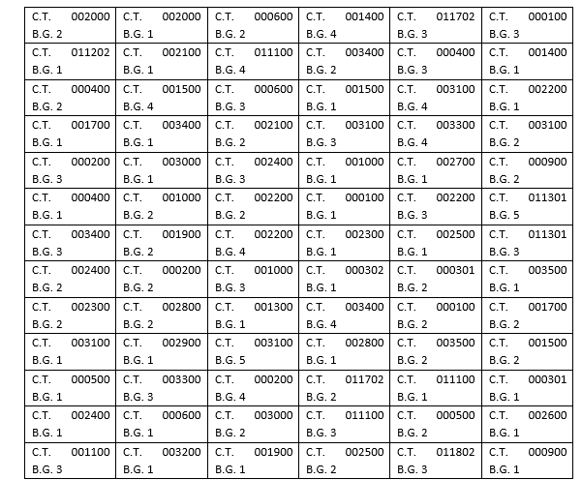
Block Groups with Greater Than 51% Low-Moderate Population

MA-60 Broadband Needs of Housing occupied by Low- and Moderate-Income Households - 91.210(a)(4), 91.310(a)(2)
Describe the need for broadband wiring and connections for households, including low- and moderate-income households and neighborhoods.
The City of South Bend has broadband trunks that run underneath the downtown of the City. The broadband trunks do not extend to the neighborhoods outside of downtown, where low- and moderate-income residents are concentrated. The City of South Bend intends to close the digital divide in the City by providing broadband access in the community centers in the peripheral neighborhoods of the City.
Describe the need for increased competition by having more than one broadband Internet service provider serve the jurisdiction.
St. Joseph County has fostered competition by providing public broadband options at St. Joseph County Public Library branches. In 2013, the Cities of South Bend and Mishawaka, as well as St. Joseph County invested in the installation of broadband fiber in the region through an in-state internet provider.

MA-65 Hazard Mitigation - 91.210(a)(5), 91.310(a)(3)
Describe the jurisdiction’s increased natural hazard risks associated with climate change.
St. Joseph County’s Emergency Management Plan identifies the major coordinating agencies and mitigation and response tasks in the event of an emergency in the County. The plan was last updated in 2006. Potential hazards include civil disorders, drought, earthquakes, energy emergencies, floods, hazardous materials, nuclear attack threats, pipeline ruptures or explosions, terrorist incidents, tornados or severe storms, transportation incidents, water shortages, and winter storms. Many of these additional disasters are associated with the risk of climate change. South Bend’s Mayor’s Office, Fire Department, and Public Information Office are integral to all of these responses.
Describe the vulnerability to these risks of housing occupied by low- and moderate-income households based on an analysis of data, findings, and methods.
Flood zones in the City of South Bend have been largely converted to park space or industrial land. Though some vulnerable areas of the City are in the low- and moderate-income Southwest neighborhood, these are a small portion of the City’s low- and moderate-income homes.

Strategic Plan

SP-05 Overview
Strategic Plan Overview
This is the City of South Bend’s and the St. Joseph County Housing Consortium’s First Year of funding under their new Five Year Consolidated Plan for FY 2020-2024. The "Vision" of the Five Year Consolidated Plan is to serve as a consolidated planning document, an application, and a strategic plan for the St. Joseph County Housing Consortium and the City of South Bend. As part of the Five Year Consolidated Plan, the community has developed goals and objectives. The following strategies with subsequent goals and priorities have been identified for the St. Joseph County Housing Consortium and the City of South Bend for the period of FY 2020 through FY 2024 for the use of the Community Development Block Grant (CDBG) Program, the HOME Investment Partnership (HOME) Program, and the Emergency Solutions Grant (ESG) Program:
HOUSING STRATEGY - HSS
Goal:
Improve, preserve, and expand the supply of affordable housing for low- and moderate-income persons and families in the cities of South Bend and Mishawaka, and the unincorporated areas of St. Joseph County.
Objectives:
- HSS-1 Homeownership Assistance - Promote and assist in developing homeownership opportunities for low- and moderate-income persons & families.
- HSS-2 Housing Construction - Promote and assist in the development of new affordable housing, both rental and sales housing.
- HSS-3 Housing Rehabilitation - Promote and assist in the preservation of existing owner and renter occupied housing stock in St. Joseph County.
- HSS-4 Fair Housing - Affirmatively further fair housing by promoting fair housing choice throughout St. Joseph County.
- HSS-5 Lead-Based Paint - Promote and assist in addressing lead-based paint in owner and renter occupied housing stock in St. Joseph County.
- HSS-6 Housing Education - Promote and assist in educating homeowners, tenants, and new homebuyers in best practices for purchase and upkeep, affordable housing rentals, and foreclosure and eviction prevention.
- HSS-7 Rental Assistance - Provide funds for tenant based rental assistance to make housing affordable to low- and moderate-income persons and families.
The City of South Bend, in addition to the overall Housing Strategies of the St. Joseph County Housing Consortium, proposes the following additional strategies for its Community Development Block Grant (CDBG) Program and Emergency Solutions Grant (ESG) Program:
HOMELESS STRATEGY - HOM
Goal:
Improve the living conditions and services for homeless persons and families in the City of South Bend.
Objectives:
- HOM-1 Housing - Promote and assist in developing housing opportunities for homeless persons and families, and those who are at-risk of becoming homeless.
- HOM-2 Operations/Support - Promote and assist in program support services for the homeless.
- HOM-3 Homeless Prevention - Promote and assist in anti-eviction and prevention of unfair housing practices which may contribute to homelessness.
- HOM-4 Permanent Supportive Housing - Promote and assist in the development and supportive service provisions of permanent supportive housing options.
- HOM-5 Shelter Housing - Support and assist in the development and operations of shelters for persons who are homeless or victims of domestic violence.
SPECIAL NEEDS STRATEGY - SNS
Goal:
Improve, preserve, and expand facilities for persons with special needs and the disabled in the City of South Bend.
Objectives:
- SNS-1 Housing - Promote and assist to increase the supply of affordable, decent, safe, sound, and accessible housing for the elderly, persons with disabilities, and persons with other special needs through rehabilitation of existing housing and new construction of accessible housing.
- SNS-2 Social Services - Promote and assist in supporting social service programs and facilities for the elderly, persons with disabilities, and persons with other special needs.
- SNS-3 Accessibility - Promote and assist in making accessibility improvements to owner occupied housing through rehabilitation and improve renter occupied housing by promoting reasonable accommodations for the physically disabled.
HOUSING STRATEGY - HSS
Goal:
Improve, preserve, and expand the supply of affordable housing for low- and moderate-income persons and families in the City of South Bend.
Objectives:
- HSS-1 Homeownership Assistance - Promote and assist in developing homeownership opportunities for low- and moderate-income persons & families.
- HSS-2 Housing Construction - Promote and assist in the development of new affordable housing, both rental and sales housing.
- HSS-3 Housing Rehabilitation - Promote and assist in the preservation of existing owner and renter occupied housing stock in the City of South Bend.
- HSS-4 Fair Housing - Affirmatively further fair housing by promoting fair housing choice throughout the City of South Bend.
- HSS-5 Lead-Based Paint - Promote and assist in addressing lead-based paint in owner and renter occupied housing stock in the City of South Bend.
- HSS-6 Housing Education - Promote and assist in educating homeowners, tenants, and new homebuyers in best practices for purchase and upkeep, affordable housing rentals, and foreclosure and eviction prevention.
- HSS-7 Rental Assistance - Provide funds for tenant based rental assistance to make housing affordable to low- and moderate-income persons and families.
COMMUNITY DEVELOPMENT STRATEGY - CDS
Goal:
Improve, preserve, and create new public and community facilities, infrastructure, and public services to ensure the quality of life for all residents of the City of South Bend.
Objectives:
- CDS-1 Infrastructure - Improve the City’s infrastructure through rehabilitation, reconstruction, and new construction of streets, walks, curbs, ADA ramps, retaining walls, sewer, linear lines, water, flood control, storm water management and separation, bridges, bike trails, green infrastructure, etc.
- CDS-2 Community Facilities - Improve the City's parks, recreational centers, and public and community facilities through rehabilitation and new construction.
- CDS-3 Public Services - Improve and increase public service programs for the youth, the elderly, disabled, and target income population, including feeding programs and social/welfare programs throughout the City.
- CDS-4 Public Transit - Promote the development of additional bus routes and improve public transportation for low- and moderate-income persons.
- CDS-5 Clearance - Remove and eliminate slum and blighting conditions through demolition of vacant and abandoned structures throughout the City.
- CDS-6 Architectural Barriers - Remove architectural barriers and make public and community facilities accessible.
- CDS-7 Public Safety - Improve public safety through upgrades to facilities, purchase of new equipment, crime prevention, community policing, and ability to respond to emergency situations.
- CDS-8 Revitalization - Promote and assist in the stabilization of residential neighborhoods by removing slums and blight, assembling sites for new housing, rehabilitation of existing housing, and code enforcement.
- CDS-9 Neighborhood Organizations - Improve capacity and encourage grassroots organizing and neighborhood development by neighborhood residents.
ECONOMIC DEVELOPMENT STRATEGY - EDS
Goal:
Increase and promote job creation, job retention, self-sufficiency, education, job training, technical assistance, and economic empowerment of low- and moderate-income residents of the City of South Bend.
Objectives:
- EDS-1 Employment - Support and encourage new job creation, job retention, employment, and job training services.
- EDS-2 Financial Assistance - Support business and commercial growth through expansion and new development with technical assistance and low interest loan programs.
- EDS-3 Development Program - Plan and promote the development and reuse of vacant commercial and industrial sites, and facilities.
- EDS-4 Financial Incentives - Support and encourage new economic development through local, state and Federal tax incentives and programs.
ADMINISTRATION, PLANNING, AND MANAGEMENT STRATEGY - APM
Goal:
Provide sound and professional planning, administration, oversight and management of federally funded programs.
Objectives:
- APM-1 Management - Continue to provide sound and professional planning, program management and oversight for the successful administration of federally funded programs.
- APM-2 Planning - Continue to develop and plan for special studies, environmental clearance, fair housing, and compliance with all Federal, state, and local laws and regulations.

SP-10 Geographic Priorities - 91.415, 91.215(a)(1)
Geographic Area
Table 52 - Geographic Priority Areas
1 | Area Name: | Low- and Moderate-Income Areas
 | Area Type: | Local Target area
 | Other Target Area Description:
 | HUD Approval Date:
 | % of Low/ Mod:
 | Revital Type: | Other
 | Other Revital Description: | Low- and Moderate-Income Areas
 | Identify the neighborhood boundaries for this target area.
 | Include specific housing and commercial characteristics of this target area.
 | How did your consultation and citizen participation process help you to identify this neighborhood as a target area?
 | Identify the needs in this target area.
 | What are the opportunities for improvement in this target area?
 | Are there barriers to improvement in this target area?

General Allocation Priorities
Describe the basis for allocating investments geographically within the state
The City of South Bend has allocated its CDBG funds for FY 2020 to principally benefit low- and moderate-income persons.
- The housing activities are either located in a low- and moderate-income census tract/block group or have a low- and moderate-income service area benefit or a clientele with over 51% low- and moderate-income.
- The public facilities activities are either located in a low- and moderate-income C.T./B.G. area, have a low- and moderate-income service area benefit, or limited clientele who are presumed to be low- and moderate-income.

The proposed activities and projects for FY 2020 are located in areas of the City with the highest percentages of low- and moderate-income persons, and those block groups with a higher than average percentage of minority persons. The following census tracts and block groups have at least 51% of the households with low- and moderate-incomes:

Block Groups with Greater Than 51% Low-Moderate Population

SP-25 Priority Needs - 91.415, 91.215(a)(2)
Priority Needs
Table 53 – Priority Needs Summary
1 | Priority Need Name | Housing Priority
 | Priority Level | High
 | Population | Extremely Low  Low  Moderate  Large Families  Families with Children  Elderly  Public Housing Residents  Rural  Chronic Homelessness  Individuals  Families with Children  Mentally Ill  Chronic Substance Abuse  veterans  Persons with HIV/AIDS  Victims of Domestic Violence  Unaccompanied Youth  Elderly  Frail Elderly  Persons with Mental Disabilities  Persons with Physical Disabilities  Persons with Developmental Disabilities  Persons with Alcohol or Other Addictions  Persons with HIV/AIDS and their Families  Victims of Domestic Violence  Non-housing Community Development
 | Geographic Areas Affected | Low- and Moderate-Income Areas
 | Associated Goals | HSS-1 Homeownership Assistance  HSS-2 Housing Construction  HSS-3 Housing Rehabilitation  HSS-4 Fair Housing  HSS-5 Lead-Based Paint  HSS-6 Housing Education  HSS-7 Rental Assistance
 | Description | Improve, preserve, and expand the supply of affordable housing for low- and moderate-income persons and families in the cities of South Bend and Mishawaka, and the unincorporated areas of St. Joseph County.
 | Basis for Relative Priority | There is a need for affordable, accessible, decent housing in the cities of South Bend and Mishawaka and the unincorporated areas of St. Joseph County. There is a need to increase the quality of the housing stock in both cities and the County for renters, homeowners, and homebuyers.
2 | Priority Need Name | Homeless Priority
 | Priority Level | High
 | Population | Extremely Low  Low  Moderate  Large Families  Families with Children  Elderly  Rural  Chronic Homelessness  Individuals  Families with Children  Mentally Ill  Chronic Substance Abuse  veterans  Persons with HIV/AIDS  Victims of Domestic Violence  Unaccompanied Youth
 | Geographic Areas Affected | Low- and Moderate-Income Areas
 | Associated Goals | HOM-1 Housing  HOM-2 Operation/Support  HOM-3 Homeless Prevention  HOM-4 Permanent Supportive Housing  HOM-5 Shelter Housing
 | Description | Improve the living conditions and services for homeless persons and families in the City of South Bend.
 | Basis for Relative Priority | There is a need to assist the homeless by providing housing, counseling, and other services in the City of South Bend.
3 | Priority Need Name | Other Special Needs Priority
 | Priority Level | Low
 | Population | Extremely Low  Low  Moderate  Large Families  Families with Children  Elderly  Chronic Homelessness  Individuals  Families with Children  Mentally Ill  Chronic Substance Abuse  veterans  Persons with HIV/AIDS  Victims of Domestic Violence  Unaccompanied Youth
 | Geographic Areas Affected | Low- and Moderate-Income Areas
 | Associated Goals | SNS-1 Housing  SNS-2 Social Services  SNS-3 Accessiblity
 | Description | Improve, preserve, and expand facilities for persons with special needs and the disabled in the City of South Bend.
 | Basis for Relative Priority | There is a need to assist persons with special needs by expanding facilities and services for individuals with disabilities, the elderly, and other persons who have special needs.
4 | Priority Need Name | Community Development Priority
 | Priority Level | High
 | Population | Extremely Low  Low  Moderate  Middle  Large Families  Families with Children  Elderly  Public Housing Residents  Chronic Homelessness  Individuals  Families with Children  Mentally Ill  Chronic Substance Abuse  veterans  Persons with HIV/AIDS  Victims of Domestic Violence  Unaccompanied Youth  Elderly  Frail Elderly  Persons with Mental Disabilities  Persons with Physical Disabilities  Persons with Developmental Disabilities  Persons with Alcohol or Other Addictions  Persons with HIV/AIDS and their Families  Victims of Domestic Violence  Non-housing Community Development
 | Geographic Areas Affected | Low- and Moderate-Income Areas
 | Associated Goals | CDS-1 Infrastructure  CDS-2 Community Facilities  CDS-3 Public Service  CDS-4 Public Transit  CDS-5 Clearance  CDS-6 Architectural Barriers  CDS-7 Public Safety  CDS-8 Revitalization  CDS-9 Neighborhood Organizations
 | Description | Improve, preserve, and create new public and community facilities, infrastructure, and public services to ensure the quality of life for all residents of the City of South Bend.
 | Basis for Relative Priority | There is a need to improve public and community facilities, infrastructure, public transit, public services, public safety, and the quality of life in the City of South Bend.
5 | Priority Need Name | Economic Development Priority
 | Priority Level | High
 | Population | Extremely Low  Low  Moderate  Large Families  Families with Children  Elderly  Public Housing Residents  Chronic Homelessness  Individuals  Families with Children  Mentally Ill  Chronic Substance Abuse  veterans  Persons with HIV/AIDS  Victims of Domestic Violence  Unaccompanied Youth  Non-housing Community Development
 | Geographic Areas Affected | Low- and Moderate-Income Areas
 | Associated Goals | EDS-1 Employment  EDS-2 Financial Assistance  EDS-3 Development Program  EDS-4 Financial Incentives
 | Description | Increase and promote job creation, job retention, self-sufficiency, education, job training, technical assistance, and economic empowerment of low- and moderate-income residents of the City of South Bend.
 | Basis for Relative Priority | There is a need to increase employment, self-sufficiency, education, job training, technical assistance, and economic empowerment of the residents of the City of South Bend.
6 | Priority Need Name | Administration, Planning, and Management Priority
 | Priority Level | High
 | Population | Extremely Low  Low  Moderate  Middle  Large Families  Families with Children  Elderly  Public Housing Residents  Rural  Chronic Homelessness  Individuals  Families with Children  Mentally Ill  Chronic Substance Abuse  veterans  Persons with HIV/AIDS  Victims of Domestic Violence  Unaccompanied Youth  Elderly  Frail Elderly  Persons with Mental Disabilities  Persons with Physical Disabilities  Persons with Developmental Disabilities  Persons with Alcohol or Other Addictions  Persons with HIV/AIDS and their Families  Victims of Domestic Violence  Non-housing Community Development
 | Geographic Areas Affected | Low- and Moderate-Income Areas
 | Associated Goals | APM-1 Management  APM-2 Planning
 | Description | Provide sound and professional planning, administration, oversight and management of federally funded programs.
 | Basis for Relative Priority | There is a continuing need for planning, administration, management, and oversight of federally funded programs.

Narrative (Optional)
The priority ranking of needs for housing; homelessness; other special needs; community development; economic development; and administration, planning, and management are as follows:
- High Priority - Activities are assigned a high priority if the City expects to fund them during the Five Year Consolidated Plan period.
- Low Priority - Activities are assigned a low priority if the activity may not be funded by the City during the Five Year Consolidated Plan period. The City may support applications for other funding if those activities are consistent with the needs identified in the Five Year Consolidated Plan.

SP-30 Influence of Market Conditions - 91.415, 91.215(b)
Influence of Market Conditions
Affordable Housing Type | Market Characteristics that will influence  the use of funds available for housing type
Tenant Based Rental Assistance (TBRA) | The St. Joseph County Housing Consortium provides Tenant Based Rental Assistance to residents that could potentially face evictions. The eviction rate in the City of South Bend remains high. TBRA keeps tenants in their homes and promotes stability within neighborhoods.
TBRA for Non-Homeless Special Needs | The St. Joseph County Housing Consortium provides Tenant Based Rental Assistance to residents that could potentially face evictions. The eviction rate in the City of South Bend remains high. TBRA keeps tenants in their homes and promotes stability within neighborhoods.
New Unit Production | There is a need for infill housing in St. Joseph County, particularly on the vacant lots throughout the City of South Bend. The City needs affordable, accessible, decent, safe, and sanitary housing.
Rehabilitation | There is a demand in St. Joseph County to provide rehabilitation assistance. The County and the Cities of South Bend and Mishawaka need affordable, accessible, decent, safe, and sanitary housing that could be accomplished through rehabilitation.
Acquisition, including preservation | The St. Joseph County Housing Consortium has no need for acquisition. The City of South Bend has previously acquired vacant lots and is in the process of determining re-uses for the lots.
Table 54 – Influence of Market Conditions

SP-35 Anticipated Resources - 91.420(b), 91.215(a)(4), 91.220(c)(1,2)
Introduction
The St. Joseph County Housing Consortium anticipates receiving $1,008,377 in HOME funds in PY 2020, $393,455 in Program Income, and $488,995 in prior year funds for a total of $1,890,827. The City of South Bend anticipates receiving $2,534,797 in CDBG funds, $339,794 in program income, and $339,794 in prior year funds for a total of $3,150,111. $218,253 in ESG funds in PY 2020. The program year is from January 1, 2020 through December 31, 2020. These funds will be used to address the following priority needs:
- Housing
- Public Services
- Public Facilities
- Emergency Shelter Operations
- Rapid Rehousing
- Economic Development
- Administration, Planning, and Management
The accomplishments of these projects/activities will be reported in the FY 2020 Consolidated Annual Performance and Evaluation Report (CAPER).
Anticipated Resources
Program | Source of Funds | Uses of Funds | Expected Amount Available Year 1 |  |  |  | Expected Amount Available Remainder of ConPlan  $ | Narrative Description
 |  |  | Annual Allocation: $ | Program Income: $ | Prior Year Resources: $ | Total:  $
CDBG | public - federal | Acquisition  Admin and Planning  Economic Development  Housing  Public Improvements  Public Services | 2,534,797 | 339,794 | 275,520 | 3,150,111 | 10,139,188 | All activities receiving South Bend's CDBG funding generally target specific and complementary geographies and activities. In 2020 South Bend will continue targeting the Near Northwest, Near West Side, and Southeast Neighborhoods through partnerships with three CDCs. These areas show relatively low incomes and high concentrations of poverty, high rates of residential vacancy and abandonment, and a high incidence of sub-prime loans. The target areas were also selected for review in the CityÃ¿Â¿Ã¿Â¿Ã¿Â¿Ã¿Â¿Ã¿Â¿Ã¿Â¿Ã¿Â¿Ã¿Â¿Ã¿Â¿Ã¿Â¿Ã¿Â¿Ã¿Â¿Ã¿Â¿Ã¿Â¿Ã¿Â¿Ã¿Â¿Ã¿Â¿Ã¿Â¿Ã¿Â¿Ã¿Â¿Ã¿Â¿Ã¿Â¿Ã¿Â¿Ã¿Â¿Ã¿Â¿Ã¿Â¿Ã¿Â¿Ã¿Â¿Ã¿Â¿Ã¿Â¿Ã¿Â¿Ã¿Â¿Ã¿Â¿Ã¿Â¿Ã¿Â¿Ã¿Â¿Ã¿Â¿Ã¿Â¿Ã¿Â¿Ã¿Â¿Ã¿Â¿Ã¿Â¿Ã¿Â¿Ã¿Â¿Ã¿Â¿Ã¿Â¿Ã¿Â¿Ã¿Â¿Ã¿Â¿Ã¿Â¿Ã¿Â¿Ã¿Â¿Ã¿Â¿Ã¿Â¿Ã¿Â¿Ã¿Â¿Ã¿Â¿Ã¿Â¿Ã¿Â¿Ã¿Â¿Ã¿Â¿Ã¿Â¿Ã¿Â¿Ã¿Â¿Ã¿Â¿Ã¿Â¿Ã¿Â¿Ã¿Â¿Ã¿Â¿Ã¿Â¿Ã¿Â¿Ã¿Â¿Ã¿Â¿Ã¿Â¿Ã¿Â¿Ã¿Â¿Ã¿Â¿Ã¿Â¿Ã¿Â¿Ã¿Â¿Ã¿Â¿Ã¿Â¿Ã¿Â¿Ã¿Â¿Ã¿Â¿Ã¿Â¿Ã¿Â¿Ã¿Â¿Ã¿Â¿Ã¿Â¿Ã¿Â¿Ã¿Â¿Ã¿Â¿Ã¿Â¿Ã¿Â¿Ã¿Â¿Ã¿Â¿Ã¿Â¿Ã¿Â¿Ã¿Â¿Ã¿Â¿Ã¿Â¿Ã¿Â¿Ã¿Â¿Ã¿Â¿Ã¿Â¿Ã¿Â¿Ã¿Â¿Ã¿Â¿Ã¿Â¿Ã¿Â¿Ã¿Â¿Ã¿Â¿Ã¿Â¿Ã¿Â¿Ã¿Â¿Ã¿Â¿Ã¿Â¿Ã¿Â¿Ã¿Â¿Ã¿Â¿Ã¿Â¿Ã¿Â¿Ã¿Â¿Ã¿Â¿Ã¿Â¿Ã¿Â¿Ã¿Â¿Ã¿Â¿Ã¿Â¿Ã¿Â¿Ã¿Â¿Ã¿Â¿Ã¿Â¿Ã¿Â¿Ã¿Â¿Ã¿Â¿Ã¿Â¿Ã¿Â¿Ã¿Â¿Ã¿Â¿Ã¿Â¿Ã¿Â¿Ã¿Â¿Ã¿Â¿Ã¿Â¿Ã¿Â¿Ã¿Â¿Ã¿Â¿Ã¿Â¿Ã¿Â¿Ã¿Â¿Ã¿Â¿Ã¿Â¿Ã¿Â¿Ã¿Â¿Ã¿Â¿Ã¿Â¿Ã¿Â¿Ã¿Â¿Ã¿Â¿Ã¿Â¿Ã¿Â¿Ã¿Â¿Ã¿Â¿Ã¿Â¿Ã¿Â¿Ã¿Â¿Ã¿Â¿Ã¿Â¿Ã¿Â¿Ã¿Â¿Ã¿Â¿Ã¿Â¿Ã¿Â¿Ã¿Â¿Ã¿Â¿Ã¿Â¿Ã¿Â¿Ã¿Â¿Ã¿Â¿Ã¿Â¿Ã¿Â¿Ã¿Â¿Ã¿Â¿Ã¿Â¿Ã¿Â¿Ã¿Â¿Ã¿Â¿Ã¿Â¿Ã¿Â¿Ã¿Â¿Ã¿Â¿Ã¿Â¿Ã¿Â¿Ã¿Â¿Ã¿Â¿Ã¿Â¿Ã¿Â¿Ã¿Â¿Ã¿Â¿Ã¿Â¿Ã¿Â¿Ã¿Â¿Ã¿Â¿Ã¿Â¿Ã¿Â¿Ã¿Â¿Ã¿Â¿Ã¿Â¿Ã¿Â¿Ã¿Â¿Ã¿Â¿Ã¿Â¿Ã¿Â¿Ã¿Â¿Ã¿Â¿Ã¿Â¿Ã¿Â¿Ã¿Â¿Ã¿Â¿Ã¿Â¿Ã¿Â¿Ã¿Â¿Ã¿Â¿Ã¿Â¿Ã¿Â¿Ã¿Â¿Ã¿Â¿Ã¿Â¿Ã¿Â¿Ã¿Â¿Ã¿Â¿Ã¿Â¿Ã¿Â¿Ã¿Â¿Ã¿Â¿Ã¿Â¿Ã¿Â¿Ã¿Â¿Ã¿Â¿Ã¿Â¿Ã¿Â¿Ã¿Â¿Ã¿Â¿Ã¿Â¿Ã¿Â¿Ã¿Â¿Ã¿Â¿Ã¿Â¿Ã¿Â¿Ã¿Â¿Ã¿Â¿Ã¿Â¿Ã¿Â¿Ã¿Â¢Ã¿Â¿Ã¿Â¿Ã¿Â¿Ã¿Â¿Ã¿Â¿Ã¿Â¿Ã¿Â¿Ã¿Â¿Ã¿Â¿Ã¿Â¿Ã¿Â¿Ã¿Â¿Ã¿Â¿Ã¿Â¿Ã¿Â¿Ã¿Â¿Ã¿Â¿Ã¿Â¿Ã¿Â¿Ã¿Â¿Ã¿Â¿Ã¿Â¿Ã¿Â¿Ã¿Â¿Ã¿Â¿Ã¿Â¿Ã¿Â¿Ã¿Â¿Ã¿Â¿Ã¿Â¿Ã¿Â¿Ã¿Â¿Ã¿Â¿Ã¿Â¿Ã¿Â¿Ã¿Â¿Ã¿Â¿Ã¿Â¿Ã¿Â¿Ã¿Â¿Ã¿Â¿Ã¿Â¿Ã¿Â¿Ã¿Â¿Ã¿Â¿Ã¿Â¿Ã¿Â¿Ã¿Â¿Ã¿Â¿Ã¿Â¿Ã¿Â¿Ã¿Â¿Ã¿Â¿Ã¿Â¿Ã¿Â¿Ã¿Â¿Ã¿Â¿Ã¿Â¿Ã¿Â¿Ã¿Â¿Ã¿Â¿Ã¿Â¿Ã¿Â¿Ã¿Â¿Ã¿Â¿Ã¿Â¿Ã¿Â¿Ã¿Â¿Ã¿Â¿Ã¿Â¿Ã¿Â¿Ã¿Â¿Ã¿Â¿Ã¿Â¿Ã¿Â¿Ã¿Â¿Ã¿Â¿Ã¿Â¿Ã¿Â¿Ã¿Â¿Ã¿Â¿Ã¿Â¿Ã¿Â¿Ã¿Â¿Ã¿Â¿Ã¿Â¿Ã¿Â¿Ã¿Â¿Ã¿Â¿Ã¿Â¿Ã¿Â¿Ã¿Â¿Ã¿Â¿Ã¿Â¿Ã¿Â¿Ã¿Â¿Ã¿Â¿Ã¿Â¿Ã¿Â¿Ã¿Â¿Ã¿Â¿Ã¿Â¿Ã¿Â¿Ã¿Â¿Ã¿Â¿Ã¿Â¿Ã¿Â¿Ã¿Â¿Ã¿Â¿Ã¿Â¿Ã¿Â¿Ã¿Â¿Ã¿Â¿Ã¿Â¿Ã¿Â¿Ã¿Â¿Ã¿Â¿Ã¿Â¿Ã¿Â¿Ã¿Â¿Ã¿Â¿Ã¿Â¿Ã¿Â¿Ã¿Â¿Ã¿Â¿Ã¿Â¿Ã¿Â¿Ã¿Â¿Ã¿Â¿Ã¿Â¿Ã¿Â¿Ã¿Â¿Ã¿Â¿Ã¿Â¿Ã¿Â¿Ã¿Â¿Ã¿Â¿Ã¿Â¿Ã¿Â¿Ã¿Â¿Ã¿Â¿Ã¿Â¿Ã¿Â¿Ã¿Â¿Ã¿Â¿Ã¿Â¿Ã¿Â¿Ã¿Â¿Ã¿Â¿Ã¿Â¿Ã¿Â¿Ã¿Â¿Ã¿Â¿Ã¿Â¿Ã¿Â¿Ã¿Â¿Ã¿Â¿Ã¿Â¿Ã¿Â¿Ã¿Â¿Ã¿Â¿Ã¿Â¿Ã¿Â¿Ã¿Â¿Ã¿Â¿Ã¿Â¿Ã¿Â¿Ã¿Â¿Ã¿Â¿Ã¿Â¿Ã¿Â¿Ã¿Â¿Ã¿Â¿Ã¿Â¿Ã¿Â¿Ã¿Â¿Ã¿Â¿Ã¿Â¿Ã¿Â¿Ã¿Â¿Ã¿Â¿Ã¿Â¿Ã¿Â¿Ã¿Â¿Ã¿Â¿Ã¿Â¿Ã¿Â¿Ã¿Â¿Ã¿Â¿Ã¿Â¿Ã¿Â¿Ã¿Â¿Ã¿Â¿Ã¿Â¿Ã¿Â¿Ã¿Â¿Ã¿Â¿Ã¿Â¿Ã¿Â¿Ã¿Â¿Ã¿Â¿Ã¿Â¿Ã¿Â¿Ã¿Â¿Ã¿Â¿Ã¿Â¿Ã¿Â¿Ã¿Â¿Ã¿Â¿Ã¿Â¿Ã¿Â¿Ã¿Â¿Ã¿Â¿Ã¿Â¿Ã¿Â¿Ã¿Â¿Ã¿Â¿Ã¿Â¿Ã¿Â¿Ã¿Â¿Ã¿Â¿Ã¿Â¿Ã¿Â¿Ã¿Â¿Ã¿Â¿Ã¿Â¿Ã¿Â¿Ã¿Â¿Ã¿Â¿Ã¿Â¿Ã¿Â¿Ã¿Â¿Ã¿Â¿Ã¿Â¿Ã¿Â¿Ã¿Â¿Ã¿Â¿Ã¿Â¿Ã¿Â¿Ã¿Â¿Ã¿Â¿Ã¿Â¿Ã¿Â¿Ã¿Â¿Ã¿Â¿Ã¿Â¿Ã¿Â¿Ã¿Â¿Ã¿Â¿Ã¿Â¿Ã¿Â¿Ã¿Â¿Ã¿Â¿Ã¿Â¿Ã¿Â¿Ã¿Â¿Ã¿Â¿Ã¿Â¿Ã¿Â¿Ã¿Â¿Ã¿Â¿Ã¿Â¿Ã¿Â¿Ã¿Â¿Ã¿Â¿Ã¿Â¿Ã¿Â¿Ã¿Â¿Ã¿Â¿Ã¿Â¿Ã¿Â¿Ã¿Â¿Ã¿Â¿Ã¿Â¿Ã¿Â¿Ã¿Â¿Ã¿Â¿Ã¿Â¿Ã¿Â¿Ã¿Â¿Ã¿Â¿Ã¿Â¿Ã¿Â¿Ã¿Â¿Ã¿Â¿Ã¿Â¿Ã¿Â¿Ã¿Â¿Ã¿Â¿Ã¿Â¿Ã¿Â¿Ã¿Â¿Ã¿Â¿Ã¿Â¿Ã¿Â¿Ã¿Â¿Ã¿Â¿Ã¿Â¿Ã¿Â¿Ã¿Â¿Ã¿Â¿Ã¿Â¿Ã¿Â¿Ã¿Â¿Ã¿Â¿Ã¿Â¿Ã¿Â¿Ã¿Â¿Ã¿Â¿Ã¿Â¿Ã¿Â¿Ã¿Â¿Ã¿Â¿Ã¿Â¿Ã¿Â¿Ã¿Â¿Ã¿Â¿Ã¿Â¿Ã¿Â¿Ã¿Â¿Ã¿Â¿Ã¿Â¿Ã¿Â¿Ã¿Â¿Ã¿Â¿Ã¿Â¿Ã¿Â¿Ã¿Â¿Ã¿Â¿Ã¿Â¿Ã¿Â¿Ã¿Â¿Ã¿Â¿Ã¿Â¿Ã¿Â¿Ã¿Â¿Ã¿Â¿Ã¿Â¿Ã¿Â¿Ã¿Â¿Ã¿Â¿Ã¿Â¿Ã¿Â¿Ã¿Â¿Ã¿Â¿Ã¿Â¿Ã¿Â¿Ã¿Â¿Ã¿Â¿Ã¿Â¿Ã¿Â¿Ã¿Â¿Ã¿Â¿Ã¿Â¿Ã¿Â¿Ã¿Â¿Ã¿Â¿Ã¿Â¿Ã¿Â¿Ã¿Â¿Ã¿Â¿Ã¿Â¿Ã¿Â¿Ã¿Â¿Ã¿Â¿Ã¿Â¿Ã¿Â¿Ã¿Â¿Ã¿Â¿Ã¿Â¿Ã¿Â¿Ã¿Â¿Ã¿Â¿Ã¿Â¿Ã¿Â¿Ã¿Â¿Ã¿Â¿Ã¿Â¿Ã¿Â¿Ã¿Â¿Ã¿Â¿Ã¿Â¿Ã¿Â¿Ã¿Â¿Ã¿Â¿Ã¿Â¿Ã¿Â¿Ã¿Â¿Ã¿Â¿Ã¿Â¿Ã¿Â¿Ã¿Â¿Ã¿Â¿Ã¿Â¿Ã¿Â¿Ã¿Â¿Ã¿Â¿Ã¿Â¿Ã¿Â¿Ã¿Â¿Ã¿Â¿Ã¿Â¿Ã¿Â¿Ã¿Â¿Ã¿Â¿Ã¿Â¿Ã¿Â¿Ã¿Â¿Ã¿Â¿Ã¿Â¿Ã¿Â¿Ã¿Â¿Ã¿Â¿Ã¿Â¿Ã¿Â¿Ã¿Â¿Ã¿Â¿Ã¿Â¿Ã¿Â¿Ã¿Â¿Ã¿Â¿Ã¿Â¿Ã¿Â¿Ã¿Â¿Ã¿Â¿Ã¿Â¿Ã¿Â¿Ã¿Â¿Ã¿Â¿Ã¿Â¿Ã¿Â¿Ã¿Â¿Ã¿Â¿Ã¿Â¿Ã¿Â¿Ã¿Â¿Ã¿Â¿Ã¿Â¿Ã¿Â¿Ã¿Â¿Ã¿Â¿Ã¿Â¿Ã¿Â¿Ã¿Â¿Ã¿Â¿Ã¿Â¿Ã¿Â¿Ã¿Â¿Ã¿Â¿Ã¿Â¿Ã¿Â¿Ã¿Â¿Ã¿Â¿Ã¿Â¿Ã¿Â¿Ã¿Â¿Ã¿Â¿Ã¿Â¿Ã¿Â¿Ã¿Â¿Ã¿Â¿Ã¿Â¿Ã¿Â¿Ã¿Â¿Ã¿Â¿Ã¿Â¿Ã¿Â¿Ã¿Â¿Ã¿Â¿Ã¿Â¿Ã¿Â¿Ã¿Â¿Ã¿Â¿Ã¿Â¿Ã¿Â¿Ã¿Â¿Ã¿Â¿Ã¿Â¿Ã¿Â¿Ã¿Â¿Ã¿Â¿Ã¿Â¿Ã¿Â¿Ã¿Â¿Ã¿Â¿Ã¿Â¿Ã¿Â¿Ã¿Â¿Ã¿Â¿Ã¿Â¿Ã¿Â¿Ã¿Â¿Ã¿Â¿Ã¿Â¿Ã¿Â¿Ã¿Â¿Ã¿Â¿Ã¿Â¿Ã¿Â¿Ã¿Â¿Ã¿Â¿Ã¿Â¿Ã¿Â¿Ã¿Â¿Ã¿Â¿Ã¿Â¿Ã¿Â¿Ã¿Â¿Ã¿Â¿Ã¿Â¿Ã¿Â¿Ã¿Â¿s 2017 Analysis of Residential Market Potential. These are neighborhoods that are seeing increased redevelopment activity and have greater market potential. Programs that assist existing owner-occupants with repairs and promote homeownership for first time homebuyers will target the LaSalle Park and Kennedy Park neighborhoods on the West Side of South Bend.
HOME | public - federal | Acquisition  Homebuyer assistance  Homeowner rehab  Multifamily rental new construction  Multifamily rental rehab  New construction for ownership  TBRA | 1,008,377 | 393,455 | 488,995 | 1,890,827 | 4,033,508 | 2020 HOME funding will support housing programs such as acquisition/rehabilitation/resale, new home construction, homeownership assistance, and tenant-based rental assistance throughout St. Joseph County. The HOME program will exceed the 25% match requirements through private funding, project sponsors and banked match.
ESG | public - federal | Conversion and rehab for transitional housing  Financial Assistance  Overnight shelter  Rapid re-housing (rental assistance)  Rental Assistance  Services  Transitional housing | 220,337 | 0 | 0 | 220,337 | 881,348 | Based on agreement with the St. Joseph County Regional Planning Council, 2020 ESG funding will be allocated as follows: up to 7.5% for program administration; no less than 32.5% for rapid re-housing; and, no more than 60% of funds will be spent on operations and essential services and for emergency shelters.
Table 55 - Anticipated Resources

Explain how federal funds will leverage those additional resources (private, state and local funds), including a description of how matching requirements will be satisfied
In addition to the entitlement funds, the St. Joseph County Housing Consortium and the City of South Bend anticipate the following Federal resources may be available to local non-profit organizations to undertake the housing strategies identified in the Five Year Consolidated Plan.
- Supportive Housing Program
- Low-Income Housing Tax Credit Program (LIHTC)
- Section 8 Rental Assistance Program
- Public Housing Capital Fund Program
Private and non-Federal resources that may be available to the St. Joseph County Housing Consortium and the City of South Bend in FY 2020 to address needs identified in the FY 2020-2024 Five Year Consolidated Plan are listed below.
- Private Banks & Credit Unions – The City partnership with local banks and credit unions to operate the Community Homebuyers Corporation. This program leverages private equity to assist low- and moderate-income individuals to purchase houses in which they may not be able to obtain a traditional mortgage.
- Indiana Housing & Community Development Authority – The IHDCA runs programs that assist individuals with first time homeownership and other housing purchases by providing funding for Veterans, rent-to-own, mortgage credits, and homebuyer subsidies.
- Department of Health & Human Services – Through the Family & Youth Service Bureau, the City of South Bend has leveraged funds through the Runaway and Homeless Youth Program to support street outreach, emergency shelters, longer-term transitional living, and maternity group home programs to serve and protect young people.
- Federal Home Loan Bank Affordable Housing Program (AHP) – Congress has mandated that ten (10%) of the Federal Home Loan Bank's (FHLB) profits be allocated to provide affordable housing. The FHLB encourages its members to work with public agencies and non-profit housing development organizations in creating highly leveraged affordable housing initiatives. Both sales and rental housing are eligible. Two (2) member banks of the Community Homebuyers Corporation are also member banks of the Federal Home Loan Bank.
If appropriate, describe publically owned land or property located within the jurisdiction that may be used to address the needs identified in the plan
Vacant City-owned lots targeted for infill housing in CDBG get areas, as well as low-moderate income neighborhoods throughout the City.
Discussion

SP-40 Institutional Delivery Structure - 91.415, 91.215(k)
Explain the institutional structure through which the jurisdiction will carry out its consolidated plan including private industry, non-profit organizations, and public institutions.
Responsible Entity | Responsible Entity Type | Role | Geographic Area Served
SOUTH BEND | Government | Planning | Jurisdiction
Housing Authority of South Bend | PHA | Public Housing  Rental | Jurisdiction
Indiana Balance of State CoC Region 2A | Continuum of care | Homelessness  Non-homeless special needs  Planning  Rental  public services | Region
Table 56 - Institutional Delivery Structure
Assess of Strengths and Gaps in the Institutional Delivery System
Persons with HIV/AIDS and their families comprise a small percentage of the County’s overall population. In 2018, it was estimated the 613 people were living with HIV/AIDS in St. Joseph County. Black and Hispanic or Latino residents of Indiana are more likely to be living with HIV/AIDS, and the prevalence of HIV/AIDS is much more common among males than females. There were 6 individuals with HIV/AIDS that were homeless according to the 2019 Point In Time Count.
AIDS Ministries/AIDS Assist (AMAA) works with local individuals with HIV/AIDS to provide care coordination and housing. AMAA receives ESG funding for Rapid Rehousing and emergency support services, and also provides Transitional Supportive Housing, state-based HOPWA housing, and permanent supportive housing. (AMAA) also conducts outreach.
The Center for the Homeless coordinates activities to assist homeless individuals and families in St. Joseph County and the City of South Bend. In addition to emergency and transitional shelters and permanent supportive housing, the Center for the Homeless provides adult self-sufficiency training, children’s support and developmental services, and mental health counseling to homeless persons in the area. They also partner with the Notre Dame Legal Clinic for legal representation for the homeless, though the Legal Clinic’s resources are limited.
Availability of services targeted to homeless persons and persons with HIV and mainstream services
Homelessness Prevention Services | Available in the Community | Targeted to Homeless | Targeted to People with HIV
Homelessness Prevention Services
Counseling/Advocacy | X
Legal Assistance | X | X
Mortgage Assistance | X
Rental Assistance | X | X
Utilities Assistance | X

Street Outreach Services
Law Enforcement
Mobile Clinics | X
Other Street Outreach Services | X | X

Supportive Services
Alcohol & Drug Abuse | X | X
Child Care | X | X
Education | X | X
Employment and Employment Training | X | X
Healthcare | X
HIV/AIDS | X | X | X
Life Skills | X | X
Mental Health Counseling | X | X
Transportation | X

Other
Table 57 - Homeless Prevention Services Summary
Describe how the service delivery system including, but not limited to, the services listed above meet the needs of homeless persons (particularly chronically homeless individuals and families, families with children, veterans and their families, and unaccompanied youth)
The following services are targeted to the homeless:
The Center for the Homeless assists in coordinating homeless individuals and families, and veterans, with services for adult self-sufficiency, children’s support, and developmental services, and mental health care. The Center for the Homeless has a Veteran’s Annex to assist this population. Life Treatment Centers assists in accommodating homeless Veterans, offering 24 beds.
AIDS Ministries/AIDS ASSIST has programs for education, which includes awareness and prevention of HIV/AIDS, testing, and the distribution of the PrEP pill to reduce the risk of HIV/AIDS in at-risk individuals. All programs are available to homeless individuals, and AMAA receives funding for housing for homeless individuals or individuals at-risk of homelessness.
Youth Service Bureau provides a variety of housing and outreach programs for area youth that are homeless or at-risk of homeless. These programs include street outreach, a drop-in center for intake, a young mothers’ program, and youth development services.
Oaklawn Psychiatric Center provides services for adults and children with mental health needs. Oaklawn conducts outreach for its targeted populations and has participated in the development of Coordinated Entry for St. Joseph County.
Describe the strengths and gaps of the service delivery system for special needs population and persons experiencing homelessness, including, but not limited to, the services listed above
Across all special needs populations and the homeless population, there is a need for permanent supportive housing in the region. Currently, services for these populations are not based in housing, but are located within the same Southeast Neighborhood and within walking distance of transitional and emergency shelters. Wraparound services tied to permanent supportive housing are ideal solutions as well.
According to the HMIS Coordinator for Region 2.a. of the Indiana Balance of State CoC, care for persons who recently became homeless in the area focuses on Rapid Rehousing solutions. Due to the high eviction rates in the City of South Bend, prevention may be more effective than Rapid Rehousing. There are additional barriers to placing households with evictions on their records into Rapid Rehousing. Eviction prevention programs can avoid these barriers. Individuals and families that have been evicted typically do not seek out services for the homeless immediately following eviction, but rely on personal connections first. There is a need to communicate that these services are targeted to this population.
Provide a summary of the strategy for overcoming gaps in the institutional structure and service delivery system for carrying out a strategy to address priority needs
The most effective way to overcome the gaps will be through the centralization of services, shelters, and housing. The proposed “Gateway Center” has the potential to act as a site for intake in supportive services and placement for the best possible housing for the individual or family. The center would function correctly if it is near the relevant supportive services, or if it is on a bus line to the services and provides funding for the transportation of these individuals and families.

SP-45 Goals - 91.415, 91.215(a)(4)
Goals Summary Information
Sort Order | Goal Name | Start Year | End Year | Category | Geographic Area | Needs Addressed | Funding | Goal Outcome Indicator
1 | HSS-1 Homeownership Assistance | 2020 | 2024 | Affordable Housing | Low- and Moderate-Income Areas | Housing Priority | CDBG: $1,298,392 | Homeowner Housing Added:  0 Household Housing Unit  Direct Financial Assistance to Homebuyers:  85 Households Assisted  Other:  0 Other
2 | HSS-2 Housing Construction | 2020 | 2024 | Affordable Housing | Low- and Moderate-Income Areas | Housing Priority | CDBG: $3,529,334 | Rental units constructed:  4 Household Housing Unit  Homeowner Housing Added:  21 Household Housing Unit  Other:  0 Other
3 | HSS-3 Housing Rehabilitation | 2020 | 2024 | Affordable Housing | Low- and Moderate-Income Areas | Housing Priority | CDBG: $3,987,385 | Rental units rehabilitated:  20 Household Housing Unit  Homeowner Housing Rehabilitated:  460 Household Housing Unit  Other:  0 Other
4 | HSS-4 Fair Housing | 2020 | 2024 | Affordable Housing | Low- and Moderate-Income Areas | Housing Priority | CDBG: $50,000 | Other:  5 Other
5 | HSS-5 Lead-Based Paint | 2020 | 2024 | Affordable Housing | Low- and Moderate-Income Areas | Housing Priority | CDBG: $0 | Rental units rehabilitated:  0 Household Housing Unit  Homeowner Housing Rehabilitated:  0 Household Housing Unit  Other:  0 Other
6 | HSS-6 Housing Education | 2020 | 2024 | Affordable Housing | Low- and Moderate-Income Areas | Housing Priority | CDBG: $324,196 | Public service activities for Low/Moderate Income Housing Benefit:  25 Households Assisted
7 | HSS-7 Rental Assistance | 2020 | 2024 | Affordable Housing | Low- and Moderate-Income Areas | Housing Priority | CDBG: $0  HOME: $0 | Tenant-based rental assistance / Rapid Rehousing:  0 Households Assisted  Other:  0 Other
8 | HOM-1 Housing | 2020 | 2024 | Homeless | Low- and Moderate-Income Areas | Homeless Priority | ESG: $661,011 | Homeless Person Overnight Shelter:  8515 Persons Assisted  Other:  0 Other
9 | HOM-2 Operation/Support | 2020 | 2024 | Homeless | Low- and Moderate-Income Areas | Homeless Priority | CDBG: $1,199,175  ESG: $440,674 | Public service activities other than Low/Moderate Income Housing Benefit:  11040 Persons Assisted  Other:  0 Other
10 | HOM-3 Homeless Prevention | 2020 | 2024 | Homeless | Low- and Moderate-Income Areas | Homeless Priority | CDBG: $0 | Homelessness Prevention:  0 Persons Assisted  Other:  0 Other
11 | HOM-4 Permanent Supportive Housing | 2020 | 2024 | Homeless | Low- and Moderate-Income Areas | Homeless Priority | HOME: $5,024,335 | Housing for Homeless added:  100 Household Housing Unit  Other:  0 Other
12 | HOM-5 Shelter Housing | 2020 | 2024 | Homeless | Low- and Moderate-Income Areas | Homeless Priority | CDBG: $0 | Homeless Person Overnight Shelter:  0 Persons Assisted  Other:  0 Other
13 | SNS-1 Housing | 2020 | 2024 | Non-Homeless Special Needs | Low- and Moderate-Income Areas | Other Special Needs Priority | HOME: $700,000 | Rental units constructed:  0 Household Housing Unit  Rental units rehabilitated:  0 Household Housing Unit  Homeowner Housing Added:  0 Household Housing Unit  Homeowner Housing Rehabilitated:  0 Household Housing Unit  Tenant-based rental assistance / Rapid Rehousing:  100 Households Assisted  Other:  0 Other
14 | SNS-2 Social Services | 2020 | 2024 | Non-Homeless Special Needs | Low- and Moderate-Income Areas | Other Special Needs Priority | CDBG: $0 | Public service activities other than Low/Moderate Income Housing Benefit:  0 Persons Assisted  Public service activities for Low/Moderate Income Housing Benefit:  0 Households Assisted  Other:  0 Other
15 | SNS-3 Accessiblity | 2020 | 2024 | Non-Homeless Special Needs | Low- and Moderate-Income Areas | Other Special Needs Priority | CDBG: $0 | Public Facility or Infrastructure Activities other than Low/Moderate Income Housing Benefit:  0 Persons Assisted  Public service activities other than Low/Moderate Income Housing Benefit:  0 Persons Assisted  Public service activities for Low/Moderate Income Housing Benefit:  0 Households Assisted  Rental units rehabilitated:  0 Household Housing Unit  Homeowner Housing Rehabilitated:  0 Household Housing Unit  Other:  0 Other
16 | CDS-1 Infrastructure | 2020 | 2024 | Non-Housing Community Development | Low- and Moderate-Income Areas | Community Development Priority | CDBG: $0 | Public Facility or Infrastructure Activities other than Low/Moderate Income Housing Benefit:  0 Persons Assisted  Public Facility or Infrastructure Activities for Low/Moderate Income Housing Benefit:  0 Households Assisted  Other:  0 Other
17 | CDS-2 Community Facilities | 2020 | 2024 | Non-Housing Community Development | Low- and Moderate-Income Areas | Community Development Priority | CDBG: $324,196 | Public Facility or Infrastructure Activities other than Low/Moderate Income Housing Benefit:  44950 Persons Assisted  Public Facility or Infrastructure Activities for Low/Moderate Income Housing Benefit:  0 Households Assisted  Other:  0 Other
18 | CDS-3 Public Service | 2020 | 2024 | Non-Housing Community Development | Low- and Moderate-Income Areas | Community Development Priority | CDBG: $0 | Public service activities other than Low/Moderate Income Housing Benefit:  0 Persons Assisted  Public service activities for Low/Moderate Income Housing Benefit:  0 Households Assisted  Other:  0 Other
19 | CDS-4 Public Transit | 2020 | 2024 | Non-Housing Community Development | Low- and Moderate-Income Areas | Community Development Priority | CDBG: $0 | Public Facility or Infrastructure Activities other than Low/Moderate Income Housing Benefit:  0 Persons Assisted  Public service activities other than Low/Moderate Income Housing Benefit:  0 Persons Assisted  Public service activities for Low/Moderate Income Housing Benefit:  0 Households Assisted  Other:  0 Other
20 | CDS-5 Clearance | 2020 | 2024 | Non-Housing Community Development | Low- and Moderate-Income Areas | Community Development Priority | CDBG: $0 | Buildings Demolished:  0 Buildings
21 | CDS-6 Architectural Barriers | 2020 | 2024 | Non-Housing Community Development | Low- and Moderate-Income Areas | Community Development Priority | CDBG: $0 | Public Facility or Infrastructure Activities other than Low/Moderate Income Housing Benefit:  0 Persons Assisted  Public Facility or Infrastructure Activities for Low/Moderate Income Housing Benefit:  0 Households Assisted  Other:  0 Other
22 | CDS-7 Public Safety | 2020 | 2024 | Non-Housing Community Development | Low- and Moderate-Income Areas | Community Development Priority | CDBG: $450,000 | Public service activities other than Low/Moderate Income Housing Benefit:  215000 Persons Assisted  Public service activities for Low/Moderate Income Housing Benefit:  0 Households Assisted  Other:  0 Other
23 | CDS-8 Revitalization | 2020 | 2024 | Non-Housing Community Development | Low- and Moderate-Income Areas | Community Development Priority | CDBG: $0 | Other:  0 Other
24 | CDS-9 Neighborhood Organizations | 2020 | 2024 | Non-Housing Community Development | Low- and Moderate-Income Areas | Community Development Priority | CDBG: $0 | Other:  0 Other
25 | EDS-1 Employment | 2020 | 2024 | Non-Housing Community Development | Low- and Moderate-Income Areas | Economic Development Priority | CDBG: $0 | Public service activities other than Low/Moderate Income Housing Benefit:  0 Persons Assisted  Jobs created/retained:  0 Jobs  Other:  0 Other
26 | EDS-2 Financial Assistance | 2020 | 2024 | Non-Housing Community Development | Low- and Moderate-Income Areas | Economic Development Priority | CDBG: $0 | Businesses assisted:  0 Businesses Assisted  Other:  0 Other
27 | EDS-3 Development Program | 2020 | 2024 | Non-Housing Community Development | Low- and Moderate-Income Areas | Economic Development Priority | CDBG: $0 | Facade treatment/business building rehabilitation:  0 Business  Other:  0 Other
28 | EDS-4 Financial Incentives | 2020 | 2024 | Non-Housing Community Development | Low- and Moderate-Income Areas | Economic Development Priority | CDBG: $0 | Businesses assisted:  0 Businesses Assisted  Other:  0 Other
29 | APM-1 Management | 2020 | 2024 | Administration | Low- and Moderate-Income Areas | Administration, Planning, and Management Priority | CDBG: $2,126,621  HOME: $200,000 | Other:  10 Other
30 | APM-2 Planning | 2020 | 2024 | Administration | Low- and Moderate-Income Areas | Administration, Planning, and Management Priority | CDBG: $0  HOME: $0 | Other:  0 Other
Table 58 – Goals Summary

Goal Descriptions

1 | Goal Name | HSS-1 Homeownership Assistance
 | Goal Description | Promote and assist in developing homeownership opportunities for low- and moderate-income persons & families.
2 | Goal Name | HSS-2 Housing Construction
 | Goal Description | Promote and assist in the development of new affordable housing, both rental and sales housing.
3 | Goal Name | HSS-3 Housing Rehabilitation
 | Goal Description | Promote and assist in the preservation of existing owner and renter occupied housing stock in the City of South Bend.
4 | Goal Name | HSS-4 Fair Housing
 | Goal Description | Affirmatively further fair housing by promoting fair housing choice throughout the City of South Bend.
5 | Goal Name | HSS-5 Lead-Based Paint
 | Goal Description | Promote and assist in addressing lead-based paint in owner and renter occupied housing stock in the City of South Bend.
6 | Goal Name | HSS-6 Housing Education
 | Goal Description | Promote and assist in educating homeowners, tenants, and new homebuyers in best practices for purchase and upkeep, affordable housing rentals, and foreclosure and eviction prevention.
7 | Goal Name | HSS-7 Rental Assistance
 | Goal Description | Promote and assist in educating homeowners, tenants, and new homebuyers in best practices for purchase and upkeep, affordable housing rentals, and foreclosure and eviction prevention.
8 | Goal Name | HOM-1 Housing
 | Goal Description | Promote and assist in developing housing opportunities for persons and families experiencing homelessness, and those who are at-risk of becoming homeless.
9 | Goal Name | HOM-2 Operation/Support
 | Goal Description | Promote and assist in program support services for the homeless.
10 | Goal Name | HOM-3 Homeless Prevention
 | Goal Description | Promote and assist in anti-eviction and prevention of unfair housing practices which may contribute to homelessness.
11 | Goal Name | HOM-4 Permanent Supportive Housing
 | Goal Description | Promote and assist in the development and supportive service provisions of permanent supportive housing options.
12 | Goal Name | HOM-5 Shelter Housing
 | Goal Description | Support and assist in the development and operations of shelters for persons who are homeless or victims of domestic violence.
13 | Goal Name | SNS-1 Housing
 | Goal Description | Promote and assist to increase the supply of affordable, decent, safe, sound, and accessible housing for the elderly, persons with disabilities, and persons with other special needs through rehabilitation of existing housing and new construction of accessible housing.
14 | Goal Name | SNS-2 Social Services
 | Goal Description | Promote and assist in supporting social service programs and facilities for the elderly, persons with disabilities, and persons with other special needs.
15 | Goal Name | SNS-3 Accessiblity
 | Goal Description | Promote and assist in making accessibility improvements to owner occupied housing through rehabilitation and improve renter occupied housing by promoting reasonable accommodations for the physically disabled.
16 | Goal Name | CDS-1 Infrastructure
 | Goal Description | Improve the City’s infrastructure through rehabilitation, reconstruction, and new construction of streets, walks, curbs, ADA ramps, retaining walls, sewer, linear lines, water, flood control, storm water management and separation, bridges, bike trails, green infrastructure, etc.
17 | Goal Name | CDS-2 Community Facilities
 | Goal Description | Improve the City's parks, recreational centers, and public and community facilities through rehabilitation and new construction.
18 | Goal Name | CDS-3 Public Service
 | Goal Description | Improve and increase public service programs for the youth, the elderly, disabled, and target income population, including feeding programs and social/welfare programs throughout the City.
19 | Goal Name | CDS-4 Public Transit
 | Goal Description | Promote the development of additional bus routes and improve public transportation for low- and moderate-income persons.
20 | Goal Name | CDS-5 Clearance
 | Goal Description | Remove and eliminate slum and blighting conditions through demolition of vacant and abandoned structures throughout the City.
21 | Goal Name | CDS-6 Architectural Barriers
 | Goal Description | Remove architectural barriers and make public and community facilities accessible.
22 | Goal Name | CDS-7 Public Safety
 | Goal Description | Improve public safety through upgrades to facilities, purchase of new equipment, crime prevention, community policing, and ability to respond to emergency situations.
23 | Goal Name | CDS-8 Revitalization
 | Goal Description | Promote and assist in the stabilization of residential neighborhoods by removing slums and blight, assembling sites for new housing, rehabilitation of existing housing, and code enforcement.
24 | Goal Name | CDS-9 Neighborhood Organizations
 | Goal Description | Improve capacity and encourage grassroots organizing and neighborhood development by neighborhood residents.
25 | Goal Name | EDS-1 Employment
 | Goal Description | Support and encourage new job creation, job retention, employment, and job training services.
26 | Goal Name | EDS-2 Financial Assistance
 | Goal Description | Support business and commercial growth through expansion and new development with technical assistance and low interest loan programs including Section 108 loans.
27 | Goal Name | EDS-3 Development Program
 | Goal Description | Plan and promote the development and reuse of vacant commercial and industrial sites, and facilities.
28 | Goal Name | EDS-4 Financial Incentives
 | Goal Description | Support and encourage new economic development through local, state and Federal tax incentives and programs.
29 | Goal Name | APM-1 Management
 | Goal Description | Continue to provide sound and professional planning, program management and oversight for the successful administration of federally funded programs.
30 | Goal Name | APM-2 Planning
 | Goal Description | Continue to develop and plan for special studies, environmental clearance, fair housing, and compliance with all Federal, state, and local laws and regulations.
Estimate the number of extremely low-income, low-income, and moderate-income families to whom the jurisdiction will provide affordable housing as defined by HOME 91.315(b)(2)
Approximately 18-20 extremely low-income, chronically homeless individuals will be receive affordable housing through a Permanent Supportive Housing project; approximately 24 extremely low-income, mentally ill individuals will receive affordable housing through Tenant-Based Rental Assistance.

SP-50 Public Housing Accessibility and Involvement - 91.415, 91.215(c)
Need to Increase the Number of Accessible Units (if Required by a Section 504 Voluntary Compliance Agreement)
The Housing Authority of South Bend currently has no recent requests to provide Section 504 accommodations. The Housing Authority has made accommodations in the past, and is not under a Voluntary Compliance Agreement. The Housing Authority of Mishawaka currently has no requests to make Section 504 accommodations. The HASB has 62 accessible units which is 7.6% of all its housing units. The HASB is in compliance with HUD’s required 5% of all units that must be accessible.
There are currently 1,489 people on the Section 8 waiting list for the Housing Authority of South Bend. 13.5% of Section 8 applicants and 12.9% of public housing applicants for the Housing Authority of South Bend have a disability. The Housing Authority of South Bend makes reasonable accommodations based on requests from tenants and provides them in public housing facilities. The Mishawaka Housing Authority makes accommodations on request after the receipt of a doctor’s note that certifies the need for accommodation. The Mishawaka Housing Authority currently has 41 accessible units, all of which are in the Riverview Towers senior housing.
Activities to Increase Resident Involvements
The Housing Authority of South Bend currently has no resident councils. The Housing Authority has attempted to create them for four (4) years, but the councils cannot sustain themselves once the participation of Housing Authority officials ends. Participation in the Family Self-Sufficiency program is high. There are over 60 participants that are involved in the Family Self-Sufficiency program, which has a community service component and cultivates involvement in this regard.
The Housing Authority of Mishawaka has resident involvement in its senior living facilities. Both councils are active. The Mishawaka Housing Authority does not have a Family Self-Sufficiency program.
Is the public housing agency designated as troubled under 24 CFR part 902?
No
Plan to remove the ‘troubled’ designation
Not Applicable.

SP-55 Strategic Plan Barriers to Affordable Housing - 91.415, 91.215(h)
Barriers to Affordable Housing
St. Joseph County's 2020 Analysis of Impediments to Fair Housing Choice has identified the following impediments, along with goals and strategies to address those impediments and affirmatively further fair housing in the County:
Strategy to Remove or Ameliorate the Barriers to Affordable Housing
The following goals and strategies were developed through the St. Joseph County Housing Consortium's Analysis of Impediments to Fair Housing Choice.
Impediment 1: Fair Housing Education and Outreach
There is a need to educate persons about their rights under the Fair Housing Act and to raise community awareness to affirmatively further fair housing choice, especially for low-income residents, minorities, and the disabled population.
Goal: Improve the public’s and local officials’ knowledge and awareness of the Fair Housing Act, related laws, regulations, and requirements to affirmatively further fair housing throughout St. Joseph County.
Strategies: To meet this goal, the following activities and strategies may be undertaken by the Cities of South Bend and Mishawaka, and St. Joseph County:
- 1-A: Continue to promote Fair Housing awareness through media, seminars, and training to provide educational opportunities for all persons to learn about their rights under the Fair Housing Act and Americans with Disabilities Act.
- 1-B: Continue to prepare and distribute literature and informational material concerning fair housing issues, an individual’s housing rights, and a landlord’s responsibilities to comply with the Fair Housing Act by making reasonable accommodations.
- 1-C: Educate residents that they have the right to live outside concentrated areas of poverty.
- 1-D: Work with the local Board of Realtors to educate and promote fair housing.
- 1-E: Strive for better intergovernmental cooperation between state and local partners, as well as community groups, to effectively identify and address potential barriers to affordable housing choice.
- 1-F: Publish forms, informational material, etc. in both English and Spanish.
Impediment 2: Quality of Rental Housing vs. Affordability
St. Joseph County has a limited supply of rental housing that is decent, safe, and affordable and 41.8% of all households are cost overburdened and spend 30% or more of their monthly income on housing.
Goal: Increase the supply of affordable rental housing through new construction and rehabilitation activities.
Strategies: To meet this goal, the following activities and strategies may be undertaken by the Cities of South Bend and Mishawaka, and St. Joseph County:
- 2-A: Continue to support and encourage community organizations to rehabilitate rental housing.
- 2-B: Continue to enforce local codes and ordinances, and develop a Rental Registry Program in the City of Mishawaka and St. Joseph County.
- 2-C: Promote and encourage the public Housing Authorities to offer Section 8 Housing Choice Voucher holders the option to convert to homeownership.
- 2-D: Continue to fund the Community Homebuyers Corporation’s down payment assistance program for qualifying individuals, including tenants that wish to buy homes.
- 2-E: Continue to fund rental assistance to lower housing costs for the very low income, mentally ill, and homeless.
Impediment 3: Lack of Quality Affordable Homeowner Housing
There is a lack of resources for low- and moderate-income households to purchase a home. Many houses that are available for purchase are in need of substantial rehabilitation work.
Goal: Increase the supply of various types of affordable housing by new construction and rehabilitation activities.
Strategies: To meet this goal, the following activities and strategies may be undertaken by the Cities of South Bend and Mishawaka, and St. Joseph County:
- 3-A: Support financially, the purchase of starter homes at affordable prices for low- and moderate-income residents throughout St. Joseph County.
- 3-B: Support and promote the development of affordable infill housing on vacant land.
- 3-C: Continue to fund the Community Homebuyers Corporation’s down payment assistance program for low- and moderate-income homebuyers.
- 3-D: Support and promote the rehabilitation of owner-occupied homes under the South Bend/UEA Pilot Home Repair Program.
- 3-E: Provide financial and development incentives to private developers and non-profits to construct and/or rehabilitate affordable housing.
- 3-F: Encourage and promote the development, construction, and/or rehabilitation of mixed-income housing in areas that are not low-moderate income.
Impediment 4: Continuing Need for Accessible Housing Units
As an older built-up environment, there is a lack of accessible housing units in St. Joseph County. 53.2% of the County’s housing units were built over 60 years ago and do not have accessibility features, while 13.7% of the County’s population is classified as disabled.
Goal: Increase the number of accessible units for the physically disabled and developmentally delayed through new construction and rehabilitation of existing housing.
Strategies: To meet this goal, the following activities and strategies may be undertaken by the Cities of South Bend and Mishawaka, and St. Joseph County:
- 4-A: Promote programs to increase the amount of accessible housing through rehabilitation of existing housing stock by homeowners and landlords.
- 4-B: Encourage the development of new construction of accessible and visitable housing through financial or development incentives.
- 4-C: Continue to enforce ADA and Fair Housing requirements for landlords to make “reasonable accommodations” for tenants who are disabled.
- 4-D: Continue to financially support the Fair Housing organizations and legal advocacy groups to assist persons who may be victims of housing discrimination and/or not aware of how to file a housing compliant.
- 4-E: Continue to promote programs to assist elderly homeowners with accessibility improvements to their properties so they may remain in their own homes.
Impediment 5: Economic Issues Affecting Housing Choice
There is a lack of economic opportunities in the County which prevents low-income households from increasing their income and choosing to live outside areas of concentrated poverty.
Goal: The local economy will provide new job opportunities, which will increase household income, and will promote fair housing choice.
Strategies: To meet this goal, the following activities and strategies may be undertaken by the Cities of South Bend and Mishawaka, and St. Joseph County:
- 5-A: Strengthen partnerships that enhance local businesses, expand the tax base, and create a more sustainable economy for residents and businesses.
- 5-B: Support and enhance workforce development and skills training that results in increased job opportunities and a living wage.
- 5-C: Continue to support programming that enhances entrepreneurship and small business development, expansion, and retention within low- and moderate-income, and minority neighborhoods.
- 5-D: Continue to promote and encourage economic development with local commercial and industrial firms to expand their operations and increase employment opportunities.
Impediment 6: Impacted Areas of Concentration
There are specific areas throughout the County where the concentration of low-income persons and minorities exceeds 70% of the area’s population.
Goal: Promote the de-concentration of minorities outside the Northwestern and Southeastern sections of the City of South Bend to reduce minority concentration.
Strategies: To meet this goal, the following activities and strategies may be undertaken by the Cities of South Bend and Mishawaka, and St. Joseph County:
- 6-A: Support, promote, and plan for affordable housing developments outside areas of minority concentration.
- 6-B: Market and promote housing opportunities for minorities outside areas of minority concentration.
- 6-C: Provide assistance to minority households to locate their residences outside areas of high minority concentration.

SP-60 Homelessness Strategy - 91.415, 91.215(d)
Describe how the jurisdiction's strategic plan goals contribute to:
Reaching out to homeless persons (especially unsheltered persons) and assessing their individual needs
Prior to joining the Indiana Balance of State the St. Joseph County CoC, the Region 2a Planning Council, voted to support the requirement of Coordinated Entry for all providers serving the homeless and adopted the use of the VI-SPDAT as an assessment tool.
Families with children – The Point In Time count for 2018 reported 41 homeless households with children in St. Joseph County, for a total of 129 persons. Numbers were higher in 2019 at 56 homeless households and 137 persons.
Veterans and their families – The Center for the Homeless has a Veterans Annex that specifically serves homeless Veterans in the region. Homeless Veterans often require additional services, with mental health services being the most commonly cited need. The number of homeless Veterans in St. Joseph County has decreased from 51 in 2018 to 33 in 2019.
Unaccompanied youth – Teens aging out of foster care, and young adults in the 18-24 transition stage can be hard to locate. Many of them are staying with friends and family temporarily, but are technically homeless. Unaccompanied youth may also move between different shelters. There were 27 unaccompanied youth counted in the 2018 Point In Time count, and 19 unaccompanied youth counted in 2019 for St. Joseph County.
Organizations that received CoC funding in St. Joseph County have adopted Coordinated Entry to better evaluate the needs of homeless individuals seeking services. Weather Amnesty Days has created an opportunity for providers to communicate with the homeless, through service providers that do not have their own resources to create events. It was assumed that a Gateway Center would provide a centralized location for outreach, intake and assessment of the homeless in the region.
Addressing the emergency and transitional housing needs of homeless persons
The Point In Time Count for St. Joseph County in 2019 reported a total of 413 homeless individuals and 325 homeless households. Of these, only 15 persons, or 3.6%, were unsheltered. There were 180 persons in transitional housing, and 218 persons that were housed in emergency shelter. There were 56 homeless and 4 chronically homeless families with children. There were 19 unaccompanied youths that were homeless in 2018. Of the 413 homeless individuals reported, 65 (15.7%) were considered chronically homeless. There were 33 homeless Veterans, and five (5) of the homeless Veterans was considered chronically homeless. This indicates a need for greater outreach and shelter/housing options for these special needs groups.
The Point In Time count for 2018 reported 41 homeless households with children in St. Joseph County, for a total of 129 persons. Numbers were higher in 2019 at 56 homeless households and 137 persons. Of the homeless households in 2019, 0 were unsheltered, but 54 persons were in emergency shelters. The number of individuals in emergency shelter among all homeless populations was 218, which is more than half of the 413 homeless persons counted in 2019. There were 180 total persons in transitional housing. Households without children most frequently utilized emergency shelter over transitional housing.
The Center for the Homeless assists in coordinating homeless individuals and families, including Veterans, to services for adult self-sufficiency, children’s support, developmental services, and mental health care. The Center for the Homeless has a Veteran’s Annex to assist this population. Life Treatment Centers assists in accommodating homeless Veterans, offering 24 beds.
AIDS Ministries/AIDS Assist has programs for education, which includes awareness and prevention of HIV/AIDS, testing, and the distribution of the PrEP pill to reduce the risk of HIV/AIDS in at-risk individuals. All programs are available to homeless individuals, and AMAA receives funding for housing for homeless individuals or individuals at-risk of homelessness.
Youth Service Bureau provides a variety of housing and outreach programs for area youth that are homeless or at-risk of homeless. These programs include street outreach, a drop-in center for intake, a young mothers’ program, and youth development services.
Oaklawn Psychiatric Center provides services for adults and children with mental health needs. Oaklawn conducts outreach for its targeted. All listed agencies participated in the development of Coordinated Entry for St. Joseph County.
The City, along with service providers Hope Ministries and Center for the Homeless, have conducted a weather amnesty program based on specific timeframe of November 1 to April 1 the last three years. Life Treatment Center has been a provider for weather amnesty but indicated they could no longer do so as of the 2018/19 period. Weather Amnesty provides a warm sleeping site from 8PM to 8AM. Outside of these hours, other than the few day centers available, the homeless are back on the street.
Helping homeless persons (especially chronically homeless individuals and families, families with children, veterans and their families, and unaccompanied youth) make the transition to permanent housing and independent living, including shortening the period of time that individuals and families experience homelessness, facilitating access for homeless individuals and families to affordable housing units, and preventing individuals and families who were recently homeless from becoming homeless again.
The Indiana Balance of State CoC’s written standards focus on a Housing First Model and follow the best practices of that model. The written standards utilize several strategies to increase the number of people that exit Emergency Shelter, Transitional Housing, and Rapid Re-housing to Permanent Housing destinations. Evaluations of these standards will be based on the length-of-time homeless of an individual or family in Emergency Shelter, Transitional Housing, or Rapid Re-Housing. The CoC will seek to make progress on the turnover rate of individuals and families, the targeting of individuals and families based on risk, and the number of positive exits into Permanent Housing.

The Mayor of the City of South Bend established a Working Group on Chronic Homelessness in 2017. The Working Group released a report in the same year that analyzed the gaps in care for homeless individuals and families and proposed policies to address the gaps. The report recommended data sharing among homeless service providers, “Community ID Cards” for those utilizing homeless care, an intake center, and the construction of Permanent Supportive Housing.

The “Gateway” or Intake center was proposed as a temporary location for those individuals experiencing homelessness as they prepare for placement in permanent supportive housing. The Working Group Report supported this concept, in combination with the development of PSH units, as the stay was discussed as a matter of weeks in anticipation of movement to units.
It was also discussed that it would serve as a new location for the Coordinated Entry process already under contract for design and development with the Center for the Homeless housing the position.
There was an unsuccessful process to select a location for the proposed “Gateway Center” in the Southeast neighborhood.
St. Joseph County severely lacks Permanent Supportive Housing. Though there are a number of emergency shelters and transitional homes, these shelters are full because residents cannot be moved to Permanent Supportive Housing due to a limited supply. Permanent Supportive Housing can be placed throughout the region, provided that supportive services are close by or readily accessible through public transit. Permanent Supportive Housing has faced resistance from the public when it has been proposed for construction in the past.
The City of South Bend has 104 VASH Vouchers which are administered through the Housing Authority of South Bend and the VA Hospital Annex in Mishawaka. Life Treatment Centers has been successful in transitioning Veterans from its shelters through the VASH program at a 75-76% success rate.
Help low-income individuals and families avoid becoming homeless, especially extremely low-income individuals and families who are likely to become homeless after being discharged from a publicly funded institution or system of care, or who are receiving assistance from public and private agencies that address housing, health, social services, employment, education or youth needs
The Indiana Balance of State CoC has prioritized Rapid Rehousing in response to the changes in Federal funding. However, given the large number of evictions and foreclosures in the City of South Bend, the CoC would like to expand by creating homelessness prevention programs. Individuals and families that are evicted or foreclosed, face barriers to returning to a secure rental or homeownership state. For this reason, preventing an eviction or foreclosure is more desirable than addressing the need after the person becomes homeless.
Discharge policies at local hospitals are designed to prevent those leaving the hospitals from being referred to the Center for the Homeless. The Center for the Homeless provides emergency shelter and transitional housing for the homeless, along with supportive services. The Regional Planning Council understands that the City and federal funding requires their participation in Coordinated Entry and HMIS but also encourages those providers who do not receive federal dollars to do the same.
Dismas House serves ex-offenders and provides them with housing in St. Joseph County. Dismas House provides food and mentorship for ex-offenders. Dismas House supports its residents in finding permanent housing, but struggles to place residents in decent housing. Most landlords will not rent to ex-offenders and the ex-offenders will only be able to find permanent housing with a slum lord that does not care about their tenants. Space is limited and sex offenders are not allowed to stay in Dismas House.
The Youth Service Bureau assists children in the region with transitional housing, emergency shelter, and other related supportive services. The Youth Service Bureau has tracked students that lack stability and who move between multiple schools, which contributes to the academic gaps in the City, leading to future unemployment and homelessness. Children without support systems frequently “couch-surf” and are difficult to reach with services.

SP-65 Lead-based Paint Hazards - 91.415, 91.215(i)
Actions to address LBP hazards and increase access to housing without LBP hazards
The revised Federal lead-based paint regulations published on September 15, 1999 (24 CFR Part 35) have had a significant impact on many activities – rehabilitation, tenant based rental assistance, and property acquisition – supported by the CDBG program. The St. Joseph County Housing Consortium and the City of South Bend will comply with Title 24 Part 35: Lead-Based Paint Poisoning Prevention in Certain Residential Structures (Current Rule).
The St. Joseph County Housing Consortium and the City of South Bend will ensure that:
- Applicants for rehabilitation funding receive the required lead-based paint information and understand their responsibilities.
- Staff properly determines whether proposed projects are exempt from some or all lead-based paint requirements.
- The level of federal rehabilitation assistance is properly calculated and the applicable lead-based paint requirements determined.
- Properly qualified personnel perform risk management, paint testing, lead hazard reduction, and clearance services when required.
- Required lead hazard reduction work and protective measures are incorporated into project rehabilitation specifications.
- Risk assessment, paint testing, lead hazard reduction, and clearance work are performed in accordance with the applicable standards established in 24 CFR Part 35.
- Required notices regarding lead-based paint evaluation, presumption, and hazard reduction are provided to occupants and documented.
- Program documents establish the rental property owner’s responsibility to perform and document ongoing lead-based paint maintenance activities, when applicable.
Program staff monitor owners for compliance with ongoing lead-based paint maintenance activities, when applicable.
How are the actions listed above related to the extent of lead poisoning and hazards?
Lead-based paint in St. Joseph County is most common in older rental housing. Older owner-occupied housing also has lead-based paint, but it is unlikely that homeowners will communicate the presence of lead to inspectors. Lead-based paint is common in the walls of housing and soil around these houses has tested positive for lead. There is a shortage of certified lead abatement workers in the region. Elevated childhood blood lead levels were found in 1.2% of children tested in St. Joseph County according to the Indiana State Department of Health. According to the St. Joseph County Health Department, in some parts of the City of South Bend, 20% of children have elevated blood lead levels, and in one Census Tract, 30% of children have elevated blood lead levels. Because the affordable housing in the area frequently has lead-based paint, there is a need to provide assistance to those looking to complete lead abatements but may not have the financial means to do so.
How are the actions listed above integrated into housing policies and procedures?
The St. Joseph County Housing Consortium and the City of South Bend will ensure that:
- Applicants for homeownership assistance receive adequate information about lead-based paint requirements.
- The staff will properly determine whether proposed projects are exempt from some or all lead based paint requirements.
- A proper visual assessment is performed to identify deteriorated paint in the dwelling unit, any common areas servicing the unit, and exterior surfaces of the building or soil.
- Prior to occupancy, properly qualified personnel perform paint stabilization and the dwelling passes a clearance exam in accordance with the standards established in 24 CFR Part 35.
- The home purchaser receives the required lead-based paint pamphlet and notices.

SP-70 Anti-Poverty Strategy - 91.415, 91.215(j)
Jurisdiction Goals, Programs and Policies for reducing the number of Poverty-Level Families
Approximately 17.1% of St. Joseph County’s residents live in poverty, which is higher than the State of Indiana where 14.6% of residents live in poverty. Approximately 25.4% of the City of South Bend’s residents live in poverty. Female-headed households with children are more affected by poverty at 36.6% in St. Joseph County, and 39.5% of female-headed households with children in South Bend are affected by poverty. Youth poverty is an acute problem in the City of South Bend, as 37.3% of all youth under the age of 18 were living in poverty, compared to St. Joseph County with a youth poverty rate of 20.4%. This information is taken from the U.S. Census "2013-2017 ACS Five-Year Estimates." The City’s goal is to reduce the extent of poverty by actions the City can control and through work with other agencies/organizations.
The resources and opportunities that the City has for reducing the number of families with incomes below the poverty line are limited. Since poverty is a function of income, its effect on housing opportunity and choice is apparent. Conversely, without adequate, stable housing, alleviating poverty is more difficult. Still, the means of addressing both issues are fragmented. Several structural barriers to poverty are addressed through different local policies. For example, the City has a policy that requires the employment of Section 3 households in construction contracts when applicable.
More direct efforts to alleviate poverty by combining case management, social services, job training, and housing assistance are becoming more common. City and County social service agencies have embraced the Continuum of Care models being introduced across the country. As these agencies increase services to the needy, poverty rates may decline.
The City’s anti-poverty strategy is based on attracting a range of businesses and supporting workforce development including job-training services for low income residents. In addition, the City’s strategy is to provide supportive services for target income residents.
Planned economic development programs include:
- EDS-1 Employment - Support and encourage new job creation, job retention, employment, and job training services.
- EDS-2 Financial Assistance - Support business and commercial growth through expansion and new development with technical assistance and low interest loan programs including Section 108 loans.
- EDS-3 Development Program - Plan and promote the development and reuse of vacant commercial and industrial sites and facilities.
- EDS-4 Financial Incentives - Support and encourage new economic development through local, state, and Federal tax incentives and programs.
How are the Jurisdiction poverty reducing goals, programs, and policies coordinated with this affordable housing plan
Providing access to and increasing the supply of affordable housing is integrally tied to the City's anti-poverty strategy. The most successful way to implement this is through job training/creation activities while providing affordable housing.

SP-80 Monitoring - 91.230
Describe the standards and procedures that the jurisdiction will use to monitor activities carried out in furtherance of the plan and will use to ensure long-term compliance with requirements of the programs involved, including minority business outreach and the comprehensive planning requirements
To ensure compliance with applicable requirements, all CDBG, HOME and ESG subrecipients are desktop-monitored multiple times throughout the year. This monitoring occurs with each claim for reimbursement that is submitted to the Department of Community Investment. All subrecipients also receive feedback and/or guidance via email and phone communication, and in-person meetings with DCI staff throughout the year. In addition, Community Investment staff conduct at least eight (8) on-site monitoring visits of sub-grantees every year to review their internal systems. As part of the monitoring visit, DCI staff meet with appropriate members of the sub-grantee staff to review procedures, client files, financial records and other pertinent data. In addition, any new sub-recipient is monitored in its first year of funding.
On-site audits at local agencies receiving CDBG, HOME, and ESG funds are scheduled per the HCD Plan, to ensure compliance. On-site monitoring visits of sub-grantees are conducted approximately every two years to review their internal systems and ensure compliance with applicable requirements. A minimum of eight (8) on-site audits are completed annually. The audits are performed by two DCI staff members that review accounting procedures and program rules. On-site monitoring visits are in addition to the desk audits completed when reviewing subrecipient claims, constant communication on projects via phone and email, and various meetings to discuss program issues. Each claim for payment submitted by a subrecipient requires a progress report relevant to the goals stated in the Scope of Services.
The monitoring process is not a “one-time” event. The process is an on-going system of planning, implementation, communication and follow-up.

Expected Resources

AP-15 Expected Resources - 91.420(b), 91.220(c)(1,2)
Introduction
The St. Joseph County Housing Consortium anticipates receiving $1,008,377 in HOME funds in PY 2020, $393,455 in Program Income, and $488,995 in prior year funds for a total of $1,890,827. The City of South Bend anticipates receiving $2,534,797 in CDBG funds, $339,794 in program income, and $339,794 in prior year funds for a total of $3,150,111. $218,253 in ESG funds in PY 2020. The program year is from January 1, 2020 through December 31, 2020. These funds will be used to address the following priority needs:
- Housing
- Public Services
- Public Facilities
- Emergency Shelter Operations
- Rapid Rehousing
- Economic Development
- Administration, Planning, and Management
The accomplishments of these projects/activities will be reported in the FY 2020 Consolidated Annual Performance and Evaluation Report (CAPER).
Anticipated Resources
Program | Source of Funds | Uses of Funds | Expected Amount Available Year 1 |  |  |  | Expected Amount Available Remainder of ConPlan  $ | Narrative Description
 |  |  | Annual Allocation: $ | Program Income: $ | Prior Year Resources: $ | Total:  $
CDBG | public - federal | Acquisition  Admin and Planning  Economic Development  Housing  Public Improvements  Public Services | 2,534,797 | 339,794 | 275,520 | 3,150,111 | 10,139,188 | All activities receiving South Bend's CDBG funding generally target specific and complementary geographies and activities. In 2020 South Bend will continue targeting the Near Northwest, Near West Side, and Southeast Neighborhoods through partnerships with three CDCs. These areas show relatively low incomes and high concentrations of poverty, high rates of residential vacancy and abandonment, and a high incidence of sub-prime loans. The target areas were also selected for review in the CityÃ¿Â¿Ã¿Â¿Ã¿Â¿Ã¿Â¿Ã¿Â¿Ã¿Â¿Ã¿Â¿Ã¿Â¿Ã¿Â¿Ã¿Â¿Ã¿Â¿Ã¿Â¿Ã¿Â¿Ã¿Â¿Ã¿Â¿Ã¿Â¿Ã¿Â¿Ã¿Â¿Ã¿Â¿Ã¿Â¿Ã¿Â¿Ã¿Â¿Ã¿Â¿Ã¿Â¿Ã¿Â¿Ã¿Â¿Ã¿Â¿Ã¿Â¿Ã¿Â¿Ã¿Â¿Ã¿Â¿Ã¿Â¿Ã¿Â¿Ã¿Â¿Ã¿Â¿Ã¿Â¿Ã¿Â¿Ã¿Â¿Ã¿Â¿Ã¿Â¿Ã¿Â¿Ã¿Â¿Ã¿Â¿Ã¿Â¿Ã¿Â¿Ã¿Â¿Ã¿Â¿Ã¿Â¿Ã¿Â¿Ã¿Â¿Ã¿Â¿Ã¿Â¿Ã¿Â¿Ã¿Â¿Ã¿Â¿Ã¿Â¿Ã¿Â¿Ã¿Â¿Ã¿Â¿Ã¿Â¿Ã¿Â¿Ã¿Â¿Ã¿Â¿Ã¿Â¿Ã¿Â¿Ã¿Â¿Ã¿Â¿Ã¿Â¿Ã¿Â¿Ã¿Â¿Ã¿Â¿Ã¿Â¿Ã¿Â¿Ã¿Â¿Ã¿Â¿Ã¿Â¿Ã¿Â¿Ã¿Â¿Ã¿Â¿Ã¿Â¿Ã¿Â¿Ã¿Â¿Ã¿Â¿Ã¿Â¿Ã¿Â¿Ã¿Â¿Ã¿Â¿Ã¿Â¿Ã¿Â¿Ã¿Â¿Ã¿Â¿Ã¿Â¿Ã¿Â¿Ã¿Â¿Ã¿Â¿Ã¿Â¿Ã¿Â¿Ã¿Â¿Ã¿Â¿Ã¿Â¿Ã¿Â¿Ã¿Â¿Ã¿Â¿Ã¿Â¿Ã¿Â¿Ã¿Â¿Ã¿Â¿Ã¿Â¿Ã¿Â¿Ã¿Â¿Ã¿Â¿Ã¿Â¿Ã¿Â¿Ã¿Â¿Ã¿Â¿Ã¿Â¿Ã¿Â¿Ã¿Â¿Ã¿Â¿Ã¿Â¿Ã¿Â¿Ã¿Â¿Ã¿Â¿Ã¿Â¿Ã¿Â¿Ã¿Â¿Ã¿Â¿Ã¿Â¿Ã¿Â¿Ã¿Â¿Ã¿Â¿Ã¿Â¿Ã¿Â¿Ã¿Â¿Ã¿Â¿Ã¿Â¿Ã¿Â¿Ã¿Â¿Ã¿Â¿Ã¿Â¿Ã¿Â¿Ã¿Â¿Ã¿Â¿Ã¿Â¿Ã¿Â¿Ã¿Â¿Ã¿Â¿Ã¿Â¿Ã¿Â¿Ã¿Â¿Ã¿Â¿Ã¿Â¿Ã¿Â¿Ã¿Â¿Ã¿Â¿Ã¿Â¿Ã¿Â¿Ã¿Â¿Ã¿Â¿Ã¿Â¿Ã¿Â¿Ã¿Â¿Ã¿Â¿Ã¿Â¿Ã¿Â¿Ã¿Â¿Ã¿Â¿Ã¿Â¿Ã¿Â¿Ã¿Â¿Ã¿Â¿Ã¿Â¿Ã¿Â¿Ã¿Â¿Ã¿Â¿Ã¿Â¿Ã¿Â¿Ã¿Â¿Ã¿Â¿Ã¿Â¿Ã¿Â¿Ã¿Â¿Ã¿Â¿Ã¿Â¿Ã¿Â¿Ã¿Â¿Ã¿Â¿Ã¿Â¿Ã¿Â¿Ã¿Â¿Ã¿Â¿Ã¿Â¿Ã¿Â¿Ã¿Â¿Ã¿Â¿Ã¿Â¿Ã¿Â¿Ã¿Â¿Ã¿Â¿Ã¿Â¿Ã¿Â¿Ã¿Â¿Ã¿Â¿Ã¿Â¿Ã¿Â¿Ã¿Â¿Ã¿Â¿Ã¿Â¿Ã¿Â¿Ã¿Â¿Ã¿Â¿Ã¿Â¿Ã¿Â¿Ã¿Â¿Ã¿Â¿Ã¿Â¿Ã¿Â¿Ã¿Â¿Ã¿Â¿Ã¿Â¿Ã¿Â¿Ã¿Â¿Ã¿Â¿Ã¿Â¿Ã¿Â¿Ã¿Â¿Ã¿Â¿Ã¿Â¿Ã¿Â¿Ã¿Â¿Ã¿Â¿Ã¿Â¿Ã¿Â¿Ã¿Â¿Ã¿Â¿Ã¿Â¿Ã¿Â¿Ã¿Â¿Ã¿Â¿Ã¿Â¿Ã¿Â¿Ã¿Â¿Ã¿Â¿Ã¿Â¿Ã¿Â¿Ã¿Â¿Ã¿Â¿Ã¿Â¿Ã¿Â¿Ã¿Â¿Ã¿Â¿Ã¿Â¿Ã¿Â¿Ã¿Â¿Ã¿Â¿Ã¿Â¢Ã¿Â¿Ã¿Â¿Ã¿Â¿Ã¿Â¿Ã¿Â¿Ã¿Â¿Ã¿Â¿Ã¿Â¿Ã¿Â¿Ã¿Â¿Ã¿Â¿Ã¿Â¿Ã¿Â¿Ã¿Â¿Ã¿Â¿Ã¿Â¿Ã¿Â¿Ã¿Â¿Ã¿Â¿Ã¿Â¿Ã¿Â¿Ã¿Â¿Ã¿Â¿Ã¿Â¿Ã¿Â¿Ã¿Â¿Ã¿Â¿Ã¿Â¿Ã¿Â¿Ã¿Â¿Ã¿Â¿Ã¿Â¿Ã¿Â¿Ã¿Â¿Ã¿Â¿Ã¿Â¿Ã¿Â¿Ã¿Â¿Ã¿Â¿Ã¿Â¿Ã¿Â¿Ã¿Â¿Ã¿Â¿Ã¿Â¿Ã¿Â¿Ã¿Â¿Ã¿Â¿Ã¿Â¿Ã¿Â¿Ã¿Â¿Ã¿Â¿Ã¿Â¿Ã¿Â¿Ã¿Â¿Ã¿Â¿Ã¿Â¿Ã¿Â¿Ã¿Â¿Ã¿Â¿Ã¿Â¿Ã¿Â¿Ã¿Â¿Ã¿Â¿Ã¿Â¿Ã¿Â¿Ã¿Â¿Ã¿Â¿Ã¿Â¿Ã¿Â¿Ã¿Â¿Ã¿Â¿Ã¿Â¿Ã¿Â¿Ã¿Â¿Ã¿Â¿Ã¿Â¿Ã¿Â¿Ã¿Â¿Ã¿Â¿Ã¿Â¿Ã¿Â¿Ã¿Â¿Ã¿Â¿Ã¿Â¿Ã¿Â¿Ã¿Â¿Ã¿Â¿Ã¿Â¿Ã¿Â¿Ã¿Â¿Ã¿Â¿Ã¿Â¿Ã¿Â¿Ã¿Â¿Ã¿Â¿Ã¿Â¿Ã¿Â¿Ã¿Â¿Ã¿Â¿Ã¿Â¿Ã¿Â¿Ã¿Â¿Ã¿Â¿Ã¿Â¿Ã¿Â¿Ã¿Â¿Ã¿Â¿Ã¿Â¿Ã¿Â¿Ã¿Â¿Ã¿Â¿Ã¿Â¿Ã¿Â¿Ã¿Â¿Ã¿Â¿Ã¿Â¿Ã¿Â¿Ã¿Â¿Ã¿Â¿Ã¿Â¿Ã¿Â¿Ã¿Â¿Ã¿Â¿Ã¿Â¿Ã¿Â¿Ã¿Â¿Ã¿Â¿Ã¿Â¿Ã¿Â¿Ã¿Â¿Ã¿Â¿Ã¿Â¿Ã¿Â¿Ã¿Â¿Ã¿Â¿Ã¿Â¿Ã¿Â¿Ã¿Â¿Ã¿Â¿Ã¿Â¿Ã¿Â¿Ã¿Â¿Ã¿Â¿Ã¿Â¿Ã¿Â¿Ã¿Â¿Ã¿Â¿Ã¿Â¿Ã¿Â¿Ã¿Â¿Ã¿Â¿Ã¿Â¿Ã¿Â¿Ã¿Â¿Ã¿Â¿Ã¿Â¿Ã¿Â¿Ã¿Â¿Ã¿Â¿Ã¿Â¿Ã¿Â¿Ã¿Â¿Ã¿Â¿Ã¿Â¿Ã¿Â¿Ã¿Â¿Ã¿Â¿Ã¿Â¿Ã¿Â¿Ã¿Â¿Ã¿Â¿Ã¿Â¿Ã¿Â¿Ã¿Â¿Ã¿Â¿Ã¿Â¿Ã¿Â¿Ã¿Â¿Ã¿Â¿Ã¿Â¿Ã¿Â¿Ã¿Â¿Ã¿Â¿Ã¿Â¿Ã¿Â¿Ã¿Â¿Ã¿Â¿Ã¿Â¿Ã¿Â¿Ã¿Â¿Ã¿Â¿Ã¿Â¿Ã¿Â¿Ã¿Â¿Ã¿Â¿Ã¿Â¿Ã¿Â¿Ã¿Â¿Ã¿Â¿Ã¿Â¿Ã¿Â¿Ã¿Â¿Ã¿Â¿Ã¿Â¿Ã¿Â¿Ã¿Â¿Ã¿Â¿Ã¿Â¿Ã¿Â¿Ã¿Â¿Ã¿Â¿Ã¿Â¿Ã¿Â¿Ã¿Â¿Ã¿Â¿Ã¿Â¿Ã¿Â¿Ã¿Â¿Ã¿Â¿Ã¿Â¿Ã¿Â¿Ã¿Â¿Ã¿Â¿Ã¿Â¿Ã¿Â¿Ã¿Â¿Ã¿Â¿Ã¿Â¿Ã¿Â¿Ã¿Â¿Ã¿Â¿Ã¿Â¿Ã¿Â¿Ã¿Â¿Ã¿Â¿Ã¿Â¿Ã¿Â¿Ã¿Â¿Ã¿Â¿Ã¿Â¿Ã¿Â¿Ã¿Â¿Ã¿Â¿Ã¿Â¿Ã¿Â¿Ã¿Â¿Ã¿Â¿Ã¿Â¿Ã¿Â¿Ã¿Â¿Ã¿Â¿Ã¿Â¿Ã¿Â¿Ã¿Â¿Ã¿Â¿Ã¿Â¿Ã¿Â¿Ã¿Â¿Ã¿Â¿Ã¿Â¿Ã¿Â¿Ã¿Â¿Ã¿Â¿Ã¿Â¿Ã¿Â¿Ã¿Â¿Ã¿Â¿Ã¿Â¿Ã¿Â¿Ã¿Â¿Ã¿Â¿Ã¿Â¿Ã¿Â¿Ã¿Â¿Ã¿Â¿Ã¿Â¿Ã¿Â¿Ã¿Â¿Ã¿Â¿Ã¿Â¿Ã¿Â¿Ã¿Â¿Ã¿Â¿Ã¿Â¿Ã¿Â¿Ã¿Â¿Ã¿Â¿Ã¿Â¿Ã¿Â¿Ã¿Â¿Ã¿Â¿Ã¿Â¿Ã¿Â¿Ã¿Â¿Ã¿Â¿Ã¿Â¿Ã¿Â¿Ã¿Â¿Ã¿Â¿Ã¿Â¿Ã¿Â¿Ã¿Â¿Ã¿Â¿Ã¿Â¿Ã¿Â¿Ã¿Â¿Ã¿Â¿Ã¿Â¿Ã¿Â¿Ã¿Â¿Ã¿Â¿Ã¿Â¿Ã¿Â¿Ã¿Â¿Ã¿Â¿Ã¿Â¿Ã¿Â¿Ã¿Â¿Ã¿Â¿Ã¿Â¿Ã¿Â¿Ã¿Â¿Ã¿Â¿Ã¿Â¿Ã¿Â¿Ã¿Â¿Ã¿Â¿Ã¿Â¿Ã¿Â¿Ã¿Â¿Ã¿Â¿Ã¿Â¿Ã¿Â¿Ã¿Â¿Ã¿Â¿Ã¿Â¿Ã¿Â¿Ã¿Â¿Ã¿Â¿Ã¿Â¿Ã¿Â¿Ã¿Â¿Ã¿Â¿Ã¿Â¿Ã¿Â¿Ã¿Â¿Ã¿Â¿Ã¿Â¿Ã¿Â¿Ã¿Â¿Ã¿Â¿Ã¿Â¿Ã¿Â¿Ã¿Â¿Ã¿Â¿Ã¿Â¿Ã¿Â¿Ã¿Â¿Ã¿Â¿Ã¿Â¿Ã¿Â¿Ã¿Â¿Ã¿Â¿Ã¿Â¿Ã¿Â¿Ã¿Â¿Ã¿Â¿Ã¿Â¿Ã¿Â¿Ã¿Â¿Ã¿Â¿Ã¿Â¿Ã¿Â¿Ã¿Â¿Ã¿Â¿Ã¿Â¿Ã¿Â¿Ã¿Â¿Ã¿Â¿Ã¿Â¿Ã¿Â¿Ã¿Â¿Ã¿Â¿Ã¿Â¿Ã¿Â¿Ã¿Â¿Ã¿Â¿Ã¿Â¿Ã¿Â¿Ã¿Â¿Ã¿Â¿Ã¿Â¿Ã¿Â¿Ã¿Â¿Ã¿Â¿Ã¿Â¿Ã¿Â¿Ã¿Â¿Ã¿Â¿Ã¿Â¿Ã¿Â¿Ã¿Â¿Ã¿Â¿Ã¿Â¿Ã¿Â¿Ã¿Â¿Ã¿Â¿Ã¿Â¿Ã¿Â¿Ã¿Â¿Ã¿Â¿Ã¿Â¿Ã¿Â¿Ã¿Â¿Ã¿Â¿Ã¿Â¿Ã¿Â¿Ã¿Â¿Ã¿Â¿Ã¿Â¿Ã¿Â¿Ã¿Â¿Ã¿Â¿Ã¿Â¿Ã¿Â¿Ã¿Â¿Ã¿Â¿Ã¿Â¿Ã¿Â¿Ã¿Â¿Ã¿Â¿Ã¿Â¿Ã¿Â¿Ã¿Â¿Ã¿Â¿Ã¿Â¿Ã¿Â¿Ã¿Â¿Ã¿Â¿Ã¿Â¿Ã¿Â¿Ã¿Â¿Ã¿Â¿Ã¿Â¿Ã¿Â¿Ã¿Â¿Ã¿Â¿Ã¿Â¿Ã¿Â¿Ã¿Â¿Ã¿Â¿Ã¿Â¿Ã¿Â¿Ã¿Â¿Ã¿Â¿Ã¿Â¿Ã¿Â¿Ã¿Â¿Ã¿Â¿Ã¿Â¿Ã¿Â¿Ã¿Â¿Ã¿Â¿Ã¿Â¿Ã¿Â¿Ã¿Â¿Ã¿Â¿Ã¿Â¿Ã¿Â¿Ã¿Â¿Ã¿Â¿Ã¿Â¿Ã¿Â¿Ã¿Â¿Ã¿Â¿Ã¿Â¿Ã¿Â¿Ã¿Â¿Ã¿Â¿Ã¿Â¿Ã¿Â¿Ã¿Â¿Ã¿Â¿Ã¿Â¿Ã¿Â¿Ã¿Â¿Ã¿Â¿Ã¿Â¿Ã¿Â¿Ã¿Â¿Ã¿Â¿Ã¿Â¿Ã¿Â¿Ã¿Â¿Ã¿Â¿Ã¿Â¿Ã¿Â¿Ã¿Â¿Ã¿Â¿Ã¿Â¿Ã¿Â¿Ã¿Â¿Ã¿Â¿Ã¿Â¿Ã¿Â¿Ã¿Â¿Ã¿Â¿Ã¿Â¿Ã¿Â¿Ã¿Â¿Ã¿Â¿Ã¿Â¿s 2017 Analysis of Residential Market Potential. These are neighborhoods that are seeing increased redevelopment activity and have greater market potential. Programs that assist existing owner-occupants with repairs and promote homeownership for first time homebuyers will target the LaSalle Park and Kennedy Park neighborhoods on the West Side of South Bend.
HOME | public - federal | Acquisition  Homebuyer assistance  Homeowner rehab  Multifamily rental new construction  Multifamily rental rehab  New construction for ownership  TBRA | 1,008,377 | 393,455 | 488,995 | 1,890,827 | 4,033,508 | 2020 HOME funding will support housing programs such as acquisition/rehabilitation/resale, new home construction, homeownership assistance, and tenant-based rental assistance throughout St. Joseph County. The HOME program will exceed the 25% match requirements through private funding, project sponsors and banked match.
ESG | public - federal | Conversion and rehab for transitional housing  Financial Assistance  Overnight shelter  Rapid re-housing (rental assistance)  Rental Assistance  Services  Transitional housing | 220,337 | 0 | 0 | 220,337 | 881,348 | Based on agreement with the St. Joseph County Regional Planning Council, 2020 ESG funding will be allocated as follows: up to 7.5% for program administration; no less than 32.5% for rapid re-housing; and, no more than 60% of funds will be spent on operations and essential services and for emergency shelters.
Table 59 - Expected Resources – Priority Table

Explain how federal funds will leverage those additional resources (private, state and local funds), including a description of how matching requirements will be satisfied
In addition to the entitlement funds, the St. Joseph County Housing Consortium and the City of South Bend anticipate the following Federal resources may be available to local non-profit organizations to undertake the housing strategies identified in the Five Year Consolidated Plan.
- Supportive Housing Program
- Low-Income Housing Tax Credit Program (LIHTC)
- Section 8 Rental Assistance Program
- Public Housing Capital Fund Program
Private and non-Federal resources that may be available to the St. Joseph County Housing Consortium and the City of South Bend in FY 2020 to address needs identified in the FY 2020-2024 Five Year Consolidated Plan are listed below.
- Private Banks & Credit Unions – The City partnership with local banks and credit unions to operate the Community Homebuyers Corporation. This program leverages private equity to assist low- and moderate-income individuals to purchase houses in which they may not be able to obtain a traditional mortgage.
- Indiana Housing & Community Development Authority – The IHDCA runs programs that assist individuals with first time homeownership and other housing purchases by providing funding for Veterans, rent-to-own, mortgage credits, and homebuyer subsidies.
- Department of Health & Human Services – Through the Family & Youth Service Bureau, the City of South Bend has leveraged funds through the Runaway and Homeless Youth Program to support street outreach, emergency shelters, longer-term transitional living, and maternity group home programs to serve and protect young people.
- Federal Home Loan Bank Affordable Housing Program (AHP) – Congress has mandated that ten (10%) of the Federal Home Loan Bank's (FHLB) profits be allocated to provide affordable housing. The FHLB encourages its members to work with public agencies and non-profit housing development organizations in creating highly leveraged affordable housing initiatives. Both sales and rental housing are eligible. Two (2) member banks of the Community Homebuyers Corporation are also member banks of the Federal Home Loan Bank.

If appropriate, describe publically owned land or property located within the jurisdiction that may be used to address the needs identified in the plan
Vacant City-owned lots targeted for infill housing in CDBG get areas, as well as low-moderate income neighborhoods throughout the City.
Discussion

Annual Goals and Objectives
AP-20 Annual Goals and Objectives - 91.420, 91.220(c)(3)&(e)
Goals Summary Information
Sort Order | Goal Name | Start Year | End Year | Category | Geographic Area | Needs Addressed | Funding | Goal Outcome Indicator
1 | HSS-1 Homeownership Assistance | 2020 | 2024 | Affordable Housing | Low- and Moderate-Income Areas | Housing Priority | CDBG: $330,000 | Direct Financial Assistance to Homebuyers: 17 Households Assisted
2 | HSS-2 Housing Construction | 2020 | 2024 | Affordable Housing | Low- and Moderate-Income Areas | Housing Priority | CDBG: $846,510 | Rental units constructed: 1 Household Housing Unit  Homeowner Housing Added: 4 Household Housing Unit
3 | HSS-3 Housing Rehabilitation | 2020 | 2024 | Affordable Housing | Low- and Moderate-Income Areas | Housing Priority | CDBG: $973,281 | Rental units rehabilitated: 4 Household Housing Unit  Homeowner Housing Rehabilitated: 92 Household Housing Unit
4 | HSS-4 Fair Housing | 2020 | 2024 | Affordable Housing | Low- and Moderate-Income Areas | Housing Priority | CDBG: $50,000 | Other: 1 Other
5 | HSS-6 Housing Education | 2020 | 2024 | Affordable Housing | Low- and Moderate-Income Areas | Housing Priority | CDBG: $500,000 | Public service activities for Low/Moderate Income Housing Benefit: 5 Households Assisted
7 | HOM-1 Housing | 2020 | 2024 | Homeless | Low- and Moderate-Income Areas | Homeless Priority | ESG: $132,202 | Homeless Person Overnight Shelter: 1703 Persons Assisted
8 | HOM-2 Operation/Support | 2020 | 2024 | Homeless | Low- and Moderate-Income Areas | Homeless Priority | CDBG: $239,835  ESG: $88,135 | Public service activities other than Low/Moderate Income Housing Benefit: 2208 Persons Assisted
9 | HOM-4 Permanent Supportive Housing | 2020 | 2024 | Homeless | Low- and Moderate-Income Areas | Homeless Priority | HOME: $8,554,135 | Housing for Homeless added: 20 Household Housing Unit
10 | SNS-1 Housing | 2020 | 2024 | Non-Homeless Special Needs | Low- and Moderate-Income Areas | Other Special Needs Priority | HOME: $140,000 | Tenant-based rental assistance / Rapid Rehousing: 20 Households Assisted
11 | CDS-2 Community Facilities | 2020 | 2024 | Non-Housing Community Development | Low- and Moderate-Income Areas | Community Development Priority | CDBG: $100,000 | Public service activities other than Low/Moderate Income Housing Benefit: 8990 Persons Assisted
12 | CDS-7 Public Safety | 2020 | 2024 | Non-Housing Community Development | Low- and Moderate-Income Areas | Community Development Priority | CDBG: $90,000 | Public service activities other than Low/Moderate Income Housing Benefit: 43000 Persons Assisted
13 | APM-1 Management | 2020 | 2024 | Administration | Low- and Moderate-Income Areas | Administration, Planning, and Management Priority | CDBG: $460,485  HOME: $40,000 | Other: 2 Other
Table 60 – Goals Summary

Goal Descriptions

1 | Goal Name | HSS-1 Homeownership Assistance
 | Goal Description | Promote and assist in developing homeownership opportunities for low- and moderate-income persons & families.
2 | Goal Name | HSS-2 Housing Construction
 | Goal Description | Promote and assist in the development of new affordable housing, both rental and sales housing.
3 | Goal Name | HSS-3 Housing Rehabilitation
 | Goal Description | Promote and assist in the preservation of existing owner and renter occupied housing stock in the City of South Bend.
4 | Goal Name | HSS-4 Fair Housing
 | Goal Description | Affirmatively further fair housing by promoting fair housing choice throughout the City of South Bend.
5 | Goal Name | HSS-6 Housing Education
 | Goal Description | Promote and assist in educating homeowners, tenants, and new homebuyers in best practices for purchase and upkeep, affordable housing rentals, and foreclosure and eviction prevention.
7 | Goal Name | HOM-1 Housing
 | Goal Description | Promote and assist in developing housing opportunities for persons and families experiencing homelessness, and those who are at-risk of becoming homeless.
8 | Goal Name | HOM-2 Operation/Support
 | Goal Description | Promote and assist in program support services for the homeless.
9 | Goal Name | HOM-4 Permanent Supportive Housing
 | Goal Description | Promote and assist in the development and supportive service provisions of permanent supportive housing options.
10 | Goal Name | SNS-1 Housing
 | Goal Description | Promote and assist to increase the supply of affordable, decent, safe, sound, and accessible housing for the elderly, persons with disabilities, and persons with other special needs through rehabilitation of existing housing and new construction of accessible housing.
11 | Goal Name | CDS-2 Community Facilities
 | Goal Description | Improve the City's parks, recreational centers, and public and community facilities through rehabilitation and new construction.
12 | Goal Name | CDS-7 Public Safety
 | Goal Description | Improve public safety through upgrades to facilities, purchase of new equipment, crime prevention, community policing, and ability to respond to emergency situations.
13 | Goal Name | APM-1 Management
 | Goal Description | Continue to provide sound and professional planning, program management and oversight for the successful administration of federally funded programs.

AP-35 Projects - 91.420, 91.220(d)
Introduction
Listed below are the FY 2020 CDBG Activities for the City of South Bend:
# | Project Name
1 | Department of Community Investment - General Administration
2 | South Bend Human Rights Commission - Fair Housing
3 | Community Homebuyers Corporation - Forgivable Second Mortgage
4 | Department of Community Investment - Activity Delivery
5 | South Bend Heritage Foundation - Activity Delivery
6 | Near Northwest Neighborhood, Inc. - Activity Delivery
7 | South Bend Heritage Foundation - Rental Rehab - Chapin Street
8 | South Bend Heritage Foundation - Rental Rehab - West LaSalle
9 | 466 Works - New Construction - Single-Family Home
10 | Near Northwest Neighborhood, Inc. - New Construction Single-Family Homes
11 | South Bend Heritage Foundation - New Construction - Single-Family Home
12 | Near Northwest Neighborhood, Inc. - New Construction Rental
13 | South Bend Pilot Home Repair Program
14 | Rebuilding Together - Homeowner Rehab
15 | Center for the Homeless - PSH Scattered Site Operations
16 | Center for the Homeless - Coordinated Entry
17 | South Bend Heritage Foundation - Support Housing Resident Assistant
18 | South Bend Police Department - Foot Patrols
19 | Department of Innovation - Digital Divide
20 | South Bend Heritage Foundation - PSH New Construction
21 | Oaklawn - TBRA
22 | Department of Community Investment - Consortium Admin
23 | ESG20 South Bend
Table 61 – Project Information

Describe the reasons for allocation priorities and any obstacles to addressing underserved needs
The City of South Bend has allocated its CDBG funds for FY 2020 to principally benefit low- and moderate-income persons.
- The infrastructure improvement activities are either located in a low- and moderate-income census tract/block group or have a low- and moderate-income service area benefit or clientele over 51% low- and moderate-income.
- The Public Facilities activities are either located in a low- and moderate-income census area or have a low- and moderate-income service area benefit or clientele.
The proposed activities and projects for FY 2020 are located in areas of the City with the highest percentages of low- and moderate-income persons, and those block groups with a higher than average percentage of minority persons.
A chart listing the low- and moderate-income block groups in the City of South Bend is available in the Appendices.

AP-38 Project Summary
Project Summary Information

1 | Project Name | Department of Community Investment - General Administration
 | Target Area | Low- and Moderate-Income Areas
 | Goals Supported | APM-1 Management
 | Needs Addressed | Administration, Planning, and Management Priority
 | Funding | CDBG: $460,485
 | Description | Overall program administration of the CDBG Programs, including: staff salaries, wages, and benefits; related costs to administer the programs including supplies, materials, mailings, duplications, etc.; monitoring and oversight; advertising and public hearing costs; planning activities and the preparation of the Annual Action Plan, Consolidated Annual Performance and Evaluation Report, etc.
 | Target Date | 12/31/2020
 | Estimate the number and type of families that will benefit from the proposed activities | 1 Other.
 | Location Description | 227 W. Jefferson Blvd, South Bend, IN 46601
 | Planned Activities | The Matrix Code is 21A General Program Administration.
2 | Project Name | South Bend Human Rights Commission - Fair Housing
 | Target Area | Low- and Moderate-Income Areas
 | Goals Supported | HSS-4 Fair Housing
 | Needs Addressed | Housing Priority
 | Funding | CDBG: $10,000
 | Description | Activities to affirmatively further fair housing.
 | Target Date | 12/31/2020
 | Estimate the number and type of families that will benefit from the proposed activities | 1 Other.
 | Location Description | 319 N. Niles Ave., South Bend, IN 46617
 | Planned Activities | The Matrix Code is 21D Fair Housing Activities (subject to admin cap)
3 | Project Name | Community Homebuyers Corporation - Forgivable Second Mortgage
 | Target Area | Low- and Moderate-Income Areas
 | Goals Supported | HSS-1 Homeownership Assistance
 | Needs Addressed | Housing Priority
 | Funding | CDBG: $250,000
 | Description | Provides mortgage reduction and closing cost assistance for first-time low- and moderate-income homebuyers.
 | Target Date | 12/31/2020
 | Estimate the number and type of families that will benefit from the proposed activities | 13 Households.
 | Location Description | 227 W. Jefferson Blvd, South Bend, IN 46601
 | Planned Activities | The national objective is Low/Mod-Income Housing.  The Matrix Code is 13B Homeownership Assistance.
4 | Project Name | Department of Community Investment - Activity Delivery
 | Target Area | Low- and Moderate-Income Areas
 | Goals Supported | HSS-3 Housing Rehabilitation
 | Needs Addressed | Housing Priority
 | Funding | CDBG: $100,000
 | Description | Subsidize staff costs directly related to CDBG housing activities.
 | Target Date | 12/31/2020
 | Estimate the number and type of families that will benefit from the proposed activities | 60 Households.
 | Location Description | 227 W. Jefferson Blvd, South Bend, IN 46601
 | Planned Activities | The national objective is Low/Mod-Income Housing.  The Matrix Code is 14H Rehabilitation Administration.
5 | Project Name | South Bend Heritage Foundation - Activity Delivery
 | Target Area | Low- and Moderate-Income Areas
 | Goals Supported | HSS-6 Housing Education
 | Needs Addressed | Housing Priority
 | Funding | CDBG: $100,000
 | Description | Subsidize SBHF staff costs directly related to homeowner counseling services.
 | Target Date | 12/31/2020
 | Estimate the number and type of families that will benefit from the proposed activities | 5 households.
 | Location Description | 803 Lincoln Way West, South Bend, IN 46616
 | Planned Activities | The national objective is Low/Mod-Income Housing.  The Matrix Code is 13A Housing Counseling, under 24 CFR 5.100, for Homeownership Assistance (13B)
6 | Project Name | Near Northwest Neighborhood, Inc. - Activity Delivery
 | Target Area | Low- and Moderate-Income Areas
 | Goals Supported | HSS-1 Homeownership Assistance
 | Needs Addressed | Housing Priority
 | Funding | CDBG: $80,000
 | Description | Subsidize NNN staff costs directly related to homeowner services.
 | Target Date | 12/31/2020
 | Estimate the number and type of families that will benefit from the proposed activities | 4 households.
 | Location Description | 1007 Portage Ave, South Bend, IN 46616
 | Planned Activities | The national objective is Low/Mod-Income Housing.  The Matrix Code is 13B Homeownership Assistance.
7 | Project Name | South Bend Heritage Foundation - Rental Rehab - Chapin Street
 | Target Area | Low- and Moderate-Income Areas
 | Goals Supported | HSS-3 Housing Rehabilitation
 | Needs Addressed | Housing Priority
 | Funding | CDBG: $330,000
 | Description | The rehabilitation of two renter-occupied units on Chapin Street in the Near West Side Neighborhood.
 | Target Date | 12/31/2020
 | Estimate the number and type of families that will benefit from the proposed activities | 2 households.
 | Location Description | 301 & 303 Chapin St, South Bend, IN 46601
 | Planned Activities | The national objective is Low/Mod-Income Housing.  The Matrix Code is 14B Rehabilitation: Multi-Unit Residential.
8 | Project Name | South Bend Heritage Foundation - Rental Rehab - West LaSalle
 | Target Area | Low- and Moderate-Income Areas
 | Goals Supported | HSS-3 Housing Rehabilitation
 | Needs Addressed | Housing Priority
 | Funding | CDBG: $100,000
 | Description | The rehabilitation of two renter-occupied units on West LaSalle Avenue in the Near West Side Neighborhood.
 | Target Date | 12/31/2020
 | Estimate the number and type of families that will benefit from the proposed activities | 2 households.
 | Location Description | 702 W. LaSalle Ave, South Bend, IN 46601
 | Planned Activities | The national objective is Low/Mod-Income Housing.  The Matrix Code is 14B Rehabilitation: Multi-Unit Residential.
9 | Project Name | 466 Works - New Construction - Single-Family Home
 | Target Area | Low- and Moderate-Income Areas
 | Goals Supported | HSS-2 Housing Construction
 | Needs Addressed | Housing Priority
 | Funding | CDBG: $124,510
 | Description | New construction of a single-family home in the Southeast Neighborhood of South Bend.
 | Target Date | 12/31/2020
 | Estimate the number and type of families that will benefit from the proposed activities | 1 Housing unit added.
 | Location Description | 221 Dayton St, South Bend, IN 46613
 | Planned Activities | The national objective is Low/Mod-Income Housing.  The Matrix Code is 12 Construction of Housing.
10 | Project Name | Near Northwest Neighborhood, Inc. - New Construction Single-Family Homes
 | Target Area | Low- and Moderate-Income Areas
 | Goals Supported | HSS-2 Housing Construction
 | Needs Addressed | Housing Priority
 | Funding | CDBG: $350,000
 | Description | New construction of two single-family homes in the Near Northwest Neighborhood of South Bend.
 | Target Date | 12/31/2020
 | Estimate the number and type of families that will benefit from the proposed activities | 2 Housing units added.
 | Location Description | TBD
 | Planned Activities | The national objective is Low/Mod-Income Housing.  The Matrix Code is 12 Construction of Housing.
11 | Project Name | South Bend Heritage Foundation - New Construction - Single-Family Home
 | Target Area | Low- and Moderate-Income Areas
 | Goals Supported | HSS-2 Housing Construction
 | Needs Addressed | Housing Priority
 | Funding | CDBG: $132,000
 | Description | New construction of a single-family home in the Southeast Neighborhood of South Bend.
 | Target Date | 12/31/2020
 | Estimate the number and type of families that will benefit from the proposed activities | 1 Housing unit added.
 | Location Description | 702 N. St Louis Blvd., South Bend, IN 46617
 | Planned Activities | The national objective is Low/Mod-Income Housing.  The Matrix Code is 12 Construction of Housing.
12 | Project Name | Near Northwest Neighborhood, Inc. - New Construction Rental
 | Target Area | Low- and Moderate-Income Areas
 | Goals Supported | HSS-2 Housing Construction
 | Needs Addressed | Housing Priority
 | Funding | CDBG: $240,000
 | Description | New construction of a duplex for rental by a low/moderate-income family in the Near Northwest Neighborhood of South Bend.
 | Target Date | 12/31/2020
 | Estimate the number and type of families that will benefit from the proposed activities | 1 Housing unit added.
 | Location Description | TBD
 | Planned Activities | The national objective is Low/Mod-Income Housing.  The Matrix Code is 12 Construction of Housing.
13 | Project Name | South Bend Pilot Home Repair Program
 | Target Area | Low- and Moderate-Income Areas
 | Goals Supported | HSS-3 Housing Rehabilitation
 | Needs Addressed | Housing Priority
 | Funding | CDBG: $300,000
 | Description | Major repairs for low- and moderate-income homeowners in South Bend.
 | Target Date | 12/31/2020
 | Estimate the number and type of families that will benefit from the proposed activities | 15 households.
 | Location Description | 227 W. Jefferson Blvd, South Bend, IN 46601
 | Planned Activities | The national objective is Low/Mod-Income Housing.  The Matrix Code is 14A Rehabilitation; Single-Unit Residential.
14 | Project Name | Rebuilding Together - Homeowner Rehab
 | Target Area | Low- and Moderate-Income Areas
 | Goals Supported | HSS-3 Housing Rehabilitation
 | Needs Addressed | Housing Priority
 | Funding | CDBG: $143,281
 | Description | Major repairs for low- and moderate-income homeowners in South Bend.
 | Target Date | 12/31/2020
 | Estimate the number and type of families that will benefit from the proposed activities | 17 Households.
 | Location Description | 803 Lincoln Way West, South Bend, IN 46616
 | Planned Activities | The national objective is Low/Mod-Income Housing.  The Matrix Code is 14A Rehabilitation; Single-Unit Residential.
15 | Project Name | Center for the Homeless - PSH Scattered Site Operations
 | Target Area | Low- and Moderate-Income Areas
 | Goals Supported | HOM-2 Operation/Support
 | Needs Addressed | Homeless Priority
 | Funding | CDBG: $129,835
 | Description | Support for expanded Permanent Supportive Housing scattered site operations.
 | Target Date | 12/31/2020
 | Estimate the number and type of families that will benefit from the proposed activities | 20 persons.
 | Location Description | 813 S. Michigan St., South Bend, IN 46601
 | Planned Activities | The national objective is Low/Mod-Income Limited Clientele.  The Matrix Code is 03T Homeless/AIDS Patients Programs.
16 | Project Name | Center for the Homeless - Coordinated Entry
 | Target Area | Low- and Moderate-Income Areas
 | Goals Supported | HOM-2 Operation/Support
 | Needs Addressed | Homeless Priority
 | Funding | CDBG: $50,000
 | Description | Subsidize the cost of a staff person to manage the St. Joseph County Regional Planning Council Coordinated Entry program.
 | Target Date | 12/31/2020
 | Estimate the number and type of families that will benefit from the proposed activities | 453 persons.
 | Location Description | 813 S. Michigan St., South Bend, IN 46601
 | Planned Activities | The national objective is Low/Mod-Income Limited Clientele.  The Matrix Code is 03T Homeless/AIDS Patients Programs.
17 | Project Name | South Bend Heritage Foundation - Support Housing Resident Assistant
 | Target Area | Low- and Moderate-Income Areas
 | Goals Supported | HOM-2 Operation/Support
 | Needs Addressed | Homeless Priority
 | Funding | CDBG: $60,000
 | Description | Subsidize the cost of a staff person to act as a resident assistant at South Bend Heritage Foundation's supportive housing.
 | Target Date | 12/31/2020
 | Estimate the number and type of families that will benefit from the proposed activities | 32 persons.
 | Location Description | 924 W. Indiana Ave., South Bend, IN 46613
 | Planned Activities | The national objective is Low/Mod-Income Limited Clientele.  The Matrix Code is 03T Homeless/AIDS Patients Programs.
18 | Project Name | South Bend Police Department - Foot Patrols
 | Target Area | Low- and Moderate-Income Areas
 | Goals Supported | CDS-7 Public Safety
 | Needs Addressed | Community Development Priority
 | Funding | CDBG: $90,000
 | Description | Subsidize salary costs of police department foot patrols in Neighborhood Reclamation Areas.
 | Target Date | 12/31/2020
 | Estimate the number and type of families that will benefit from the proposed activities | 43,000 persons.
 | Location Description | Neighborhood Reclamation Areas
 | Planned Activities | The national objective is Low/Mod-Income Area Benefit (LMA).  The Matrix Code is 05I Crime Awareness/Prevention.
19 | Project Name | Department of Innovation - Digital Divide
 | Target Area | Low- and Moderate-Income Areas
 | Goals Supported | CDS-2 Community Facilities
 | Needs Addressed | Community Development Priority
 | Funding | CDBG: $100,000
 | Description | Extend free wi-fi accessibility to low- and moderate-income neighborhoods via community centers.
 | Target Date | 12/31/2020
 | Estimate the number and type of families that will benefit from the proposed activities | 8,990 persons.
 | Location Description | 227 W. Jefferson Blvd, South Bend, IN 46601
 | Planned Activities | The national objective is Low/Mod-Income Clientele.  The Matrix Code is 03E Neighborhood Facilities.
20 | Project Name | South Bend Heritage Foundation - PSH New Construction
 | Target Area | Low- and Moderate-Income Areas
 | Goals Supported | HOM-4 Permanent Supportive Housing
 | Needs Addressed | Homeless Priority
 | Funding | HOME: $1,710,827
 | Description | CHDO Project - Funding for South Bend Heritage Foundation to construct permanent supportive housing. Location is TBD.
 | Target Date | 12/31/2020
 | Estimate the number and type of families that will benefit from the proposed activities | 20 persons.
 | Location Description | TBD
 | Planned Activities | The national objective is Low/Mod-Income Housing.  The Matrix Code is 12 Construction of Housing.
21 | Project Name | Oaklawn - TBRA
 | Target Area | Low- and Moderate-Income Areas
 | Goals Supported | SNS-1 Housing
 | Needs Addressed | Other Special Needs Priority
 | Funding | HOME: $140,000
 | Description | Subsidize rents for severely mentally ill Oaklawn Psychiatric Center clients.
 | Target Date | 12/31/2020
 | Estimate the number and type of families that will benefit from the proposed activities | 20 persons.
 | Location Description | 415 E. Madison, South Bend, IN 46617
 | Planned Activities | The national objective is Low/Mod-Income Housing.  The Matrix Code is 12 Construction of Housing.
22 | Project Name | Department of Community Investment - Consortium Admin
 | Target Area | Low- and Moderate-Income Areas
 | Goals Supported | APM-1 Management
 | Needs Addressed | Administration, Planning, and Management Priority
 | Funding | HOME: $40,000
 | Description | DCI staff will administer the St. Joseph County Housing Consortium's HOME grant and contract for the Analysis of Impediments to Fair Housing Choice (AI).
 | Target Date | 12/31/2020
 | Estimate the number and type of families that will benefit from the proposed activities | 1 Other.
 | Location Description | Citywide.
 | Planned Activities | The Matrix Code is 21A General Program Administration.
23 | Project Name | ESG20 South Bend
 | Target Area | Low- and Moderate-Income Areas
 | Goals Supported | HOM-1 Housing  HOM-2 Operation/Support
 | Needs Addressed | Homeless Priority
 | Funding | ESG: $220,337
 | Description | Subsidize the costs of operating emergency homeless shelters; provide case management and rent/utility assistance for individuals and families transitioning out of homelessness; subsidize the cost of DCI's administration of the ESG program. Assistance will be provided to homelessness service providers for the following activities related to COVID-19: rental assistance for rapid rehousing or homeless prevention; reimbursement of expenditures to prevent, prepare for, and/or respond to COVID-19; reimburse expenditures for upgrading the HMIS or similar homelessness data collection system. The Department of Community Investment will be reimbursed for staff costs associated with administering ESG-CV funds.
 | Target Date | 12/31/2020
 | Estimate the number and type of families that will benefit from the proposed activities | 1,703 persons.
 | Location Description | Citywide.
 | Planned Activities | The national objective is Low/Mod Income Clientele Benefit (LMC).  The project matrix code is 05F Substance Abuse Services, 05G Services for Victims of Domestic Violence, Dating Violence, Sexual Assault, or Stalking, 05Q (Subsistence Payments), 05S (Rental Housing Subsidies), and 05T (Security Deposit).

AP-50 Geographic Distribution - 91.420, 91.220(f)
Description of the geographic areas of the entitlement (including areas of low-income and minority concentration) where assistance will be directed
The following information provides a profile of the population, age, and racial/ethnic composition of the City of South Bend. This information was obtained from the U.S. Census Bureau American Factfinder website, http://factfinder.census.gov. The 2013-2017 American Community Survey 5-Year Estimates were used to analyze the social, economic, housing, and general demographic characteristics of the City of South Bend. The 5-year estimates are the most recent data available for the City.
POPULATION:
The City of South Bend’s overall population as reported in the 2013-2017 American Community Survey Five-Year Estimates was 101,928:
- Between 2000 and 2010, the population decreased from 107,789 to 102,073
- Since 2000, the population decreased by 5.4%
AGE:
The City of South Bend’s age of population:
- Median Age in the City is 33.4 years old
- Youth under age 18 account for 26.8% of the population
- Adults between the ages of 35 and 54 account for 23.5% of the population
- Seniors over the age of 65 account for 12.6% of the population
RACE/ETHNICITY:
Racial/ethnic composition of the City of South Bend from the 2013-2017 American Community Survey Five Year Estimates:
- 63.1% are White
- 26.4% are Black or African American
- 0.4% are American Indian or Alaska Native
- 1.4% are Asian
- 0.1% are Native Hawaiian and Other Pacific Islander
- 4.2% are Other
- 4.2% are Two or more races
- 14.4% of residents identified as Hispanic or Latino
INCOME PROFILE:
At the time of the 2013-2017 American Community Survey, median household income in the City of South Bend was $37,441.
- 29.3% of households have earnings received from Social Security Income
- 2.7% of households have earnings received from public assistance
- 14.2% of households have earnings received from retirement income
- 39.5% of female-headed households with children under the age of 18 were living in poverty
- 37.3% of all youth under 18 years of age were living in poverty
The City of South Bend has an overall low- and moderate-income percentage of 53.8%. 78 out of 124 block groups in the City are over 51% low- and moderate-income.
ECONOMIC PROFILE:
The following illustrates the economic profile for the City of South Bend as of the 2013-2017 American Community Survey:
- 8.4% of the employed civilian population had occupations classified as professional, scientific, and management, and administrative, and waste management services
- 28.3% were considered employed in the educational services, health care, and social assistance
- 10.6% of workers were arts, entertainment, and recreation, and accommodation and food service
- 11.2% of workers were considered retail trade
- 87.3% of workers were considered in private wage and salary workers class
- 3.9% of workers were considered in the self-employed workers in their own not incorporated business
According to the U.S. Labor Department, the preliminary unemployment rate for the City of South Bend in August of 2019 was 4.1% compared to a seasonally adjusted rate of 3.3% for the State of Indiana.
The City of South Bend will provide CDBG funds to activities principally benefitting low/mod income persons and areas in the City.
Geographic Distribution
Target Area | Percentage of Funds
Low- and Moderate-Income Areas | 100
Table 62 - Geographic Distribution

Rationale for the priorities for allocating investments geographically
The City of South Bend will allocate its CDBG funds to those geographic areas whose residents are above the 51% low- and moderate-income rate. At least 70% of all the City’s CDBG funds that are budgeted for activities will principally benefit low- and moderate-income persons. The following guidelines for allocating CDBG and HOME funds were used by the City for the FY 2020 Program Year:
- The public services activities are for social service organizations whose clientele are considered lower income or in certain cases, a limited clientele with a presumed low- and moderate-income status.
- The public facilities activities are either located in a low- and moderate-income census tract/block group, have a low- and moderate-income service area benefit, or have clientele over 51% low- and moderate-income.
- The infrastructure improvement activities are either located in a low- and moderate-income census tract/block group or have a low- and moderate-income service area benefit or clientele, which is over 51% low- and moderate-income.
- The housing activities have income eligibility criteria; therefore, the income requirement limits funds to low- and moderate-income households throughout the City.
- Economic development projects will either be located in a low- and moderate-income census tract/block group, or a poverty tract greater than 20%, or part of a redevelopment area, or 51% of the jobs will be made available to low- and moderate-income households.
The proposed Activities/Projects under the FY 2020 CDBG and HOME Program Year are located in areas with the highest percentages of low- to moderate-income persons and those block groups with a percentage of minority persons above the average for the City of South Bend.
The HOME funds will be used for administration and for housing projects. These funds will be targeted to low-income persons and projects designed to provide affordable housing to low-income persons and are usually located in low- and moderate-income areas.
The ESG funds will be used for street outreach, emergency shelters, homeless prevention, rapid re-housing, and HMIS. Funding will also be used for the renovations, operating expenses, and essential services such as child care, drug and alcohol abuse education, job training, and counseling for homeless individuals and organizations that serve the homeless. The disbursement is based on need of each shelter or agency, not by geographic area.
Discussion
The City is allocating its CDBG funds to areas or projects/activities which predominantly benefit low- and moderate-income persons to rehabilitate or construct new housing for low- and moderate-income households; to create low- and moderate-income jobs; and to projects/activities that benefit the low- and moderate-income population.

Affordable Housing

AP-55 Affordable Housing - 91.420, 91.220(g)
Introduction
The City of South Bend intends to use its FY 2020 CDBG, HOME, and ESG funding to support the following types of households:
One Year Goals for the Number of Households to be Supported
Homeless | 63
Non-Homeless | 84
Special-Needs | 20
Total | 167
Table 64 - One Year Goals for Affordable Housing by Support Requirement

One Year Goals for the Number of Households Supported Through
Rental Assistance | 64
The Production of New Units | 26
Rehab of Existing Units | 45
Acquisition of Existing Units | 13
Total | 148
Table 65 - One Year Goals for Affordable Housing by Support Type
Discussion
During the FY 2020 Program Year, the City intends to fund the following housing activities:
CDBG Funds:
- Community Homebuyers Corporation – Forgivable Second Mortgage – 13 units
- South Bend Heritage Foundation – Rehab – Two units at Chapin St – 2 units
- South Bend Heritage Foundation – Rehab – Two units at W. LaSalle Ave – 2 units
- 466 Works – New Construction – One Single-Family Home on Dayton Street – 1 unit
- Near Northwest Neighborhood, Inc. – New Construction – Two Single-Family Homes on Van Buren and Sherman – 2 units
- South Bend Heritage Foundation – New Construction – One Single-Family Home on St. Louis – 1 unitNear Northwest Neighborhood, Inc. – One Duplex on Harrison or Sherman – 2 unitsDepartment of Community Investment – Pilot Home Repair Program – 15 unitsRebuilding Together – 17 units
HOME Funds
- South Bend Heritage Foundation – PSH New Construction – 20 units
- Oaklawn – Tenant-Based Rental Assistance – 20 units
ESG Funds
- YWCA – Rapid Re-Housing TBRA – 27 units
- Youth Service Bureau – Rapid Re-Housing TBRA – 17 units
- AIDS Ministries/AIDS Assist - Rapid Re-Housing TBRA - 19 units

AP-60 Public Housing - 91.420, 91.220(h)
Introduction
According to the Five Year and Annual Plan for 2018-2022, HASB’s progress in meeting their mission and goals states that HASB will attain and maintain high performer status in both of its housing programs. The Housing Authority of South Bend has struggled to form Resident Councils and Resident Advisory Boards. The Housing Authority of South Bend has strategized in recruiting more Section 8 Housing Choice landlords. Demand among public housing residents for Section 8 Housing Choice Vouchers has increased.
The Housing Authority of South Bend has the following units:
- Monroe Plaza – 91 units
- Rabbi Albert M. Shulman Complex – 127 units
- Laurel Court – 42 units
- South Bend Ave – 20 units
- LaSalle Landing – 24 units
- WestScott/Quads – 179 units
- Harber Homes – 54 units
- Edison and Twyckenham – 38 units
- Scattered Sites – 239 units
Total – 814 units
There are sixty-two (62) units that are considered accessible in the Housing Authority of South Bend’s public housing inventory.
The Housing Authority of South Bend administers 2,021 Section 8 Housing Choice Vouchers as of April 22, 2019. A total of 1,937 of these vouchers are living in Section 8 Housing. Demand for a quality Section 8 Housing rental exceeds the supply of decent, affordable rental units. Section 8 Housing is currently at 95% occupancy. There were 1,489 families/individuals on the Housing Choice Voucher waiting list as of September 30, 2019 (the last waiting list available). The waiting list is currently closed.
Actions planned during the next year to address the needs to public housing
The Housing Authority of South Bend has organized its fourteen (14) developments of 326 buildings into four Asset Management Planning (AMP) units. HASB submitted its Five Year Plan Update for its FY 2018 through FY 2022 Public Housing Capital Fund Program Grant, along with its complete Five Year Plan on June 1, 2018. The Capital Fund Grant award for FY 2019 was $1,963,947. The Housing Authority of South Bend has determined that the current housing is worth preserving and will not be converted to RAD. However, improvements are needed on all public housing properties, for which HASB plans to utilize its Capital Fund.
The major work items for the Housing Authority of South Bend’s properties are as follows: replacement of showers, furnaces, doors, exterior lighting, boilers, window blinds, ceiling panels, potable water tanks, roofs, retaining walls, air conditioners, and central air; addition of exterior lighting, gas line metering, security cameras, and automatic sprinkling; repairs of fencing, fire pumps, and retaining walls; landscaping; repaving parking lots; refurbishing elevator cabs and the day care; upgrading plumbing; painting units; and general rehab work.
Actions to encourage public housing residents to become more involved in management and participate in homeownership
The Housing Authority of South Bend currently has no resident councils. The Housing Authority has attempted to create them for four (4) years, but the councils cannot sustain themselves once the participation of Housing Authority officials ends. Participation in the Family Self-Sufficiency program is high. There are over 60 participants that are involved in the Family Self-Sufficiency program, which has a community service component and cultivates involvement in this regard.
The Housing Authority of the City of Mishawaka has resident involvement in its senior living facilities. Both councils are active. The Mishawaka Housing Authority does not have a Family Self-Sufficiency program.
If the PHA is designated as troubled, describe the manner in which financial assistance will be provided or other assistance
The Housing Authority of South Bend and the Housing Authority of the City of Mishawaka are not designated as troubled. Not applicable.
Discussion
The Housing Authority of South Bend will continue to pursue its goals of no longer being considered “troubled.” The Housing Authority of South Bend is will continue to modernize its public housing properties and encourage new landlords to participate in the Section 8 Program and modernize rental housing to meet Federal code standards.

AP-65 Homeless and Other Special Needs Activities - 91.420, 91.220(i)
Introduction
The Five Year Consolidated Plan is to serve as a consolidated planning document, an application, and a strategic plan for the City South Bend, IN. The following goals and objective for the City of South Bend’s Homeless Strategy have been identified for the five year period of FY 2020 through FY 2024.
- HOM-1 Housing - Promote and assist in developing housing opportunities for persons and families experiencing homelessness, and those who are at-risk of becoming homeless.
- HOM-2 Operations/Support - Promote and assist in program support services for the homeless.
- HOM-3 Homeless Prevention - Promote and assist in anti-eviction and prevention of unfair housing practices which may contribute to homelessness.
- HOM-4 Permanent Supportive Housing - Promote and assist in the development and supportive service provisions of permanent supportive housing options.
- HOM-5 Shelter Housing - Support and assist in the development and operations of shelters for persons who are homeless or victims of domestic violence.
Describe the jurisdictions one-year goals and actions for reducing and ending homelessness including
Reaching out to homeless persons (especially unsheltered persons) and assessing their individual needs
Prior to joining the IN Balance of State the St. Joseph County CoC, now the Region 2a Planning Council, voted to support the requirement of Coordinated Entry for all providers serving the homeless and adopted the use of the VI-SPDAT as an assessment tool. The Point In Time Count for St. Joseph County in 2019 reported a total of 413 homeless individuals and 325 homeless households. Of these, only 15 persons, or 3.6%, were unsheltered. There were 180 persons in transitional housing, and 218 persons that were housed in emergency shelter. There were 56 homeless and 4 chronically homeless families with children. There were 19 unaccompanied youths that were homeless in 2018. Of the 413 homeless individuals reported, 65 (15.7%) were considered chronically homeless. There were 33 homeless Veterans, and five (5) of the homeless Veterans was considered chronically homeless. This indicates a need for greater outreach and shelter/housing options for these special needs groups.
Families with children – The Point In Time count for 2018 reported 41 homeless households with children in St. Joseph County, for a total of 129 persons. Numbers were higher in 2019 at 56 homeless households and 137 persons.
Veterans and their families – The Center for the Homeless has a Veterans Annex that specifically serves homeless Veterans in the region. Homeless Veterans often require additional services, with mental health services being the most commonly cited need. The number of homeless Veterans in St. Joseph County has decreased from 51 in 2018 to 33 in 2019.
Unaccompanied youth – Teens aging out of foster care, and young adults in the 18-24 transition stage can be hard to locate. Many of them are staying with friends and family temporarily, but are technically homeless. Unaccompanied youth may also move between different shelters. There were 27 unaccompanied youth counted in the 2018 Point In Time count, and 19 unaccompanied youth counted in 2019 for St. Joseph County.
Organizations that received CoC funding in St. Joseph County have adopted Coordinated Entry to better evaluate the needs of homeless individuals seeking services. Weather Amnesty Days has created an opportunity for providers to communicate with the homeless, through service providers that do not have their own resources to create events. It was assumed that a Gateway Center would provide a centralized location for outreach, intake and assessment of the homeless in the region.
Addressing the emergency shelter and transitional housing needs of homeless persons
The Point In Time count for 2018 reported 41 homeless households with children in St. Joseph County, for a total of 129 persons. Numbers were higher in 2019 at 56 homeless households and 137 persons. Of the homeless households in 2019, 0 were unsheltered, but 54 persons were in emergency shelters. The number of individuals in emergency shelter among all homeless populations was 218, which is more than half of the 413 homeless persons counted in 2019. There were 180 total persons in transitional housing. Households without children most frequently utilized emergency shelter over transitional housing.
The Center for the Homeless assists in coordinating homeless individuals and families, including Veterans, to services for adult self-sufficiency, children’s support, developmental services, and mental health care. The Center for the Homeless has a Veteran’s Annex to assist this population. Life Treatment Centers assists in accommodating homeless Veterans, offering 24 beds.
AIDS Ministries/AIDS Assist has programs for education, which includes awareness and prevention of HIV/AIDS, testing, and the distribution of the PrEP pill to reduce the risk of HIV/AIDS in at-risk individuals. All programs are available to homeless individuals, and AMAA receives funding for housing for homeless individuals or individuals at-risk of homelessness.
Youth Service Bureau provides a variety of housing and outreach programs for area youth that are homeless or at-risk of homeless. These programs include street outreach, a drop-in center for intake, a young mothers’ program, and youth development services.
Oaklawn Psychiatric Center provides services for adults and children with mental health needs. Oaklawn conducts outreach for its targeted. All listed agencies participated in the development of Coordinated Entry for St. Joseph County.
The City, along with service providers Hope Ministries and Center for the Homeless, have conducted a weather amnesty program based on specific timeframe of November 1 to April 1 the last three years. Life Treatment Center has been a provider for weather amnesty but indicated they could no longer do so as of the 2018/19 period. Weather Amnesty provides a warm sleeping site from 8PM to 8AM. Outside of these hours, other than the few day centers available, the homeless are back on the street.
Helping homeless persons (especially chronically homeless individuals and families, families with children, veterans and their families, and unaccompanied youth) make the transition to permanent housing and independent living, including shortening the period of time that individuals and families experience homelessness, facilitating access for homeless individuals and families to affordable housing units, and preventing individuals and families who were recently homeless from becoming homeless again
The Indiana Balance of State CoC’s written standards focus on a Housing First Model and follow the best practices of that model. The written standards utilize several strategies to increase the number of people that exit Emergency Shelter, Transitional Housing, and Rapid Re-housing to Permanent Housing destinations. Evaluations of these standards will be based on the length-of-time homeless of an individual or family in Emergency Shelter, Transitional Housing, or Rapid Re-Housing. The CoC will seek to make progress on the turnover rate of individuals and families, the targeting of individuals and families based on risk, and the number of positive exits into Permanent Housing.
The Mayor of the City of South Bend established a Working Group on Chronic Homelessness in 2017. The Working Group released a report in the same year that analyzed the gaps in care for homeless individuals and families and proposed policies to address the gaps. The report recommended data sharing among homeless service providers, “Community ID Cards” for those utilizing homeless care, an intake center, and the construction of Permanent Supportive Housing.
The “Gateway” or Intake center was proposed as a temporary location for those individuals experiencing homelessness as they prepare for placement in permanent supportive housing. The Working Group Report supported this concept, in combination with the development of PSH units, as the stay was discussed as a matter of weeks in anticipation of movement to units.
It was also discussed that it would serve as a new location for the Coordinated Entry process already under contract for design and development with the Center for the Homeless housing the position.
There was an unsuccessful process to select a location for the proposed “Gateway Center” in the Southeast neighborhood.
St. Joseph County severely lacks Permanent Supportive Housing. Though there are a number of emergency shelters and transitional homes, these shelters are full because residents cannot be moved to Permanent Supportive Housing due to a limited supply. Permanent Supportive Housing can be placed throughout the region, provided that supportive services are close by or readily accessible through public transit. Permanent Supportive Housing has faced resistance from the public when it has been proposed for construction in the past.
The City of South Bend has 104 VASH Vouchers which are administered through the Housing Authority of South Bend and the VA Hospital Annex in Mishawaka. Life Treatment Centers has been successful in transitioning Veterans from its shelters through the VASH program at a 75-76% success rate.
Helping low-income individuals and families avoid becoming homeless, especially extremely low-income individuals and families and those who are: being discharged from publicly funded institutions and systems of care (such as health care facilities, mental health facilities, foster care and other youth facilities, and corrections programs and institutions); or, receiving assistance from public or private agencies that address housing, health, social services, employment, education, or youth needs.
The Indiana Balance of State CoC has prioritized Rapid Rehousing in response to the changes in Federal funding. However, given the large number of evictions and foreclosures in the City of South Bend, the CoC would like to expand by creating homelessness prevention programs. Individuals and families that are evicted or foreclosed, face barriers to returning to a secure rental or homeownership state. For this reason, preventing an eviction or foreclosure is more desirable than addressing the need after the person becomes homeless.
Discharge policies at local hospitals are designed to prevent those leaving the hospitals from being referred to the Center for the Homeless. The Center for the Homeless provides emergency shelter and transitional housing for the homeless, along with supportive services. The Regional Planning Council understands that the City and federal funding requires their participation in Coordinated Entry and HMIS but also encourages those providers who do not receive federal dollars to do the same.
Dismas House serves ex-offenders and provides them with housing in St. Joseph County. Dismas House provides food and mentorship for ex-offenders. Dismas House supports its residents in finding permanent housing, but struggles to place residents in decent housing. Most landlords will not rent to ex-offenders and the ex-offenders will only be able to find permanent housing with a slum lord that does not care about their tenants. Space is limited and sex offenders are not allowed to stay in Dismas House.
The Youth Service Bureau assists children in the region with transitional housing, emergency shelter, and other related supportive services. The Youth Service Bureau has tracked students that lack stability and who move between multiple schools, which contributes to the academic gaps in the City, leading to future unemployment and homelessness. Children without support systems frequently “couch-surf” and are difficult to reach with services.
Discussion
Not Applicable.

AP-75 Barriers to affordable housing - 91.420, 91.220(j)
Introduction
The FY 2020 Analysis of Impediments identified the following impediments to fair housing:
- Impediment 1: Fair Housing Education and Outreach - There is a need to educate persons about their rights under the Fair Housing Act and to raise community awareness to affirmatively further fair housing choice, especially for low-income residents, minorities, and the disabled population.
- Impediment 2: Quality Rental Housing vs. Affordability - St. Joseph County has a limited supply of rental housing that is decent, safe, and affordable and 41.8% of all households are cost overburdened and spend 30% or more of their monthly income on housing.
- Impediment 3: Lack of Quality Affordable Homeowner Housing - There is a lack of resources for low- and moderate-income households to purchase a home. Many houses that are available for purchase are in need of substantial rehabilitation work.
- Impediment 4: Continuing Need for Accessible Housing Units - As an older built-up environment, there is a lack of accessible housing units in St. Joseph County. 53.2% of the County’s housing units were built over 60 years ago and do not have accessibility features, while 13.7% of the County’s population is classified as disabled.
- Impediment 5: Economic Issues Affecting Housing Choice - There is a lack of economic opportunities in the County which prevents low-income households from increasing their income and choosing to live outside areas of concentrated poverty.
- Impediment 6: Impacted Areas of Concentration - There are specific areas throughout the County where the concentration of low-income persons and minorities exceeds 70% of the area’s population.
Actions it planned to remove or ameliorate the negative effects of public policies that serve as barriers to affordable housing such as land use controls, tax policies affecting land, zoning ordinances, building codes, fees and charges, growth limitations, and policies affecting the return on residential investment
The St. Joseph County Housing Consortium in its most recent Analysis of Impediments to Fair Housing Choice did not identify any negative effects of its public policies that serve as barriers to affordable housing. The City had previously revised and updated its Zoning Ordinance and Land Development and Use Controls. These documents are consistent with the Fair Housing Act, Section 504, and the Americans with Disabilities Act. There are no other public policies that restrict fair housing.
The St. Joseph County Housing Consortium has prepared a new Analysis of Impediments to Fair Housing Choice for 2020. The St. Joseph County Housing Consortium is committed to affirmatively furthering fair housing.
During its FY 2020 CDBG, HOME, and ESG Program Year the St. Joseph County Housing Consortium, the City of South Bend, and the City of Mishawaka propose to fund activities/projects that affirmatively further fair housing. This includes:
- Assistance with rehabilitation costs for lower income homeowners and renters.Funds for affordable second mortgages for first-time homebuyers.Funds for downpayment assistance for first-time homebuyers.Funds for education and outreach for fair housing.Funds for neighborhood fair housing organizations.Housing counseling services.Funds for project financing and related costs for affordable housing developments.Funds for permanent supportive housing development.
Discussion
A full list of the Impediments to Fair Housing Choice and related strategies to overcome these impediments is attached in the Appendix section of the Five Year Consolidated Plan.

AP-85 Other Actions - 91.420, 91.220(k)
Introduction
The City of South Bend has developed the following actions planned to: address obstacles to meeting underserved needs, foster and maintain affordable housing, reduce lead-based hazards, reduce the number of poverty-level families, develop institutional structures, and enhance coordination between public and private housing and social service agencies.
Actions planned to address obstacles to meeting underserved needs
Despite efforts made by the City of South Bend and social service providers, a number of significant obstacles remain to meeting underserved needs. With funding resources being scarce, funding becomes the greatest obstacle for the City of South Bend to meet its underserved needs. Insufficient funding lessens the ability to fund many worthwhile public service programs, activities, and agencies. Through its planning efforts, the City will use its limited resources to address the City of South Bend’s greatest needs and improve the quality of life for its residents. The following obstacles need to be overcome in order to meet underserved needs:
- Lack of decent, safe, sound, and affordable owner and renter housing.
- High cost of construction and rehabilitation work.
- Aging in place population who need accessibility improvements.
- Need major rehabilitation of the City’s aging housing stock.
- High eviction rates and foreclosure rates leading to vacant properties.
- Low wages in the service and retail sector job market.
Actions planned to foster and maintain affordable housing
To foster and maintain affordable housing, the City of South Bend proposes the following Five-Year Goals and Strategies:
- HSS-1 Homeownership Assistance - Promote and assist in developing homeownership opportunities for low- and moderate-income persons & families.
- HSS-2 Housing Construction - Promote and assist in the development of new affordable housing, both rental and sales housing.
- HSS-3 Housing Rehabilitation - Promote and assist in the preservation of existing owner and renter occupied housing stock in the City of South Bend.
- HSS-4 Fair Housing - Affirmatively further fair housing by promoting fair housing choice throughout the City of South Bend.
- HSS-5 Lead-Based Paint - Promote and assist in addressing lead-based paint in owner and renter occupied housing stock in the City of South Bend.
- HSS-6 Housing Education - Promote and assist in educating homeowners, tenants, and new homebuyers in best practices for purchase and upkeep, affordable housing rentals, and foreclosure and eviction prevention.
- HSS-7 Rental Assistance - Provide funds for tenant based rental assistance to make housing affordable to low- and moderate-income persons and families.
The City of South Bend will continue to work with the City’s Human Rights Commission during this program year to again provide education and outreach and conduct activities to affirmatively further fair housing.
Actions planned to reduce lead-based paint hazards
The revised Federal lead-based paint regulations published on September 15, 1999 (24 CFR Part 35) have had a significant impact on many activities – rehabilitation, tenant based rental assistance, and property acquisition – supported by the CDBG program. The St. Joseph County Housing Consortium and the City of South Bend will comply with Title 24 Part 35: Lead-Based Paint Poisoning Prevention in Certain Residential Structures (Current Rule).
The St. Joseph County Housing Consortium and the City of South Bend will ensure that:
- Applicants for rehabilitation funding receive the required lead-based paint information and understand their responsibilities.
- Staff properly determines whether proposed projects are exempt from some or all lead-based paint requirements.
- The level of federal rehabilitation assistance is properly calculated and the applicable lead-based paint requirements determined.
- Properly qualified personnel perform risk management, paint testing, lead hazard reduction, and clearance services when required.
- Required lead hazard reduction work and protective measures are incorporated into project rehabilitation specifications.
- Risk assessment, paint testing, lead hazard reduction, and clearance work are performed in accordance with the applicable standards established in 24 CFR Part 35.
- Required notices regarding lead-based paint evaluation, presumption, and hazard reduction are provided to occupants and documented.
- Program documents establish the rental property owner’s responsibility to perform and document ongoing lead-based paint maintenance activities, when applicable.
Program staff monitor owners for compliance with ongoing lead-based paint maintenance activities, when applicable.
The St. Joseph County Housing Consortium and the City of South Bend will ensure that:
- Applicants for homeownership assistance receive adequate information about lead-based paint requirements.
- The staff will properly determine whether proposed projects are exempt from some or all lead based paint requirements.
- A proper visual assessment is performed to identify deteriorated paint in the dwelling unit, any common areas servicing the unit, and exterior surfaces of the building or soil.
- Prior to occupancy, properly qualified personnel perform paint stabilization and the dwelling passes a clearance exam in accordance with the standards established in 24 CFR Part 35.
- The home purchaser receives the required lead-based paint pamphlet and notices.
Actions planned to reduce the number of poverty-level families
According to the 2013-2017 American Community Survey, approximately 25.4% of South Bend’s residents live in poverty. Female-headed households with children are particularly affected by poverty at 39.5%, and 37.3% of all youth under the age of 18 were living in poverty.
The City’s anti-poverty strategy is based on attracting a range of businesses and supporting workforce development, including job-training services for low-income residents. In addition, the City’s is going to continue to partner with local social service organizations that target low-income residents.
Planned economic development and anti-poverty programs include:
- Job-training services through South Bend Career Pathways.
- Developing small businesses.
- Encouraging entrepreneurship among women and minorities.
- Incubating start-ups that begin at Notre Dame.
- Development of new commercial/industrial facilities.
- Homeless prevention services.
- Promotion of new job opportunities.
Actions planned to develop institutional structure
The City of South Bend works with the following agencies to enhance coordination:
- City of South Bend – Department of Community Investment - oversees the CDBG and ESG programs, and the HOME program on behalf of the St. Joseph County Housing Consortium.
- Housing Authority of South Bend - oversees the improvements to public housing communities, Section 8 Housing Choice Voucher Program and the development of scattered site housing.
- Social Services Agencies - the City provides funds to address the needs of low- and moderate-income persons.
- Housing Providers - the City provides funds to rehabilitate and develop affordable housing for low- and moderate-income families and individuals.
- Indiana Balance of State CoC Region 2a Planning Council - oversees the Continuum of Care Network for St. Joseph County.
As part of the CDBG application planning process, local agencies, and organization are invited to submit proposals for CDBG funds for eligible activities. These groups participate in the planning process by attending the public hearings, informational meetings, and completing survey forms.
Actions planned to enhance coordination between public and private housing and social service agencies
Public Institutions: The City will act as a clearinghouse and facilitator for many of the activities described in the annual action plan. As the local unit of government, the City is empowered to apply for and administer certain types of grants. Support from the City, expressed as a certification of consistency or some other instrument, may be all that is required for some activities. Other activities will involve the more direct participation of the City for funding, acquisition of land or buildings, or in convening meetings of various agencies to iron out differences or strategies on how to seize opportunities. The City will continue to administer the CDBG and ESG programs, and the HOME program on behalf of the St. Joseph County Housing Consortium.
The Housing Authority of South Bend administers public housing and Section 8 Rental Assistance Programs in the City. This Authority is responsible for the management and maintenance of public housing units. The Housing Authority will continue in its efforts to modernize these public housing units in order to provide decent, affordable housing in the City.
Non-Profit Organizations: Non-profit housing agencies play a role in the implementation of this plan. Through the construction of new housing, and the rehabilitation of existing units, these agencies access financing sources such as the Low Income Housing Tax Credit, the Federal Home Loan Bank, and charitable contributions that increase the supply of affordable housing. While some groups focus on the rehabilitation of single units for resale to first time homebuyers, others have attempted to create assisted rental developments.
The City of South Bend works closely with its neighborhood organizations and CDCs to undertake housing development and rehabilitation projects in the City. Two (2) of the CDCs are certified CHDOs and receive funding through the St. Joseph County Housing Consortium to develop additional housing in the City.
Social service agencies are a link between the provision of housing and the population it is intended to serve. The agencies work directly with providers of services to persons with special needs including: mental health, mental retardation, elderly, drug and alcohol addiction and families that are at-risk of becoming homeless. Although these agencies cannot provide housing, they can direct housing efforts where needed and are integral in the planning of housing and services for target populations. Emergency shelters, including the Center for the Homeless, will continue to provide shelter for the homeless.
Private Industry: Several lending institutions cooperate with the City and the St. Joseph County Housing Consortium to provide funding for downpayment assistance and second mortgages. Those lending institutions play an important role by providing financial partnerships that would not otherwise be available to low- and moderate-income households.
Discussion
Monitoring:
To ensure compliance with applicable requirements, all CDBG, HOME and ESG subrecipients are desktop-monitored multiple times throughout the year. This monitoring occurs with each claim for reimbursement that is submitted to the Department of Community Investment. All subrecipients also receive feedback and/or guidance via email and phone communication, and in-person meetings with DCI staff throughout the year. In addition, Community Investment staff conduct at least eight (8) on-site monitoring visits of sub-grantees every year to review their internal systems. As part of the monitoring visit, DCI staff meet with appropriate members of the sub-grantee staff to review procedures, client files, financial records and other pertinent data. In addition, any new sub-recipient is monitored in its first year of funding.
On-site audits at local agencies receiving CDBG, HOME, and ESG funds are scheduled per the HCD Plan, to ensure compliance. On-site monitoring visits of sub-grantees are conducted approximately every two years to review their internal systems and ensure compliance with applicable requirements. A minimum of eight (8) on-site audits are completed annually. The audits are performed by two DCI staff members that review accounting procedures and program rules. On-site monitoring visits are in addition to the desk audits completed when reviewing subrecipient claims, constant communication on projects via phone and email, and various meetings to discuss program issues. Each claim for payment submitted by a subrecipient requires a progress report relevant to the goals stated in the Scope of Services.
The monitoring process is not a “one-time” event. The process is an on-going system of planning, implementation, communication and following-up.

Program Specific Requirements
AP-90 Program Specific Requirements - 91.420, 91.220(l)(1,2,4)
Introduction
The City of South Bend receives an annual allocation of CDBG funds. Since the City receives this federal allocation the questions below have been completed, as they are applicable.
Community Development Block Grant Program (CDBG)
Reference 24 CFR 91.220(l)(1)
Projects planned with all CDBG funds expected to be available during the year are identified in the Projects Table. The following identifies program income that is available for use that is included in projects to be carried out.

1. The total amount of program income that will have been received before the start of the next program year and that has not yet been reprogrammed | 2,000
2. The amount of proceeds from section 108 loan guarantees that will be used during the year to address the priority needs and specific objectives identified in the grantee's strategic plan. | 0
3. The amount of surplus funds from urban renewal settlements | 0
4. The amount of any grant funds returned to the line of credit for which the planned use has not been included in a prior statement or plan | 0
5. The amount of income from float-funded activities | 0
Total Program Income: | 2,000

Other CDBG Requirements
1. The amount of urgent need activities | 0

2. The estimated percentage of CDBG funds that will be used for activities that benefit persons of low and moderate income.Overall Benefit - A consecutive period of one, two or three years may be used to determine that a minimum overall benefit of 70% of CDBG funds is used to benefit persons of low and moderate income. Specify the years covered that include this Annual Action Plan. | 100.00%

HOME Investment Partnership Program (HOME)
Reference 24 CFR 91.220(l)(2)
- A description of other forms of investment being used beyond those identified in Section 92.205 is as follows:
The St. Joseph County Housing Consortium does not intend to use any other forms of investment other than those described in 24 CFR 92.205(b).

- A description of the guidelines that will be used for resale or recapture of HOME funds when used for homebuyer activities as required in 92.254, is as follows:
See attachments.

- A description of the guidelines for resale or recapture that ensures the affordability of units acquired with HOME funds? See 24 CFR 92.254(a)(4) are as follows:
No units will be acquired with HOME funds by the HOME Consortium.

- Plans for using HOME funds to refinance existing debt secured by multifamily housing that is rehabilitated with HOME funds along with a description of the refinancing guidelines required that will be used under 24 CFR 92.206(b), are as follows:
The St. Joseph County Housing Consortium does not intend to refinance any existing debt for multifamily housing that will be rehabilitated with HOME Funds.

Emergency Solutions Grant (ESG)
Reference 91.220(l)(4)

- Include written standards for providing ESG assistance (may include as attachment)
The Regional Planning Council (RPC) agrees that any client is eligible to receive assistance up to 12 months within a 3-year period as determined by the certification process required for all ESG clients. In December 2014 the RPC agreed to extend the time period for youth to a maximum of 24 months. The RPC anticipates this timeframe to be of assistance, and believes it supports the rapid re-housing emphasis of the program. It is the case manager’s responsibility to document client need and ensure that ESG is the most appropriate assistance for the client. Any potential client must go through a detailed intake process in order to determine and document eligibility to participate in the program. Case managers will consistently reevaluate the need for assistance during the 12 month period. All sub-grantees are expected to provide support to clients for the full time necessary to stabilize that client and provide for the likelihood of a positive housing outcome after assistance.
Also approved by the RPC in December 2014 was the option for an agency to tier the rent assistance over the 12-month period. For example, 100% assistance would be provided for the first three (3) months, 75% for months four (4) through six (6), 50% for months seven (7) through nine (9), and 25% for the remaining three months of the period. This scale may be adjusted for youth that are eligible for 24 months of assistance.
- If the Continuum of Care has established centralized or coordinated assessment system that meets HUD requirements, describe that centralized or coordinated assessment system.
The RPC started implementing coordinated entry in 2017. Agencies agreed to the use of the VI-SPDAT to coordinate with the BoS use of the assessment tool. Specific days/times and locations were agreed upon for outreach. Monthly meetings occur to review and update the list with referrals being made as appropriate.
- Identify the process for making sub-awards and describe how the ESG allocation available to private nonprofit organizations (including community and faith-based organizations).
The City of South Bend has the final decision-making authority on the selection of proposals to be funded. Proposals will be evaluated and preference given to those which address the following:
- Priority is given to agencies that are actively involved in the Regional Planning Council;
- Allow for the use of ESG Program funds so that as many homeless individuals and families as possible will be assisted;
- Demonstrate a commitment to the project in terms of time, effort, resources, etc.;
- Include a realistic, detailed financial package that documents the ability of the applicant entity to match the Emergency Solutions Grant funds and demonstrates the ability to leverage financing from other sources. (Expenditures should be explained);
- Describe the nature and extent of the (documented) unmet homeless need within the applicant’s jurisdiction and detailed extent to which the proposed activities address the need;
- Provide the ability of the applicant entity to carry out the proposed activities within the 2019 program year;
- Demonstrate effectiveness in serving the homeless, including the ability to establish, maintain, and/or improve the self-sufficiency of homeless individuals;
- Timeliness of reimbursement requests/draw requests will be considered for currently or previously funded entities; and,
- It is a HUD policy that, within the framework of constitutional church-state guidelines, faith-based organizations should be able to compete on an equal footing with other organizations for Federal funding. Accordingly, organizations that are faith-based are eligible, on the same basis as any other organization, to participate in HUD programs and activities, and therefore the City of South Bend’s HUD-funded programs and activities.
- If the jurisdiction is unable to meet the homeless participation requirement in 24 CFR 576.405(a), the jurisdiction must specify its plan for reaching out to and consulting with homeless or formerly homeless individuals in considering policies and funding decisions regarding facilities and services funded under ESG.
The City, along with the Regional Planning Council, has as their combined agenda the development of a long-term plan to include homeless participation on the Continuum. All sub-grantees are required to involve program participants in the operation of their ESG-funded programs. This involvement can be in the form of a program participant’s’ employment or volunteering in program activities such as construction, renovation, maintenance, general operation of facilities, and provision of services. For example, a shelter might involve participation in ongoing maintenance tasks or other operations of the facility such as staffing the reception desk. This involvement can include paid and/or volunteer work. One formerly homeless individual serves on the St. Joseph County Regional Planning Council.
- Describe performance standards for evaluating ESG.
The City, like HUD, recognizes that performance standards will evolve over the next few years as ESG sub-grantees improve their program outcomes through evaluation of HMIS data and through the integration of ESG services into the Continuum of Care. Implementation of the Emergency Solutions Grant will allow the City to gain baseline data about specific performance measures and performance standards. Information from FY 2012 through FY 2016 is used to further refine measures and standards for the FY 2017 ESG funds. When developing the performance standards, the City will also consider which data elements were required to be collected in HMIS for ESG, and additional data elements included in the March 2010 HMIS Data Standards. Discussion to date has included standards of housing stability; maintaining income/employment; access to other resources assistance; and the ability of a client to not fall back into a homeless situation. The CoC will continue to be a consulting partner as the ESG performance standards are finalized.
The list below is from the 2012 Substantial Amendment related to ESG. The City is currently in discussion with the BoS regarding whether these may change so that South Bend’s plans, goals, and processes coordinate with and support the broader BoS efforts.
Performance Measures for Homelessness Prevention: A reduction in the number of homeless households involving families with children (a priority need for homeless assistance within the local RPC community)
Expected Outcome: At least 35% of participants assisted will remain in permanent housing six (6) months after the last assistance provided under ESG.
Performance Measure for Homeless Rapid Rehousing: A reduction in the number of homeless households involving families with children, both sheltered and unsheltered (a priority need for homeless assistance within the local RPC community).
Expected Outcome: At least 35% of participants assisted will remain in permanent housing six (6) months after the last assistance provided under ESG.

The City of South Bend was designated a “Participating Jurisdiction” under the HOME Investment Partnership Program by forming the St. Joseph County Housing Consortium. The HOME Consortium consists of the Cities of South Bend and Mishawaka, and unincorporated areas of St. Joseph County.

Appendix - Alternate/Local Data Sources

1 | Data Source Name  Maplebrook Survey Data
List the name of the organization or individual who originated the data set.
City
Provide a brief summary of the data set.
Survey conducted by the City
What was the purpose for developing this data set?
Detailed analysis of potential target area.
 | Provide the year (and optionally month, or month and day) for when the data was collected.
 | Briefly describe the methodology for the data collection.
 | Describe the total population from which the sample was taken.
 | Describe the demographics of the respondents or characteristics of the unit of measure, and the number of respondents or units surveyed.
2 | Data Source Name  2013-2017 ACS
List the name of the organization or individual who originated the data set.
US Census Bureau
Provide a brief summary of the data set.
Updated ACS
What was the purpose for developing this data set?
Provide up-to-date population counts
How comprehensive is the coverage of this administrative data? Is data collection concentrated in one geographic area or among a certain population?
Comprehensive
What time period (provide the year, and optionally month, or month and day) is covered by this data set?
2013-2017
What is the status of the data set (complete, in progress, or planned)?
Complete
3 | Data Source Name  2013-2017 ACS, Realtytrac, and Code Enforcement
List the name of the organization or individual who originated the data set.
2013-2017 ACS, Realtytrac.com, and the City of South Bend's Code Enforcement
Provide a brief summary of the data set.
Data derived from online sources and verified by Code Enforcement department
What was the purpose for developing this data set?
Determine the number of vacant units
How comprehensive is the coverage of this administrative data? Is data collection concentrated in one geographic area or among a certain population?
Comprehensive
What time period (provide the year, and optionally month, or month and day) is covered by this data set?
2017-2019
What is the status of the data set (complete, in progress, or planned)?
Complete

Executive Summary

ES-05 Executive Summary – 24 CFR 91.200(c), 91.220(b)
1. Introduction
The City of Mishawaka, Indiana is an entitlement community under the U.S. Department of Housing & Urban Development’s (HUD) Community Development Block Grant (CDBG) Program. In addition, the City of Mishawaka is a member of the St. Joseph County Housing Consortium, which is administered by the City of South Bend. In compliance with the HUD regulations, the City of Mishawaka has prepared this FY 2020-2024 Five Year Consolidated Plan for the period of January 1, 2020 through December 31, 2024. This consolidated plan is a strategic plan for the implementation of the City’s Federal Programs for housing, community and economic development within the City of Mishawaka.
The Five Year Consolidated Plan establishes the City’s goals for the next five (5) year period and outlines the specific initiatives the City will undertake to address its needs and objectives by promoting the rehabilitation and construction of decent, safe and sanitary housing, creating a suitable living environment, removing slums and blighting conditions, promoting fair housing, promote affordable housing, improving public services, expanding economic opportunities, and principally benefitting low- and moderate-income persons.
This Five Year Consolidated Plan is a collaborative effort of the City of Mishawaka, City of South Bend, the St. Joseph County Housing Consortium, the Community at large, social service agencies and providers, housing providers, community development agencies, and economic development groups. The planning process was accomplished through a series of public meetings, stakeholder interviews, resident surveys, statistical data, and review of previous community development plans.
Available Funds:
The following financial resources are included in the FY 2020 Annual Action Plan which anticipates funding to be received to address the priority needs and goals identified in the City of Mishawaka’s FY 2020-2024 Consolidated Plan. The City of Mishawaka anticipates it will receive the following Federal funds during the FY 2020 program year:
- FY 2020 CDBG Allocation: $479,928.00
- Prior Year Funds: $115,057.01
- Total Funds: $594,985.01
FY 2020 CDBG:
The City of Mishawaka proposes to undertake the following activities with the FY 2020 CDBG funds:
- City of Mishawaka – Administration: $80,985.60
- St. Joseph County Housing Consortium – Administration: $5,000.00
- South Bend Human Rights: $10,000.00
- YWCA North Central Indiana: $15,000.00
- Real Services – Adult Guardianship Program: $13,000.00
- Boys & Girls Club of St. Joseph County: $20,000.00
- Mishawaka Food Pantry: $23,989.20
- Public Infrastructure: $297,010.21
- Summer of Service: $20,000.00
- Habitat for Humanity: $110,000.00
Maps:
Below are the following maps which illustrate the demographic characteristics of the City of Mishawaka:
- Percent White Population by Block Group
- Percent Minority Population by Block Group
- Number of People Aged 65+ by Block Group
- Percent Population Age 65+ by Block Group
- Population Density by Block Group
- Housing Density by Block Group
- Percent Owner-Occupied Housing Units by Block Group
- Percent Renter-Occupied Housing Units by Block Group
- Percent Vacant Housing Units by Block Group
- Low/Moderate Income Percentage by Block Group
- Low/Moderate Income and High Minority Concentration by Block Group
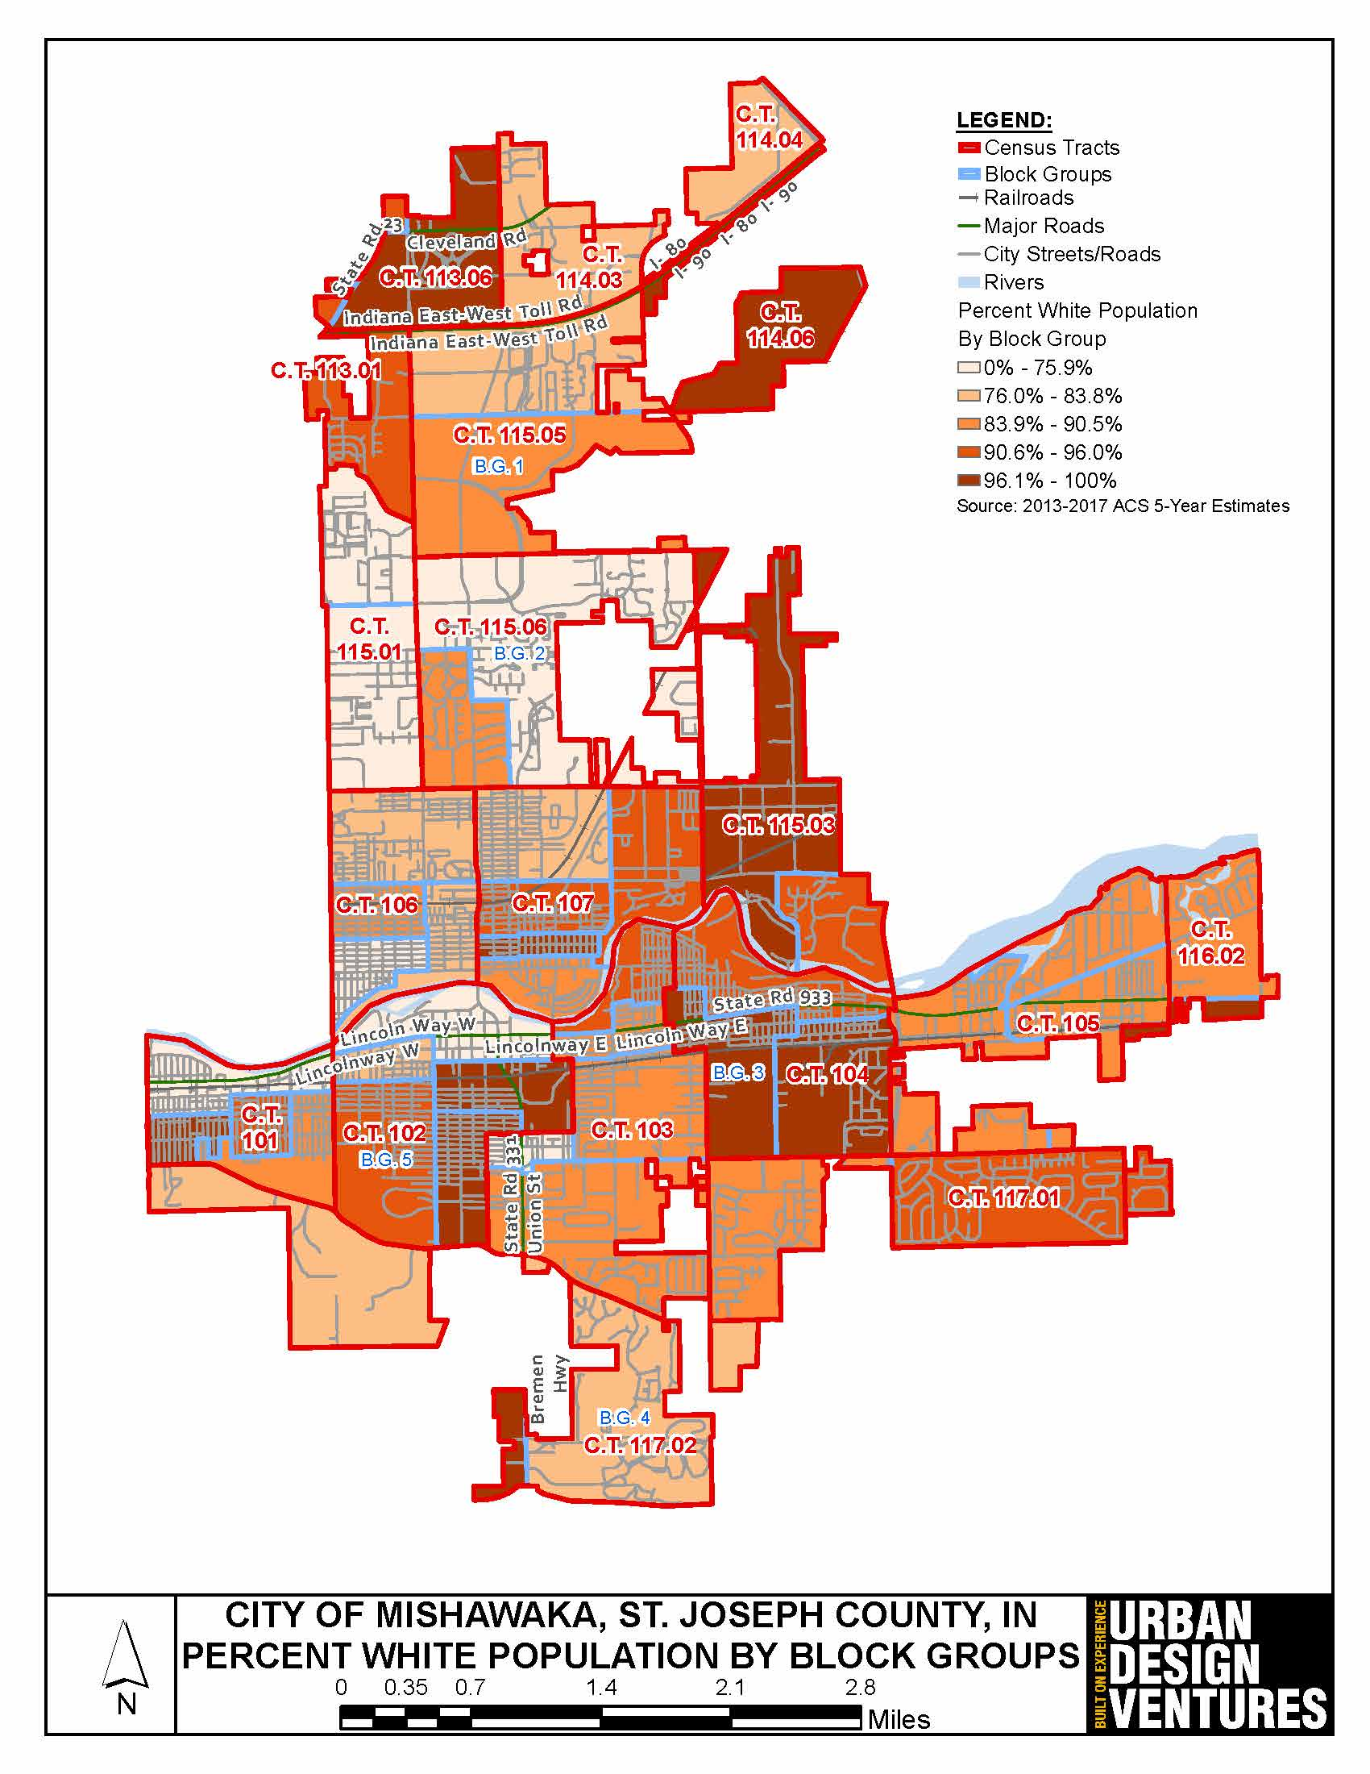
Percent White Population
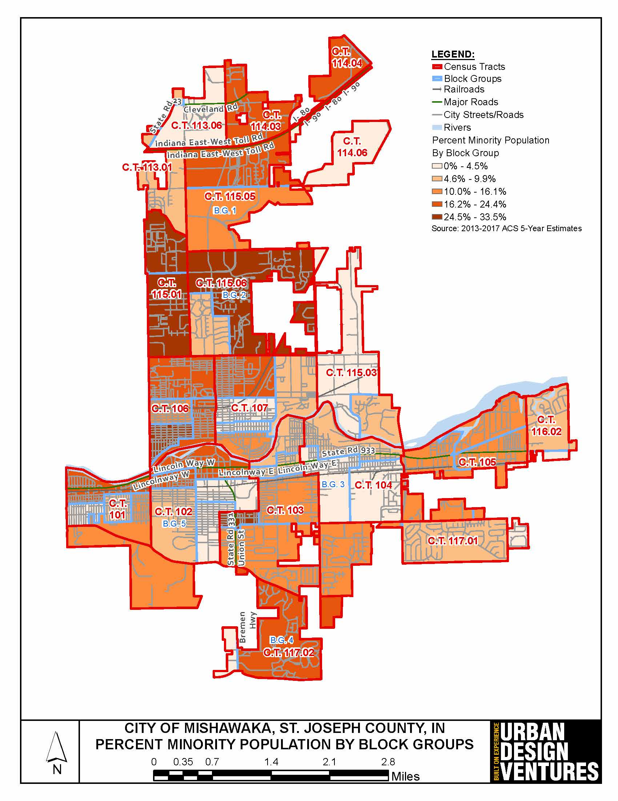
Percent Minority Population
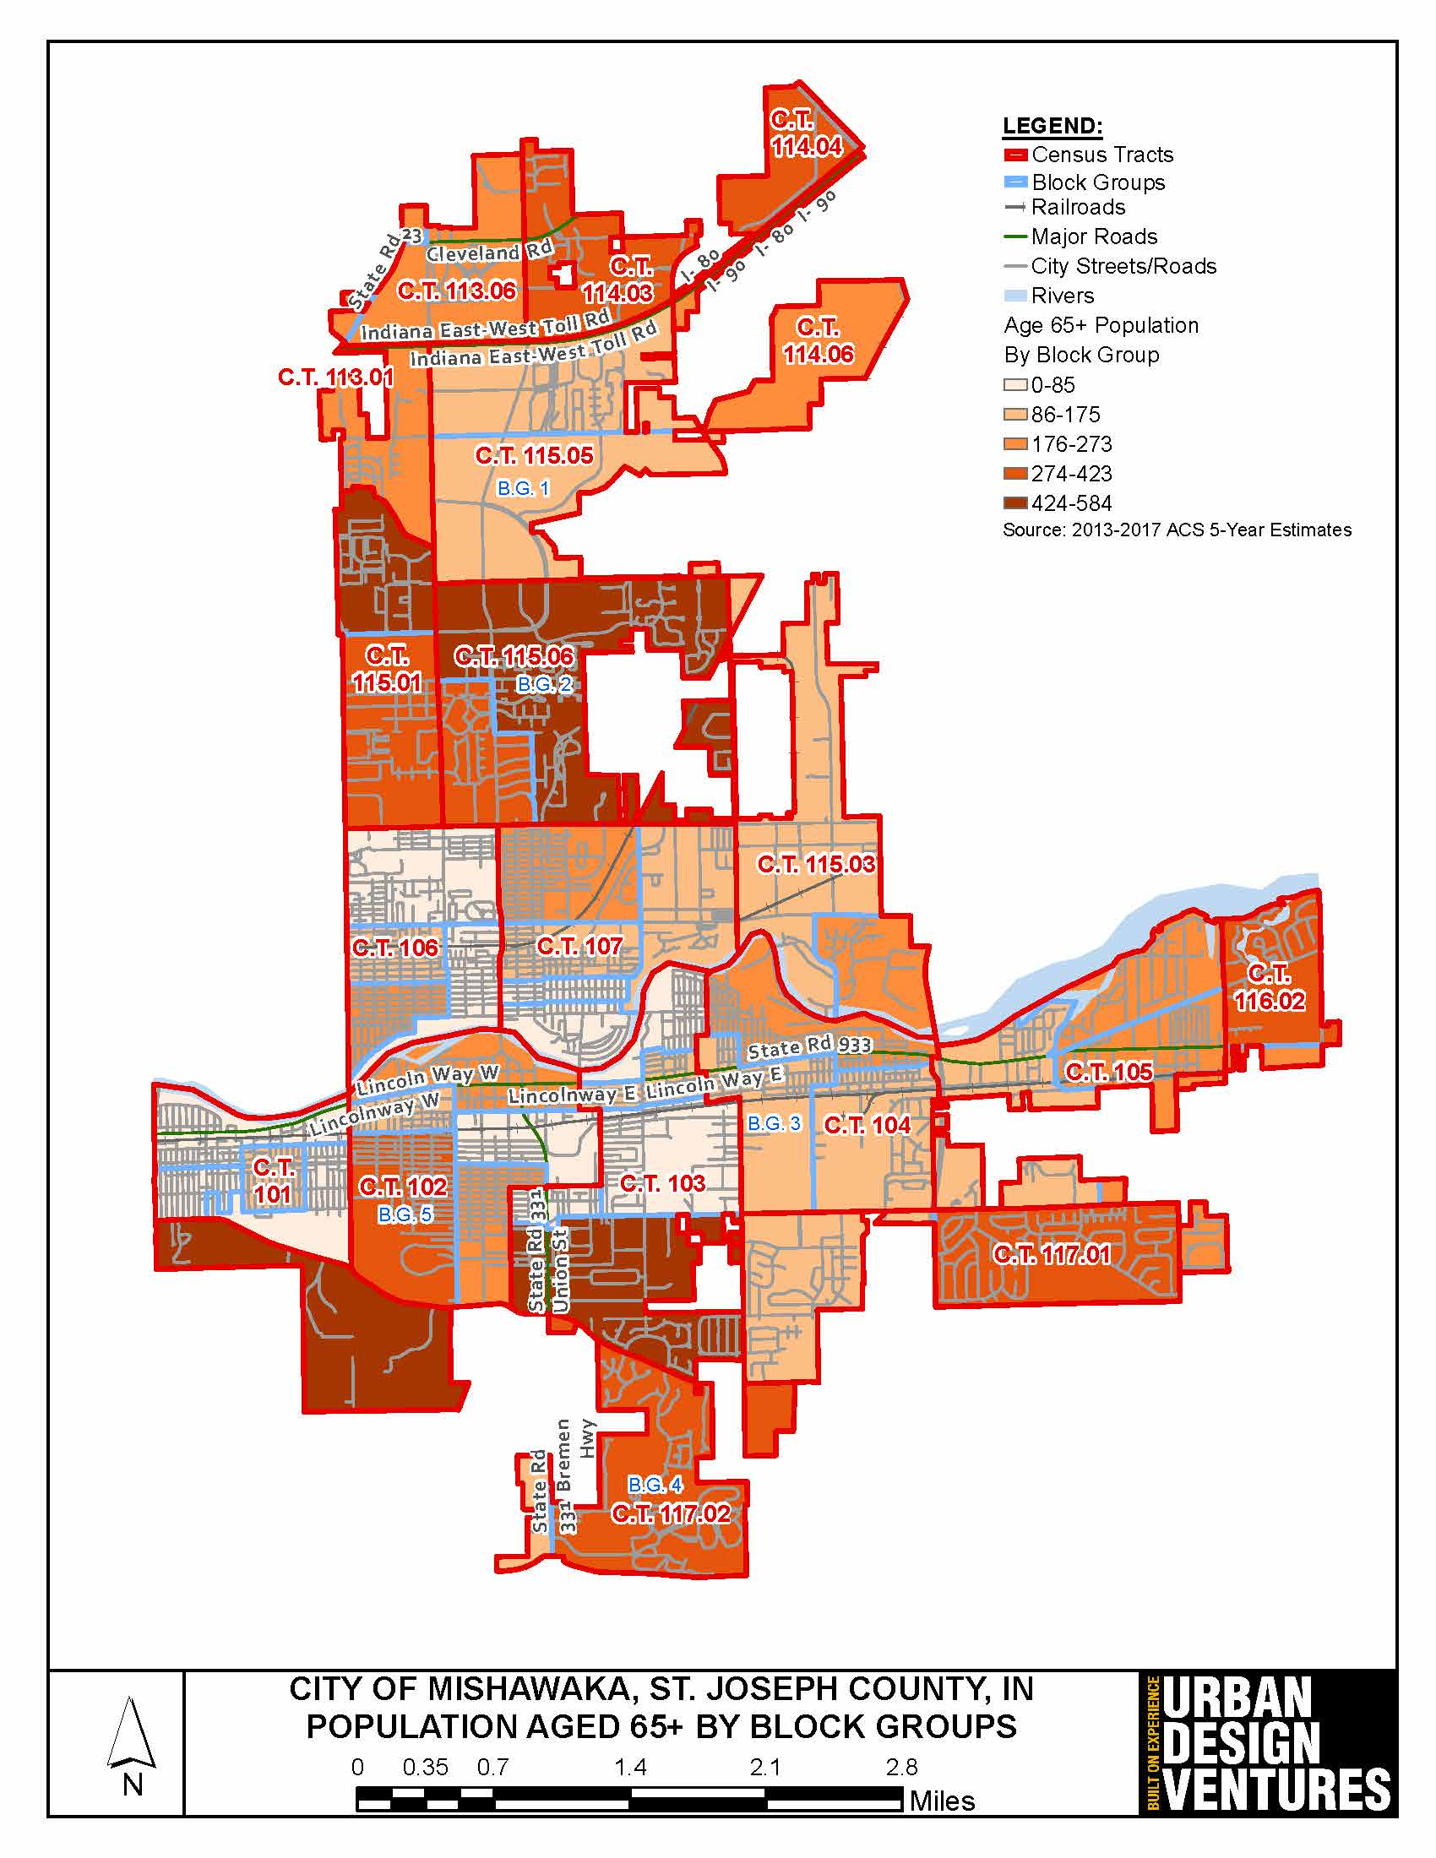
Number of People Aged 65+
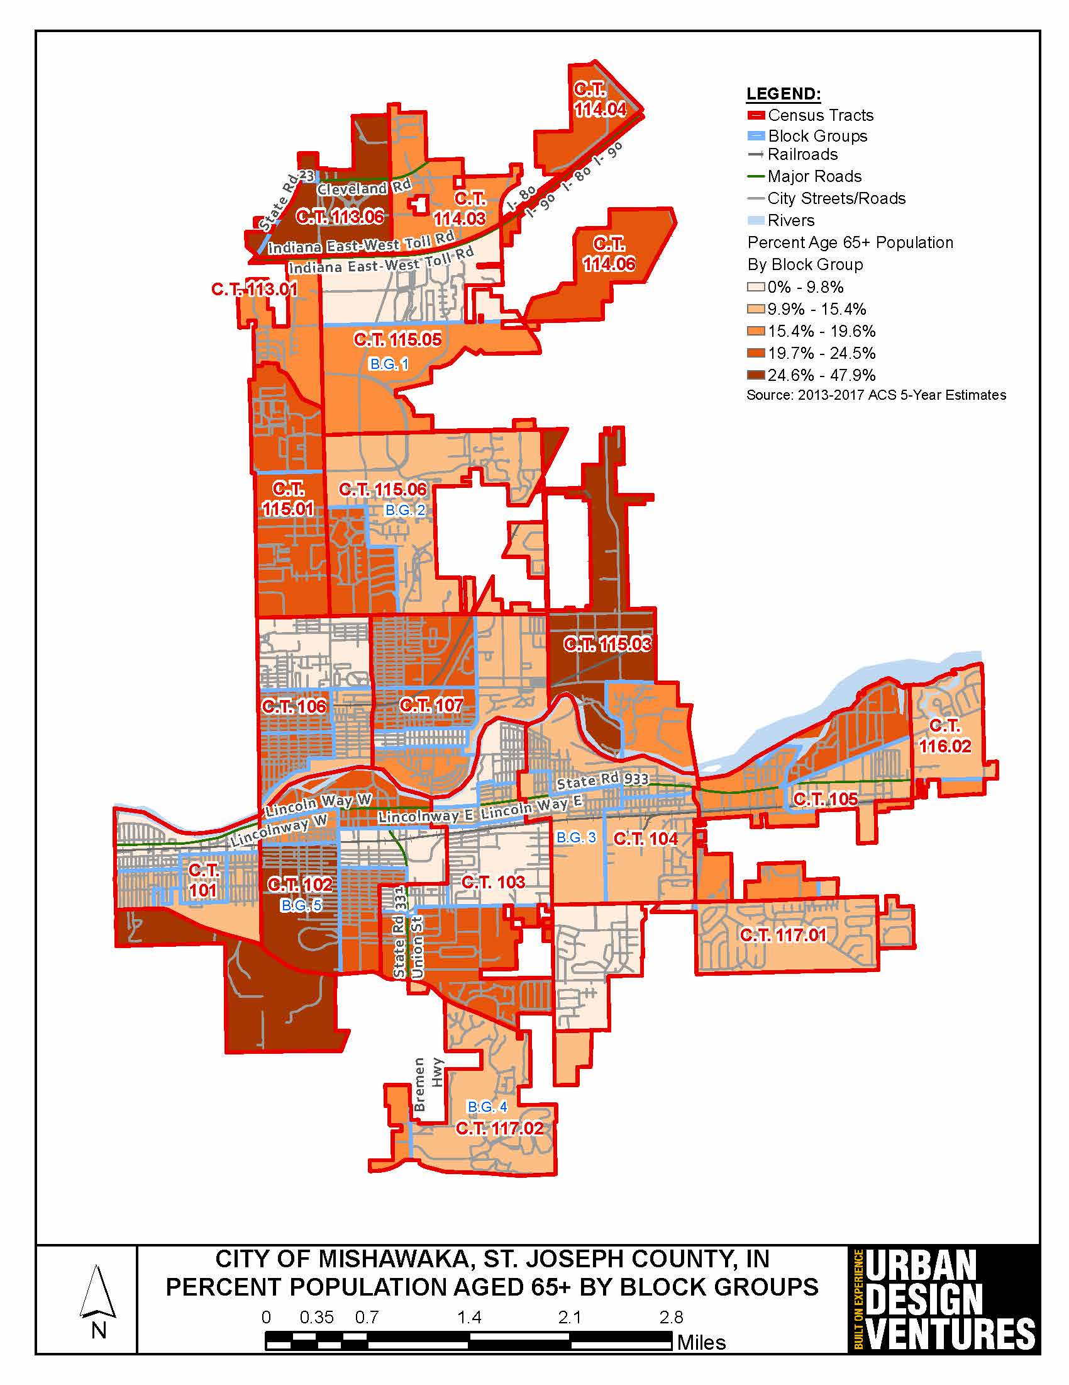
Percent Population Aged 65+
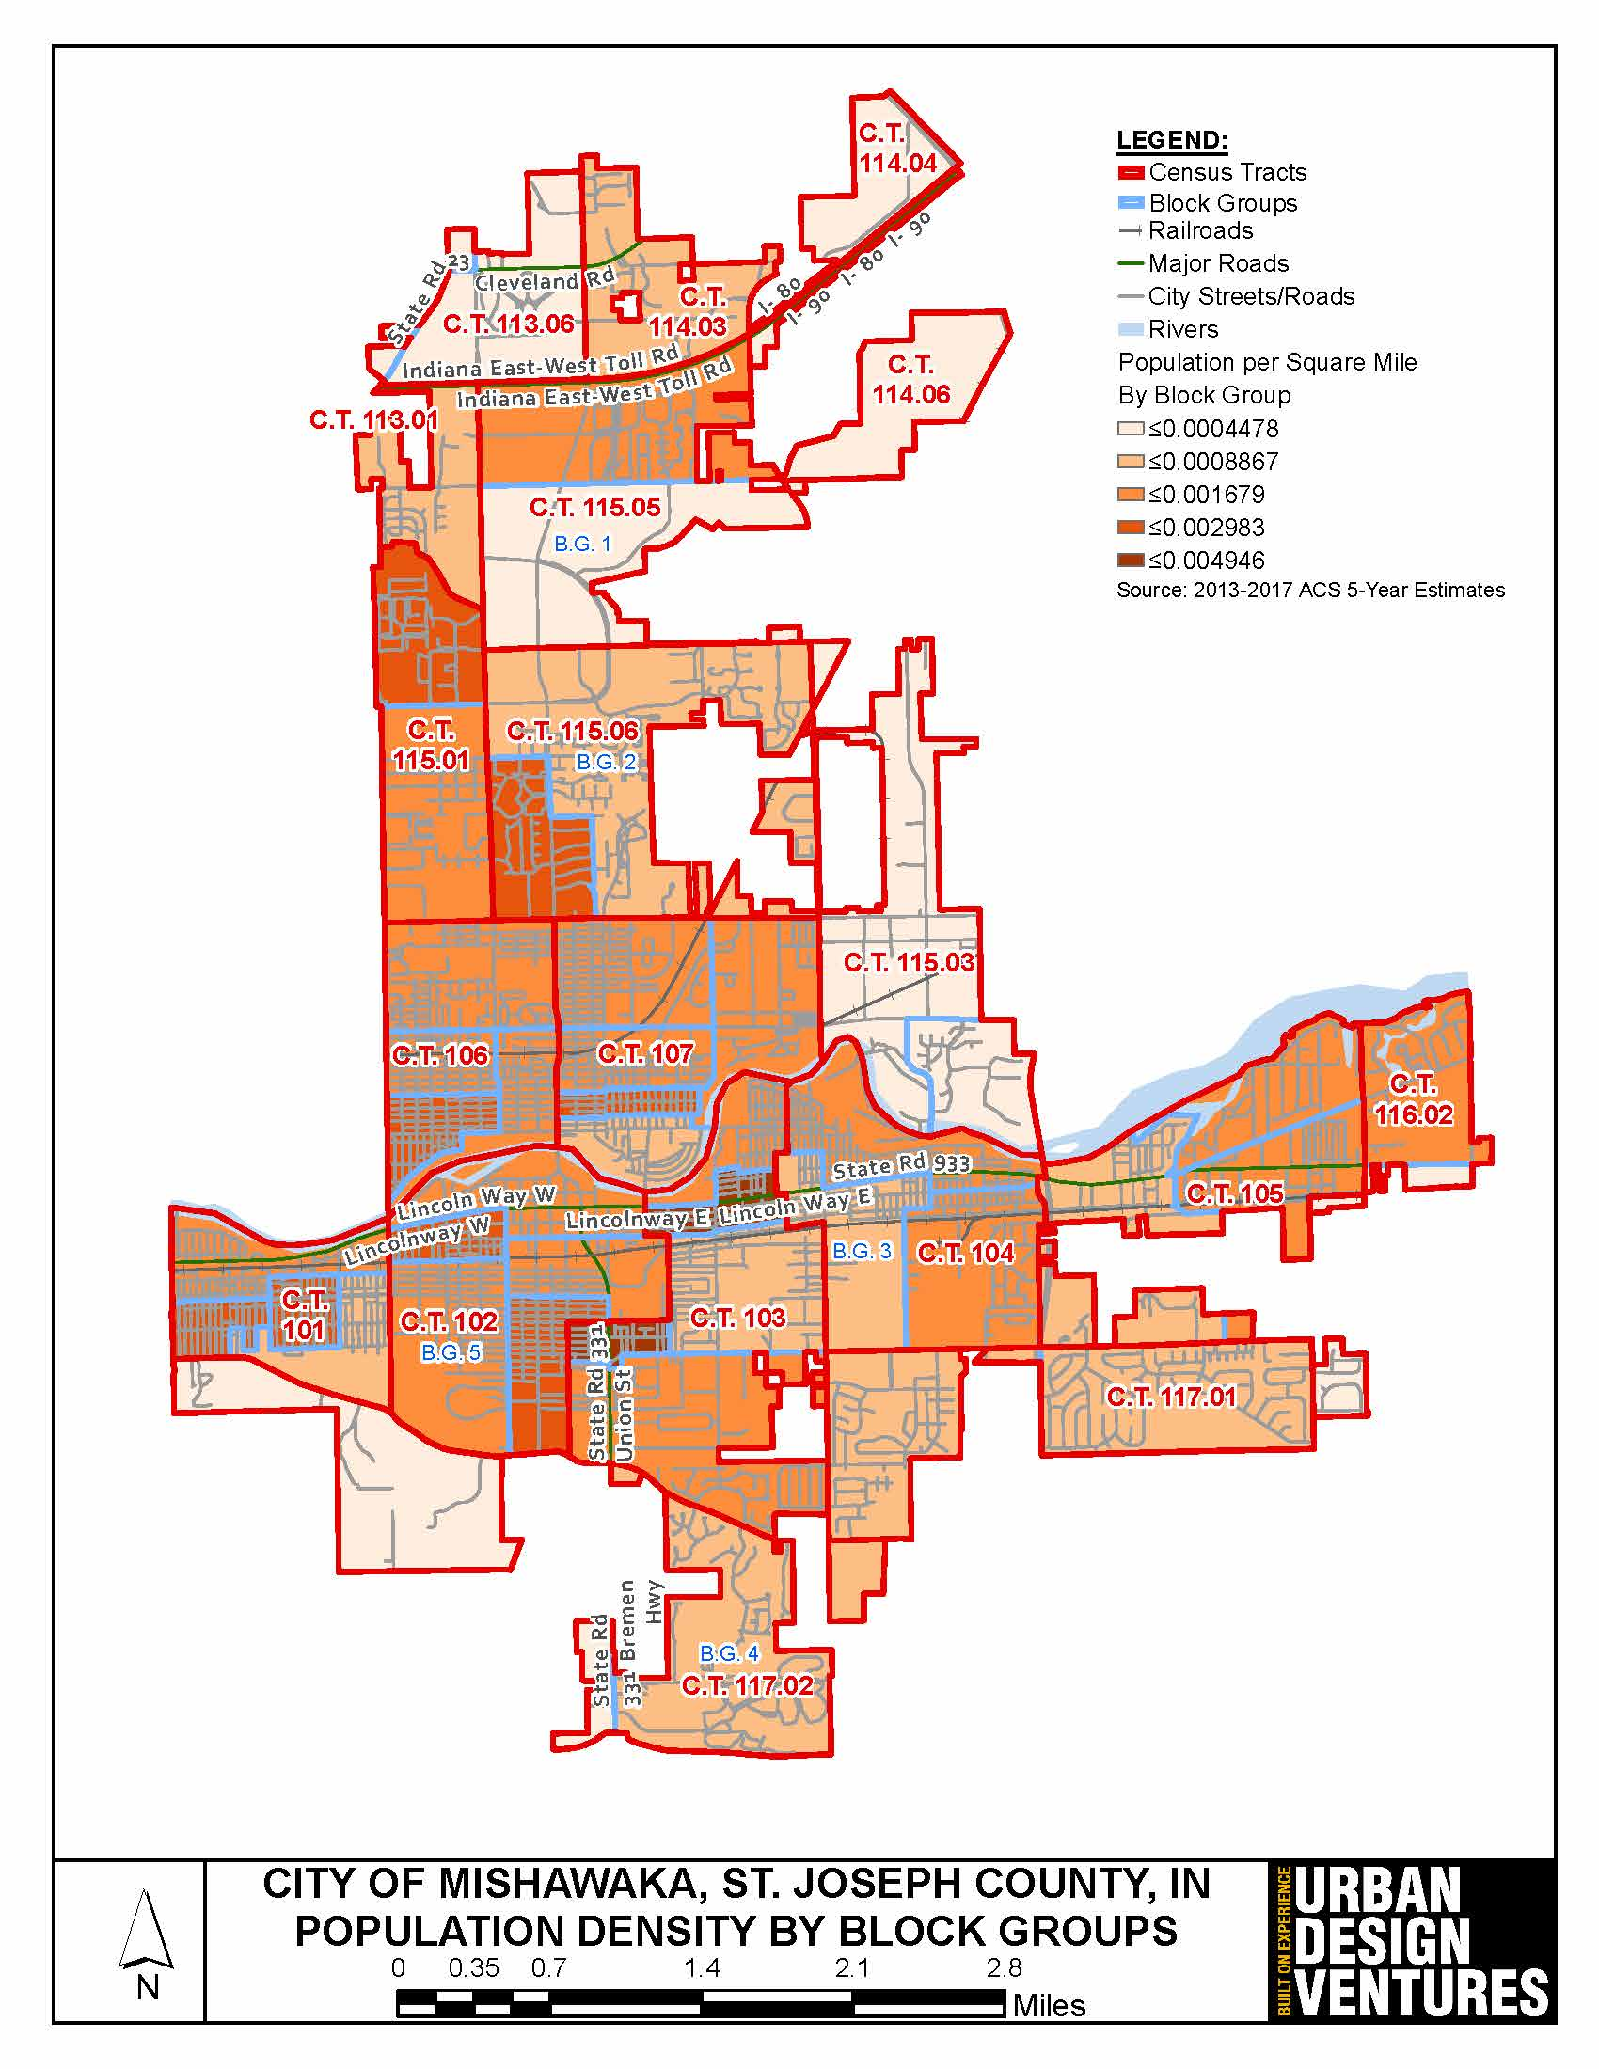
Population Density
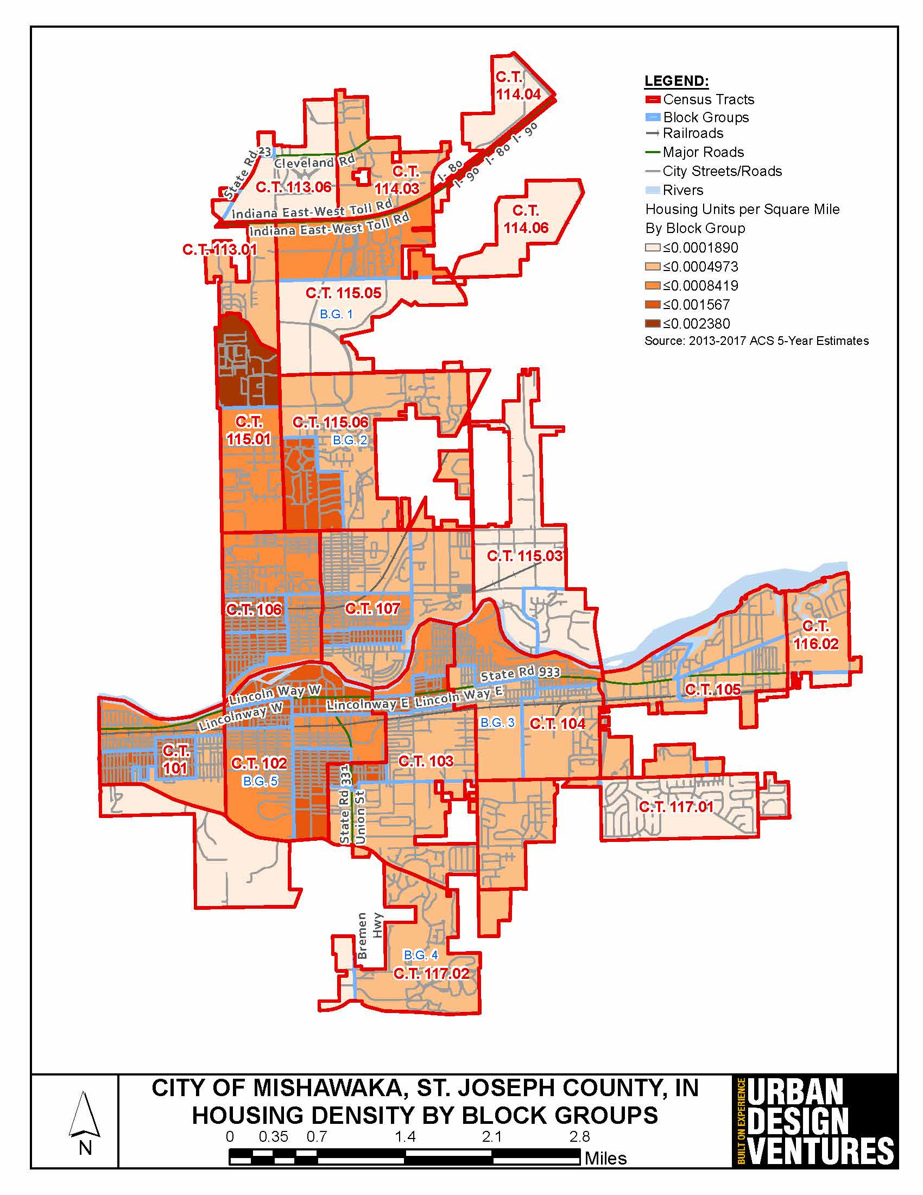
Housing Density
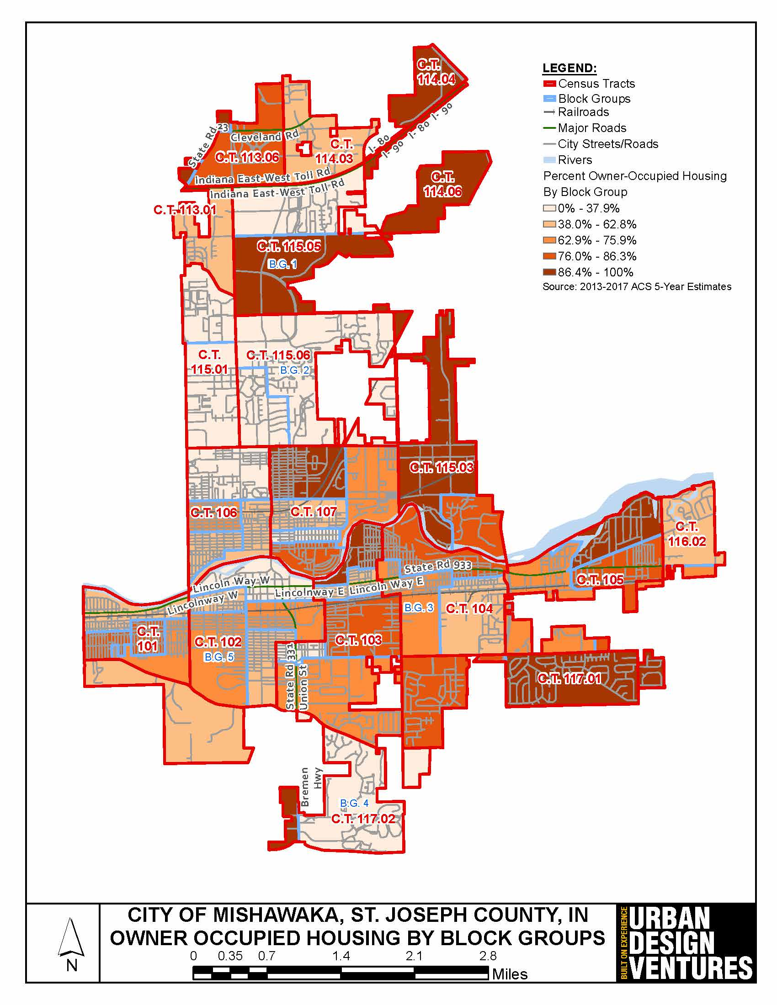
Owner-Occupied Housing
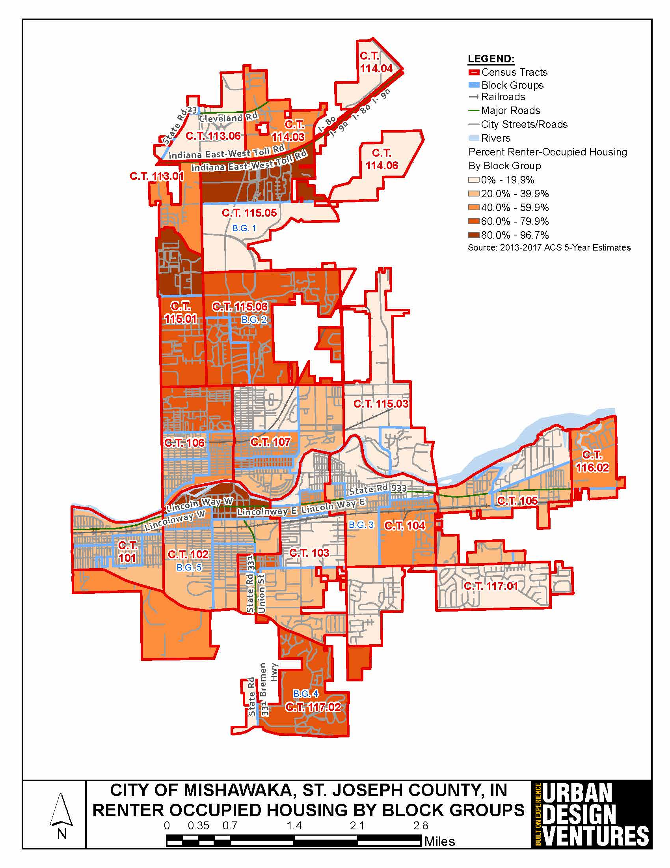
Renter-Occupied Housing
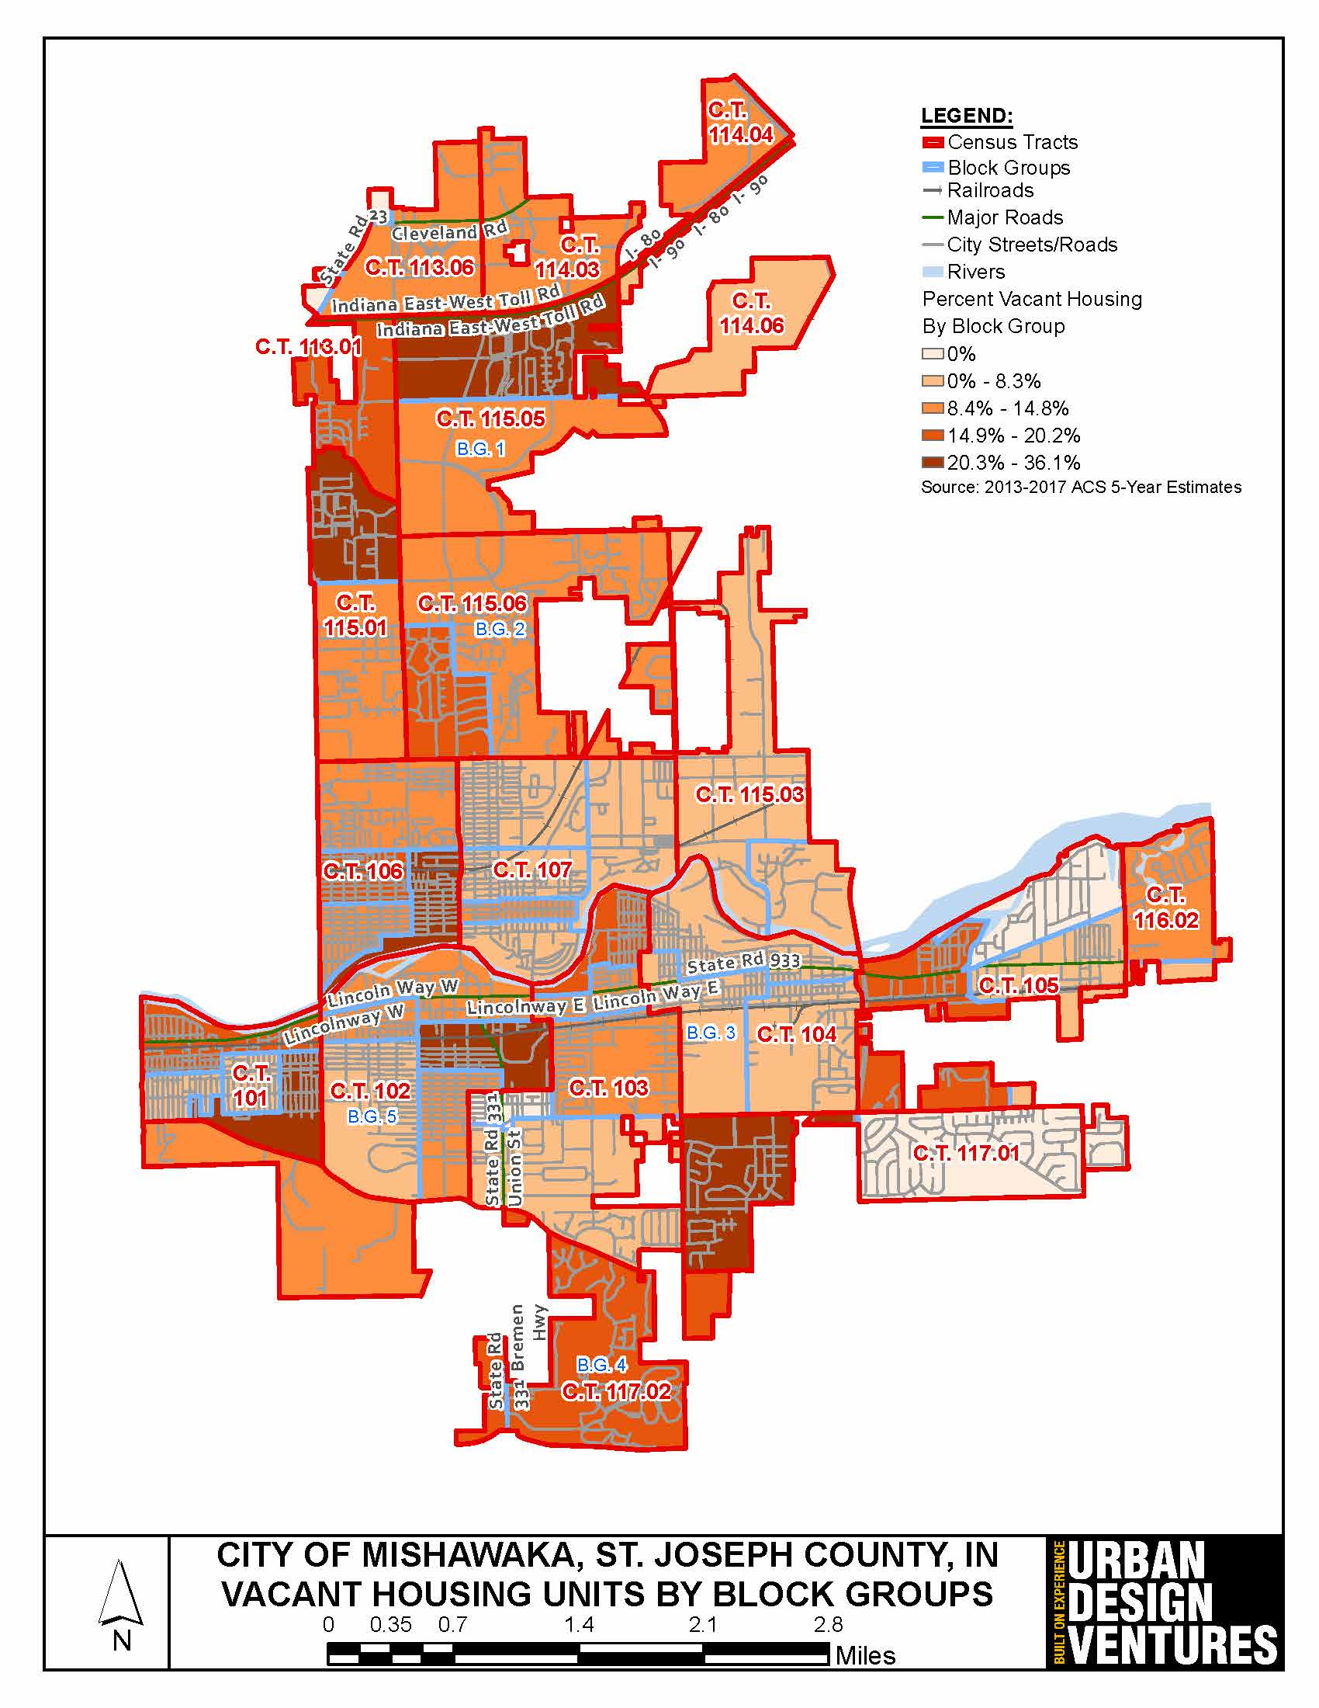
Vacant Housing Units
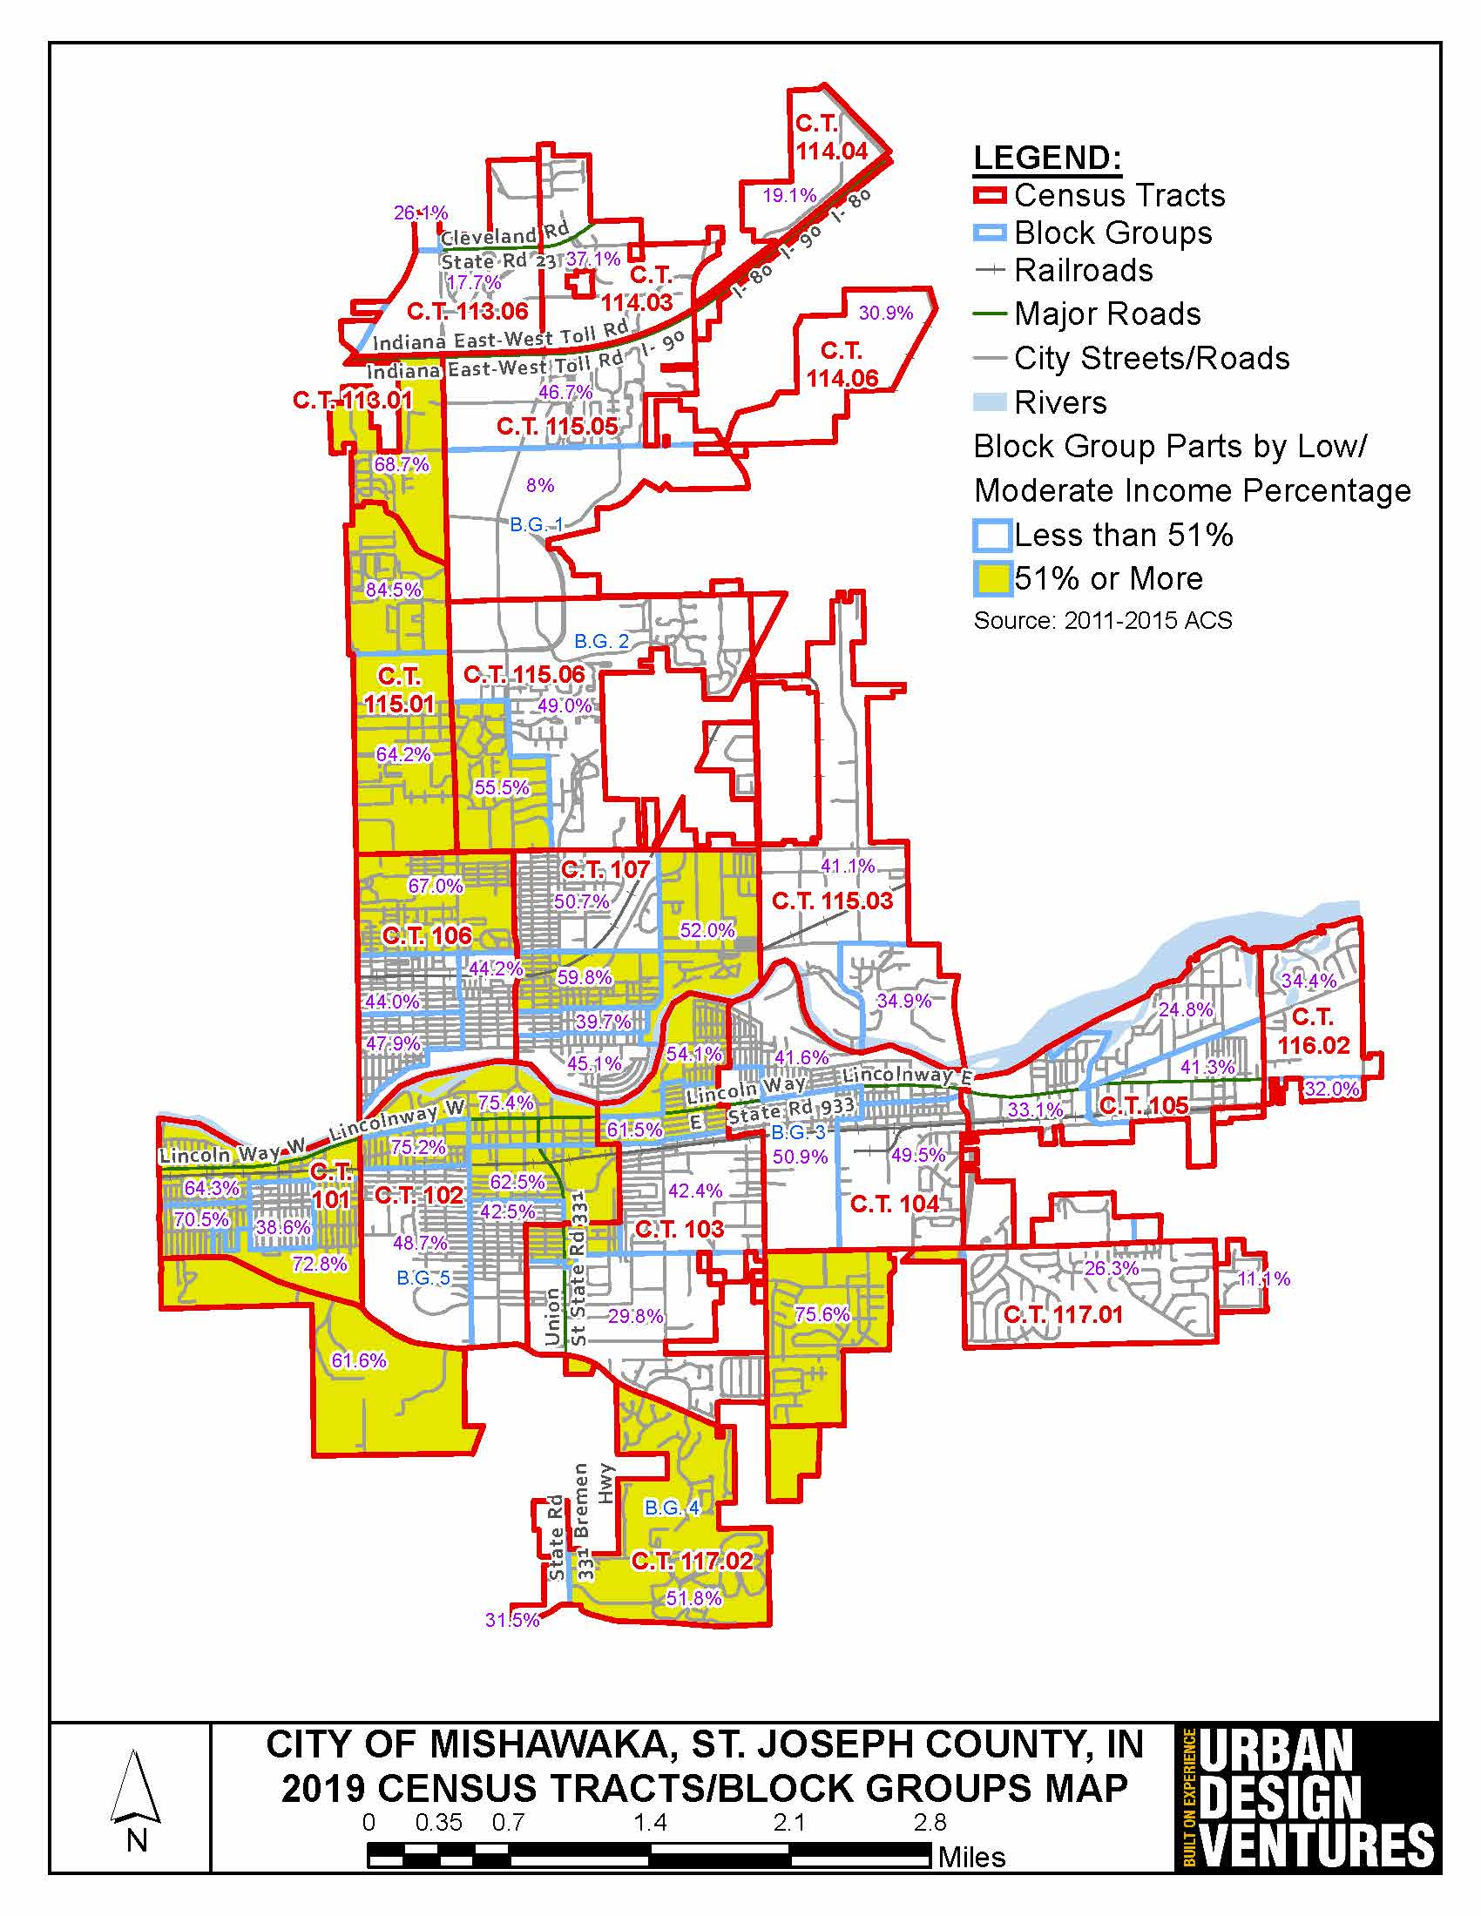
Low/Moderate Income Population by Block Group
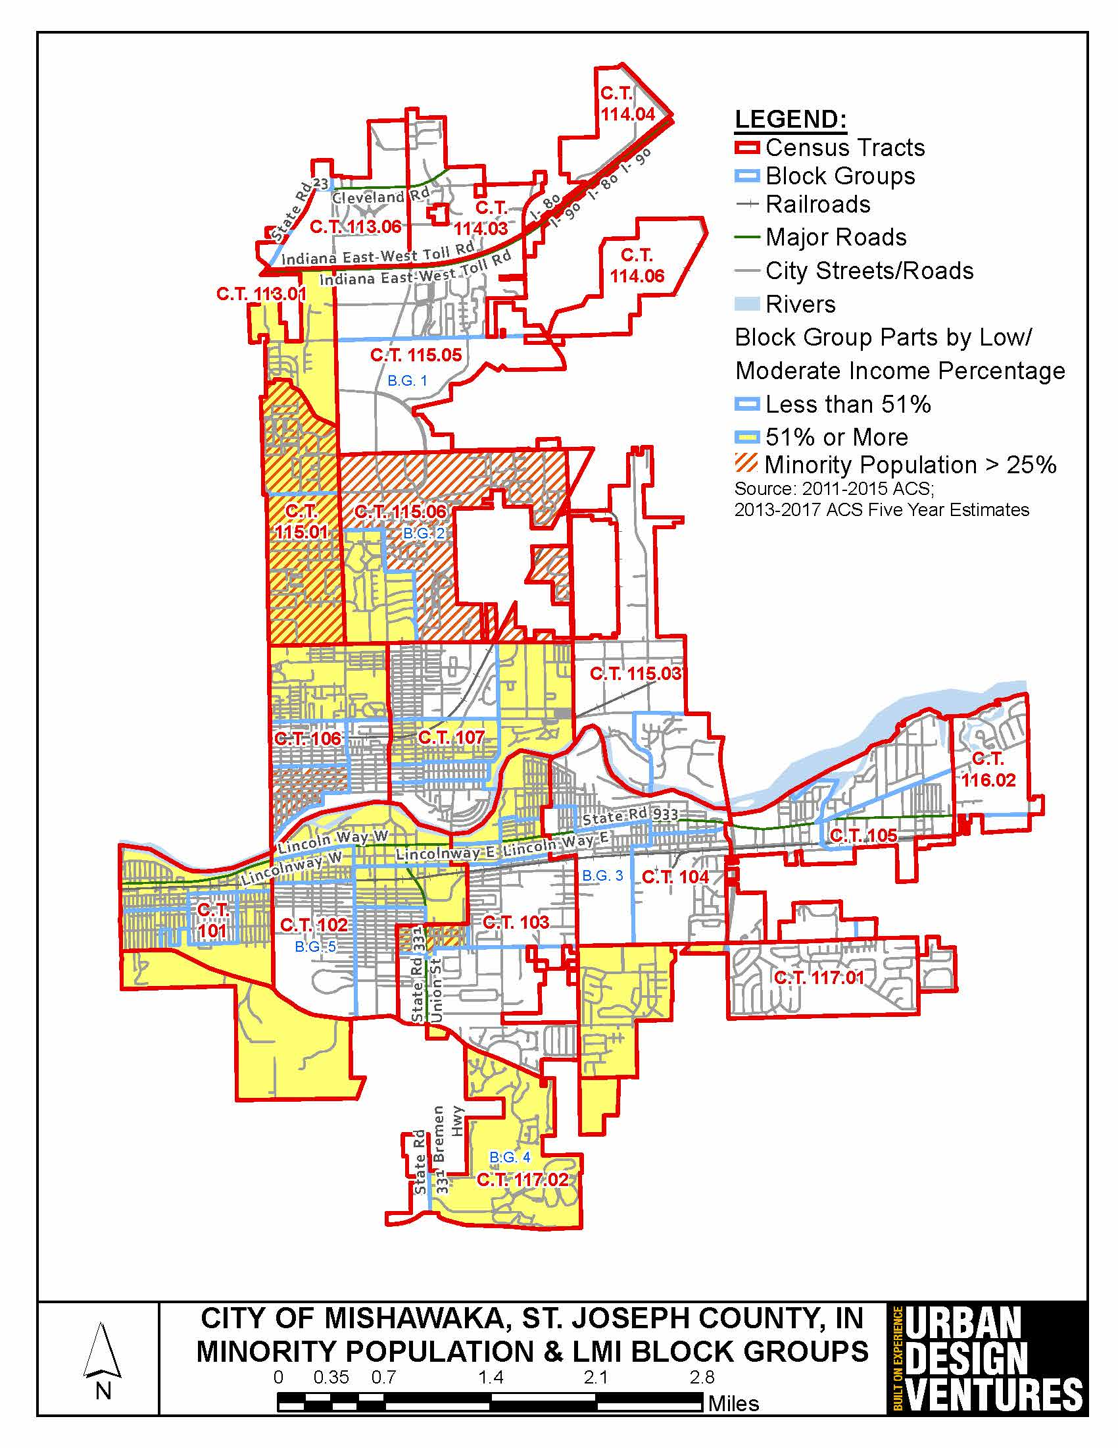
Low/Moderate Income Population and Minority Population by Block Group
2. Summary of the objectives and outcomes identified in the Plan Needs Assessment Overview
The "Vision" of this Five Year Consolidated Plan is to serve as a consolidated planning document, an application, and a strategic plan for the City of Mishawaka. The following goals and outcomes have been identified for the five year period of FY 2020 through FY 2024:
HOMELESS PRIORITY - HOM
Goal: Improve the living conditions and services for homeless persons and families in the City of Mishawaka.
Objectives:
- HOM-1 Public Services – Improve and increase public services through funding to programs that target and serve homeless individuals.
OTHER SPECIAL NEEDS PRIORITY - SNS
Goal: Improve the living conditions and services for persons and families living below poverty line, including homeless persons and families living in the City of Mishawaka.
Objectives:
- SNS-1 Public Services - Improve and increase public service programs for the youth, the elderly, disabled, and target low income population, including feeding programs and social/welfare programs throughout the City.
HOUSING PRIORITY - HSS
Goal: Improve, preserve, and expand the supply of affordable housing for low- and moderate-income persons and families in the City of Mishawaka.
Objectives:
- HSS-1 Homeownership Assistance - Promote and assist in developing homeownership opportunities for low- and moderate-income persons & families through down payment assistance.
- HSS-2 Affordable Housing - Promote and assist in the development of new affordable housing through renovation of existing units.
- HSS-3 Housing Construction - Promote and assist in the development of new affordable housing through construction of new units.
- HSS-4 Housing Rehabilitation - Promote and assist in the preservation of existing owner-occupied housing stock in the City of Mishawaka thru the Summer of Service Program.
- HSS-5 Accessibility - Promote and assist in making accessibility improvements to owner occupied housing through rehabilitation.
COMMUNITY DEVELOPMENT PRIORITY - CDS
Goal: Improve, preserve, and create new public and community facilities, infrastructure, and public services to ensure the quality of life for all residents of the City of Mishawaka.
Objectives:
- CDS-1 Infrastructure - Improve the City’s infrastructure through rehabilitation, reconstruction, and new construction of streets, walks, curbs, ADA ramps, retaining walls, sewer, linear lines, water, flood control, storm water management and separation, bridges, bike trails, green infrastructure, etc.
- CDS-2 Community Facilities - Improve the City's parks, recreational centers, and public and community facilities through rehabilitation and new construction.
- CDS-3 Clearance - Remove and eliminate slum and blighting conditions through demolition of vacant and abandoned structures throughout the City.
ADMINISTRATION, PLANNING, AND MANAGEMENT PRIORITY - APM
Goal: Provide sound and professional planning, administration, oversight and management of Federal, state, and local funded programs.
Objectives:
- APM-1 Management - Continue to provide sound and professional planning, program management and oversight for the successful administration of Federal, state, and local funded programs.
- APM-2 Fair Housing - Affirmatively further fair housing by promoting fair housing choice throughout the City of Mishawaka.
3. Evaluation of past performance
The City of Mishawaka meets the performance standards established by HUD. Each year the City prepares its Consolidated Annual Performance and Evaluation Report (CAPER). This report is submitted within ninety (90) days after the start of the new program year. Copies of the CAPER are available for review at the offices of the City of Mishawaka.
The FY 2018 CAPER, is the fourth CAPER for the FY 2014-2019 Five Year Consolidated Plan. In the FY 2018 CAPER, the City of Mishawaka expended 90.43% of its CDBG funds to benefit low- and moderate-income persons. The City expended 11.99% of its funds during the FY 2018 CAPER period on public services, which is below the statutory maximum of 15%. The City expended 9.75% of its funds during this CAPER period on Planning and Administration, which is below the statutory maximum of 20%. The City was under the 1.5 maximum drawdown ratio with a drawdown ratio of 1.15.
4. Summary of citizen participation process and consultation process
The City of Mishawaka has followed its Citizen Participation Plan in the planning and preparation of the Five Year Consolidated Plan. The City held its first public hearing on the needs of the community and its residents on April 24, 2019. This provided the residents, agencies and organizations with the opportunity to discuss the City’s CDBG and HOME Programs and to provide suggestions for the future CDBG and HOME Programs priorities and activities.
The City maintains a list of agencies and organizations for its CDBG Program and sends out Funding Applications for the FY 2020 CDBG Program.
A copy of the “Draft FY 2020-2024 Five Year Consolidated Plan and the FY 2020 Annual Action Plan” was placed on public display for 30-day review from November 2, 2019 to December 2, 2019 for general public agencies and organizations in the community. A newspaper notice announcing that these documents were placed on public display was published in a newspaper of general circulation in the area. The “Draft Five Year Consolidated plan and the FY 2020 Annual Action Plan” were on public display at the following locations:
- Mishawaka-Penn-Harris Public Library
- Mishawaka Branch209 Lincolnway EastMishawaka, IN 46544
- Mishawaka-Penn-Harris Public Library
- Bittersweet Branch602 Bittersweet RoadMishawaka, IN 46544
- City of Mishawaka Planning Department
- 600 E 3rd StreetMishawaka, IN 46544
In April, 2019, resident survey was prepared and sent out to residents. A copy was placed on the City’s website. The results of the survey were used to help determine the goals and strategies. A more detailed analysis and description of the citizen participation process is contained in Section PR-15 Citizen Participation.
The City of Mishawaka updated its Citizen Participation Plan to include provisions for public display and public comment during a declaration of a state of emergency by the Governor of Indiana and the City loses its ability to hold public hearings in person. These provisions shortened display periods for plans and substantial amendments to 5 days, allowed for virtual public meetings, and the requirement that plans either be displayed on the City’s website or be emailed to any resident that requests them within two (2) business days.
5. Summary of public comments
The City of Mishawaka held its First Public Hearing on April 24, 2019 at 5:30 PM. Comments received at that public hearing are included in the attachments at the end of the Five Year Plan.
The FY 2020-2024 Five Year Consolidated Plan and FY 2020 Annual Action Plan were placed on public display and a Second Public Hearing was scheduled for November 13, 2019. Comments that were received at the Second Public Hearing are included in the attachments at the end of the Five Year Plan.
6. Summary of comments or views not accepted and the reasons for not accepting them
All comments and suggestions that were received to date, have been accepted and incorporated into the planning document.
7. Summary
The main goal of the Five Year Consolidated Plan is to improve the living conditions of the City of Mishawaka residents, by improving the housing conditions in the City, creating a suitable and sustainable living environment for the City’s residents, and to address the community and economic development needs of the City residents.
The Five Year Consolidated Planning process requires that the City prepare in a single document its priorities, goals, and strategies to address the needs for housing, homelessness, other special needs, community development, economic development, administration and planning. The City will use the Consolidated Plan priorities to allocate its CDBG funds over the next five (5) years and to provide direction to its strategic partners, participating agencies, and stakeholder organizations to address the housing and community development needs of the low- and moderate-income residents of the City of Mishawaka. HUD will evaluate the City’s performance based on the goals established in the Five Year Consolidated Plan.
A “draft” of the Five Year Consolidated Plan and FY 2020 Annual Action Plan were placed on display at: Mishawaka-Penn-Harris Public Libraries at 209 Lincolnway East, Mishawaka, IN 46544 and 602 Bittersweet Road, Mishawaka, IN 46544; and the Mishawaka Planning Department at 600 E 3rd Street, Mishawaka, IN 46544. The display period started on November 1, 2019 through December 2, 2019 for a 30 day display period. A second public hearing was held to discuss the proposed activities and solicit citizen comments on the Plans. Upon completion of the 30 day comment period, the City of Mishawaka will be submitting the Five Year Consolidated Plan and FY 2020 Annual Action Plan to the U.S. Department of Housing and Urban Development Indianapolis Office.

The Process

PR-05 Lead & Responsible Agencies - 91.200(b)
1. Describe agency/entity responsible for preparing the Consolidated Plan and those responsible for administration of each grant program and funding source
The following are the agencies/entities responsible for preparing the Consolidated Plan and those responsible for administration of each grant program and funding source.
Agency Role | Name | Department/Agency
Lead Agency | MISHAWAKA

CDBG Administrator | MISHAWAKA | Department of Community Development
HOPWA Administrator
HOME Administrator
HOPWA-C Administrator
Table 1– Responsible Agencies

Narrative
The administering lead agency is the City of Mishawaka’s Department of Community Development for the CDBG Program. Along with St. Joseph County, the City of South Bend and the City of Mishawaka share an annual HOME Investment Partnership (HOME) Grant. The City of South Bend is the lead agency for the allocation and is responsible for the administration of all HOME funds. The City of Mishawaka prepares the Five Year Consolidated Plan, Annual Action Plans, ERR’s, and the Consolidated Annual Performance and Evaluation Reports (CAPER), processes pay requests, performs contracting, and oversight of the programs on a day to day basis.
Consolidated Plan Public Contact Information
Ms. Laura Viramontes, Grant Administrator
City of Mishawaka
600 3rd Street
Mishawaka, IN 46544
Phone: (574) 258-1609
Fax: (574) 968-6999
Email: lviramontes@mishawaka.in.gov
Website: http://mishawaka.in.gov

PR-10 Consultation - 91.100, 91.110, 91.200(b), 91.300(b), 91.215(l) and 91.315(l)
1. Introduction
While preparing the FY 2020-2024 Five Year Consolidated Plan and FY 2020 Annual Action Plan, the City of Mishawaka consulted with the Housing Authority of the City of Mishawaka, social services and housing agencies, and the Indiana Balance of State CoC.
Provide a concise summary of the jurisdiction’s activities to enhance coordination between public and assisted housing providers and private and governmental health, mental health and service agencies (91.215(I)).
The City of Mishawaka works with the following agencies to enhance coordination:
- Housing Authority of the City of Mishawaka - Section 8 Housing Choice Vouchers, improvements to public housing communities, and scattered site housing.
- Social Services Agencies - funds to improve services to low- and moderate-income persons.
- Housing Providers - funds to rehab and develop affordable housing to improve housing options for low- and moderate-income families and individuals.
- Center for the Homeless - oversees the Continuum of Care.
- City of South Bend – Participating Jurisdiction for the HOME Consortium.
Describe coordination with the Continuum of Care and efforts to address the needs of homeless persons (particularly chronically homeless individuals and families, families with children, veterans, and unaccompanied youth) and persons at risk of homelessness
The Indiana Balance of State CoC addresses the needs of homeless persons and persons at risk of becoming homeless in St. Joseph County. St. Joseph County is a separate region within the Balance of State CoC that encompasses all of, and only St. Joseph County. The region has utilized Coordinated Entry since January of 2019 to determine the needs of homeless individuals and families and place them in the program best suited to provide them with housing and services. Persons who are homeless or at-risk of becoming homeless are evaluated using the VI-SPDAT and placed in the appropriate housing. The VI-SPDAT metric prioritizes veterans and domestic violence survivors. The adoption of Coordinated Entry, placement rates of homeless individuals and families have been high.
The Point in Time Counts for Sheltered and Unsheltered homeless persons are completed on a designated date twice a year in the months of January and July. The results of the statewide counts are available to the public on the Indiana Balance of State CoC website.
Describe consultation with the Continuum(s) of Care that serves the jurisdiction's area in determining how to allocate ESG funds, develop performance standards and evaluate outcomes, and develop funding, policies and procedures for the administration of HMIS
ESG – The Center for the Homeless, the YWCA, Dismas House, Youth Services Bureau, and AIDS Assist receive ESG funds from the City of South Bend. ESG funds for St. Joseph County are administered through the City of South Bend’s Department of Community Investment. The South Bend Department of Community Investment issues an RFP for ESG-funded projects through the Neighborhood Development Office. The process is competitive for projects that provide emergency shelter, related services, and rapid re-housing to the homeless.
Develop Performance Standards and Evaluate Outcomes – The Indiana Balance of State CoC’s written standards focus on a Housing First Model and follow the best practices of that model. The written standards utilize several strategies to increase the number of people who exit emergency shelter, transitional housing, and rapid re-housing to Permanent Housing destinations. Evaluations of these standards will be based on the length-of-time homeless measurement of an individual or family who resides in emergency shelter, transitional housing, or rapid re-housing. The CoC seeks to make progress on eviction prevention, the targeting of individuals and families based on risk, and the influencing developers in the area to create Permanent Supportive Housing.
HMIS – Throughout different times of the year, the CoC and the HMIS Lead work together to assess data quality throughout the CoC. This includes working on the Point In Time (PIT) count, project reviews/ranking, and working with individuals programs while completing their Annual Performance Reports (APRs). The system ensures data quality by requiring many of the universal data elements upon enrolling a participant into a program. Additionally, the system has an alert system with exit date reminders. The work flow of data entry has been updated to improve data quality. The HMIS Lead supports users through the staffing of a Help Desk and ongoing training opportunities. Agency users are able to run self-reports to assess their program’s data quality. ESG-funded applications are required to use the HMIS system. CoC-funded organizations are motivated to provide good data quality, because the CoC has moved toward a data-driven project review and ranking system. Projects with poor data quality are more likely to show poor outcomes, which can impact their funding.
2. Describe Agencies, groups, organizations and others who participated in the process and describe the jurisdictions consultations with housing, social service agencies and other entities

Table 2– Agencies, groups, organizations who participated
1 | Agency/Group/Organization | MISHAWAKA
 | Agency/Group/Organization Type | Other government - Local  Planning organization  Grantee Department
 | What section of the Plan was addressed by Consultation? | Housing Need Assessment  Homelessness Strategy  Homeless Needs - Chronically homeless  Homeless Needs - Families with children  Homelessness Needs - Veterans  Homelessness Needs - Unaccompanied youth  Non-Homeless Special Needs  Economic Development  Market Analysis  Anti-poverty Strategy  Community Development Strategy
 | How was the Agency/Group/Organization consulted and what are the anticipated outcomes of the consultation or areas for improved coordination? | The City of Mishawaka was the lead entity on the Five Year Consolidated Plan. The City reviewed its program and funded activities that met the goals and objectives as outlined in the City's Five Year Consolidated Plan.
2 | Agency/Group/Organization | Mishawaka Housing Authority
 | Agency/Group/Organization Type | Housing  PHA
 | What section of the Plan was addressed by Consultation? | Housing Need Assessment  Lead-based Paint Strategy  Public Housing Needs  Non-Homeless Special Needs  Anti-poverty Strategy  Community Development Strategy
 | How was the Agency/Group/Organization consulted and what are the anticipated outcomes of the consultation or areas for improved coordination? | The Housing Authority of the City of Mishawaka was contacted to determine the housing needs of its very low-income clients. The City reviewed its program and funded activities that met the goals and objectives as outlined in the City's Five Year Consolidated Plan to address these housing needs.
3 | Agency/Group/Organization | SOUTH BEND
 | Agency/Group/Organization Type | Other government - Local
 | What section of the Plan was addressed by Consultation? | Housing Need Assessment  Homelessness Strategy  Homeless Needs - Chronically homeless  Homeless Needs - Families with children  Homelessness Needs - Veterans  Homelessness Needs - Unaccompanied youth  Non-Homeless Special Needs  Economic Development  Market Analysis  Anti-poverty Strategy  Community Development Strategy
 | How was the Agency/Group/Organization consulted and what are the anticipated outcomes of the consultation or areas for improved coordination? | The City of South Bend is Participating Jurisdiction of the St. Joseph County Housing Consortium. The City reviewed its program and funded activities that met the goals and objectives as outlined in the City's Five Year Consolidated Plan to address these housing needs.
4 | Agency/Group/Organization | Oaklawn Psychiatric Center
 | Agency/Group/Organization Type | Services-homeless  Regional organization
 | What section of the Plan was addressed by Consultation? | Housing Need Assessment  Homelessness Strategy  Homeless Needs - Chronically homeless  Homeless Needs - Families with children  Homelessness Needs - Veterans  Homelessness Needs - Unaccompanied youth  Non-Homeless Special Needs  Anti-poverty Strategy  Community Development Strategy
 | How was the Agency/Group/Organization consulted and what are the anticipated outcomes of the consultation or areas for improved coordination? | Group meeting held, phone calls; housing and community development priorities; social service and economic development needs.
5 | Agency/Group/Organization | HOPE Ministries
 | Agency/Group/Organization Type | Housing  Services - Housing  Services-Children  Services-Elderly Persons  Services-Persons with Disabilities  Services-Victims of Domestic Violence  Services-homeless  Services - Victims
 | What section of the Plan was addressed by Consultation? | Housing Need Assessment  Homelessness Strategy  Homeless Needs - Chronically homeless  Homeless Needs - Families with children  Homelessness Needs - Veterans  Homelessness Needs - Unaccompanied youth  Non-Homeless Special Needs  Anti-poverty Strategy  Community Development Strategy
 | How was the Agency/Group/Organization consulted and what are the anticipated outcomes of the consultation or areas for improved coordination? | Group meeting held, phone calls; housing and community development priorities; social service and economic development needs.
6 | Agency/Group/Organization | YOUTH SERVICE BUREAU
 | Agency/Group/Organization Type | Housing  Services - Housing  Services-Children  Services-homeless  Child Welfare Agency  Regional organization
 | What section of the Plan was addressed by Consultation? | Housing Need Assessment  Homelessness Strategy  Homeless Needs - Chronically homeless  Homeless Needs - Families with children  Homelessness Needs - Veterans  Homelessness Needs - Unaccompanied youth  Non-Homeless Special Needs  Anti-poverty Strategy  Community Development Strategy
 | How was the Agency/Group/Organization consulted and what are the anticipated outcomes of the consultation or areas for improved coordination? | Group meeting held, phone calls; housing and community development priorities; social service and economic development needs.
7 | Agency/Group/Organization | ST. MARGARET'S HOUSE
 | Agency/Group/Organization Type | Services - Housing  Services-Children  Services-Victims of Domestic Violence  Services - Victims
 | What section of the Plan was addressed by Consultation? | Housing Need Assessment  Homelessness Strategy  Homeless Needs - Chronically homeless  Homeless Needs - Families with children  Homelessness Needs - Veterans  Homelessness Needs - Unaccompanied youth  Non-Homeless Special Needs  Anti-poverty Strategy  Community Development Strategy
 | How was the Agency/Group/Organization consulted and what are the anticipated outcomes of the consultation or areas for improved coordination? | Group meeting held, phone calls; housing and community development priorities; social service and economic development needs.
8 | Agency/Group/Organization | Center for the Homeless, Inc
 | Agency/Group/Organization Type | Housing  Services - Housing  Services-Children  Services-Persons with HIV/AIDS  Services-Victims of Domestic Violence  Services-homeless  Services - Victims  Publicly Funded Institution/System of Care  Correction Facilities
 | What section of the Plan was addressed by Consultation? | Housing Need Assessment  Homelessness Strategy  Homeless Needs - Chronically homeless  Homeless Needs - Families with children  Homelessness Needs - Veterans  Homelessness Needs - Unaccompanied youth  Non-Homeless Special Needs  Anti-poverty Strategy  Community Development Strategy
 | How was the Agency/Group/Organization consulted and what are the anticipated outcomes of the consultation or areas for improved coordination? | Group meeting held, phone calls; housing and community development priorities; social service and economic development needs.
9 | Agency/Group/Organization | St. Joseph County Public Library
 | Agency/Group/Organization Type | Services-Children  Services-Elderly Persons  Services-homeless  Services-Education  Services-Employment
 | What section of the Plan was addressed by Consultation? | Housing Need Assessment  Homelessness Strategy  Homeless Needs - Chronically homeless  Homeless Needs - Families with children  Homelessness Needs - Veterans  Homelessness Needs - Unaccompanied youth  Non-Homeless Special Needs  Anti-poverty Strategy  Community Development Strategy
 | How was the Agency/Group/Organization consulted and what are the anticipated outcomes of the consultation or areas for improved coordination? | Group meeting held, phone calls; housing and community development priorities; social service and economic development needs.
10 | Agency/Group/Organization | BOYS AND GIRLS CLUB OF ST. JOSEPH COUNTY
 | Agency/Group/Organization Type | Services-Children  Services-Education  Child Welfare Agency  Regional organization
 | What section of the Plan was addressed by Consultation? | Housing Need Assessment  Homelessness Strategy  Homeless Needs - Chronically homeless  Homeless Needs - Families with children  Homelessness Needs - Veterans  Homelessness Needs - Unaccompanied youth  Non-Homeless Special Needs  Anti-poverty Strategy  Community Development Strategy
 | How was the Agency/Group/Organization consulted and what are the anticipated outcomes of the consultation or areas for improved coordination? | Group meeting held, phone calls; housing and community development priorities; social service and economic development needs.
11 | Agency/Group/Organization | Goodwill Bridges out of Poverty
 | Agency/Group/Organization Type | Services-Education  Services-Employment
 | What section of the Plan was addressed by Consultation? | Housing Need Assessment  Homelessness Strategy  Homeless Needs - Chronically homeless  Homeless Needs - Families with children  Homelessness Needs - Veterans  Homelessness Needs - Unaccompanied youth  Non-Homeless Special Needs  Anti-poverty Strategy  Community Development Strategy
 | How was the Agency/Group/Organization consulted and what are the anticipated outcomes of the consultation or areas for improved coordination? | Group meeting held, phone calls; housing and community development priorities; social service and economic development needs.
12 | Agency/Group/Organization | AIDS MINISTRIES/AIDS ASSIST
 | Agency/Group/Organization Type | Services-Persons with HIV/AIDS  Services-homeless  Health Agency
 | What section of the Plan was addressed by Consultation? | Housing Need Assessment  Homelessness Strategy  Homeless Needs - Chronically homeless  Homeless Needs - Families with children  Homelessness Needs - Veterans  Homelessness Needs - Unaccompanied youth  Non-Homeless Special Needs  Anti-poverty Strategy  Community Development Strategy
 | How was the Agency/Group/Organization consulted and what are the anticipated outcomes of the consultation or areas for improved coordination? | Group meeting held, phone calls; housing and community development priorities; social service and economic development needs.
13 | Agency/Group/Organization | Upper Room Recovery
 | Agency/Group/Organization Type | Services-homeless  Services-Employment  Health Agency
 | What section of the Plan was addressed by Consultation? | Housing Need Assessment  Homelessness Strategy  Homeless Needs - Chronically homeless  Homeless Needs - Families with children  Homelessness Needs - Veterans  Homelessness Needs - Unaccompanied youth  Non-Homeless Special Needs  Anti-poverty Strategy  Community Development Strategy
 | How was the Agency/Group/Organization consulted and what are the anticipated outcomes of the consultation or areas for improved coordination? | Group meeting held, phone calls; housing and community development priorities; social service and economic development needs.
14 | Agency/Group/Organization | Dismas House of South Bend
 | Agency/Group/Organization Type | Services-homeless
 | What section of the Plan was addressed by Consultation? | Housing Need Assessment  Homelessness Strategy  Homeless Needs - Chronically homeless  Homeless Needs - Families with children  Homelessness Needs - Veterans  Homelessness Needs - Unaccompanied youth  Non-Homeless Special Needs  Anti-poverty Strategy  Community Development Strategy
 | How was the Agency/Group/Organization consulted and what are the anticipated outcomes of the consultation or areas for improved coordination? | Group meeting held, phone calls; housing and community development priorities; social service and economic development needs.
15 | Agency/Group/Organization | St. Joseph Area Plan Commission
 | Agency/Group/Organization Type | Other government - County  Regional organization  Planning organization
 | What section of the Plan was addressed by Consultation? | Housing Need Assessment  Homelessness Strategy  Homeless Needs - Chronically homeless  Homeless Needs - Families with children  Homelessness Needs - Veterans  Homelessness Needs - Unaccompanied youth  Non-Homeless Special Needs  Anti-poverty Strategy  Community Development Strategy
 | How was the Agency/Group/Organization consulted and what are the anticipated outcomes of the consultation or areas for improved coordination? | Group meeting held, phone calls; housing and community development priorities; social service and economic development needs.
16 | Agency/Group/Organization | Mishawaka Fire Department
 | Agency/Group/Organization Type | Other government - Local
 | What section of the Plan was addressed by Consultation? | Housing Need Assessment  Economic Development  Market Analysis  Anti-poverty Strategy  Community Development Strategy
 | How was the Agency/Group/Organization consulted and what are the anticipated outcomes of the consultation or areas for improved coordination? | Group meeting held, phone calls; housing and community development priorities; social service and economic development needs.
17 | Agency/Group/Organization | CITY OF MISHAWAKA - DEPT OF PLANNING & COMMUNITY DEV
 | Agency/Group/Organization Type | Other government - Local  Planning organization  Civic Leaders
 | What section of the Plan was addressed by Consultation? | Housing Need Assessment  Homelessness Strategy  Homeless Needs - Chronically homeless  Homeless Needs - Families with children  Homelessness Needs - Veterans  Homelessness Needs - Unaccompanied youth  Non-Homeless Special Needs  Economic Development  Market Analysis  Anti-poverty Strategy  Community Development Strategy
 | How was the Agency/Group/Organization consulted and what are the anticipated outcomes of the consultation or areas for improved coordination? | Group meeting held, phone calls; housing and community development priorities; social service and economic development needs.
18 | Agency/Group/Organization | Business Development Department
 | Agency/Group/Organization Type | Other government - County  Other government - Local  Regional organization  Planning organization  Business Leaders  Business and Civic Leaders
 | What section of the Plan was addressed by Consultation? | Housing Need Assessment  Economic Development  Market Analysis  Anti-poverty Strategy  Community Development Strategy
 | How was the Agency/Group/Organization consulted and what are the anticipated outcomes of the consultation or areas for improved coordination? | Group meeting held, phone calls; housing and community development priorities; social service and economic development needs.
19 | Agency/Group/Organization | Indiana Small Business Development Center
 | Agency/Group/Organization Type | Services-Employment  Regional organization  Planning organization  Business Leaders
 | What section of the Plan was addressed by Consultation? | Housing Need Assessment  Economic Development  Market Analysis  Anti-poverty Strategy  Community Development Strategy
 | How was the Agency/Group/Organization consulted and what are the anticipated outcomes of the consultation or areas for improved coordination? | Group meeting held, phone calls; housing and community development priorities; social service and economic development needs.
20 | Agency/Group/Organization | South Bend Career Pathways
 | Agency/Group/Organization Type | Services-Employment  Regional organization  Planning organization  Business Leaders  Business and Civic Leaders
 | What section of the Plan was addressed by Consultation? | Housing Need Assessment  Economic Development  Market Analysis  Anti-poverty Strategy  Community Development Strategy
 | How was the Agency/Group/Organization consulted and what are the anticipated outcomes of the consultation or areas for improved coordination? | Group meeting held, phone calls; housing and community development priorities; social service and economic development needs.
21 | Agency/Group/Organization | Women's Entrepreneurship Initiative
 | Agency/Group/Organization Type | Services-Education  Services-Employment  Regional organization  Business Leaders  Civic Leaders  Business and Civic Leaders
 | What section of the Plan was addressed by Consultation? | Housing Need Assessment  Economic Development  Market Analysis  Anti-poverty Strategy  Community Development Strategy
 | How was the Agency/Group/Organization consulted and what are the anticipated outcomes of the consultation or areas for improved coordination? | Group meeting held, phone calls; housing and community development priorities; social service and economic development needs.
22 | Agency/Group/Organization | Notre Dame Economic Justice Clinic
 | Agency/Group/Organization Type | Housing  Service-Fair Housing
 | What section of the Plan was addressed by Consultation? | Housing Need Assessment  Homelessness Strategy  Homeless Needs - Chronically homeless  Homeless Needs - Families with children  Homelessness Needs - Veterans  Homelessness Needs - Unaccompanied youth  Non-Homeless Special Needs  Market Analysis  Community Development Strategy
 | How was the Agency/Group/Organization consulted and what are the anticipated outcomes of the consultation or areas for improved coordination? | Group meeting held, phone calls; housing and community development priorities; social service and economic development needs.
23 | Agency/Group/Organization | St. Joseph County Department of Health
 | Agency/Group/Organization Type | Services - Housing  Services-Health  Other government - County  Other government - Local
 | What section of the Plan was addressed by Consultation? | Housing Need Assessment  Lead-based Paint Strategy  Market Analysis  Community Development Strategy
 | How was the Agency/Group/Organization consulted and what are the anticipated outcomes of the consultation or areas for improved coordination? | Group meeting held, phone calls; housing and community development priorities; social service and economic development needs.
24 | Agency/Group/Organization | Place Homes, Inc.
 | Agency/Group/Organization Type | Housing  Services - Housing  Business Leaders
 | What section of the Plan was addressed by Consultation? | Housing Need Assessment  Homelessness Strategy  Homeless Needs - Chronically homeless  Homeless Needs - Families with children  Homelessness Needs - Veterans  Homelessness Needs - Unaccompanied youth  Non-Homeless Special Needs  Economic Development  Market Analysis  Anti-poverty Strategy  Community Development Strategy
 | How was the Agency/Group/Organization consulted and what are the anticipated outcomes of the consultation or areas for improved coordination? | Group meeting held, phone calls; housing and community development priorities; social service and economic development needs.
25 | Agency/Group/Organization | HABITAT FOR HUMANITY OF ST. JOSEPH COUNTY
 | Agency/Group/Organization Type | Housing  Services - Housing
 | What section of the Plan was addressed by Consultation? | Housing Need Assessment  Homelessness Strategy  Homeless Needs - Chronically homeless  Homeless Needs - Families with children  Homelessness Needs - Veterans  Homelessness Needs - Unaccompanied youth  Non-Homeless Special Needs  Economic Development  Market Analysis  Anti-poverty Strategy
 | How was the Agency/Group/Organization consulted and what are the anticipated outcomes of the consultation or areas for improved coordination? | Group meeting held, phone calls; housing and community development priorities; social service and economic development needs.
26 | Agency/Group/Organization | Hurry Home
 | Agency/Group/Organization Type | Housing  Services - Housing
 | What section of the Plan was addressed by Consultation? | Housing Need Assessment  Homelessness Strategy  Homeless Needs - Chronically homeless  Homeless Needs - Families with children  Homelessness Needs - Veterans  Homelessness Needs - Unaccompanied youth  Non-Homeless Special Needs  Economic Development  Market Analysis  Anti-poverty Strategy
 | How was the Agency/Group/Organization consulted and what are the anticipated outcomes of the consultation or areas for improved coordination? | Group meeting held, phone calls; housing and community development priorities; social service and economic development needs.
27 | Agency/Group/Organization | NAACP South Bend
 | Agency/Group/Organization Type | Civic Leaders  Services - Advocacy
 | What section of the Plan was addressed by Consultation? | Housing Need Assessment  Homelessness Strategy  Homeless Needs - Chronically homeless  Homeless Needs - Families with children  Homelessness Needs - Veterans  Homelessness Needs - Unaccompanied youth  Non-Homeless Special Needs  Economic Development  Market Analysis  Anti-poverty Strategy  Community Development Strategy
 | How was the Agency/Group/Organization consulted and what are the anticipated outcomes of the consultation or areas for improved coordination? | Group meeting held, phone calls; housing and community development priorities; social service and economic development needs.
28 | Agency/Group/Organization | IN*Source
 | Agency/Group/Organization Type | Services-Children  Services-Persons with Disabilities  Services-Health  Services-Education  Health Agency  Child Welfare Agency
 | What section of the Plan was addressed by Consultation? | Housing Need Assessment  Homelessness Strategy  Homeless Needs - Chronically homeless  Homeless Needs - Families with children  Homelessness Needs - Veterans  Homelessness Needs - Unaccompanied youth  Non-Homeless Special Needs  Economic Development  Market Analysis  Anti-poverty Strategy  Community Development Strategy
 | How was the Agency/Group/Organization consulted and what are the anticipated outcomes of the consultation or areas for improved coordination? | Group meeting held, phone calls; housing and community development priorities; social service and economic development needs.
29 | Agency/Group/Organization | LOGAN CENTER - REGIONAL AUTISM CENTER
 | Agency/Group/Organization Type | Services-Children  Services-Persons with Disabilities  Services-Education  Child Welfare Agency  Regional organization
 | What section of the Plan was addressed by Consultation? | Housing Need Assessment  Homelessness Strategy  Homeless Needs - Chronically homeless  Homeless Needs - Families with children  Homelessness Needs - Veterans  Homelessness Needs - Unaccompanied youth  Non-Homeless Special Needs  Economic Development  Market Analysis  Anti-poverty Strategy  Community Development Strategy
 | How was the Agency/Group/Organization consulted and what are the anticipated outcomes of the consultation or areas for improved coordination? | Group meeting held, phone calls; housing and community development priorities; social service and economic development needs.
30 | Agency/Group/Organization | REAL SERVICES, INC.
 | Agency/Group/Organization Type | Services-Elderly Persons  Services-Persons with Disabilities  Services-Health  Services-Employment  Regional organization
 | What section of the Plan was addressed by Consultation? | Housing Need Assessment  Homelessness Strategy  Homeless Needs - Chronically homeless  Homeless Needs - Families with children  Homelessness Needs - Veterans  Homelessness Needs - Unaccompanied youth  Non-Homeless Special Needs  Economic Development  Market Analysis  Anti-poverty Strategy  Community Development Strategy
 | How was the Agency/Group/Organization consulted and what are the anticipated outcomes of the consultation or areas for improved coordination? | Group meeting held, phone calls; housing and community development priorities; social service and economic development needs.
31 | Agency/Group/Organization | La Casa de Amistad
 | Agency/Group/Organization Type | Regional organization  Civic Leaders  Services - Advocacy
 | What section of the Plan was addressed by Consultation? | Housing Need Assessment  Homelessness Strategy  Homeless Needs - Chronically homeless  Homeless Needs - Families with children  Homelessness Needs - Veterans  Homelessness Needs - Unaccompanied youth  Non-Homeless Special Needs  Economic Development  Market Analysis  Anti-poverty Strategy  Community Development Strategy
 | How was the Agency/Group/Organization consulted and what are the anticipated outcomes of the consultation or areas for improved coordination? | Group meeting held, phone calls; housing and community development priorities; social service and economic development needs.
32 | Agency/Group/Organization | Catholic Worker of Michiana
 | Agency/Group/Organization Type | Services - Housing  Services-homeless  Child Welfare Agency
 | What section of the Plan was addressed by Consultation? | Housing Need Assessment  Homelessness Strategy  Homeless Needs - Chronically homeless  Homeless Needs - Families with children  Homelessness Needs - Veterans  Homelessness Needs - Unaccompanied youth  Non-Homeless Special Needs  Economic Development  Market Analysis  Anti-poverty Strategy  Community Development Strategy
 | How was the Agency/Group/Organization consulted and what are the anticipated outcomes of the consultation or areas for improved coordination? | Group meeting held, phone calls; housing and community development priorities; social service and economic development needs.
33 | Agency/Group/Organization | Cross Community
 | Agency/Group/Organization Type | Housing  Services - Housing  Civic Leaders
 | What section of the Plan was addressed by Consultation? | Housing Need Assessment  Homelessness Strategy  Homeless Needs - Chronically homeless  Homeless Needs - Families with children  Homelessness Needs - Veterans  Homelessness Needs - Unaccompanied youth  Non-Homeless Special Needs  Economic Development  Market Analysis  Anti-poverty Strategy  Community Development Strategy
 | How was the Agency/Group/Organization consulted and what are the anticipated outcomes of the consultation or areas for improved coordination? | Group meeting held, phone calls; housing and community development priorities; social service and economic development needs.
34 | Agency/Group/Organization | United Religious Community
 | Agency/Group/Organization Type | Civic Leaders
 | What section of the Plan was addressed by Consultation? | Housing Need Assessment  Homelessness Strategy  Homeless Needs - Chronically homeless  Homeless Needs - Families with children  Homelessness Needs - Veterans  Homelessness Needs - Unaccompanied youth  Non-Homeless Special Needs  Economic Development  Market Analysis  Anti-poverty Strategy  Community Development Strategy
 | How was the Agency/Group/Organization consulted and what are the anticipated outcomes of the consultation or areas for improved coordination? | Group meeting held, phone calls; housing and community development priorities; social service and economic development needs.
35 | Agency/Group/Organization | Veterans Administration
 | Agency/Group/Organization Type | Services-homeless  Services-Health  Services-Employment  Health Agency  Publicly Funded Institution/System of Care  Other government - Federal  Veterans
 | What section of the Plan was addressed by Consultation? | Housing Need Assessment  Homelessness Strategy  Homeless Needs - Chronically homeless  Homeless Needs - Families with children  Homelessness Needs - Veterans  Homelessness Needs - Unaccompanied youth  Non-Homeless Special Needs  Economic Development  Market Analysis  Anti-poverty Strategy  Community Development Strategy
 | How was the Agency/Group/Organization consulted and what are the anticipated outcomes of the consultation or areas for improved coordination? | Group meeting held, phone calls; housing and community development priorities; social service and economic development needs.
36 | Agency/Group/Organization | Transpo
 | Agency/Group/Organization Type | Regional organization  Planning organization  Public Transit
 | What section of the Plan was addressed by Consultation? | Housing Need Assessment  Economic Development  Market Analysis  Anti-poverty Strategy  Community Development Strategy
 | How was the Agency/Group/Organization consulted and what are the anticipated outcomes of the consultation or areas for improved coordination? | Group meeting held, phone calls; housing and community development priorities; social service and economic development needs.
37 | Agency/Group/Organization | 1st Source Bank
 | Agency/Group/Organization Type | Business Leaders  Private Sector Banking / Financing
 | What section of the Plan was addressed by Consultation? | Housing Need Assessment  Economic Development  Market Analysis  Anti-poverty Strategy
 | How was the Agency/Group/Organization consulted and what are the anticipated outcomes of the consultation or areas for improved coordination? | Group meeting held, phone calls; housing and community development priorities; social service and economic development needs.
38 | Agency/Group/Organization | Communitywide FCU
 | Agency/Group/Organization Type | Business Leaders  Private Sector Banking / Financing
 | What section of the Plan was addressed by Consultation? | Housing Need Assessment  Economic Development  Market Analysis  Anti-poverty Strategy
 | How was the Agency/Group/Organization consulted and what are the anticipated outcomes of the consultation or areas for improved coordination? | Group meeting held, phone calls; housing and community development priorities; social service and economic development needs.
39 | Agency/Group/Organization | Teachers Credit Union
 | Agency/Group/Organization Type | Business Leaders  Private Sector Banking / Financing
 | What section of the Plan was addressed by Consultation? | Housing Need Assessment  Economic Development  Market Analysis  Anti-poverty Strategy
 | How was the Agency/Group/Organization consulted and what are the anticipated outcomes of the consultation or areas for improved coordination? | Group meeting held, phone calls; housing and community development priorities; social service and economic development needs.
40 | Agency/Group/Organization | Mutual Bank
 | Agency/Group/Organization Type | Business Leaders  Private Sector Banking / Financing
 | What section of the Plan was addressed by Consultation? | Housing Need Assessment  Economic Development  Market Analysis  Anti-poverty Strategy
 | How was the Agency/Group/Organization consulted and what are the anticipated outcomes of the consultation or areas for improved coordination? | Group meeting held, phone calls; housing and community development priorities; social service and economic development needs.
41 | Agency/Group/Organization | Community Homebuyers Corporation
 | Agency/Group/Organization Type | Housing  Services - Housing  Business and Civic Leaders  Private Sector Banking / Financing
 | What section of the Plan was addressed by Consultation? | Housing Need Assessment  Economic Development  Market Analysis  Anti-poverty Strategy
 | How was the Agency/Group/Organization consulted and what are the anticipated outcomes of the consultation or areas for improved coordination? | Group meeting held, phone calls; housing and community development priorities; social service and economic development needs.
42 | Agency/Group/Organization | Notre Dame FCU
 | Agency/Group/Organization Type | Business Leaders  Private Sector Banking / Financing
 | What section of the Plan was addressed by Consultation? | Housing Need Assessment  Economic Development  Market Analysis  Anti-poverty Strategy
 | How was the Agency/Group/Organization consulted and what are the anticipated outcomes of the consultation or areas for improved coordination? | Group meeting held, phone calls; housing and community development priorities; social service and economic development needs.
43 | Agency/Group/Organization | Lake City Bank
 | Agency/Group/Organization Type | Business and Civic Leaders  Private Sector Banking / Financing
 | What section of the Plan was addressed by Consultation? | Housing Need Assessment  Economic Development  Market Analysis  Anti-poverty Strategy
 | How was the Agency/Group/Organization consulted and what are the anticipated outcomes of the consultation or areas for improved coordination? | Group meeting held, phone calls; housing and community development priorities; social service and economic development needs.
44 | Agency/Group/Organization | Mishawaka Food Pantry Inc.
 | Agency/Group/Organization Type | Services-homeless  Services-Health
 | What section of the Plan was addressed by Consultation? | Housing Need Assessment  Homelessness Strategy  Homeless Needs - Chronically homeless  Homeless Needs - Families with children  Homelessness Needs - Veterans  Homelessness Needs - Unaccompanied youth  Non-Homeless Special Needs  Economic Development  Market Analysis  Anti-poverty Strategy  Community Development Strategy
 | How was the Agency/Group/Organization consulted and what are the anticipated outcomes of the consultation or areas for improved coordination? | Phone calls; housing and community development priorities; social service and economic development needs.

Identify any Agency Types not consulted and provide rationale for not consulting
All agency types were consulted and contacted during the planning process.

Other local/regional/state/federal planning efforts considered when preparing the Plan
Name of Plan | Lead Organization | How do the goals of your Strategic Plan overlap with the goals of each plan?
Continuum of Care | Indiana Balance of State Continuum of Care | They are incorporated in the Five Year Consolidated Plan and the Annual Action Plans.
Annual and Five Year Capital Plans | The Housing Authority of the City of Mishawaka | The Housing Authority of the City of Mishawaka is the lead agency providing public housing assistance in the City of Mishawaka. The goals of the County, City, and the Housing Authority are complementary.
FY 2020-2024 Five Year Consolidated Plan | City of Mishawaka | They are incorporated in the Five Year Consolidated Plan and the Annual Action Plans.
2015 Blood Lead Surveillance Report | Indiana Environmental Public Health Division Lead & Health Homes Program | Blood Lead Levels are included in the Needs Assessment.
Table 3– Other local / regional / federal planning efforts

Describe cooperation and coordination with other public entities, including the State and any adjacent units of general local government, in the implementation of the Consolidated Plan (91.215(l))
The City of Mishawaka has a close working relationship with its neighboring city of South Bend. The City of South Bend is the Participating Jurisdiction (PJ) for the St. Joseph County Housing Consortium and is the administering agency for the HOME funds. The City of South Bend’s Department of Community Investment’s Neighborhood Development Office is also the administrating agency for the ESG funds. Close coordination is maintained with other city departments such as the Fire Department, Public Utilities, and Parks & Recreation, as well as County departments such as the Health Department, Transpo, the Area Planning Commission, and the Indiana Balance of State Continuum of Care. Coordination with various non-profit organizations, such as the Center for the Homeless, Youth Services Bureau, and the Mishawaka Food Pantry helped aid the planning process and develop priorities. The City works closely with regional organizations and County staff to address projects and activities that extend beyond the City limits. The City and the County agencies have a good working relationship.
The Indiana Balance of State CoC coordinates Con Planning, CoC strategic planning and ESG policies/priorities/allocations. This updated process results in greater statewide input in identifying unmet needs, priority populations, and ESG performance standards.
Narrative
The following social services, housing, and community and economic development agencies/ organizations were consulted:
- IN*Source
- Logan Center
- La Casa de Amistad
- Catholic Workers
- Cross Community CDC
- St. Joseph County Area Planning Commission
- 1st Source Bank
- Communitywide FCU
- Mutual Bank
- Teachers Credit Union
- Community Homebuyers
- Halpin Slough, PC, Attorneys
- Notre Dame FCU
- Lake City Bank
- South Bend Continuum of Care
- Indiana Small Business Development Center
- South Bend Career Pathways
- Women’s Entrepreneurship Initiative
- United Religious Community of St. Joseph County
- St. Joseph County Department of Health
- Housing Authority of the City of South Bend
- Housing Authority of the City of Mishawaka
- Place Builders, Inc.
- Habitat for Humanity
- Hurry Home
- Veterans’ Administration
- Oaklawn Psychiatric Care
- HOPE Ministries
- Youth Service Bureau
- St. Margaret’s House
- Center for the Homeless
- St. Joseph County Public Library
- Boys & Girls Club of St. Joseph’s County
- Goodwill Bridges Out of Poverty
- AIDS Assist
- Upper Room Recovery
- Dismas House
- Transpo
- Notre Dame Economic Justice Clinic
- Mishawaka Food Pantry
- Real Services, Inc.
- YWCA

PR-15 Citizen Participation - 91.105, 91.115, 91.200(c) and 91.300(c)
1. Summary of citizen participation process/Efforts made to broaden citizen participation
Summarize citizen participation process and how it impacted goal-setting

The FY 2020-2024 Five Year Consolidated Plan and FY 2020 Annual Action Plan have many components which try to reach out and encourage resident participation. These components are the following: interviews and roundtable discussions with various stakeholders; a needs hearing; and a hearing to gather public comments on the draft plan on public display. The City of Mishawaka, in conjunction with the City of South Bend also prepared a resident survey form which it posted on the City’s website, and at strategic locations. It was sent out via email to agencies and organizations across the City. The City received back over one hundred (100) completed resident surveys. All of these comments are included in the Five Year Consolidated Plan and Annual Action Plan in the Exhibit Section. Through the citizen participation process, the City uses resident input to develop how the plan will serve the low- and moderate-income population to reach the goals set forth in the Five Year Consolidated Plan.
The FY 2020-2024 Five Year Consolidated Plan and FY 2020 Annual Action Plan were available for review for a 30 day public review period from November 2, 2019 to December 2, 2019. Comments received during public hearings and the public review period are attached to this document.
The City has followed its approved Citizens Participation Plan to develop its Five Year Consolidated Plan.
The City of Mishawaka updated its Citizen Participation Plan to include provisions for public display and public comment during a declaration of a state of emergency by the Governor of Indiana and the City loses its ability to hold public hearings in person. These provisions shortened display periods for plans and substantial amendments to 5 days, allowed for virtual public meetings, and the requirement that plans either be displayed on the City’s website or be emailed to any resident that requests them within two (2) business days.

Citizen Participation Outreach
Sort Order | Mode of Outreach | Target of Outreach | Summary of  response/attendance | Summary of  comments received | Summary of comments not accepted and reasons | URL (If applicable)
1 | Public Meeting | Minorities  Persons with disabilities  Non-targeted/broad community  Residents of Public and Assisted Housing  Agencies/Organizations | See public hearing comments in the summaries and the sign-in sheets. | See public hearing comments in Exhibits section of the Consolidated Plan. | None. | Not Applicable.
2 | Newspaper Ad | Minorities  Non-English Speaking - Specify other language: Spanish  Persons with disabilities  Non-targeted/broad community  Residents of Public and Assisted Housing  Agencies/Organizations | None. | None. | None. | Not Applicable.
3 | Resident Surveys | Minorities  Persons with disabilities  Non-targeted/broad community  Residents of Public and Assisted Housing  Citywide | Placed the Resident Survey on the City's website and emailed surveys to agencies/ organizations. In addition, they were passed out at public hearing and agencies/ organizations meetings. | The City received back 100 resident surveys. The tabulations of the Resident Surveys are in the Exhibit section of this Consolidated Plan. | All comments were accepted. | https://www.surveymonkey.com/r/2020StJosephCounty
4 | Resident Surveys | Minorities  Persons with disabilities  Non-targeted/broad community  Residents of Public and Assisted Housing  Agencies/Organizations | The agency/ organization surveys were sent out to agencies/ organizations in the City. | A summary of the survey responses and meeting minutes can be found in the appendix section of this Consolidated Plan. | All comments were accepted. | Not Applicable.
5 | Newspaper Ad | Minorities  Non-English Speaking - Specify other language: Spanish  Persons with disabilities  Non-targeted/broad community  Residents of Public and Assisted Housing  Agencies/Organizations | None. | None. | None. | Not Applicable.
6 | Public Hearing | Minorities  Persons with disabilities  Non-targeted/broad community  Residents of Public and Assisted Housing  Agencies/Organizations | There were no attendees. | No comments were received. | No comments were received. | Not Applicable.
Table 4– Citizen Participation Outreach

Needs Assessment

NA-05 Overview
Needs Assessment Overview
The City of Mishawaka as part of the St. Joseph County Housing Consortium Five Year Consolidated Plan used the HUD Comprehensive Housing Affordability Strategy (CHAS) data to provide statistical data on housing needs, to prepare its estimates and determine projects to fund. The tables in this section have been prepopulated with HUD data sets based on the American Community Survey (ACS) Data five year estimates. This data is the most current information available to assess housing needs, homeless needs, special needs, social service needs, economic development needs, etc.
The CHAS data also provides a summary of the number of households in each income category by tenure and household type and the percentage of such households that had a housing problem. The needs of various households, by household type within each income category, are described in this section. The extent to which the households within each group are cost overburdened, severely cost overburdened, and/or living in substandard housing, is examined. Also, the extent to which such problems impact minority households is reviewed.
The City of Mishawaka has a need for affordable housing, including rehabilitation and new construction. Though there are multi-unit apartments in the Central Part of Mishawaka, they do not completely serve the needs of those persons with lower incomes. There are vacant, dilapidated properties in the City that need to be acquired and demolished, which could be used as parcels for new construction. The City will continue to utilize a variety of strategies and funding sources to address these needs, including its partnership with Habitat for Humanity that has received national attention.
Mishawaka is part of the Indiana Balance of State Continuum of Care Region 2A, which serves all of St. Joseph County. Data for the development for the Homeless Needs Section was obtained from the Continuum of Care.
The Housing Authority of the City of Mishawaka assists in meeting the public housing needs of the City of Mishawaka. The Housing Authority has three (3) properties with 299 units in Mishawaka. The Mishawaka Housing Authority is eligible for 345 Section 8 Housing Choice Vouchers.
Additional needs for the City of Mishawaka were obtained from input and interviews with various social service agencies, housing providers, city staff, and survey responses.

NA-50 Non-Housing Community Development Needs - 91.415, 91.215 (f)
Describe the jurisdiction’s need for Public Facilities:
The following are the needs for improvement to the City of Mishawaka’s public facilities:
- Parks require upkeep and improvements. There is a need for bathroom improvements in the parks.
- Connectivity of parks is an important part of the City’s Park plan. There has been progress in connecting parks along the river.
- There is a need for a skateboard park. However, this project faces resistance from neighborhoods.
- The City’s swimming pool requires renovation work.
- There is a need to construct a new water reservoir in the City to replace the old reservoir.
How were these needs determined?
These needs for public facility improvements were determined through: the resident surveys; agency needs surveys; interviews with City staff, Mayor, and other City and County agencies; public hearing comments on needs; and the Comprehensive Plan.

Describe the jurisdiction’s need for Public Improvements:
The following are the City of Mishawaka’s needs for public improvements:
- There is a need to upgrade the electric system in the City Center.
- The business parks in the northern part of the City have expanded rapidly and required extensions of the electrical service.
- There is a need to separate storm water and waste water in the City.
- There is a need to improve and reconstruct streets in the City.
- There is a need to improve sidewalks throughout the City.
- The City parks need to be connected to the low- and moderate-income areas via new sidewalks and other modes of travel for residents.
How were these needs determined?
These needs for public improvements were determined through: the resident surveys; agency needs surveys; interviews with City staff, Mayor, and other City and County agencies; public hearing comments on needs; and the Comprehensive Plan.

Describe the jurisdiction’s need for Public Services:
The following are the public services needs for the City of Mishawaka:
- There is a need for services to assist the homeless.
- There is a need for improved public transit for low-income individuals in the City of South Bend.
- Transpo provides public transit for the area. Paratransit requests have been increasing while fixed route bus ridership has remained stagnant. There is a need for capital purchases to meet these needs.
- The state will no longer collect additional taxes in the coming years. There is a need to plan for public transit and other services once the funding is capped.
- There is a need for programming for seniors in the City.
- There is a need for additional programming for youth in the City.
- Early childhood care and affordable daycare are needs for workers in the City.
- There is a need for mental health care, particularly for individuals with addictions to drugs or alcohol in Mishawaka.
How were these needs determined?
These needs for public services were determined through: the resident surveys; agency needs surveys; interviews with City staff, Mayor, and other City and County agencies; public hearing comments on needs; and the County’s Comprehensive Plan.

Based on the needs analysis above, describe the State's needs in Colonias

Housing Market Analysis

MA-05 Overview
Housing Market Analysis Overview:
St. Joseph County is the center of the South Bend-Mishawaka Metropolitan Statistical Area, which extends to Cass County, Michigan. It is located approximately 70 miles (114 km) west of Chicago, and approximately 27 miles (41 km) from the shores of Lake Michigan. Mishawaka is the second largest City in the Metropolitan Statistical area, following South Bend. Although St. Joseph County’s population fluctuated between 1950 and 2010, the City of Mishawaka’s grew steadily from 32,918 in 1950 to 48,252 in 2010. According to the 2013-2017 ACS Five Year Estimates, St. Joseph County’s population is 268,613. Approximately 18.1% of the population of St. Joseph County lives in Mishawaka, which had a population estimate of 48,582 in the same time period.
Slightly more than one quarter (27.7%) of all owner-occupied housing units in St. Joseph County were built before 1950, which is close to 70 years ago. In Mishawaka, 25.5% of housing units were built before 1950, and 34.9% of the housing stock was built between 1950 and 1979. About two-fifths (38.8%) of the housing in the County was built between 1950-1979, and about one quarter (23.0%) was built between 1980-1999. In the last twenty years, a little more than a tenth (10.4%) of the housing stock was built. In the City of Mishawaka, only 12.1% of the housing stock was built in the last twenty years.
According to 2013-2017 American Community Survey Data, St. Joseph County now has 68,361 owner-occupied housing units (67.8% of all occupied housing units) and 32,333 renter-occupied housing units (32.2 % of all occupied housing units). In the City of Mishawaka, there are 20,568 occupied housing units, 10,334 (50.2%) of which are owner-occupied housing units and 10,234 of which are renter-occupied (49.8%).
The overall condition of the housing stock is good, but a small percentage of the housing stock is either neglected or not adequately maintained. According to the ACS data for 2013-2017, there are 15,384 vacant housing units in St. Joseph County, which is approximately 13.3% of all the housing units. In the City of Mishawaka, there are 3,795 vacant housing units, which is 15.6% of all housing units in the City. The region has a higher vacancy rate than the State of Indiana, which is 11.1%.
The median home value in the City of Mishawaka as of 2017 was $39,821 and the median contract rent was $730/month for the same time period.

MA-45 Non-Housing Community Development Assets - 91.410, 91.210(f)
Introduction
The goal of the City of Mishawaka’s Department of Community Development is to plan and design the City's future and character, support community values, preserve the environment, promote the use of resources, and protect public health and safety through code enforcement. The Department of Community Development, is the administrator of the Community Development Block Grant funds.
Economic Development Market Analysis
Business Activity
Business by Sector | Number of Workers | Number of Jobs | Share of Workers  % | Share of Jobs  % | Jobs less workers  %
Agriculture, Mining, Oil & Gas Extraction | 41 | 0 | 0 | 0 | 0
Arts, Entertainment, Accommodations | 2,280 | 5,161 | 11 | 17 | 6
Construction | 808 | 628 | 4 | 2 | -2
Education and Health Care Services | 4,743 | 7,533 | 23 | 25 | 2
Finance, Insurance, and Real Estate | 943 | 2,086 | 5 | 7 | 2
Information | 282 | 476 | 1 | 2 | 1
Manufacturing | 4,681 | 3,537 | 23 | 12 | -11
Other Services | 705 | 937 | 3 | 3 | 0
Professional, Scientific, Management Services | 1,240 | 1,278 | 6 | 4 | -2
Public Administration | 0 | 0 | 0 | 0 | 0
Retail Trade | 2,737 | 7,270 | 14 | 24 | 10
Transportation and Warehousing | 590 | 416 | 3 | 1 | -2
Wholesale Trade | 1,211 | 640 | 6 | 2 | -4
Total | 20,261 | 29,962 | -- | -- | --
Table 11 - Business Activity
Data Source: | 2011-2015 ACS (Workers), 2015 Longitudinal Employer-Household Dynamics (Jobs)

Labor Force
Total Population in the Civilian Labor Force | 25,257
Civilian Employed Population 16 years and over | 23,050
Unemployment Rate | 8.86
Unemployment Rate for Ages 16-24 | 35.17
Unemployment Rate for Ages 25-65 | 5.81
Table 12 - Labor Force
Data Source: | 2011-2015 ACS

Occupations by Sector | Number of People
Management, business and financial | 4,080
Farming, fisheries and forestry occupations | 800
Service | 2,770
Sales and office | 5,860
Construction, extraction, maintenance and repair | 1,654
Production, transportation and material moving | 1,544
Table 13 – Occupations by Sector
Data Source: | 2011-2015 ACS

Travel Time
Travel Time | Number | Percentage
< 30 Minutes | 17,105 | 78%
30-59 Minutes | 4,125 | 19%
60 or More Minutes | 695 | 3%
Total | 21,925 | 100%
Table 14 - Travel Time
Data Source: | 2011-2015 ACS

Education:
Educational Attainment by Employment Status (Population 16 and Older)
Educational Attainment | In Labor Force
 | Civilian Employed | Unemployed | Not in Labor Force
Less than high school graduate | 1,240 | 488 | 1,150
High school graduate (includes equivalency) | 5,230 | 360 | 1,600
Some college or Associate's degree | 6,305 | 320 | 1,465
Bachelor's degree or higher | 5,395 | 255 | 710
Table 15 - Educational Attainment by Employment Status
Data Source: | 2011-2015 ACS

Educational Attainment by Age
 | Age
 | 18–24 yrs | 25–34 yrs | 35–44 yrs | 45–65 yrs | 65+ yrs
Less than 9th grade | 20 | 70 | 160 | 458 | 380
9th to 12th grade, no diploma | 565 | 555 | 630 | 995 | 1,085
High school graduate, GED, or alternative | 1,950 | 1,899 | 1,419 | 3,880 | 2,740
Some college, no degree | 2,223 | 2,105 | 1,515 | 2,140 | 1,055
Associate's degree | 170 | 695 | 699 | 944 | 314
Bachelor's degree | 840 | 1,545 | 1,245 | 1,348 | 629
Graduate or professional degree | 103 | 675 | 485 | 1,044 | 494
Table 16 - Educational Attainment by Age
Data Source: | 2011-2015 ACS

Educational Attainment – Median Earnings in the Past 12 Months
Educational Attainment | Median Earnings in the Past 12 Months
Less than high school graduate | 29,766
High school graduate (includes equivalency) | 64,593
Some college or Associate's degree | 76,357
Bachelor's degree | 97,700
Graduate or professional degree | 135,091
Table 17 – Median Earnings in the Past 12 Months
Data Source: | 2011-2015 ACS

Based on the Business Activity table above, what are the major employment sectors within your jurisdiction?
The Education and Health Care Services Sector and the Manufacturing Sector are the largest sectors in terms of number of employees in the City of Mishawaka, at 4,743 employees and 4,681 employees respectively. Following these sectors, Retail employs the third-most employees at 2,737. Arts, Entertainment, and Accommodations also employs 2,280 employees. There are 7,533 jobs in the Education and Health Care Services Sector, which is larger than the share of employees in the sector, and 7,270 jobs in Retail, which is more than triple the number of employees in the sector. This is due to the new VA Hospital and Regional Health Care Center, as well as the retail constructed in the northern part of the City. These developments have brought many new jobs to the area for both skilled and unskilled workers. However, the number of new residents has not followed the creation of new employment opportunities. There are also 4,681 employees in Manufacturing for 3,537 jobs, which results from the area’s manufacturing base still being centered in South Bend.
Describe the workforce and infrastructure needs of the business community:
- The City of Mishawaka continues to annex land for commercial development.
- There is a need for public transit that serves the Low- and Moderate-Income communities of Mishawaka. The new developments are located on the northern end of the City, while the Low- and Moderate-Income neighborhoods are located in the west side of the City, the south side of the City, and the center of the City.
- A lack of child care and a lack of adequate public transportation affects those seeking job opportunities and prevents them from pursuing job training programs.
- Underemployment is common in the area and it is difficult to target these individuals. There is the potential to assist these workers with partnerships between employers and job trainers.
- There is a need for more diverse suppliers in the region. Challenges exist to finding M/WBEs.
- There is a TIF district in the northern part of the City of Mishawaka. This district has experienced retail development.
- Wraparound services for workers in training are needed.
- Workforce development training is not particularly flexible in terms of timing. This creates difficulties for those that may be working or caring for children at training times.
- Small businesses struggle to find employees more than large businesses. There is a need for recruitment for workers in small businesses.
- Ex-offenders struggle to find employment. There is a need to assist these individuals in overcoming barriers to employment.
Describe any major changes that may have an economic impact, such as planned local or regional public or private sector investments or initiatives that have affected or may affect job and business growth opportunities during the planning period. Describe any needs for workforce development, business support or infrastructure these changes may create.
The City of Mishawaka is home to a newly constructed VA Hospital and a newly constructed regional hospital. These two hospitals have created an employment boom for skilled workers for the region. The development of retail that attracts shoppers from South Bend and neighboring Counties to St. Joseph County has provided more jobs for unskilled workers. It is anticipated that the retail areas will continue to grow as the northern end of the City is rapidly expanding commercially.
Undeveloped space is available for tech park development, including sites within an Opportunity Zone in the neighboring City of South Bend. The former Studebaker Plant now has tech startups, and a coding school. Prosperity in neighboring South Bend can positively affect the workers in the City of Mishawaka and provide jobs opportunities.
How do the skills and education of the current workforce correspond to employment opportunities in the jurisdiction?
The unemployment rate for the City of South Bend is 6.3%, which is comparable to the unemployment rate of 6.4% for St. Joseph County. The unemployment rate in Mishawaka is 6.3%. Though there are employment opportunities in the area, they do not reach all residents of the City of Mishawaka. Unemployment rates are higher for individuals in the 20-24 age range at 10.5% and 30-34 age range at 9.3%. Lower unemployment in the area has been driven by employment training for jobs that feature the potential for upward mobility. As these employees upskill, more positions open at the lower end of available jobs.
Some employment sectors require a better trained and educated workforce. St. Joseph County and the City of Mishawaka must compete with other areas to recruit these workers. There is a need for recruitment programs and retention of the educated work force that results from nearby Notre Dame University.
Describe any current workforce training initiatives, including those supported by Workforce Investment Boards, community colleges and other organizations. Describe how these efforts will support the jurisdiction's Consolidated Plan.
Multiple organizations exist in South Bend to assist women owned and minority business enterprises in St. Joseph County, which includes the City of Mishawaka. These programs employ mentoring for entrepreneurs, as well as some encouragement to work in key growth industries, particularly among women. There are also accelerators that have assisted in pivoting women entrepreneurs to high growth industries, such as transportation and logistics.
There is a need for incremental development in the region. There are small business owners that can utilize their mixed-use property. Incremental development would provide benefits for these small business enterprises.
Outreach for workers has taken place at local churches and community resource centers. Placement results from this program have been positive. However, the program is new and retention rates have not been tracked yet. Effective job training on the part of South Bend’s City Business Development staff has assisted in placing workers in jobs with upward mobility. When these employees are able to upskill and receive promotions, more jobs are opened up beneath them. There is the potential for a partnership between the City of Mishawaka and workforce development groups that train employees.
There are resources for capital which is targeted to entrepreneurs that wish to start-up businesses. However, the entrepreneurs still ask for more access to capital. There is no source of microloans in the area. Local stakeholders have developed a working group for a Community Development Financial Institution that is exploring the distribution of these financial products.
Does your jurisdiction participate in a Comprehensive Economic Development Strategy (CEDS)?
Yes
If so, what economic development initiatives are you undertaking that may be coordinated with the Consolidated Plan? If not, describe other local/regional plans or initiatives that impact economic growth.
Based on the Michiana Area Council of Government’s 2015-2019 CEDS, the St. Joseph County region intends to leverage its world-class education to create community partnerships, promote access and connectivity between communities, and encourage the development and attraction of high-paying employers to the region while promoting green infrastructure and increase public transit in all objectives. To accomplish these objectives, the region will apply for $42 million from the Regional Cities Initiative, and utilize funding from development tools such as the Economic Development Income Tax (EDIT), the County Option Income Tax (COIT), and Tax Increment Financing. The innovation parks and business incubators in South Bend and neighboring Elkhart are designed to attract and incubate businesses and promote economic growth.
Discussion
There is a need for job training for residents of St. Joseph County and the City of Mishawaka. There are both skilled and unskilled labor positions in the City that remain unfilled due to the new developments in the area. The City will focus on recruiting employees to the sectors where jobs are most available. There is also a need to recruit and retain educated workers for the positions in healthcare and arts and entertainment. Additionally, organizations in the County have worked to address regional disparities in employment by working with potential entrepreneurs who are women and people of color.

MA-50 Needs and Market Analysis Discussion
Are there areas where households with multiple housing problems are concentrated? (include a definition of "concentration")
Areas with multiple housing problems are concentrated in the block groups that have greater than 51% Low- and Moderate-Income residents. The following census tracts and block groups have at least 51% of the households with low- and moderate-incomes: CT 101, BG’s 1, 2 & 4; CT 102, BG’s 1, 2 & 3; CT 103, BG’s 1, 3 & 5; BG 103.01, BG 5; CT 106, BG 4; CT 107, BG’s 1 & 4; CT 115.01, BG’s 1 & 2; CT 115.06, BG 1; CT 117.01, BG 2; CT 117.02, BG’s 2 & 4.
The Low- and Moderate-Income population of the City of Mishawaka is concentrated on the western side of the City in the Census Tracts that border the City of South Bend, and in the southern parts of the City with trailer parks, and also in the center of the City.
Are there any areas in the jurisdiction where racial or ethnic minorities or low-income families are concentrated? (include a definition of "concentration")
HUD defines an area of minority concentration as a Census Tract with a minority population of 20% more than that of the housing market as a whole, or a Census Tract with more than 50% minorities. St. Joseph County is 73.6% white only. In the City of Mishawaka, there are no Census Tracts with a minority population of more than 33.5%, which is below the criteria for minority concentration. A map of minority population by Block Group is available in the Executive Summary.
What are the characteristics of the market in these areas/neighborhoods?
The housing stock in the areas of the City of Mishawaka that borders the City of South Bend tend to have lower median housing values than the portions of the City in the northern and western parts of the City.
Are there any community assets in these areas/neighborhoods?
Portions of the Low- and Moderate-Income Census Tracts in the City of Mishawaka border the park system. The City of Mishawaka is investing in the park system to provide programming for city residents and make the parks along the river attractive to residents. Proximity to the park system and jobs has the potential to increase the housing values of these areas.
Are there other strategic opportunities in any of these areas?
The City of Mishawaka continues to attract commercial development and jobs. As more workers move to the area, there will be a greater demand for decent, safe, and affordable housing. The housing stock in low- and moderate-income areas of the City of Mishawaka could be rehabilitated and sold to workers migrating to the region as long as economic development continues.

MA-60 Broadband Needs of Housing occupied by Low- and Moderate-Income Households - 91.210(a)(4), 91.310(a)(2)
Describe the need for broadband wiring and connections for households, including low- and moderate-income households and neighborhoods.
The neighboring City of South Bend has broadband trunks that run underneath the downtown of the City. The broadband trunks do not extend to municipalities outside of downtown South Bend. There is a need to connect the broadband trunks in the City of South Bend to the low-income neighborhoods of the City of Mishawaka. St. Joseph County intends to close the digital divide in the County by providing broadband access in the community centers in the peripheral neighborhoods of the County.
Describe the need for increased competition by having more than one broadband Internet service provider serve the jurisdiction.
St. Joseph County has fostered competition by providing public broadband options at St. Joseph County Public Library branches. In 2013, the Cities of South Bend and Mishawaka, as well as St. Joseph County invested in the installation of broadband fiber in the region through an in-state internet provider.

MA-65 Hazard Mitigation - 91.210(a)(5), 91.310(a)(3)
Describe the jurisdiction’s increased natural hazard risks associated with climate change.
St. Joseph County’s Emergency Management Plan identifies the major coordinating agencies and mitigation and response tasks in the event of an emergency in the County. The plan was last updated in 2006. Potential hazards include civil disorders, drought, earthquakes, energy emergencies, floods, hazardous materials, nuclear attack threats, pipeline ruptures or explosions, terrorist incidents, tornados or severe storms, transportation incidents, water shortages, and winter storms. Many of these additional disasters are associated with the risk of climate change. Mishawaka’s Mayor’s Office, Fire Department, and Public Information Office are integral to all of these responses.
Describe the vulnerability to these risks of housing occupied by low- and moderate-income households based on an analysis of data, findings, and methods.
Flood zones in the southern portions of the City of Mishawaka have been largely converted to park space or industrial land. Along the northern portions of the City of Mishawaka, flood zones are present in some legacy low-income housing located in the Lake Shore Estates mobile home park. However, new housing built along the northern flood zones is engineered to be above the flood zone.

Strategic Plan

SP-05 Overview
Strategic Plan Overview
The Five Year Consolidated Plan is a guide for the City of Mishawaka to use in its housing, community development, and economic programs and initiatives. The Strategic Plan portion of the Five Year Consolidated Plan establishes the St. Joseph County Housing Consortium’s and the City’s goals and strategies to address its priorities for:
- Housing
- Homelessness
- Other Special needs
- Community development
- Economic development
- Administration, Planning, and Management
These priorities are the results of meetings, surveys, and consultation. It is based on the needs assessment and market analysis.
The over-riding objective and strategy is to assist low and moderate income residents (income of less than 80% of the area median income). These residents are referred to as the “target income” group. The City has an overall low and moderate income percentage of its population at 52.4%. The City is cognizant of the Federal Regulation that at least 70% of all its CDBG funds must principally benefit low and moderate income persons. The City is committed to this and has designed its Strategic Plan to meet that requirement.
The principles of the FY 2020-2024 Consolidated Plan are as follows:
- Assist - By developing comprehensive strategies to support and assist those residents who are low and moderate income.
- Involve - The community and provide opportunities for citizen input in the planning process and preparation of the plan.
- Collaborate - Between public, private, and non-profit agencies and organizations to ensure that activities and services will be efficient and effective.
- Leverage - CDBG funds and other local resources to maximize the effectiveness of programs and services.
- Promote - Involvement of agencies and organization to undertake specific projects and activities to assist low and moderate income persons.
The priority needs of the Five Year Consolidated Plan were determined based on the following:
- Research of existing data on needs of the City of Mishawaka
- Review of previous plans and special studies
- Thorough consultation with City staff and Mayor
- Interviews and meetings with stakeholders
- Public hearings
- Resident surveys
- Surveys of social service providers, housing organizations, and community and economic development agencies
- Follow-up phone interviews
The key factors affecting the determination of the Five Year priorities for the Consolidated Plan include the following:
- The types of target income households with the greatest needs
- The areas with the greatest concentration of low-income households
- Activities that will best address the needs of City residents
- The limited amount of funding available to meet the needs
- The ability to leverage additional financial resources

SP-10 Geographic Priorities - 91.415, 91.215(a)(1)
Geographic Area
Table 18 - Geographic Priority Areas
1 | Area Name: | City of Mishawaka
 | Area Type: | Local Target area
 | Other Target Area Description:
 | HUD Approval Date:
 | % of Low/ Mod:
 | Revital Type: | Comprehensive
 | Other Revital Description:
 | Identify the neighborhood boundaries for this target area.
 | Include specific housing and commercial characteristics of this target area.
 | How did your consultation and citizen participation process help you to identify this neighborhood as a target area? | The Citizen Participation process included many facets of communication, public meeting, survey, private consultations with several stakeholders and an open public comment period.
 | Identify the needs in this target area.
 | What are the opportunities for improvement in this target area? | Opportunities for improvement with curb and sidewlak repair/replacement, spot blight elimination and new opportunities for low-mode housing construction thru out the City of Mishawaka. The main focus will continue to be in low-mod income areas as defined by the cesus tracts.
 | Are there barriers to improvement in this target area? | n/a

General Allocation Priorities
Describe the basis for allocating investments geographically within the state
The City of Mishawaka has allocated its CDBG funds for FY 2020 to principally benefit low- and moderate-income persons. Though CDBG funding will be spent throughout the City of Mishawaka, the City’s focus will be low- and moderate-income areas.
The proposed activities and projects for FY 2020 are located in areas of the City with the highest percentages of low- and moderate-income persons, and those block groups with a higher than average percentage of minority persons. The following census tracts and block groups have at least 51% or more of the households with low- and moderate-incomes:
- C.T. 011501, B.G. 1
- C.T. 011701, B.G. 2
- C.T. 010200, B.G. 1
- C.T. 010200, B.G. 2
- C.T. 010100, B.G. 2
- C.T. 010300, B.G. 1
- C.T. 010100, B.G. 4
- C.T. 011301, B.G. 5
- C.T. 010600, B.G. 4
- C.T. 010100, B.G. 1
- C.T. 011501, B.G. 2
- C.T. 010200, B.G. 3
- C.T. 011702, B.G. 2
- C.T. 010300, B.G. 3
- C.T. 010700, B.G. 4
- C.T. 011506, B.G. 1
- C.T. 010300, B.G. 5
- C.T. 010700, B.G. 1
- C.T. 011702, B.G. 4
A map of these Block Groups is available below.

Low/Moderate Income Population by Block Group

SP-25 Priority Needs - 91.415, 91.215(a)(2)
Priority Needs
Table 19 – Priority Needs Summary
1 | Priority Need Name | Housing Priority
 | Priority Level | High
 | Population | Extremely Low  Low  Moderate  Middle  Large Families  Families with Children  Elderly  Public Housing Residents  Individuals  Families with Children  Mentally Ill  Chronic Substance Abuse  veterans  Persons with HIV/AIDS  Victims of Domestic Violence  Elderly  Frail Elderly  Persons with Mental Disabilities  Persons with Physical Disabilities  Persons with Developmental Disabilities  Persons with Alcohol or Other Addictions  Persons with HIV/AIDS and their Families  Victims of Domestic Violence
 | Geographic Areas Affected | City of Mishawaka
 | Associated Goals | HSS-1 Homeownership Assistance  HSS-2 Affordable Housing  HSS-3 Housing Construction  HSS-4 Housing Rehabilitation  HSS-5 Accessibility
 | Description | Improve, preserve, and expand the supply of affordable housing for low- and moderate-income persons and families in the City of Mishawaka.
 | Basis for Relative Priority | The City of Mishawaka intends to fund housing programs in the FY 2020-2024 Five Year period.
2 | Priority Need Name | Homeless Priority
 | Priority Level | Low
 | Population | Extremely Low  Low  Moderate  Large Families  Families with Children  Elderly  Rural  Chronic Homelessness  Individuals  Families with Children  Mentally Ill  Chronic Substance Abuse  veterans  Persons with HIV/AIDS  Victims of Domestic Violence  Unaccompanied Youth
 | Geographic Areas Affected | City of Mishawaka
 | Associated Goals | HOM-1 Public Services
 | Description | Improve the living conditions and services for homeless persons and families in the City of Mishawaka.
 | Basis for Relative Priority | The City of Mishawaka does not inted to fund housing programs for the homeless in the FY 2020-2024 Five Year period.
3 | Priority Need Name | Other Special Needs Priority
 | Priority Level | High
 | Population | Extremely Low  Low  Moderate  Large Families  Families with Children  Elderly  Chronic Homelessness  Individuals  Families with Children  Mentally Ill  Chronic Substance Abuse  veterans  Persons with HIV/AIDS  Victims of Domestic Violence  Unaccompanied Youth  Elderly  Victims of Domestic Violence
 | Geographic Areas Affected | City of Mishawaka
 | Associated Goals | SNS-1 Public Services
 | Description | Improve and increase public service programs for the youth, the elderly , disabled, and target low income population, including feeding programs and social/welfare programs throughout the City.
 | Basis for Relative Priority | The City of Mishawaka intends to fund Public Service programs in the FY 2020-2024 Five Year Period.
4 | Priority Need Name | Community Development Priority
 | Priority Level | High
 | Population | Extremely Low  Low  Moderate  Middle  Large Families  Families with Children  Elderly  Public Housing Residents  Rural  Chronic Homelessness  Individuals  Families with Children  Mentally Ill  Chronic Substance Abuse  veterans  Persons with HIV/AIDS  Victims of Domestic Violence  Unaccompanied Youth  Elderly  Frail Elderly  Persons with Mental Disabilities  Persons with Physical Disabilities  Persons with Developmental Disabilities  Persons with Alcohol or Other Addictions  Persons with HIV/AIDS and their Families  Victims of Domestic Violence  Non-housing Community Development
 | Geographic Areas Affected | City of Mishawaka
 | Associated Goals | HSS-1 Homeownership Assistance  HSS-5 Accessibility  CDS-1 Infrastructure  CDS-2 Community Facilities  CDS-3 Clearance
 | Description | Improve, preserve, and create new public and community facilities, infrastructure, and public services to ensure the quality of life for all residents of the City of Mishawaka.
 | Basis for Relative Priority | The City of Mishawaka intends to fund a number of community development programs in the FY 2020-2024 Five Year period.
5 | Priority Need Name | Administration, Planning, and Management Priority
 | Priority Level | High
 | Population | Extremely Low  Low  Moderate  Middle  Large Families  Families with Children  Elderly  Public Housing Residents  Chronic Homelessness  Individuals  Families with Children  Mentally Ill  Chronic Substance Abuse  veterans  Persons with HIV/AIDS  Victims of Domestic Violence  Unaccompanied Youth  Elderly  Frail Elderly  Persons with Mental Disabilities  Persons with Physical Disabilities  Persons with Developmental Disabilities  Persons with Alcohol or Other Addictions  Persons with HIV/AIDS and their Families  Victims of Domestic Violence  Non-housing Community Development
 | Geographic Areas Affected | City of Mishawaka
 | Associated Goals | APM-1 Management  APM-2 Fair Housing
 | Description | Provide sound and professional planning, administration, oversight and management of Federal, state, and local funded programs.
 | Basis for Relative Priority | The City of Mishawaka intends to fund its administration to implement its housing and community development programs in the FY 2020-2024 Five Year period.

Narrative (Optional)
The priority ranking of needs for housing, homelessness, other special needs, community development, and economic development, are as follows:
- High Priority - Activities are assigned a high priority if the City expects to fund them during the Five Year Consolidated Plan period.
- Low Priority - Activities are assigned a low priority if the activity may not be funded by the City during the Five Year Consolidated Plan period. The City may support applications for other funding if those activities are consistent with the needs identified in the Five Year Consolidated Plan.

SP-35 Anticipated Resources - 91.420(b), 91.215(a)(4), 91.220(c)(1,2)
Introduction
The City of Mishawaka is receiving $479,928.00 in FY 2020 CDBG funds. The City of Mishawaka has $115,057.01 in rollover funds from prior years, totaling $594,985.01 in CDBG funds for Program Year 2020. The program year goes from January 1, 2020 through December 31, 2020. These funds will be used to address the following priority needs:
- Housing
- Homeless
- Other Special Needs
- Community Development
- Economic Development
- Administration, Planning, and Management
- Fair Housing

The accomplishments of these projects/activities will be reported in the FY 2020 Consolidated Annual Performance and Evaluation Report (CAPER).

Anticipated Resources
Program | Source of Funds | Uses of Funds | Expected Amount Available Year 1 |  |  |  | Expected Amount Available Remainder of ConPlan  $ | Narrative Description
 |  |  | Annual Allocation: $ | Program Income: $ | Prior Year Resources: $ | Total:  $
CDBG | public - federal | Acquisition  Admin and Planning  Economic Development  Housing  Public Improvements  Public Services | 479,928 | 0 | 115,057 | 594,985 | 1,919,712 | The City has estimated the annual allocation remain steady over the course of the Con Plan. However that allocation may increase or decrease in any given year.
Table 20 - Anticipated Resources

Explain how federal funds will leverage those additional resources (private, state and local funds), including a description of how matching requirements will be satisfied
The following financial resources may be available for FY 2020, including anticipated funds to address the priority needs and specific objectives identified in the City of Mishawaka’s Five Year Consolidated Plan and Strategy. Federal dollars will be utilizied in conjuntion with public infrastructure projects that are funded locally to complete curb and sidewalk projects throughout the city as needed. Comparatively, the CDBG portion used will be very small compared to the larger public infrastructure project throughout the City.
St. Joseph County Housing Consortium:
The St. Joseph County Housing Consortium is a HOME Consortium that is administered by the City of South Bend. The Consortium is anticipating that it will receive $1,008,377.00 under FY 2020 HOME funds.
Public Housing:
The Housing Authority of the City of Mishawaka will receive $597,269 as a HUD Capital Fund Grant in FY 2019. It is anticipated that these funds will be used for the following activities: Operations, Administration, Fees and Costs, siding application and new appliances at Barbee Creek, and air units, heat pumps, and air conditioners at River View.
The Housing Authority administers 345 Section 8 Housing Choice Vouchers, with 524 families on the waiting list as of September 2019. The waiting list is currently open. The waiting list for public housing units is also currently open. As of September 2019, there were 317 families on the waiting list for public housing.
Continuum of Care:
Indiana Balance of State CoC Region 2A will be applying for funding under the HUD Continuum of Care Program Competition for FY 2020 for supportive housing services, and new housing for both the homeless and very low-income population. The City of Mishawaka continues to support the needs for the homeless and the FY 2020 CoC Application.
Section 202/811:
The City of Mishawaka does not have any Section 202 or Section 811 Supportive Housing Projects planned or under construction during this program year.
Other Resources:
The City of Mishawaka will leverage public and private financial resources to address the needs identified in the City’s Five Year Consolidated Plan and implemented under the FY 2020 Annual Action Plan.
If appropriate, describe publically owned land or property located within the state that may be used to address the needs identified in the plan
The City does own lots that have been purchased with CDBG funds in the past and it is our intenet to use the buildable lots we have accumulated in years past for builds with Habitat for Humanity prior to utilizing newly purchased lots in a best case scenario.
Discussion

SP-40 Institutional Delivery Structure - 91.415, 91.215(k)
Explain the institutional structure through which the jurisdiction will carry out its consolidated plan including private industry, non-profit organizations, and public institutions.
Responsible Entity | Responsible Entity Type | Role | Geographic Area Served
CITY OF MISHAWAKA | Government | Planning | Jurisdiction
Mishawaka Housing Authority | PHA | Public Housing  Rental | Jurisdiction
Indiana Balance of State CoC Region 2A | Continuum of care | Homelessness  Non-homeless special needs  Planning  Rental  public services | Region
Table 21 - Institutional Delivery Structure
Assess of Strengths and Gaps in the Institutional Delivery System
Many of the services that serve the City of Mishawaka serve the entire region and are based out of either the City of South Bend or the City of Mishawaka.
Persons with HIV/AIDS and their families comprise a small percentage of the County’s overall population. In 2018, it was estimated the 613 people were living with HIV/AIDS in St. Joseph County. Black and Hispanic or Latino residents of Indiana are more likely to be living with HIV/AIDS, and the prevalence of HIV/AIDS is much more common among males than females. There were 6 individuals with HIV/AIDS that were homeless according to the 2019 Point In Time Count.
AIDS Assist works with local individuals with HIV/AIDS to provide care coordination and housing. AIDS Assist receives ESG funding for rapid rehousing and emergency support services, and also provides transitional supportive housing, state-based HOPWA housing, and permanent supportive housing. AIDS Assist also conducts outreach.
The Center for the Homeless coordinates activities to assist homeless individuals and families in St. Joseph County and the City of South Bend. In addition to emergency and transitional shelters and permanent supportive housing, the Center for the Homeless provides adult self-sufficiency training, children’s support and developmental services, and mental health counseling to homeless persons in the area. They also partner with the Notre Dame Legal Clinic for legal representation for the homeless, though the Legal Clinic’s resources are limited.
Availability of services targeted to homeless persons and persons with HIV and mainstream services
Homelessness Prevention Services | Available in the Community | Targeted to Homeless | Targeted to People with HIV
Homelessness Prevention Services
Counseling/Advocacy | X
Legal Assistance | X | X
Mortgage Assistance | X
Rental Assistance | X | X
Utilities Assistance | X

Street Outreach Services
Law Enforcement
Mobile Clinics | X
Other Street Outreach Services | X | X

Supportive Services
Alcohol & Drug Abuse | X | X
Child Care | X | X
Education | X | X
Employment and Employment Training | X | X
Healthcare | X
HIV/AIDS | X | X | X
Life Skills | X | X
Mental Health Counseling | X | X
Transportation | X

Other
Table 22 - Homeless Prevention Services Summary
Describe how the service delivery system including, but not limited to, the services listed above meet the needs of homeless persons (particularly chronically homeless individuals and families, families with children, veterans and their families, and unaccompanied youth)
The following services are targeted to the homeless:
The Center for the Homeless assists in coordinating homeless individuals and families, including veterans, with services for adult self-sufficiency, children’s support and developmental services, as well as mental health care. The Center for the Homeless has a Veteran’s Annex to assist this population. Life Treatment Centers assists in accommodating homeless veterans, offering 24 beds.
AIDS Assist has programs for education, which includes awareness and prevention of HIV/AIDS, testing, and the distribution of the PrEP pill to reduce the risk of HIV/AIDS in at-risk individuals. All programs are available to homeless individuals, and AIDS Assist receives funding for housing for homeless individuals or individuals at-risk of homelessness.
Youth Services Bureau provides a variety of housing and outreach programs for area youth that are homeless or at-risk of becoming homeless. These programs include street outreach, a drop-in center for intake, a young mothers’ program, and youth development services.
Oaklawn Psychiatric provides services for adults and children with mental health needs. Oaklawn conducts outreach for its targeted populations and has participated in the development of Coordinated Entry for St. Joseph County.
Describe the strengths and gaps of the service delivery system for special needs population and persons experiencing homelessness, including, but not limited to, the services listed above
Across all special needs populations and homeless populations, there is a need for Permanent Supportive Housing in the region. Currently, services for these populations are not based in housing, but are located outside of the City of Mishawaka and in the neighboring City of South Bend. These services are not easily accessed by public transit from the City of Mishawaka. Wraparound services tied to Permanent Supportive Housing are ideal solutions as well.
Homeless care in the area focuses on Rapid Rehousing solutions. However, the eviction rates in the City of Mishawaka are lower than those of the City of South Bend. Youth homelessness and homelessness related to mental health issues are increasing in the City of Mishawaka. There is a lack of mental health assistance programs in the City. Most assistance within the City of Mishawaka is provided by the Mishawaka Food Pantry, though it issues referrals to individuals and families that require more assistance than its food and clothing programs.
There is a need for a centralized location to coordinate service provision and housing placement for the region’s homeless populations. The centralized location should be readily available to those seeking its services through public transit from the City of Mishawaka.
Provide a summary of the strategy for overcoming gaps in the institutional structure and service delivery system for carrying out a strategy to address priority needs
The most effective way to overcome the gaps will be through the centralization of services, shelters, and housing. Permanent Supportive Housing in the City of Mishawaka with wrap around services can meet the needs of homeless families and individuals in the region.

SP-45 Goals - 91.415, 91.215(a)(4)
Goals Summary Information
Sort Order | Goal Name | Start Year | End Year | Category | Geographic Area | Needs Addressed | Funding | Goal Outcome Indicator
1 | HSS-1 Homeownership Assistance | 2020 | 2024 | Affordable Housing | City of Mishawaka | Housing Priority  Community Development Priority | CDBG: $55,000 | Direct Financial Assistance to Homebuyers:  10 Households Assisted
2 | HSS-2 Affordable Housing | 2020 | 2024 | Affordable Housing | City of Mishawaka | Housing Priority | CDBG: $0 | Rental units rehabilitated:  0 Household Housing Unit  Homeowner Housing Rehabilitated:  0 Household Housing Unit  Other:  0 Other
3 | HSS-3 Housing Construction | 2020 | 2024 | Affordable Housing | City of Mishawaka | Housing Priority | CDBG: $0 | Rental units constructed:  0 Household Housing Unit  Homeowner Housing Added:  0 Household Housing Unit  Other:  0 Other
4 | HSS-4 Housing Rehabilitation | 2020 | 2024 | Affordable Housing | City of Mishawaka | Housing Priority | CDBG: $100,000 | Homeowner Housing Rehabilitated:  10 Household Housing Unit
5 | HSS-5 Accessibility | 2020 | 2024 | Affordable Housing | City of Mishawaka | Housing Priority  Community Development Priority | CDBG: $0 | Homeowner Housing Rehabilitated:  4 Household Housing Unit
6 | HOM-1 Public Services | 2020 | 2024 | Homeless | City of Mishawaka | Homeless Priority | CDBG: $119,946 | Public service activities other than Low/Moderate Income Housing Benefit:  500 Persons Assisted  Public service activities for Low/Moderate Income Housing Benefit:  0 Households Assisted  Other:  0 Other
7 | SNS-1 Public Services | 2020 | 2024 | Non-Housing Community Development | City of Mishawaka | Other Special Needs Priority | CDBG: $240,000 | Public service activities other than Low/Moderate Income Housing Benefit:  300 Persons Assisted  Public service activities for Low/Moderate Income Housing Benefit:  0 Households Assisted  Other:  0 Other
8 | CDS-1 Infrastructure | 2020 | 2024 | Non-Housing Community Development | City of Mishawaka | Community Development Priority | CDBG: $909,766 | Public Facility or Infrastructure Activities other than Low/Moderate Income Housing Benefit:  8 Persons Assisted  Public Facility or Infrastructure Activities for Low/Moderate Income Housing Benefit:  0 Households Assisted  Other:  0 Other
9 | CDS-2 Community Facilities | 2020 | 2024 | Non-Housing Community Development | City of Mishawaka | Community Development Priority | CDBG: $0 | Public Facility or Infrastructure Activities other than Low/Moderate Income Housing Benefit:  0 Persons Assisted  Public Facility or Infrastructure Activities for Low/Moderate Income Housing Benefit:  0 Households Assisted  Other:  0 Other
10 | CDS-3 Clearance | 2020 | 2024 | Non-Housing Community Development | City of Mishawaka | Community Development Priority | CDBG: $0 | Buildings Demolished:  4 Buildings
11 | APM-1 Management | 2020 | 2024 | Administration | City of Mishawaka | Administration, Planning, and Management Priority | CDBG: $429,928 | Other:  10 Other
12 | APM-2 Fair Housing | 2020 | 2024 | Administration Fair Housing | City of Mishawaka | Administration, Planning, and Management Priority | CDBG: $50,000 | Other:  5 Other
Table 23 – Goals Summary

Goal Descriptions

1 | Goal Name | HSS-1 Homeownership Assistance
 | Goal Description | Promote and assist in developing homeownership opportunities for low- and moderate-income persons & families through down payment assistance.
2 | Goal Name | HSS-2 Affordable Housing
 | Goal Description | Promote and assist in the development of new affordable housing through renovation of existing units.
3 | Goal Name | HSS-3 Housing Construction
 | Goal Description | Promote and assist in the development of new affordable housing through construction of new affordable housing through construction of new units.
4 | Goal Name | HSS-4 Housing Rehabilitation
 | Goal Description | Promote and assist in the preservation of existing owner-occupied housing stock in the City of Mishawaka through the Summer of Service Program.
5 | Goal Name | HSS-5 Accessibility
 | Goal Description | Promote and assist in making accessibility improvements to owner occupied housing through rehabilitation.
6 | Goal Name | HOM-1 Public Services
 | Goal Description | Improve and increase public service through funding to programs that target and serve homeless individuals.
7 | Goal Name | SNS-1 Public Services
 | Goal Description | Improve and increase public service programs for the youth, the elderly, disabled, and target low income population, including feeding programs and social/welfare programs throughout the City.
8 | Goal Name | CDS-1 Infrastructure
 | Goal Description | Improve the City’s infrastructure through rehabilitation, reconstruction, and new construction of streets, walks, curbs, ADA ramps, retaining walls, sewer, linear lines, water, flood control, storm water management and separation, bridges, bike trails, green infrastructure, etc.
9 | Goal Name | CDS-2 Community Facilities
 | Goal Description | Improve the City's parks, recreational centers, and public and community facilities through rehabilitation and new construction.
10 | Goal Name | CDS-3 Clearance
 | Goal Description | Remove and eliminate slum and blighting conditions through demolition of vacant and abandoned structures throughout the City.
11 | Goal Name | APM-1 Management
 | Goal Description | Continue to provide sound and professional planning, program management and oversight for the successful administration of federally funded programs.
12 | Goal Name | APM-2 Fair Housing
 | Goal Description | City of Mishawaka will affirmatively further fair housing by promoting fair housing choice.
Estimate the number of extremely low-income, low-income, and moderate-income families to whom the jurisdiction will provide affordable housing as defined by HOME 91.315(b)(2)
The City of Mishawaka anticipates funding the following affordable housing activities with its FY 2020 CDBG allocation:
- Habitat for Humanity – Downpayment Assistance will assist 11 low-income households.
- Summer of Service will assist 4 moderate-income households.
The City of Mishawaka, City of South Bend and St. Joseph County share an annual HOME allocation. The City of South Bend is the lead agency for that allocation and is responsible for administration of all HOME funds. Any planning and reporting related to HOME funding is completed by the City of South Bend.

SP-65 Lead-based Paint Hazards - 91.415, 91.215(i)
Actions to address LBP hazards and increase access to housing without LBP hazards
The revised Federal lead-based paint regulations published on September 15, 1999 (24 CFR Part 35) have had a significant impact on many activities – rehabilitation, tenant based rental assistance, and property acquisition – supported by the CDBG program. The St. Joseph County Housing Consortium and the City of Mishawaka will comply with Title 24 Part 35: Lead-Based Paint Poisoning Prevention in Certain Residential Structures (Current Rule).
The St. Joseph County Housing Consortium and the City of Mishawaka will ensure that:
- Applicants for rehabilitation funding receive the required lead-based paint information and understand their responsibilities.
- Staff properly determines whether proposed projects are exempt from some or all lead-based paint requirements.
- The level of federal rehabilitation assistance is properly calculated and the applicable lead-based paint requirements determined.
- Properly qualified personnel perform risk management, paint testing, lead hazard reduction, and clearance services when required.
- Required lead hazard reduction work and protective measures are incorporated into project rehabilitation specifications.
- Risk assessment, paint testing, lead hazard reduction, and clearance work are performed in accordance with the applicable standards established in 24 CFR Part 35.
- Required notices regarding lead-based paint evaluation, presumption, and hazard reduction are provided to occupants and documented.
- Program documents establish the property owner’s responsibility to perform and document ongoing lead-based paint maintenance activities, when applicable.
Program staff monitors owner compliance with ongoing lead-based paint maintenance activities, when applicable.
How are the actions listed above integrated into housing policies and procedures?
The St. Joseph County Housing Consortium and the City of Mishawaka will ensure that:
- Applicants for homeownership assistance receive adequate information about lead-based paint requirements.
- Staff properly determines whether proposed projects are exempt from some or all lead based paint requirements.
- A proper visual assessment is performed to identify deteriorated paint in the dwelling unit, any common areas servicing the unit, and exterior surfaces of the building or soil.
- Prior to occupancy, properly qualified personnel perform paint stabilization and the dwelling passes a clearance exam in accordance with the standards established in 24 CFR Part 35.
- The home purchaser receives the required lead-based paint pamphlet and notices.

SP-70 Anti-Poverty Strategy - 91.415, 91.215(j)
Jurisdiction Goals, Programs and Policies for reducing the number of Poverty-Level Families
Approximately 17.1% of St. Joseph County’s residents live in poverty, which is higher than the State of Indiana where 14.6% of residents live in poverty. Approximately 18.8% of the City of Mishawka’s residents live in poverty. Female-headed households with children are more affected by poverty at 36.6% in St. Joseph County, and 37.3% of female-headed households with children in Mishawaka are affected by poverty. In the City of Mishawaka, 29.0% of all youth under the age of 18 were living in poverty, compared to St. Joseph County with a youth poverty rate of 20.4%. This information is taken from the U.S. Census "2013-2017 ACS Five-Year Estimates." The City’s goal is to reduce the extent of poverty by actions the City can control and through work with other agencies/organizations.
The resources and opportunities that the City has for reducing the number of families with incomes below the poverty line are limited. Since poverty is a function of income, its effect on housing opportunity and choice is apparent. Conversely, without adequate, stable housing, alleviating poverty is more difficult. Still, the means of addressing both issues are fragmented. Several structural barriers to poverty are addressed through different local policies. For example, the City has a policy that requires the employment of Section 3 households in construction contracts when possible.
More direct efforts to alleviate poverty by combining case management, social services job training, along with housing assistance are becoming more common. City and county social service agencies have become more committed to the continuum of care models being introduced across the country. As these agencies become more proficient at providing services to the needy, the poverty rates will decline.
The City’s anti-poverty strategy is based on attracting a range of businesses and supporting workforce development including job-training services for low income residents. In addition, the City’s strategy is to provide supportive services for target income residents.
How are the Jurisdiction poverty reducing goals, programs, and policies coordinated with this affordable housing plan
Providing access and increasing the supply of affordable housing is integrally tied to the City's anti-poverty strategy. The most successful way to implement this is through job training/creation activities while providing affordable housing.
Until an official directive on the matter is received from the Federal and state agencies responsible for these entitlement programs, the City will try to induce the local program coordinators to confer on the matter and develop local strategies.

SP-80 Monitoring - 91.230
Describe the standards and procedures that the jurisdiction will use to monitor activities carried out in furtherance of the plan and will use to ensure long-term compliance with requirements of the programs involved, including minority business outreach and the comprehensive planning requirements
To ensure compliance with applicable requirements, all CDBG and HOME subrecipients are monitored with each claim for reimbursement that is submitted to the Department of Planning & Economic Development. The City of Mishawaka will conduct site visits and/or desktop monitorings annually, and may make additional visits as deemed necessary by grants managements staff.
Subrecipients are notified, in writing, at least two weeks prior to the monitoring visit. This notification will include potential dates and times of the visit, and a list of documents to be reviewed. These documents must be readily available at the monitoring visit. If documents are not available or insufficient a Finding may be issued. An interview during the site visit with the subrecipient’s Executive Director is required. Any additional staff (i.e., financial staff, etc.) that will need to be present for the visit should also plan to be available during the designated time.
A monitoring review will be held with the Executive Director and the Director of the funded program and/or department. A CDBG staff member will ask a series of questions relating to the capacity of the organization, program effectiveness, contractual compliance and any recent changes that the organization as undergone. CDBG staff will also verify that all required data/files are accessible. Using the guidelines established in the monitoring form, CDBG staff will review the client files thoroughly, noting any missing or incomplete information. Client eligibility and other requirements will be verified to demonstrate compliance with Federal Regulations. Claims will be reviewed to verify that the organization is maintaining appropriate and sufficient records. Specifically, the City reserves the right to assess any financial back-up documentation for these claims to determine whether unnecessary or unreasonable expenditures occurred. CDBG staff will conduct an exit interview with the Executive Director and the Director of the funded program and/or department in order to answer any questions or clarify any missing or unusual information found during the visit if needed.
The City of Mishawaka will mail a Monitoring Evaluation letter to the subrecipient, citing both strengths and weaknesses in addition to any corrective actions that should be taken. An organization may receive either a Finding, which is a regulatory or contractual violation, or they may receive a Concern, which is a programmatic violation or problem. A deadline will be set for these actions to be taken (no more than 60 days), and directions will be given regarding how to demonstrate compliance (i.e. a follow-up visit, written response, etc.).
If a subrecipient does not complete all corrective actions in the time allotted, a letter will be sent to the subrecipient, detailing areas of non-compliance, copies of previous correspondence, and listing sanctions that will be taken (including possible funding decrease) if the situation is not rectified. In addition, no claims will be paid on any grant contracts until the necessary documentation is received.
In certain instances, City staff may monitor projects through a “desk monitoring” process of reviewing documents submitted by subrecipient of relevant activities.
The Board President/Chair of each subrecipient will be included on all monitoring correspondence and other communications relating to contractual agreement(s) between the City and the subrecipient. This correspondence is an effort by the City to ensure that the Board Members are kept informed of the activities within the organization
The monitoring process is not a “one-time” event. The process is an on-going system of planning, implementation, communication and following-up.

Expected Resources

AP-15 Expected Resources - 91.420(b), 91.220(c)(1,2)
Introduction
The City of Mishawaka is receiving $479,928.00 in FY 2020 CDBG funds. The City of Mishawaka has $115,057.01 in rollover funds from prior years, totaling $594,985.01 in CDBG funds for Program Year 2020. The program year goes from January 1, 2020 through December 31, 2020. These funds will be used to address the following priority needs:
- Housing
- Homeless
- Other Special Needs
- Community Development
- Economic Development
- Administration, Planning, and Management
- Fair Housing

The accomplishments of these projects/activities will be reported in the FY 2020 Consolidated Annual Performance and Evaluation Report (CAPER).

Anticipated Resources
Program | Source of Funds | Uses of Funds | Expected Amount Available Year 1 |  |  |  | Expected Amount Available Remainder of ConPlan  $ | Narrative Description
 |  |  | Annual Allocation: $ | Program Income: $ | Prior Year Resources: $ | Total:  $
CDBG | public - federal | Acquisition  Admin and Planning  Economic Development  Housing  Public Improvements  Public Services | 479,928 | 0 | 115,057 | 594,985 | 1,919,712 | The City has estimated the annual allocation remain steady over the course of the Con Plan. However that allocation may increase or decrease in any given year.
Table 24 - Expected Resources – Priority Table

Explain how federal funds will leverage those additional resources (private, state and local funds), including a description of how matching requirements will be satisfied
The following financial resources may be available for FY 2020, including anticipated funds to address the priority needs and specific objectives identified in the City of Mishawaka’s Five Year Consolidated Plan and Strategy. Federal dollars will be utilizied in conjuntion with public infrastructure projects that are funded locally to complete curb and sidewalk projects throughout the city as needed. Comparatively, the CDBG portion used will be very small compared to the larger public infrastructure project throughout the City.
St. Joseph County Housing Consortium:
The St. Joseph County Housing Consortium is a HOME Consortium that is administered by the City of South Bend. The Consortium is anticipating that it will receive $1,008,377.00 under FY 2020 HOME funds.
Public Housing:
The Housing Authority of the City of Mishawaka will receive $597,269 as a HUD Capital Fund Grant in FY 2019. It is anticipated that these funds will be used for the following activities: Operations, Administration, Fees and Costs, siding application and new appliances at Barbee Creek, and air units, heat pumps, and air conditioners at River View.
The Housing Authority administers 345 Section 8 Housing Choice Vouchers, with 524 families on the waiting list as of September 2019. The waiting list is currently open. The waiting list for public housing units is also currently open. As of September 2019, there were 317 families on the waiting list for public housing.
Continuum of Care:
Indiana Balance of State CoC Region 2A will be applying for funding under the HUD Continuum of Care Program Competition for FY 2020 for supportive housing services, and new housing for both the homeless and very low-income population. The City of Mishawaka continues to support the needs for the homeless and the FY 2020 CoC Application.
Section 202/811:
The City of Mishawaka does not have any Section 202 or Section 811 Supportive Housing Projects planned or under construction during this program year.
Other Resources:
The City of Mishawaka will leverage public and private financial resources to address the needs identified in the City’s Five Year Consolidated Plan and implemented under the FY 2020 Annual Action Plan.

If appropriate, describe publically owned land or property located within the jurisdiction that may be used to address the needs identified in the plan
The City does own lots that have been purchased with CDBG funds in the past and it is our intenet to use the buildable lots we have accumulated in years past for builds with Habitat for Humanity prior to utilizing newly purchased lots in a best case scenario.
Discussion

Annual Goals and Objectives
AP-20 Annual Goals and Objectives - 91.420, 91.220(c)(3)&(e)
Goals Summary Information
Sort Order | Goal Name | Start Year | End Year | Category | Geographic Area | Needs Addressed | Funding | Goal Outcome Indicator
1 | HSS-1 Homeownership Assistance | 2020 | 2024 | Affordable Housing | City of Mishawaka | Housing Priority | CDBG: $110,000 | Direct Financial Assistance to Homebuyers: 11 Households Assisted
2 | HSS-4 Housing Rehabilitation | 2020 | 2024 | Affordable Housing | City of Mishawaka | Housing Priority | CDBG: $20,000 | Homeowner Housing Rehabilitated: 2 Household Housing Unit
3 | HOM-1 Public Services | 2020 | 2024 | Homeless | City of Mishawaka | Homeless Priority | CDBG: $23,989 | Public service activities other than Low/Moderate Income Housing Benefit: 300 Persons Assisted
4 | SNS-1 Public Services | 2020 | 2024 | Non-Housing Community Development | City of Mishawaka | Other Special Needs Priority | CDBG: $48,000 | Public service activities other than Low/Moderate Income Housing Benefit: 514 Persons Assisted
5 | CDS-1 Infrastructure | 2020 | 2024 | Non-Housing Community Development | City of Mishawaka | Community Development Priority | CDBG: $297,010 | Other: 2 Other
6 | APM-1 Management | 2020 | 2024 | Administration | City of Mishawaka | Administration, Planning, and Management Priority | CDBG: $85,986 | Other: 2 Other
7 | APM-2 Fair Housing | 2020 | 2024 | Administration Fair Housing | City of Mishawaka | Administration, Planning, and Management Priority | CDBG: $10,000 | Other: 1 Other
Table 25 – Goals Summary

Goal Descriptions

1 | Goal Name | HSS-1 Homeownership Assistance
 | Goal Description | Promote and assist in developing homeownership opportunities for low- and moderate-income persons & families through down payment assistance.
2 | Goal Name | HSS-4 Housing Rehabilitation
 | Goal Description | Promote and assist in the preservation of existing owner-occupied housing stock in the City of Mishawaka through the Summer of Service Program.
3 | Goal Name | HOM-1 Public Services
 | Goal Description | Improve and increase public service through funding to programs that target and serve homeless individuals.
4 | Goal Name | SNS-1 Public Services
 | Goal Description | Improve and increase public service programs for the youth, the elderly, disabled, and target low income population, including feeding programs and social/welfare programs throughout the City.
5 | Goal Name | CDS-1 Infrastructure
 | Goal Description | Improve the City’s infrastructure through rehabilitation, reconstruction, and new construction of streets, walks, curbs, ADA ramps, retaining walls, sewer, linear lines, water, flood control, storm water management and separation, bridges, bike trails, green infrastructure, etc..
6 | Goal Name | APM-1 Management
 | Goal Description | Continue to provide sound and professional planning, program management and oversight for the successful administration of federally funded programs.
7 | Goal Name | APM-2 Fair Housing
 | Goal Description | Affirmatively further fair housing by promoting fair housing choice throughout the City of Mishawaka.

AP-35 Projects - 91.420, 91.220(d)
Introduction
The City of Mishawaka proposes to undertake the following activities with the FY 2020 CDBG funds:
# | Project Name
1 | City of Mishawaka - Administration
2 | St. Joseph County Housing Consortium - Administration
3 | South Bend Human Rights Commission
4 | YWCA North Central Indiana
5 | Real Services - Adult Guardianship Program
6 | Boys & Girls Club of St. Joseph County
7 | Mishawaka Food Pantry
8 | Public Infrastructure
9 | Summer of Service Program
10 | Habitat for Humanity
Table 26 – Project Information

Describe the reasons for allocation priorities and any obstacles to addressing underserved needs
The City of Mishawaka has allocated its CDBG funds for FY 2020 to principally benefit low- and moderate-income persons.
- The Public Infrastructure activities are located in City of Mishawaka city limits. Curbs and Sidewalks are being repaired or replaced making them ADA Compliant.
- The Public Services activities are either located in a low- and moderate-income census area or have a low- and moderate-income services area benefit or clientele.
- The Public Facilities activities are either located in a low- and moderate-income census area or have a low- and moderate-income service area benefit or clientele.
- Demolition of structures that are either located in a low- and moderate-income census area, or fall under removal of slum and blight on a spot basis.
- The housing activities for the first time homebuyers and volunteer rehab program have an income eligibility criteria, therefore the income requirement restricts funds to low- and moderate-income households throughout the City.

The proposed activities and projects for FY 2020 are located in areas of the City with the highest percentages of low- and moderate-income persons, and those block groups with a higher than average percentage of minority persons. The following census tracts and block groups have at least 51% of the households with low- and moderate-incomes:
- C.T. 011501, B.G. 1
- C.T. 011701, B.G. 2
- C.T. 010200, B.G. 1
- C.T. 010200, B.G. 2
- C.T. 010100, B.G. 2
- C.T. 010300, B.G. 1
- C.T. 010100, B.G. 4
- C.T. 011301, B.G. 5
- C.T. 010600, B.G. 4
- C.T. 010100, B.G. 1
- C.T. 011501, B.G. 2
- C.T. 010200, B.G. 3
- C.T. 011702, B.G. 2
- C.T. 010300, B.G. 3
- C.T. 010700, B.G. 4
- C.T. 011506, B.G. 1
- C.T. 010300, B.G. 5
- C.T. 010700, B.G. 1
- C.T. 011702, B.G. 4
Under the FY 2020 CDBG Program, the City of Mishawaka will receive a grant in the amount of $479,928.00, and has $115,057.01 in prior year rollover funds for a total of $594,985.01. The City will budget $95,985.60 for planning and administration. The balance of funds ($498,999.01) will be allocated to activities which principally benefit low- and moderate-income persons in the amount of $71,989.20 in public services and $427,010.21 in other community development activities.
Despite the efforts of the City and social service providers, a number of significant obstacles to meeting underserved needs remain. Because resources are scarce, funding becomes the greatest obstacle. Insufficient funds hinder maintenance and limit the availability of funding to the many worthy public service programs, activities, and agencies. Planning and effective use of these limited resources will prove critical in addressing Mishawaka’s needs and improving the quality of life of its residents. The following obstacles need to be overcome in order to meet underserved needs:
- Aging housing stock in need of rehabilitation
- Lack of decent, safe, and affordable rental housing
- High cost of housing
- Aging population
- Increased number of disabled persons needing housing
- Low wages
- Increased number of vacant and abandoned properties
- Increase in drug and alcohol abuse

AP-38 Project Summary
Project Summary Information

1 | Project Name | City of Mishawaka - Administration
 | Target Area | City of Mishawaka
 | Goals Supported | APM-1 Management
 | Needs Addressed | Administration, Planning, and Management Priority
 | Funding | CDBG: $80,986
 | Description | Overall program administration of the CDBG Programs, including: staff salaries, wages, and benefits; related costs to administer the programs including supplies, materials, mailings, duplications, etc.; monitoring and oversight; advertising and public hearing costs; planning activities and the preparation of the Annual Action Plan, Consolidated Annual Performance and Evaluation Report, Environmental Review Record, etc.
 | Target Date | 12/31/2020
 | Estimate the number and type of families that will benefit from the proposed activities | 1 Other.
 | Location Description | 600 E 3rd St #201, Mishawaka, IN 46544
 | Planned Activities | The Matrix Code is 21A General Program Administration.
2 | Project Name | St. Joseph County Housing Consortium - Administration
 | Target Area | City of Mishawaka
 | Goals Supported | APM-1 Management
 | Needs Addressed | Administration, Planning, and Management Priority
 | Funding | CDBG: $5,000
 | Description | Provide administration assistance as part of the St. Joseph County Housing Consortium.
 | Target Date | 12/31/2020
 | Estimate the number and type of families that will benefit from the proposed activities | 1 Other.
 | Location Description | 600 E 3rd St #201, Mishawaka, IN 46544
 | Planned Activities | The Matrix Code is 21A General Program Administration.
3 | Project Name | South Bend Human Rights Commission
 | Target Area | City of Mishawaka
 | Goals Supported | APM-2 Fair Housing
 | Needs Addressed | Administration, Planning, and Management Priority
 | Funding | CDBG: $10,000
 | Description | Provide promotional and educational workshops, training, and complaint/grievance process
 | Target Date | 12/31/2020
 | Estimate the number and type of families that will benefit from the proposed activities | 1 Other.
 | Location Description | 227 W. Jefferson Blvd, South Bend, IN 46601
 | Planned Activities | The Matrix Code is 21D Fair Housing Activities (subject to admin cap).
4 | Project Name | YWCA North Central Indiana
 | Target Area | City of Mishawaka
 | Goals Supported | SNS-1 Public Services
 | Needs Addressed | Homeless Priority  Other Special Needs Priority
 | Funding | CDBG: $15,000
 | Description | Provide funding for the YWCA Domestic Violence Shelter.
 | Target Date | 12/31/2020
 | Estimate the number and type of families that will benefit from the proposed activities | 10
 | Location Description | 1102 Fellows Street, South Bend, IN 46601
 | Planned Activities | The national objective is Low/Mod-Income Limited Clientele (LMC) Presumed Benefit.
5 | Project Name | Real Services - Adult Guardianship Program
 | Target Area | City of Mishawaka
 | Goals Supported | SNS-1 Public Services
 | Needs Addressed | Other Special Needs Priority
 | Funding | CDBG: $13,000
 | Description | Provide comprehensive support and services to senior citizens.
 | Target Date | 12/31/2020
 | Estimate the number and type of families that will benefit from the proposed activities | 4 Individuals.
 | Location Description | 1151 S Michigan St, South Bend, IN 46601
 | Planned Activities | The national objective is Low/Mod-Income Clientele (LMC).  The Matrix Code is 05A Senior Services
6 | Project Name | Boys & Girls Club of St. Joseph County
 | Target Area | City of Mishawaka
 | Goals Supported | SNS-1 Public Services
 | Needs Addressed | Other Special Needs Priority
 | Funding | CDBG: $20,000
 | Description | Provide funding for the Boys & Girls Club After school Program.
 | Target Date | 12/31/2020
 | Estimate the number and type of families that will benefit from the proposed activities | 500 individuals.
 | Location Description | 502 E Sample St, South Bend, IN 46601
 | Planned Activities | The national objective is Low/Mod-Income Limited Clientele (LMC).  The Matrix Code is 05D Youth Services.
7 | Project Name | Mishawaka Food Pantry
 | Target Area | City of Mishawaka
 | Goals Supported | HOM-1 Public Services
 | Needs Addressed | Homeless Priority
 | Funding | CDBG: $23,989
 | Description | Provide food and clothing to eligible households.
 | Target Date | 12/31/2020
 | Estimate the number and type of families that will benefit from the proposed activities | 700 individuals.
 | Location Description | 315 Lincolnway W, Mishawaka, IN 46544
 | Planned Activities | The national objective is Low/Mod-Income Clientele (LMC).  The Matrix Code is 05W Food Banks.
8 | Project Name | Public Infrastructure
 | Target Area | City of Mishawaka
 | Goals Supported | CDS-1 Infrastructure
 | Needs Addressed | Community Development Priority
 | Funding | CDBG: $297,010
 | Description | ADA compliance, curb repair, and sidewalk repair.
 | Target Date | 12/31/2020
 | Estimate the number and type of families that will benefit from the proposed activities | 2 other.
 | Location Description | TBD
 | Planned Activities | The national objective is Low/Mod-Income Area Benefit (LMA).  The Matrix Codes are 03K Street Improvements and 03L Sidewalks.
9 | Project Name | Summer of Service Program
 | Target Area | City of Mishawaka
 | Goals Supported | HSS-4 Housing Rehabilitation
 | Needs Addressed | Housing Priority
 | Funding | CDBG: $20,000
 | Description | Minor rehabilitation for homeowner-occupied housing.
 | Target Date | 12/31/2020
 | Estimate the number and type of families that will benefit from the proposed activities | 2 homeowner housing units.
 | Location Description | TBD
 | Planned Activities | The national objective is Low/Mod-Income Housing.  The Matrix Code is 14A Rehabilitation: Single-Unit Residential.
10 | Project Name | Habitat for Humanity
 | Target Area | City of Mishawaka
 | Goals Supported | HSS-1 Homeownership Assistance
 | Needs Addressed | Housing Priority
 | Funding | CDBG: $110,000
 | Description | Provide downpayment assistance to first time homebuyers.
 | Target Date | 12/31/2020
 | Estimate the number and type of families that will benefit from the proposed activities | 11 households.
 | Location Description | 402 E South St, South Bend, IN 46601
 | Planned Activities | The national objective is Low/Mod-Income Housing.  The Matrix Code is 05R Homebuyer Downpayment Assistance - Excluding Housing Counseling, under 24 CFR 5.100.

AP-50 Geographic Distribution - 91.420, 91.220(f)
Description of the geographic areas of the entitlement (including areas of low-income and minority concentration) where assistance will be directed
The following information provides a profile of the population, age, and racial/ethnic composition of the City of Mishawaka. This information was obtained from the U.S. Census Bureau American Factfinder website, http://factfinder.census.gov. The 2013-2017 American Community Survey 5-Year Estimates were used to analyze the social, economic, housing, and general demographic characteristics of the City of Mishawaka. The 5-year estimates are the most recent data available for the City.
POPULATION:
The City of Mishawaka’s overall population as reported in the 2013-2017 American Community Survey Five-Year Estimates was 48,582:
- Between 2000 and 2010, the population increased from 46,557 to 47,981
- Since 2000, the population increased by 4.2%
AGE:
The City of Mishawaka’s age of population:
- Median Age in the City is 35.4 years old
- Youth under age 18 account for 22.7% of the population
- Adults between the ages of 35 and 54 account for 24.2% of the population
- Seniors over the age of 65 account for 15.4% of the population
RACE/ETHNICITY:
Racial/ethnic composition of the City of Mishawaka from the 2013-2017 American Community Survey Five Year Estimates:
- 84.9% are White
- 7.2% are Black or African American
- 0.8% are American Indian or Alaska Native
- 1.9% are Asian
- 0.1% are Native Hawaiian and Other Pacific Islander
- 1.1% are Other
- 3.9% are Two or more races
- 6.3% of residents identified as Hispanic or Latino
INCOME PROFILE:
At the time of the 2013-2017 American Community Survey, median household income in the City of Mishawaka was $39,821.
- 31.3% of households have earnings received from Social Security Income
- 2.4% of households have earnings received from public assistance
- 16.9% of households have earnings received from retirement income
- 37.3% of female-headed households with children under the age of 18 were living in poverty
- 15.8% of all youth under 18 years of age were living in poverty
The City of Mishawaka has an overall low- and moderate-income percentage of 46.9%. 19 out of 49 block groups in the City are over 51% low- and moderate-income.
ECONOMIC PROFILE:
The following illustrates the economic profile for the City of Mishawaka as of the 2013-2017 American Community Survey:
- 7.4% of the employed civilian population had occupations classified as professional, scientific, and management, and administrative, and waste management services
- 25.0% were considered employed in the educational services, health care, and social assistance
- 9.8% of workers were arts, entertainment, and recreation, and accommodation and food service
- 15.8% of workers were considered retail trade
- 89.0% of workers were considered in private wage and salary workers class
- 3.0% of workers were considered in the self-employed workers in their own not incorporated business
According to the U.S. Labor Department, the preliminary unemployment rate for the City of Mishawaka in May of 2019 was 3.7% compared to a seasonally adjusted rate of 3.3% for the State of Indiana.
The City of Mishawaka will provide CDBG funds to activities principally benefitting low/mod income persons and areas in the City.
Geographic Distribution
Target Area | Percentage of Funds
City of Mishawaka | 100
Table 27 - Geographic Distribution

Rationale for the priorities for allocating investments geographically
The City of Mishawaka has allocated its CDBG funds for FY 2020 to principally benefit low- and moderate-income persons.
- The Public Services activities are either located in a low- and moderate-income census area or have a low- and moderate-income services area benefit or clientele.
- The Public Facilities activities consist of Public Infrastructure projects making Curbs and sidewalks ADA Compliant.
- Demolition of structures that are either located in a low- and moderate-income census area, or fall under removal of slum and blight on a spot basis.
- The housing activities for the first time homebuyers and volunteer rehab program have an income eligibility criteria, therefore the income requirement restricts funds to low- and moderate-income households throughout the City.

The proposed activities and projects for FY 2020 are located in areas of the City with the highest percentages of low- and moderate-income persons, and those block groups with a higher than average percentage of minority persons. The following census tracts and block groups have at least 51% of the households with low- and moderate-incomes:
- C.T. 011501, B.G. 1
- C.T. 011701, B.G. 2
- C.T. 010200, B.G. 1
- C.T. 010200, B.G. 2
- C.T. 010100, B.G. 2
- C.T. 010300, B.G. 1
- C.T. 010100, B.G. 4
- C.T. 011301, B.G. 5
- C.T. 010600, B.G. 4
- C.T. 010100, B.G. 1
- C.T. 011501, B.G. 2
- C.T. 010200, B.G. 3
- C.T. 011702, B.G. 2
- C.T. 010300, B.G. 3
- C.T. 010700, B.G. 4
- C.T. 011506, B.G. 1
- C.T. 010300, B.G. 5
- C.T. 010700, B.G. 1
- C.T. 011702, B.G. 4

Under the FY 2020 CDBG Program, the City of Mishawaka will receive a grant in the amount of $479,928.00, and has $115,057.01 in prior year rollover funds for a total of $594,985.01. The City will budget $95,985.60 for planning and administration, 71,989.20 will be allocated to Public Services, these fund activities which principally benefit low-moderate income persons. The remainder $427,010.21 will be allocated to community development activities and homeownership assistance.
Despite the efforts of the City and social service providers, a number of significant obstacles to meeting underserved needs remain. Because resources are scarce, funding becomes the greatest obstacle. Insufficient funds hinder maintenance and limit the availability of funding to the many worthy public service programs, activities, and agencies. Planning and effective use of these limited resources will prove critical in addressing Mishawaka’s needs and improving the quality of life of its residents. The following obstacles need to be overcome in order to meet underserved needs:
- Aging housing stock in need of rehabilitation
- Lack of decent, safe, and affordable rental housing
- High cost of housing
- Aging population
- Increased number of disabled persons needing housing
- Low wages
- Increased number of vacant and abandoned properties
- Increase in drug and alcohol abuse
Discussion
The geographic locations and the public benefit for the FY 2020 CDBG Activities/Projects are as follows:
- City of Mishawaka - Administration – City of Mishawaka
- St. Joseph County Housing Consortium - Administration - City of Mishawaka
- South Bend Human Rights Commission - City of Mishawaka
- YWCA North Central Indiana - Low/Mod Clientele (LMC) Presumed Benefit/City of Mishawaka
- Real Services – Adult Guardianship Program - Low/Mod Clientele (LMC) Presumed Benefit/City of Mishawaka
- Boys & Girls Club - Low/Mod Clientele (LMC) Presumed Benefit/City of Mishawaka
- Mishawaka Food Pantry - Low/Mod Clientele (LMC) Presumed Benefit/City of Mishawaka
- Public Infrastructure - Low/Mod Clientele (LMC) Presumed Benefit/City of Mishawaka
- Summer of Service - Low/Mod Housing/City of Mishawaka
- Habitat for Humanity - Low/Mod Housing/City of Mishawaka

AP-85 Other Actions - 91.420, 91.220(k)
Introduction
The City of Mishawaka has developed the following actions planned to: address obstacles to meeting underserved needs, foster and maintain affordable housing, reduce lead-based hazards, reduce the number of poverty-level families, develop institutional structures, and enhance coordination between public and private housing and social service agencies.
Actions planned to address obstacles to meeting underserved needs
Despite the efforts of the City and social service providers, a number of significant obstacles to meeting underserved needs remain. Because resources are scarce, funding becomes the greatest obstacle. Insufficient funds hinder maintenance and limit the availability of funding to the many worthy public service programs, activities, and agencies. Planning and effective use of these limited resources will prove critical in addressing Mishawaka’s needs and improving the quality of life of its residents. The following obstacles need to be overcome in order to meet underserved needs:
- Aging housing stock in need of rehabilitation
- Lack of decent, safe, and affordable rental housing
- High cost of housing
- Aging population
- Increased number of disabled persons needing housing
- Low wages
- Increased number of vacant and abandoned properties
- Increase in drug and alcohol abuse
The City of Mishawaka will work to address these obstacles through the agencies and programs to be funded in FY 2020. Some of the activities to address these obstacles include:
- Summer of Service Program
- Habitat for Humanity
Additionally, the City of Mishawaka is a partner of the St. Joseph County Housing Consortium. The Housing Consortium utilizes HOME funds to construct and preserve affordable housing in St. Joseph County, including in the City of Mishawaka.
Actions planned to foster and maintain affordable housing
To foster and maintain affordable housing, the City of Mishawaka proposes to carry out the following activities:
- Summer of Service Program
- Habitat for Humanity
Additionally, the City of Mishawaka is a partner of the St. Joseph County Housing Consortium. The Housing Consortium utilizes HOME funds to construct and preserve affordable housing in St. Joseph County, including in the City of Mishawaka.
Actions planned to reduce lead-based paint hazards
The City of Mishawaka's lead-based paint policies are included in the appendix section in the Grantee Unique Appendices.
Actions planned to reduce the number of poverty-level families
According to the 2013-2017 American Community Survey, 18.8% of the residents of Mishawaka are living in poverty. 37.3% of female-headed households were living in poverty. Of female-headed households with children under the age of 18, 53.3% were living below the poverty level. Of the female-headed households with children under the age of 5, 47.0% are living in poverty. 15.4% of all families were living in poverty.
Actions planned to develop institutional structure
Effective implementation of the Consolidated Plan and Annual Action Plan involves a variety of agencies in the community and the region. Coordination and collaboration between agencies is important to ensuring that the needs in the community are addressed. The key agencies that are involved in the implementation of the Plans, as well as additional resources that may be available, are described below.
PUBLIC SECTOR:
City of Mishawaka – The City’s Community Development Department will be responsible for the administration of the City’s community development programs, including some of the local programs that assist target income residents. The Department’s responsibilities will include managing and implementing the City’s affordable housing policies, including the Consolidated Plan and related documents.
The Housing Authority of the City of Mishawaka – The Housing Authority of the City of Mishawaka is one of the primary owners of affordable housing within the community. The Housing Authority also administers the Housing Choice (Section 8) Voucher Program. The City will continue to work in close consultation with the Housing Authority regarding affordable housing issues in Mishawaka.
St. Joseph County Department of Health – The County Health Department offers a variety of referral services to City and County residents.
St. Joseph County Planning Commission – The City will continue to actively support the Planning Commission in meeting the region’s multi-modal transportation and redevelopment strategies.
Indiana Small Business Development Center – The City of Mishawaka will continue to support and partner with the Small Business Development Center in meeting its organizational objectives and encouraging small business development in the region.
Veteran’s Administration – The City will continue to support and collaborate with the Veteran’s Administration to provide housing options for Veterans in St. Joseph County through VASH vouchers.
Transpo – Transpo is the primary provider of transportation in St. Joseph County. The City will continue to support and assist in the region’s transportation and infrastructure development strategies.
Redevelopment Authority of the City of Mishawaka – The Redevelopment Authority has been active in creating the TIF district in the City of Mishawaka. The City provides administrative and financial assistance to the Redevelopment Authority.
NON-PROFIT AGENCIES:
There are several non-profit agencies that serve target income households in St. Joseph County and, by extension, the City of Mishawaka. The City will collaborate with these essential service providers. Some of them include:
- Notre Dame Economic Justice Clinic
- Mishawaka Food Pantry
- Real Services, Inc.
- YWCA
PRIVATE SECTOR:
The private sector is an important collaborator in the services and programs associated with the Consolidated Plan. The private sector brings additional resources and expertise that can be used to supplement existing services or fill gaps in the system. Lenders, affordable housing developers, business and economic development organizations, and private service providers offer a variety of assistance to residents such as health care, small business assistance, home loan programs, and assisted housing, among others. The City will work closely with these agencies to meet the goals and objectives of the Consolidated Plan.
- Community Homebuyers Corporation
- Local Banks
- Federal Home Loan Bank
Actions planned to enhance coordination between public and private housing and social service agencies
The Housing Authority of the City of Mishawaka will receive $597,269 as a HUD Capital Fund Grant in FY 2019. It is anticipated that these funds will be used for the following activities:
- Barbee Creek Village – Siding Application - $300,000.00
- Barbee Creek Village – New Appliances - $125,533.00
- River View Towers – AAON Unit - $99,972.00
- River View Towers – Heat Pumps - $73,634.50
- River View Towers – Air Conditioner - $73,634.50
The Housing Authority administers 345 Section 8 Housing Choice Vouchers, with 524 families on the waiting list as of September 2019. The waiting list is currently open. The waiting list for public housing units is also currently open. As of September 2019, there were 317 families on the waiting list for public housing.
The Housing Authority has 41 accessible units in River View Towers. There are Resident Councils at the two (2) senior communities: River View Towers and Mary Phillips School.
The Housing Authority is not designated as “troubled” by HUD and is performing satisfactorily according to HUD guidelines and standards.
Discussion
Not Applicable.

Program Specific Requirements
AP-90 Program Specific Requirements - 91.420, 91.220(l)(1,2,4)
Introduction
The City of Mishawaka receives an annual allocation of CDBG funds. Since the City receives these federal allocations the questions below have been completed, as they are applicable.
Community Development Block Grant Program (CDBG)
Reference 24 CFR 91.220(l)(1)
Projects planned with all CDBG funds expected to be available during the year are identified in the Projects Table. The following identifies program income that is available for use that is included in projects to be carried out.

1. The total amount of program income that will have been received before the start of the next program year and that has not yet been reprogrammed | 0
2. The amount of proceeds from section 108 loan guarantees that will be used during the year to address the priority needs and specific objectives identified in the grantee's strategic plan. | 0
3. The amount of surplus funds from urban renewal settlements | 0
4. The amount of any grant funds returned to the line of credit for which the planned use has not been included in a prior statement or plan | 0
5. The amount of income from float-funded activities | 0
Total Program Income: | 0

Other CDBG Requirements
1. The amount of urgent need activities | 0

2. The estimated percentage of CDBG funds that will be used for activities that benefit persons of low and moderate income.Overall Benefit - A consecutive period of one, two or three years may be used to determine that a minimum overall benefit of 70% of CDBG funds is used to benefit persons of low and moderate income. Specify the years covered that include this Annual Action Plan. | 70.00%

Discussion
The St. Joseph County Housing Consortium, administered by the City of South Bend, is anticipating that it will receive $1,008,377 under FY 2020 HOME funds. The Housing Consortium will also receive $393,455 in Program Income, and has $488,995 in previous years’ HOME funds for a total of $1,890,827. Those funds are budgeted as follows:
- South Bend Heritage Foundation – Permanent Supportive Housing New Construction (City of South Bend): $1,710,827.00
- Oaklawn Psychiatric Care – Rental Assistance: $140,00000
- St. Joseph County Housing Consortium Administration: $40,000.00
- Total: $1,890,827.00
The St. Joseph County Housing Consortium does not expect to receive any additional HOME program income during this program year.
The St. Joseph County Housing Consortium has excess HOME Match funds from previous years in the amount of $3,167,245. The St. Joseph County Housing Consortium will have additional HOME Match from the Federal Home Loan Bank, and other private funds during this program year.

Appendix - Alternate/Local Data Sources

